## Tests for Step2.py

## Written by B00319125

## 2017-04

## Step 2

### Functional Requirements

|  |  |  |  |
| --- | --- | --- | --- |
| Functional Requirement | Description of Functionality | Description of Test | Test Case # |
| 1 | Create a display_restricted method to print a subset of the attributes of an instance of the request class. | Create a functional derivate of display_all method called display restricted with only non sensitive student data | 1 |
| 2 | Provide a simple menu allowing the user to enter a new request or quit | Check if the menu with the options “New request” and “Quit” working as expected | 2 |
| 3 | Use the display_restricted method to demonstrate this step has been completed | Replace the call of display_all to prove the correct operation of the new method display_restricted | 3 |

### Test Cases

|  |  |  |  |
| --- | --- | --- | --- |
| Test Case | Description of Functionality | Test Data | Expected Result |
| 1 | Create a functional derivate of display_all method called display_restricted with only with this values:  Programme  Module  Year  Campus  Availables Times | None | The new method successfully created |
| 2 | Create a menu with two options:  New Request: Create a new request  Quit: quit the menu | None | The new working menu of options |
| 3 | Replace the call of display_all to prove the correct operation of the new method display_restricted | Create a new request with any values | Print the current values with the new method |
|  |  |  |  |

### Test Results & Actions

|  |  |  |
| --- | --- | --- |
| Test Case | Actual Results | Action Required |
| 1 | Success | None |
| 2 | Success | None |
| 3 | Success | None |

### Evidence

Test Case 1

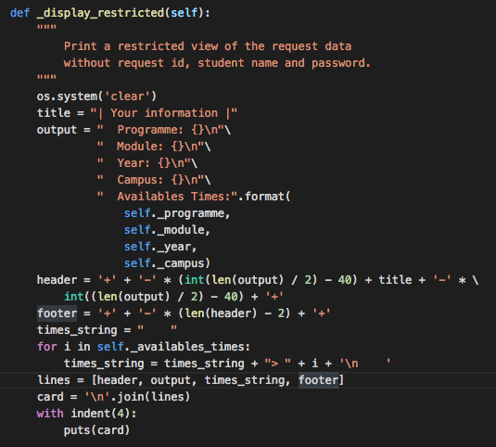

In the screenshot we can see the display_restricted method witch maintain the format of the display_all method but without the sensitive data

Test Case 2

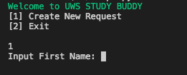

Test Case 3

