## Tests for Step4.py

## Written by B00319125

## 2017-04

## Step 4

### Functional Requirements

|  |  |  |  |
| --- | --- | --- | --- |
| Functional Requirement | Description of Functionality | Description of Test | Test Case # |
| 1 | Create a matching algorithm | Create a matching algorithm the the requests in all the stored requests | 1 |
| 2 | Whenever a new request is entered into the system compare to all previously stored request files, count the number of matches and display matches. | Check all the stored requests and find the matches | 2 |

### Test Cases

|  |  |  |  |
| --- | --- | --- | --- |
| Test Case | Description of Functionality | Test Data | Expected Result |
| 1 | Whenever a new request is entered into the system compare to all previously stored request files, count the number of matches and display matches. | None | Method find_matches created |
| 2 | Check all the stored requests and find the matches | Previously requests created | Show the matches for the current requests created |
|  |  |  |  |

### Test Results & Actions

|  |  |  |
| --- | --- | --- |
| Test Case | Actual Results | Action Required |
| 1 | Success | None |
| 2 | Success | None |

### Evidence

Test Case 1

The screenshot bellow shows the find_matches method:

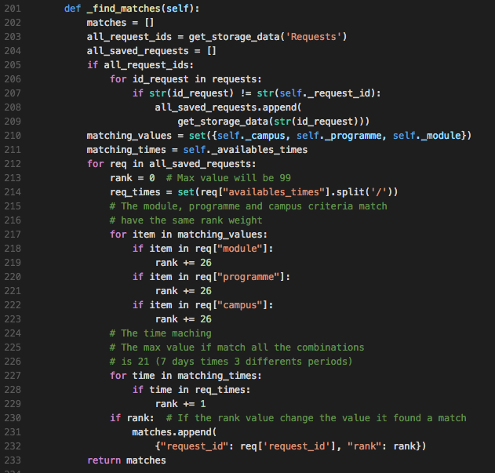

For the line 203 to the line 211 we get all the requests stored in the current directory, and all the current data of the current request, then begin the matching algorithm with module, programme, campus and available times as matching criteria data.

Test 2

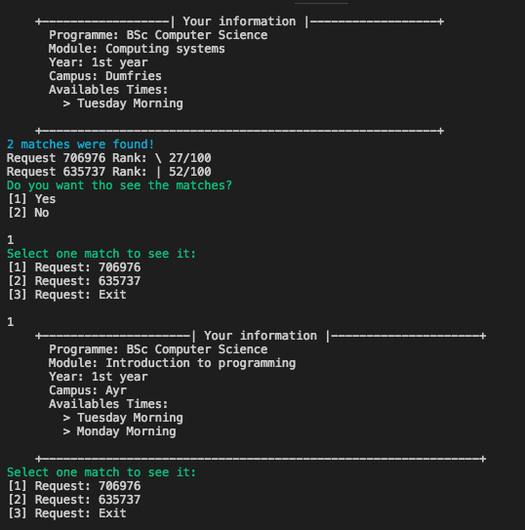

The screenshot shows the current request and the matches were are found with their rank or accuracy of asserts, also we can navigate thrown the matches