## Tests for Step5.py

## Written by B00319125

## 2017-04

## Step 5

### Functional Requirements

|  |  |  |  |
| --- | --- | --- | --- |
| Functional Requirement | Description of Functionality | Description of Test | Test Case # |
| 1 | Edit an existing request | Create a method to edit a request | 1 |
| 2 | Validate all entries | Check if All the inputs are properly handled and formatted | 2 |
| 3 | Check not existing files | Check if the program can run without any file previously created | 3 |

### Test Cases

|  |  |  |  |
| --- | --- | --- | --- |
| Test Case | Description of Functionality | Test Data | Expected Result |
| 1 | Create a method to edit a request | Previously requests created | Successful edit an existing request |
| 2 | Check if All the inputs are properly handled and formatted | Create a new request but intentionally input not valid values | The programs runs without errors |
| 3 | Check if the program can run without any file previously created | Erase a previously request created | The program warning about the files missing |

### Test Results & Actions

|  |  |  |
| --- | --- | --- |
| Test Case | Actual Results | Action Required |
| 1 | Success | None |
| 2 | Success | None |
| 3 | Success | Restore the file deleted |

### Evidence

Test Case 1

The menu now had the edit request option:

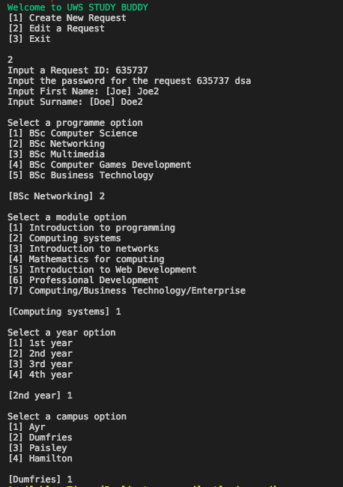

The program permits edit and shows the previous values as default and after shows the news matches if exists:

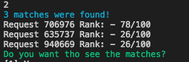

Test 2

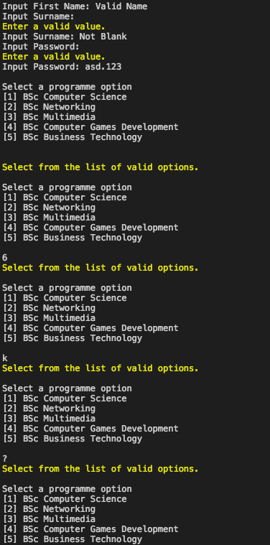

The screenshot show the different tests in the inputs and the program properly is warning about the correct way to do an input in the prompt

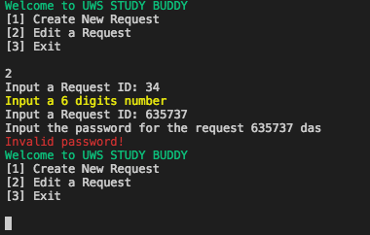

Test 3

Intentionally delete the file 492028.pickle

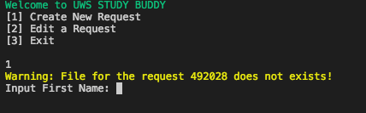

and the program properly warning about the issue