Is There a Gender Pay Gap?
Joy Xu
2026-10-09
The analysis examined whether the population mean hourly gender pay gap differed from zero. Positive values indicate that women’s mean hourly pay is lower than men’s mean hourly pay.

Distribution of the Gender Pay Gap
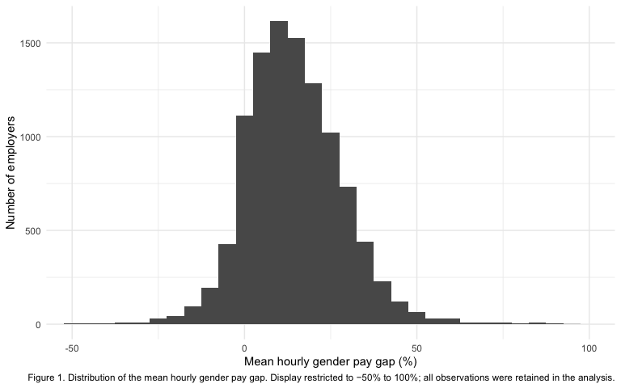

Results
A one-sample $t$-test indicated that the mean hourly gender pay gap was significantly greater than zero, $M=14.29\%$, 95% CI $[14.00\%,14.58\%]$, $t(10,531)=96.50$, $p<.0001$. On average, women’s mean hourly pay was approximately 14.29% lower than men’s mean hourly pay. Therefore, the null hypothesis that the population mean hourly gender pay gap equals zero was rejected.

