How Weather Affects Capital Bikeshare Rentals
Joy Xu · Quantitative Methods 1 · Bike-sharing regression exercise

Results

Data and Descriptive Statistics
The data were the daily records of the Capital Bikeshare scheme in Washington, DC, from 1 January 2011 to 31 December 2012 (N = 731 days; Fanaee-T & Gama, 2013). The outcome was the total number of bikes rented per day. Temperature and wind speed were provided in normalised form and were converted back to their original units: temperature in degrees Celsius (normalised value × 47 − 8) and wind speed in miles per hour (normalised value × 67 km/h × 0.621). Table 1 gives descriptive statistics.
Daily rentals were roughly symmetrically distributed but varied widely, from 22 bikes (29 October 2012, the day Hurricane Sandy reached the region) to 8,714. Temperature was spread across the whole year, with one cluster of days in winter and another in summer, and wind speed was right-skewed, with most days between 5 and 10 mph and a few windy days above 15 mph.
Table 1
Descriptive Statistics for Daily Rentals, Temperature and Wind Speed (N = 731 days)
Variable | M | SD | Min | Mdn | Max
Bikes rented per day | 4,504.3 | 1,937.2 | 22 | 4,548 | 8,714
Temperature (°C) | 15.3 | 8.6 | −5.2 | 15.4 | 32.5
Wind speed (mph) | 7.9 | 3.2 | 0.9 | 7.5 | 21.1

Correlations
Rentals were strongly positively correlated with temperature, r = .63, 95% CI [.58, .67], and weakly negatively correlated with wind speed, r = −.23, 95% CI [−.30, −.16] (Table 2). The two predictors were only weakly related, r = −.16, 95% CI [−.23, −.09]: windier days tended to be slightly cooler. This low correlation is welcome, because it means temperature and wind speed carry largely separate information. Multicollinearity is therefore negligible (variance inflation factor = 1.03), and the separate associations of each predictor with rentals can be estimated precisely when both are entered in the same model.
Table 2
Pearson Correlations With 95% Confidence Intervals
Variable | 1 | 2 | 3
1. Bikes rented per day | —
2. Temperature (°C) | .63 [.58, .67] | —
3. Wind speed (mph) | −.23 [−.30, −.16] | −.16 [−.23, −.09] | —
Scatterplots confirmed these patterns but showed that the relationship with temperature was not linear (Figure 1). Rentals rose steeply from below freezing to about 20 °C, levelled off between 20 and 25 °C, and fell on the hottest days. The linear estimates below should therefore be read as average slopes across the year. The relationship with wind speed was approximately linear (Figure 2).
Figure 1
Daily Bike Rentals by Temperature
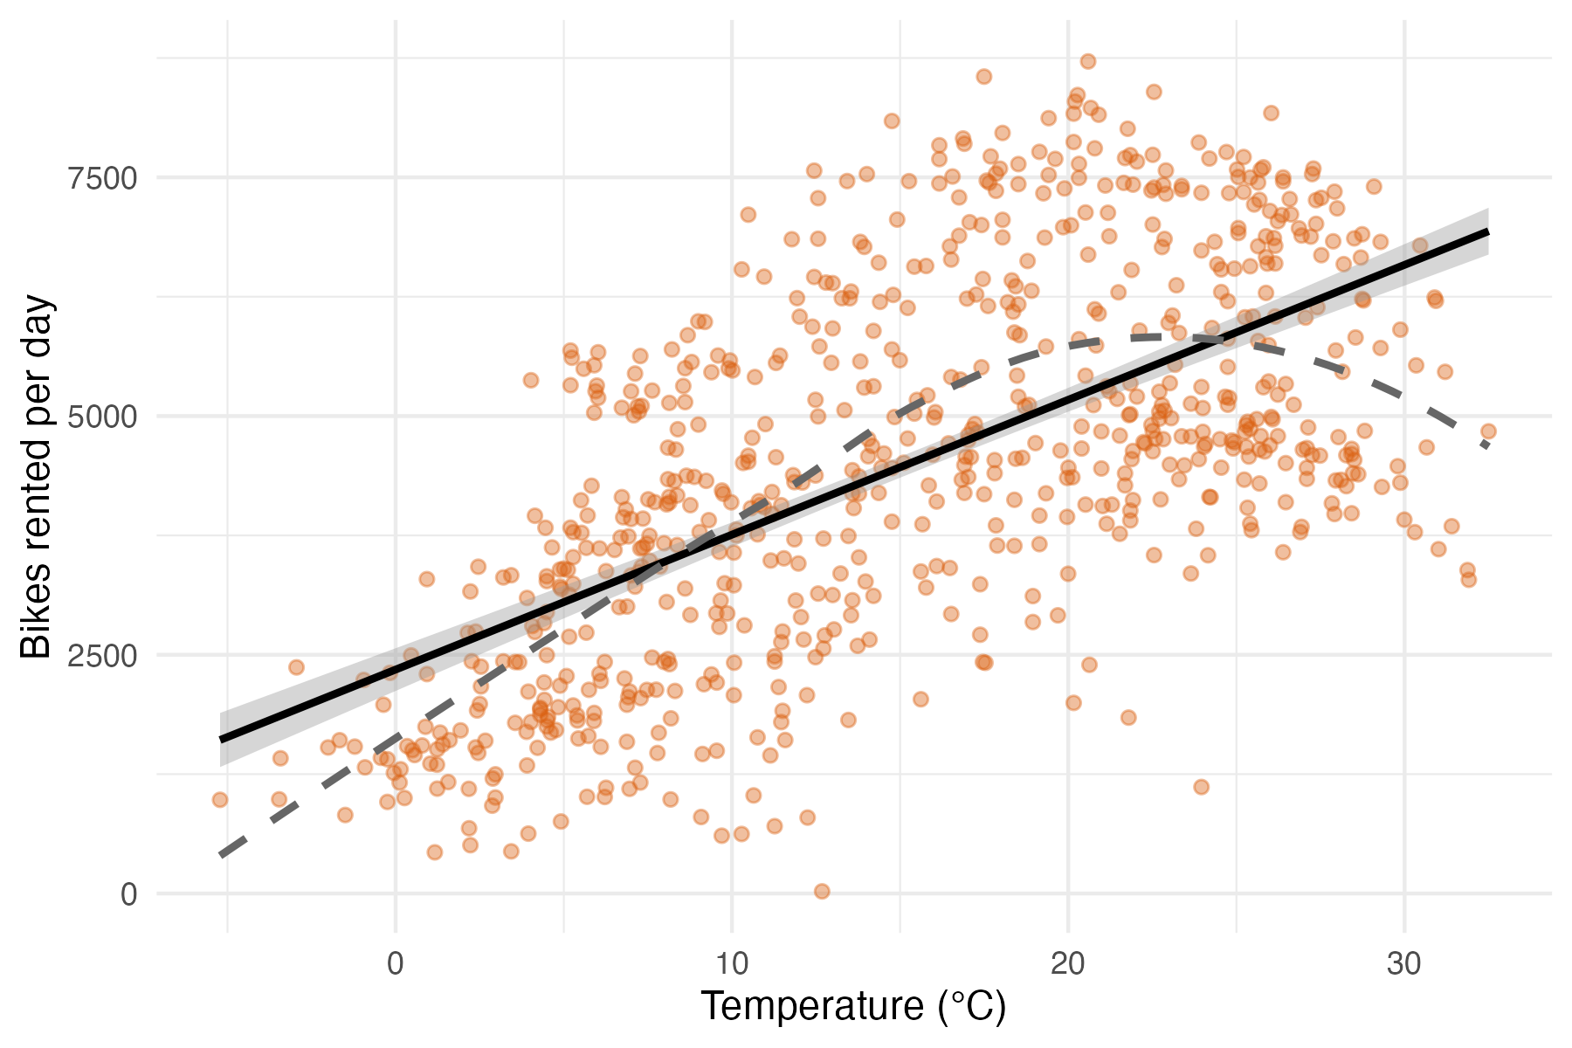
Note. Each point is one day. The solid line is the least-squares fit with its 95% confidence band; the dashed line is a loess smooth.
Figure 2
Daily Bike Rentals by Wind Speed
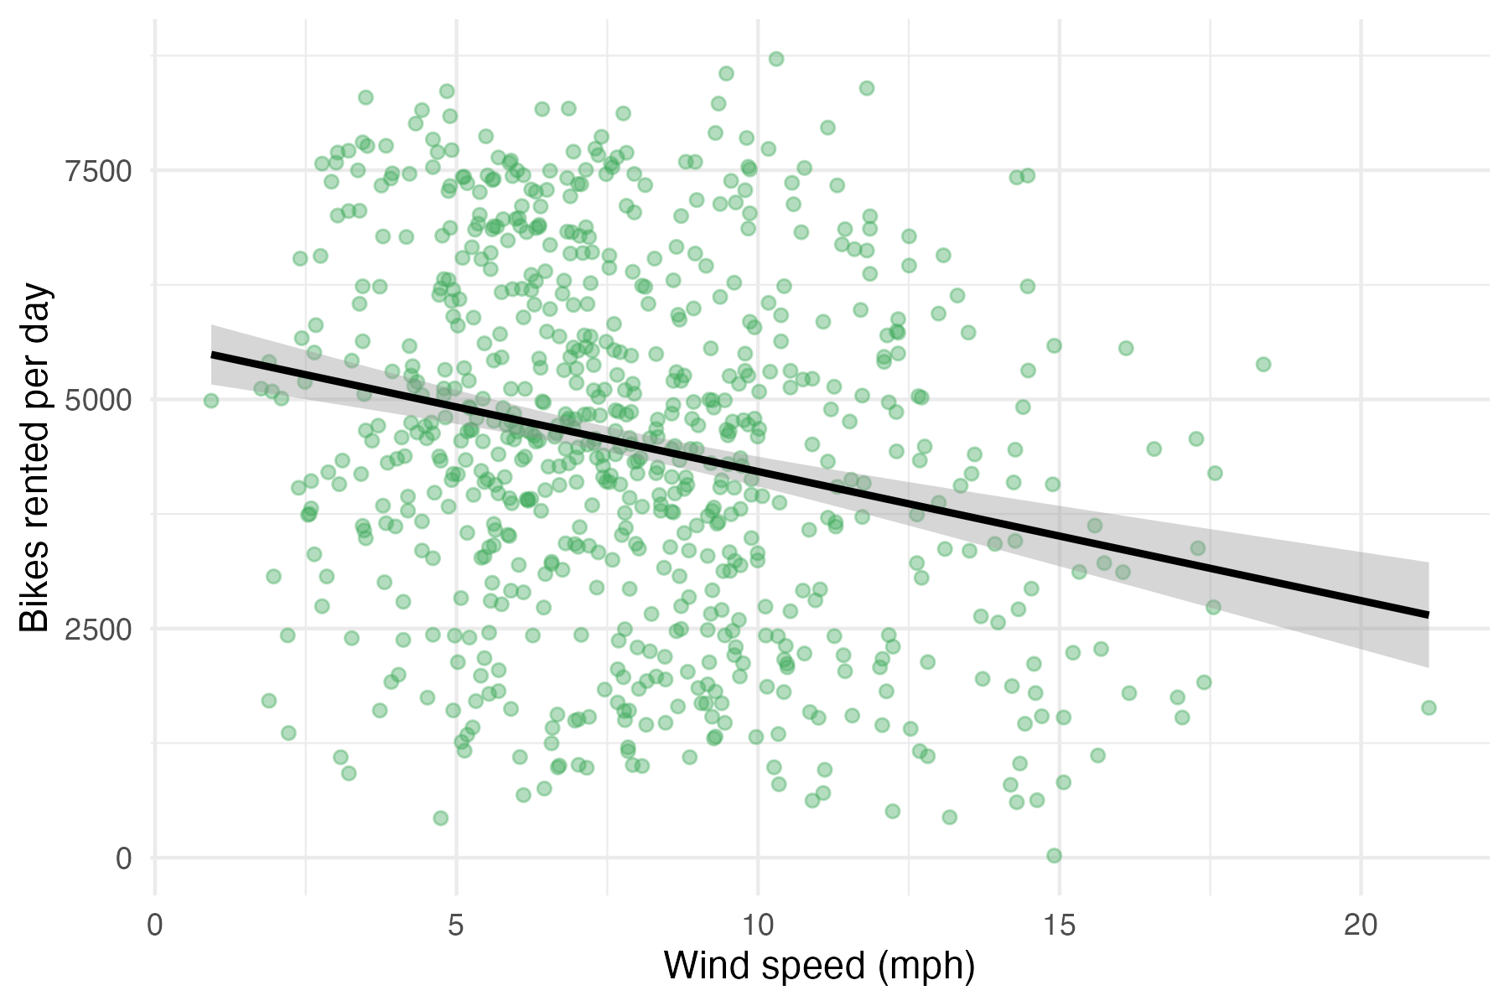
Note. Each point is one day. The solid line is the least-squares fit with its 95% confidence band.

Regression Models
Table 3 reports three ordinary least squares regressions of daily rentals. On its own, each 1 °C increase in temperature was associated with 141 more rentals per day, 95% CI [129, 154] (Model 2), and each 1 mph increase in wind speed was associated with 141 fewer rentals per day, 95% CI [98, 183] (Model 1).
When both predictors were entered together (Model 3), the temperature estimate was almost unchanged: holding wind speed constant, each 1 °C increase was associated with 136 more rentals per day, 95% CI [124, 149]. The wind speed estimate, however, fell by about 40%: holding temperature constant, each 1 mph increase was associated with 83 fewer rentals per day, 95% CI [49, 117].
The difference between the two wind speed estimates is an example of omitted variable bias. Windier days were also cooler: each additional mph was associated with a temperature 0.42 °C lower. When temperature is left out of the model, wind speed takes credit for part of the effect of temperature. The size of the bias is exactly the temperature slope multiplied by this difference (136.4 × −0.42 = −57.4), which accounts for the gap between the single-predictor estimate (−140.8) and the multiple-regression estimate (−83.4). The temperature estimate changed very little because wind speed has a much smaller association with rentals.
Table 3
Regression of Daily Bike Rentals on Wind Speed and Temperature
Predictor | Model 1 | Model 2 | Model 3
Intercept | 5,621.2 (185.1) | 2,345.0 (113.9) | 3,081.9 (189.4)
 | [5,257.8, 5,984.5] | [2,121.4, 2,568.5] | [2,710.0, 3,453.7]
Wind speed (mph) | −140.8 (21.6) |  | −83.4 (17.3)
 | [−183.3, −98.4] |  | [−117.3, −49.5]
Temperature (°C) |  | 141.3 (6.5) | 136.4 (6.5)
 |  | [128.5, 154.0] | [123.6, 149.1]
R² | .055 | .394 | .413
Residual SE | 1,884.5 | 1,509.4 | 1,486.8
Note. N = 731 days. Cells show unstandardised coefficients (bikes per day) with standard errors in parentheses and 95% confidence intervals in brackets.

Relative Importance of Temperature and Wind Speed
Because the two coefficients are in different units, their relative importance was compared on common scales. Temperature alone explained 39.4% of the variance in daily rentals, compared with 5.5% for wind speed alone. Adding wind speed to the temperature model raised R² by only 1.9 percentage points (to 41.3%), whereas adding temperature to the wind speed model raised it by 35.8 points. Standardised coefficients from Model 3 told the same story: a one-standard-deviation increase in temperature (8.6 °C) was associated with 0.61 SD more rentals, 95% CI [0.55, 0.66], about 1,170 bikes per day, whereas a one-standard-deviation increase in wind speed (3.2 mph) was associated with 0.14 SD fewer rentals, 95% CI [0.08, 0.20], about 270 bikes per day.
Temperature therefore matters roughly four times as much as wind speed for bike hire. If only one of the two variables could be known, temperature would be far more useful for predicting demand. Even together, however, the two variables left most of the day-to-day variation in rentals (59%) unexplained.

Variation Across the Year
To examine whether the relationship with temperature differed across the year, rentals were regressed on temperature separately for each month (Figure 3). In cooler months the association was clearly positive: from January to May and in October and December, each 1 °C increase was associated with between 110 and 291 more rentals per day, with the largest slope in March (291, 95% CI [226, 357]). In June and July, by contrast, warmer days had fewer rentals (June: −120, 95% CI [−220, −20]; July: −158, 95% CI [−287, −30]). Estimates for August, September and November were imprecise, with confidence intervals that included zero, partly because temperature varied little within those months.
The overall slope of 141 rentals per °C therefore averages over a strong positive effect in cool weather and a negative effect in hot weather, matching the curvature seen in Figure 1. For Capital Bikeshare, warmer weather increases demand in winter, spring and autumn, but in midsummer additional heat reduces it. Because each month combines data from 2011 and 2012, and rentals were higher overall in 2012, small differences between months should be interpreted with caution.
Figure 3
Slope of Daily Rentals on Temperature, Estimated Separately for Each Month
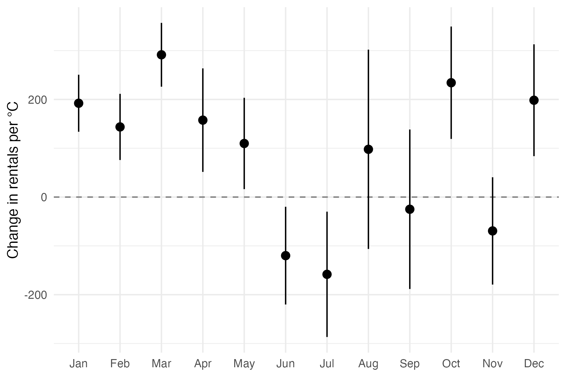
Note. Points are unstandardised slopes (change in bikes rented per day per 1 °C) from separate regressions for each month, pooling 2011 and 2012; bars are 95% confidence intervals. The dashed line marks zero.
Reference
Fanaee-T, H., & Gama, J. (2013). Event labeling combining ensemble detectors and background knowledge. Progress in Artificial Intelligence, 2(2), 113–127. https://doi.org/10.1007/s13748-013-0040-3

