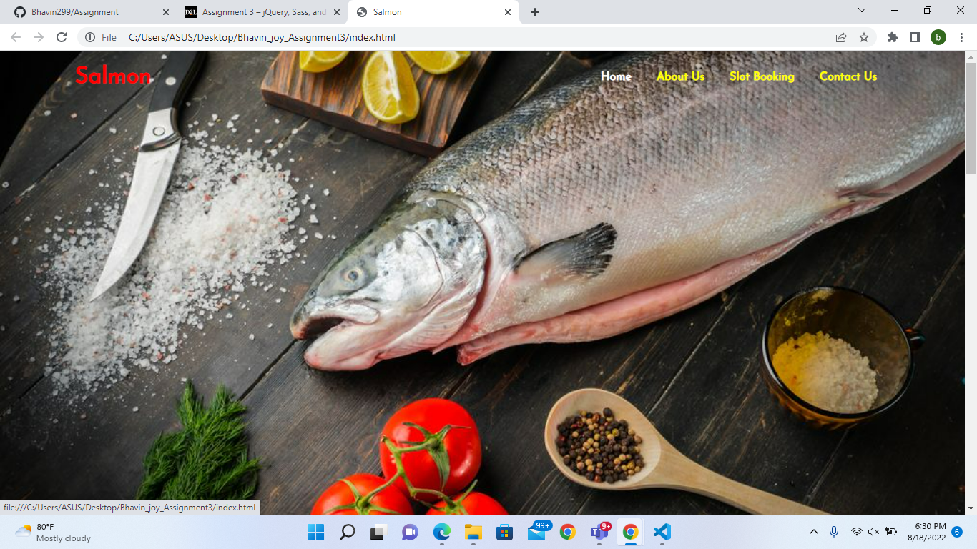

In this assignment , firstly I created the saas file in my folder where I created index.html folder, after that I add the effects where I change the font color from white to yellow .

After the font color, I change the hover effect , where I used white color from yellow while we hover around the text

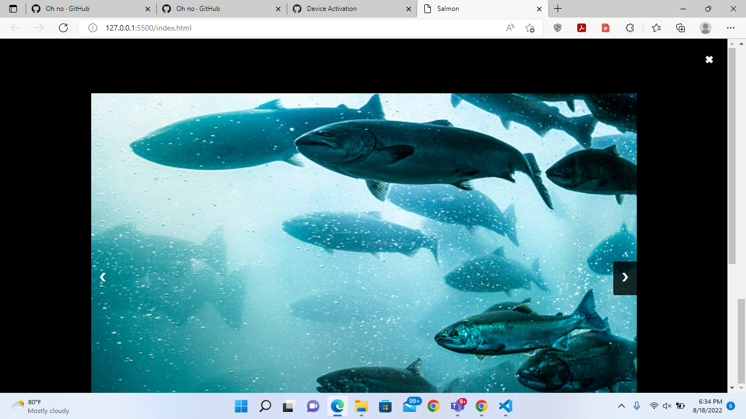

In this picture we used jquery to apply the slide show or we can say that I used the jquery to show the light box, I also used the navigation button which is used to change the images , afterwards outside the images I also created a exit button which is used to exit from the light box

In this picture , I change the background color of the button to red , after changing the color I applied a after effect where the text: submit is change to capital Submit , after that I applied border in the form , which is known as dashed border.

After performing all the changes I upload my project in the github using my mohawk college account.

Github repository link: https://github.com/Joy-nareshbhai/joyassignment