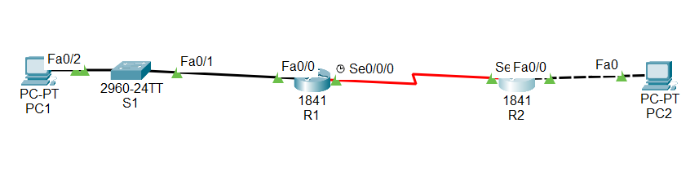

Router 1 :

Basic configuration – fa0/0 = 192.168.1.1 255.255.255.0

s0/0/0 = 192.168.2.1 255.255.255.0

Erase previous Configuration :

Router>en

Router# erase startup-config

Router#reload

Assign hostname :

Router#conf t

Router(config)#hostname R1

R1(config)#no ip domain-lookup

Assign encrypted password :

R1(config)#enable secret class

Message of the day :

R1(config)#banner motd #

Enter TEXT message. End with the character 'I'.

How are you ?

#

Password assign in console port :

R1(config)#line console 0

R1(config-line)#password cisco

R1(config-line)#login

R1(config-line)#exit

Password assign in vty port :

R1(config)#line vty 0 4

R1(config-line)#password cisco

R1(config-line)#login

R1(config-line)#exit

Assign IP in port fa0/0 :

R1(config)#int fa0/0

R1(config-if)#ip add 192.168.1.1 255.255.255.0

R1(config-if)#no shut

Assign IP in port s0/0/0 :

R1(config-if)#int s0/0/0

R1(config-if)#ip add 192.168.2.1 255.255.255.0

R1(config-if)#clock rate 64000

R1(config-if)#no shut

R1(config-if)#exit

R1(config)#exit

Saving configurations :

R1#copy running-config startup-config

Check configurations :

R1#show ip route

R1# show ip interface brief

Router 2 :

Basic configuration – fa0/0 = 192.168.3.1 255.255.255.0

s0/0/0 = 192.168.2.2 255.255.255.0

Erase previous Configuration :

Router>en

Router# erase startup-config

Router#reload

Assign hostname :

Router#conf t

Router(config)#hostname R2

R2(config)#no ip domain-lookup

Assign encrypted password :

R2(config)#enable secret class

Message of the day :

R2(config)#banner motd #

Enter TEXT message. End with the character 'I'.

How are you ?

#

Password assign in console port :

R2(config)#line console 0

R2(config-line)#password cisco

R2(config-line)#login

R2(config-line)#exit

Password assign in vty port :

R2(config)#line vty 0 4

R2(config-line)#password cisco

R2(config-line)#login

R1(config-line)#exit

Assign IP in port fa0/0 :

R2(config)#int fa0/0

R2(config-if)#ip add 192.168.3.1 255.255.255.0

R2(config-if)#no shut

Assign IP in port s0/0/0 :

R2(config-if)#int s0/0/0

R2(config-if)#ip add 192.168.2.2 255.255.255.0

R2(config-if)#clock rate 64000

R2(config-if)#no shut

R2(config-if)#exit

R2(config)#exit

Saving configurations :

R2#copy running-config startup-config

Check configurations :

R2#show ip route

R2# show ip interface brief