**NAMES: IKIREZI JOY**

**ID: 24885**

**UI SCREENSHOTS**

1. **SIGNIN PAGE**

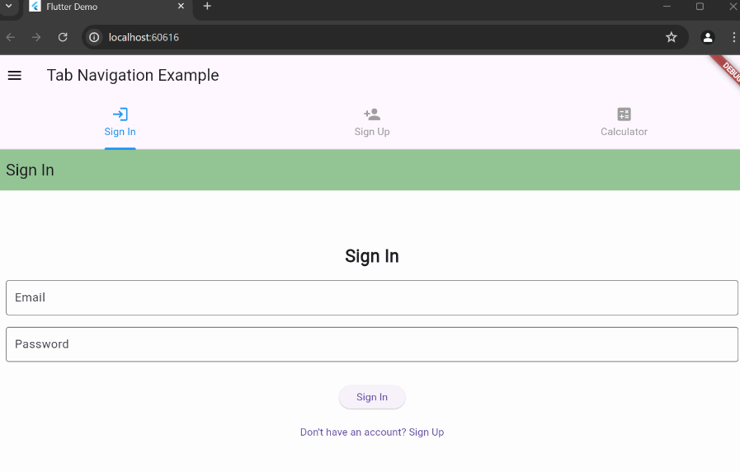

1. **SIGNUP PAGE**

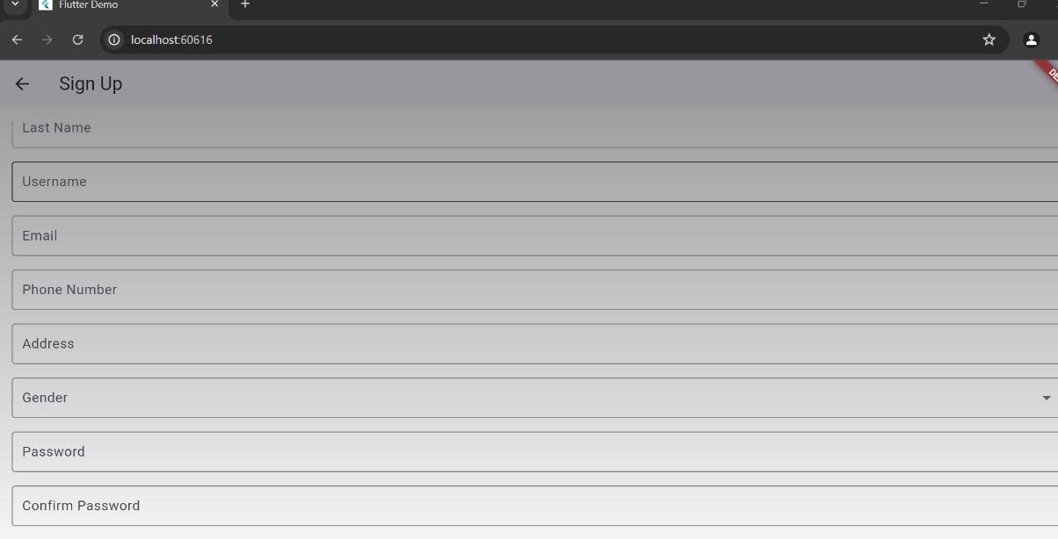

1. **CALCULATOR SCREEN**

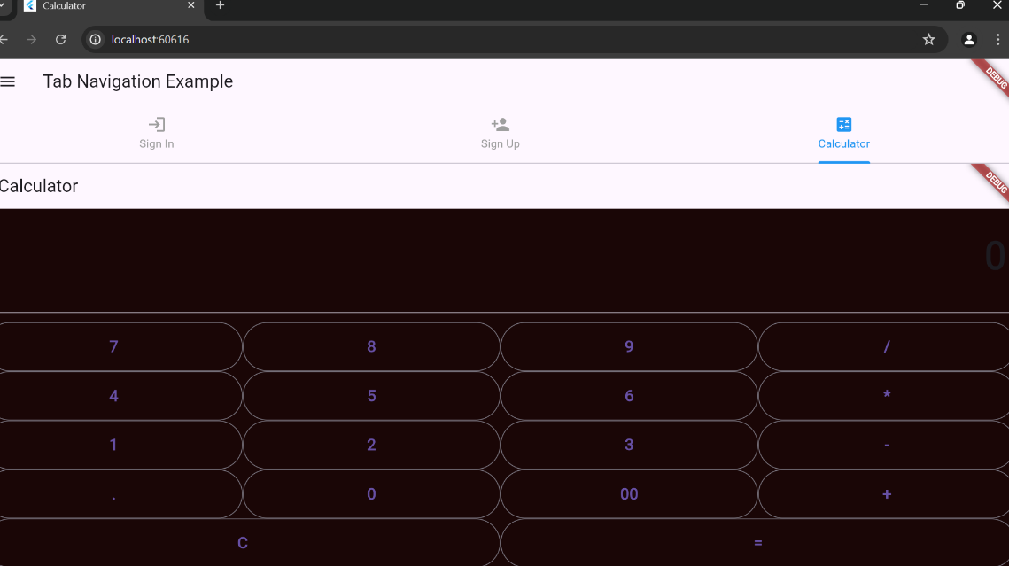

1. **MENU BAR**

