**Matharon**

**Game Name: Matharon.**

**Game Concept:** Our goal is to create a game in which a player will try in a competitive way to accomplish a certain task. Players will control over a character and move him in jump & run style through a flat map, collecting numbers, avoiding obstacles and solving maths. There will be several types of numbers like green and red where green numbers will add points and red numbers will subtract points. Sometimes bonus boxes will appear where players can increase their abilities by solving math problems.

**Explanation of Novel Idea:** Our game introduces a unique twist to the jump & run genre and will enforce children to build interest in mathematics. As games are always enjoyable, our idea is to enhance a player's mathematics knowledge with fun.

**Outline of Gameplay:** The player has to do different things like jumping, avoiding obstacles, collecting only green coins, will take a major role in the gameplay. This will be done with simple mechanics like the player has to jump when obstacles come. But it will also incorporate more complicated situations where he has to solve a math within 30 seconds after collecting 3 red coins. Otherwise it’s game over.

**Targeted Consumer:** The main targeted consumers are children between 3-10 years. But by increasing difficulty level any age people can play this.

**Game Screen:**

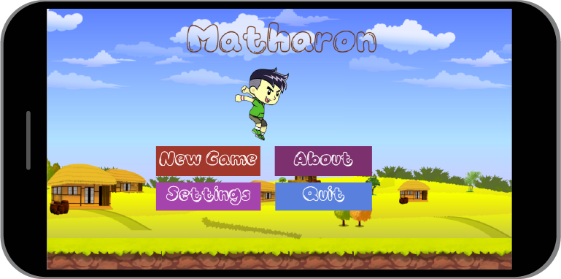

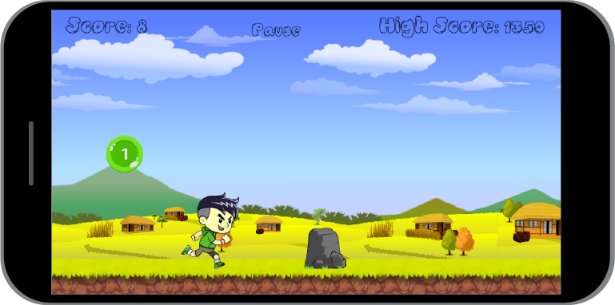

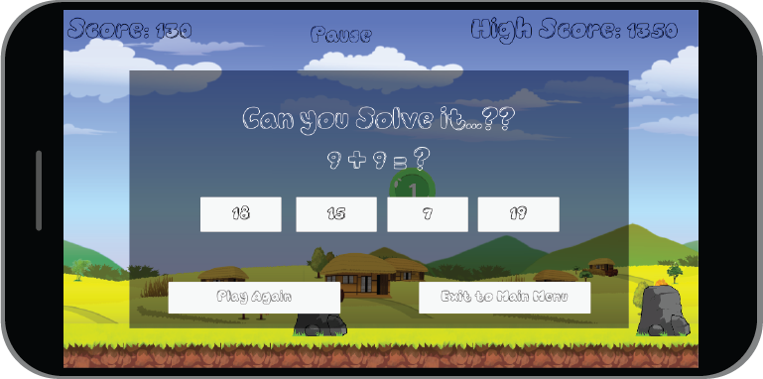

**More Feature Yet to come:**

1. Dark Mode
2. Limited light system for Dark Mode
3. New Character
4. Slide movement for Character
5. More obstacles