**TODO APP**

Joynal Abedin

Senior Project Warm-Up Challenge

3rd September 2018

URL: <http://todo.joynal.me>

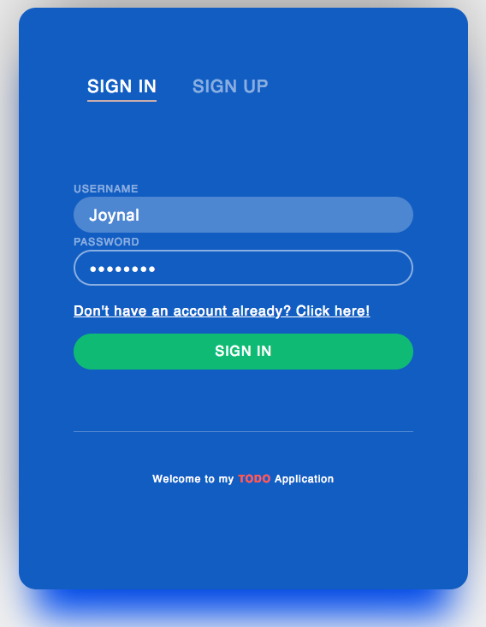

Table of Contents

Functional requirements 3

Non-Functional requirements 3

Test Cases 3

System Architecture Diagram 6

Data-Flow Diagram 6

Sequence Diagram 7

Database Diagram 7

Use Case Diagram 8

## **Functional requirements**

1. User must be able to register for a new account.
2. User must be able to login with the new username and password.
3. User must be able to add new tasks.
4. User must be able to see all tasks.
5. User must be able to delete tasks.
6. User must be able to use a web application for managing tasks.

## **Non-Functional requirements**

|  |  |
| --- | --- |
| NFA | NFR |
| **Security** | **Login -** Access levels  **CRUD -** Create, Read, Update and Delete levels  **Encryption (**data in flight and at rest)  **Data** **Classification**: all data must be protected |
| **Performance** | Response times – browser refresh times, application loading  Processing times – functions, imports, exports  Query and Reporting times- initial loads |
| **Availability** | Total uptime. Locations of operation (Nearest region if deployed to cloud). |
| **Reliability** | Mean time between failures and recovery. Deploy to cloud platform. |
| **Usability** | User standards in terms of Look and feel. |

## Test Cases

|  |  |
| --- | --- |
| Test Case Name | Register new Account |
| Test Case ID | TC-1 |
| Priority | High |
| Preconditions | Type username and password |
| Post conditions | New user directed home page |
| Test Steps | 1. Open a browser 2. Navigate to todo.joynal.me/register 3. Type “testUser” in Username field 4. Type “testPassword” |
| Expected Results | Allows user to register and redirect the page to home page |

|  |  |
| --- | --- |
| Test Case Name | Login – using valid username and password |
| Test Case ID | TC-2 |
| Priority | High |
| Preconditions | Username and Password already exists (TC-1) |
| Post conditions | New user directed to home page |
| Test Steps | 1. Open a browser 2. Navigate to todo.joynal.me 3. Type “testUser” in Username field 4. Type “testPassword” |
| Expected Results | Allows user to Login and redirect the page to home page |

|  |  |
| --- | --- |
| Test Case Name | Add a new todo item |
| Test Case ID | TC-3 |
| Priority | Medium |
| Preconditions | Must have an account and be logged in already (TC-1 & TC-2) |
| Post conditions | New item appears in the home page |
| Test Steps | 1. Open a browser 2. Navigate to todo.joynal.me/login 3. Type “testUser” in Username field 4. Type “testPassword” 5. Type “testTodoItem1” in “Add new todo” box 6. Hit Enter |
| Expected Results | New todo item appears |

|  |  |
| --- | --- |
| Test Case Name | Delete a todo item |
| Test Case ID | TC-4 |
| Priority | High |
| Preconditions | Must have an account and be logged in already (TC-1 & TC-2) |
| Post conditions | Item is being deleted and disappears from view |
| Test Steps | 1. Open a browser 2. Navigate to todo.joynal.me/register 3. Type “testUser” in Username field 4. Type “testPassword” 5. Create a new todo item by typing “testTodoItem1” in “Add new todo” box. 6. Now hover over this item 7. Click on Trash icon. |
| Expected Results | Todo item is being deleted and disappeared |

|  |  |
| --- | --- |
| Test Case Name | Logout |
| Test Case ID | TC-5 |
| Priority | Medium |
| Preconditions | Must be logged in already. (TC-1 & TC-2) |
| Post conditions | User directed to login page |
| Test Steps | 1. Open a browser 2. Navigate to todo.joynal.me/register 3. Type “testUser” in Username field 4. Type “testPassword” 5. Once you’re on the home page, click on “Logout” button |
| Expected Results | User will be signed out and redirected the page to the login page. |

## **System Architecture Diagram**

## ../Downloads/Todo%20diagram/TODO%20Architectural%20Diagram.png

## **Data-Flow Diagram**

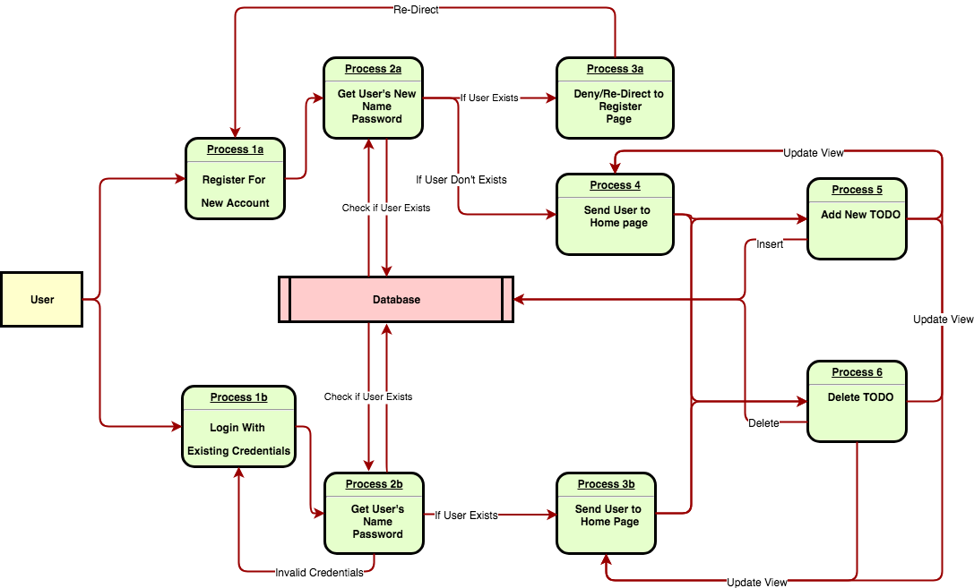

## **Sequence Diagram**

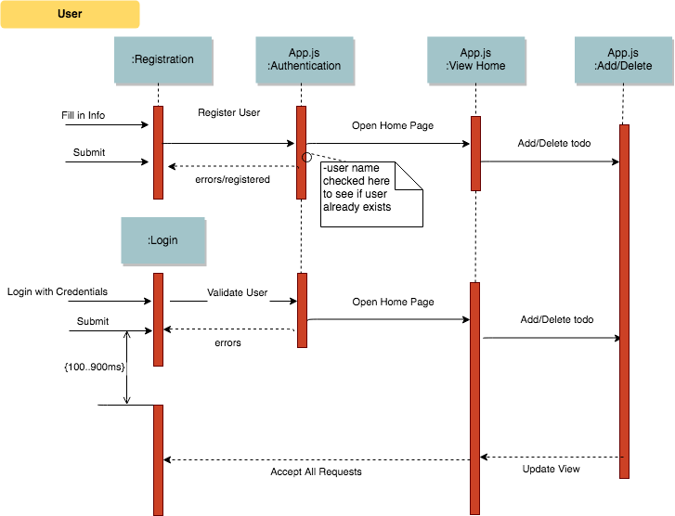

## **Database Diagram**

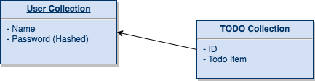

## **Use Case Diagram**

../Downloads/Todo%20diagram/TODO%20Use%20cases.png