Joynal Abedin FY9237

CSC 4500 04/02/2018

Q1: Convert the following

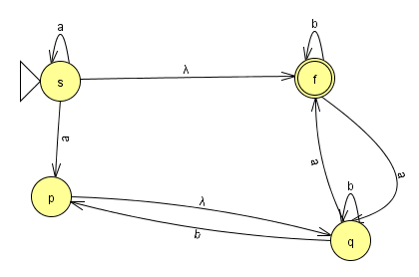

Converted to DFA:

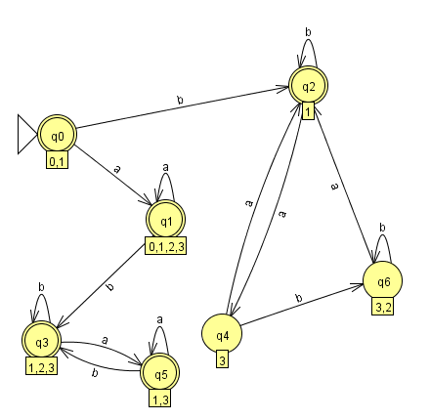

Q2. Convert the following

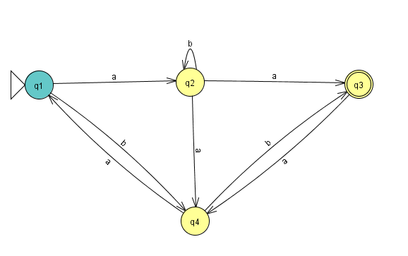

REGULAR EXPRESSION: (((b+ab\*a)a)\*(ab\*a+(b+ab\*a)b)(ab)\*aa)\*((b+ab\*a)a)\*(ab\*a+(b+ab\*a)b)(ab)\*

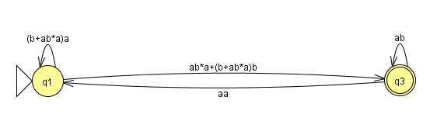

Q3:

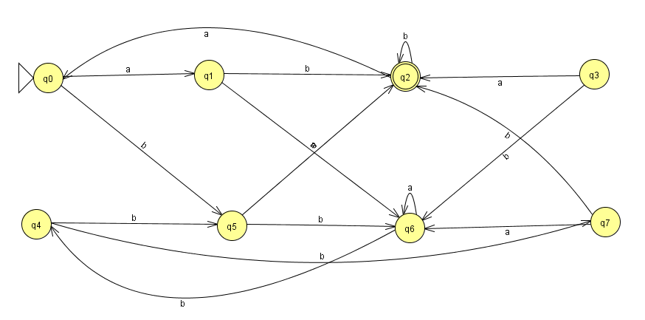

MINIMAL DFA

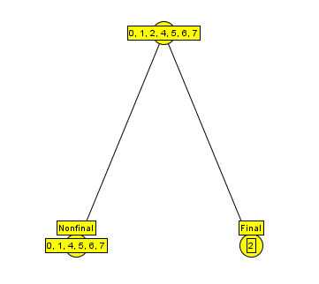

Q4.



LL PDA

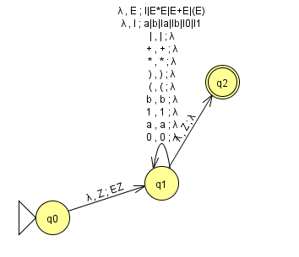

LR PDA

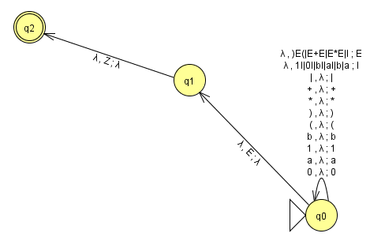

Q5. Regular Grammar: a\*(λ+a(b+b)\*a)(b+a(b+b)\*a)\*

Graph:

