**(Airline Ticket Reservation System)**

# FINAL PROJECT REPORT

CSD 3204_11 -Relational Database & SQL

The aim of this project is to develop an application which would facilitate the reservation of online air tickets through an effective and yet simple GUI for a normal passenger intending to travel in airways.

The project is basically targeted at those people who would like to travel through air. Apart from reserving tickets, through this system a passenger can compare fares ‘from’ various cities ‘to’ various cities.

**You will focus on the backend using Oracle. Which mean you have design and implement database for Airline Ticket Reservation System**

The design of the database is an art-work and is up to the student, however, it should provide the following facilities:

**Flight:**

Each flight has flight number, aircraft, source, destination, air-line and flight time.

**Reservation:**

Passenger, ticket, airline, source, destination, etc.

**Ticket:**

To be designed to fulfill the requirements of the queries.

**Passenger:**

To be designed to fulfill the requirements of the queries.

**Note:**

More than one airline travel from one city to the other city. Also, you may add more tables if required.

Part 1:

1. Create ERD for database
2. Define the entities, the attributes and the relationship
3. Perform normalization (3th normal form)
4. Create Database Tables
5. Construct CREATE statements for each table
6. Include IDENTITY and SEQUENCE columns (optional)
7. Construct INSERT statements and populate each table with with at least 3 rows

## Constraints:

## Identify Business Rules/Database Constraints.

1. Implement the constraints into the database creation statements

Part 2:

Queries:

Implement queries for following:

1. Data entry into tables that you have created.
2. Travel history of a specific passenger.
3. Total hours that a specific aircraft has served during a specific time interval.
4. Total number of aircrafts belonging to a specific airline.
5. Total number of hours that a specific passenger has travelled during a specific time interval.
6. Total number of hours that a specific airline has been running during a specific time interval.
7. List of all passengers who flew to a specific city during a specific time interval.
8. Most visited city during the last month.
9. List of aircrafts that have **not** been in used from a specific source location.
10. List of airlines that run flight from a specific source to a destination.
11. The list of all options that a passenger can have when travelling from a source to a destination. This includes a connecting flight, for instance, a passenger is travelling from Toronto to Dehli and there is no direct flight, therefore, you have to find the options for this passenger.
12. What is the minimum number of hours that it will take for a passenger to travel from a source city to a destination city. Again, consider the connecting flights as mentioned in item number 9, e.g. travelling from Toronto to Dehli.

**You can work as a group of four students toward completion of this project**

PART 1

1. Entity Relationship Diagram

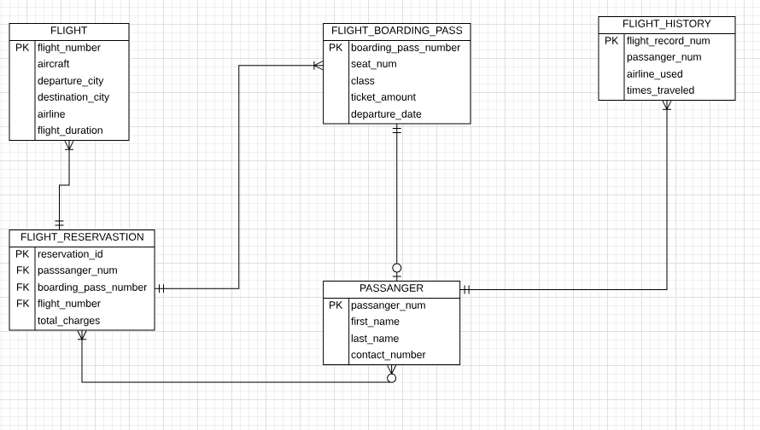

1. Normalization (3NF)
2. FLIGHT

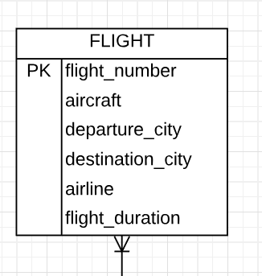

1. FLIGHT_BOARDING_PASS

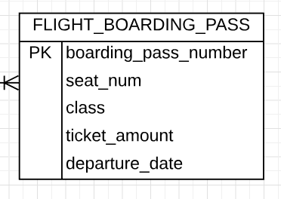

1. FLIGHT_HISTORY

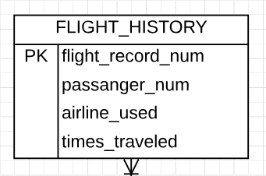

1. FLIGHT_RESERVATION

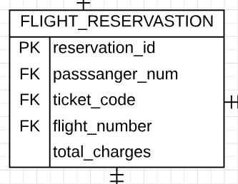

1. PASSANGER

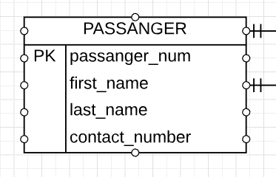

1. (A)Creating Tables
2. Creating Table FLIGHT :

CREATE TABLE FLIGHT(

FLIGHT_NUM VARCHAR(15) NOT NULL,

AIRCRAFT VARCHAR(15),

DEPARTURE_CITY VARCHAR(20) NOT NULL,

DESTINATION_CIITY VARCHAR(20) NOT NULL,

FLIGHT_DURATION VARCHAR(6),

PRIMARY KEY (FLIGHT_NUM)

);

1. Creating Table FLIGHT_BOARDING_PASS :

CREATE TABLE FLIGHT_BOARDING_PASS(

BOARDING_PASS_NUMBER NUMBER(6) NOT NULL,

SEAT_NUM VARCHAR(3) NOT NULL,

FLYING_CLASS VARCHAR(15) NOT NULL,

DEPARTURE_DATE DATE NOT NULL,

PRIMARY KEY (BOARDING_PASS_NUMBER)

);

1. Creating Table FLIGHT_HISTORY :

CREATE TABLE FLIGHT_HISTORY(

FLIGHT_RECORD_NUM NUMBER(5) NOT NULL,

PASSANGER_NUM NUMBER(5) NOT NULL,

AIRLINE_USED NUMBER(5),

TIMES_TRAVELED NUMBER(5),

PRIMARY KEY (FLIGHT_RECORD_NUM)

);

1. Creating Table FLIGHT_RESERVATION :

CREATE TABLE FLIIGHT_RESERVATION(

RESERVATION_ID NUMBER(5) NOT NULL,

PASSANGER_NUM NUMBER(5) NOT NULL,

BOARDING_PASS_NUMBER NUMBER(6) NOT NULL,

TOTAL_AMOUNT NUMBER(20),

PRIMARY KEY (RESERVATION_ID)

);

1. Creating Table PASSANGER :

CREATE TABLE PASSANGER (

PASSANGER_NUM NUMBER(5) NOT NULL,

FIRST_NAME VARCHAR(15) NOT NULL,

LAST_NAME VARCHAR(15) NOT NULL,

CONTACT_NUMBER NUMBER(11),

PRIMARY KEY (PASSANGER_NUM)

);

3.(C) Construct INSERT Statements And Populate Each Table With At least 3 Rows

1. **Inserting Values In Table FLIGHT :**

INSERT INTO FLIGHT(

"FLIGHT_NUM","AIRCRAFT","DEPARTURE_CITY","DESTINATION_CITY","AIRLINE","FLIGHT_DURATION")

VALUES (

'001','BOEING777','BOMBAY','TORONTO','AIR CANADA','18');

INSERT INTO FLIGHT(

"FLIGHT_NUM","AIRCRAFT","DEPARTURE_CITY","DESTINATION_CITY","AIRLINE","FLIGHT_DURATION")

VALUES (

'002','BOEING370','SYDNEY','AMSTARDEM','SINGAPORE AIRLINE','22');

INSERT INTO FLIGHT(

"FLIGHT_NUM","AIRCRAFT","DEPARTURE_CITY","DESTINATION_CITY","AIRLINE","FLIGHT_DURATION")

VALUES (

'003','BOEING730','DUBAI','DELHI','EMIRATES','4');

INSERT INTO FLIGHT(

"FLIGHT_NUM","AIRCRAFT","DEPARTURE_CITY","DESTINATION_CITY","AIRLINE","FLIGHT_DURATION")

VALUES (

'004','BOEING457','PARIS','NEW YORK','AMERICAN AIRLINES','18:30');

1. **Inserting Values In FLIGHT_BOARDING_PASS Table :**

INSERT INTO FLIGHT_BOARDING_PASS(

"BOARDING_PASS_NUMBER","SEAT_NUM","FLYING_CLASS","DEPARTURE_DATE")

VALUES (

'1234','L14','BUSINESS','2018-11-30');

INSERT INTO FLIGHT_BOARDING_PASS(

"BOARDING_PASS_NUMBER","SEAT_NUM","FLYING_CLASS","DEPARTURE_DATE")

VALUES (

'1235','A2','FIRST','2019-01-01');

INSERT INTO FLIGHT_BOARDING_PASS(

"BOARDING_PASS_NUMBER","SEAT_NUM","FLYING_CLASS","DEPARTURE_DATE")

VALUES (

'1259','K22','ECONOMY','2019-06-05');

INSERT INTO FLIGHT_BOARDING_PASS(

"BOARDING_PASS_NUMBER","SEAT_NUM","FLYING_CLASS","DEPARTURE_DATE")

VALUES (

'1269','B2','BUSINESS','2019-06-06');

1. **Inserting Values In FLIGHT_HISTORY Table :**

INSERT INTO FLIGHT_HISTORY(

"FLIGHT_RECORD_NUM","PASSANGER_NUM","AIRLINE_USED","TIMES_TRAVELED")

VALUES(

'11','121','3','5');

INSERT INTO FLIGHT_HISTORY(

"FLIGHT_RECORD_NUM","PASSANGER_NUM","AIRLINE_USED","TIMES_TRAVELED")

VALUES(

'12','125','9','17');

INSERT INTO FLIGHT_HISTORY(

"FLIGHT_RECORD_NUM","PASSANGER_NUM","AIRLINE_USED","TIMES_TRAVELED")

VALUES(

'13','120','4','15');

INSERT INTO FLIGHT_HISTORY(

"FLIGHT_RECORD_NUM","PASSANGER_NUM","AIRLINE_USED","TIMES_TRAVELED")

VALUES(

'14','127','17','30');

1. **Inserting Values In FLIGHT_RESERVATION Table :**

INSERT INTO FLIIGHT_RESERVATION(

"RESERVATION_ID","PASSANGER_NUM","BOARDING_PASS_NUMBER","TOTAL_AMOUNT")

VALUES (

'1','121','1234','3500');

INSERT INTO FLIIGHT_RESERVATION(

"RESERVATION_ID","PASSANGER_NUM","BOARDING_PASS_NUMBER","TOTAL_AMOUNT")

VALUES (

'2','125','1235','12548');

INSERT INTO FLIIGHT_RESERVATION(

"RESERVATION_ID","PASSANGER_NUM","BOARDING_PASS_NUMBER","TOTAL_AMOUNT")

VALUES (

'3','120','1259','1200');

INSERT INTO FLIIGHT_RESERVATION(

"RESERVATION_ID","PASSANGER_NUM","BOARDING_PASS_NUMBER","TOTAL_AMOUNT")

VALUES (

'4','127','1269','5500');

1. **Inserting Values In PASSANGER Table :**

INSERT INTO PASSANGER(

"PASSANGER_NUM","FIRST_NAME","LAST_NAME","CONTACT_NUMBER")

VALUES(

'121','BLACK','WIDOW','6886885574');

INSERT INTO PASSANGER(

"PASSANGER_NUM","FIRST_NAME","LAST_NAME","CONTACT_NUMBER")

VALUES(

'125','TONY','STARK','7787789999');

INSERT INTO PASSANGER(

"PASSANGER_NUM","FIRST_NAME","LAST_NAME","CONTACT_NUMBER")

VALUES(

'120','CPT','AMERICA','4567891122');

INSERT INTO PASSANGER(

"PASSANGER_NUM","FIRST_NAME","LAST_NAME","CONTACT_NUMBER")

VALUES(

'127','Dr','STRANGE','1234567899');

1. **CONSTRAINTS**

**Foreign Key:**

ALTER TABLE FLIGHT_HISTORY

ADD FOREIGN KEY (PASSANGER_NUM) REFERENCES PASSANGER(PASSANGER_NUM);

PART 2

1. Data entry into tables that you have created.

********** Code Is Already Given Above **********

1. Travel history of a specific passenger.

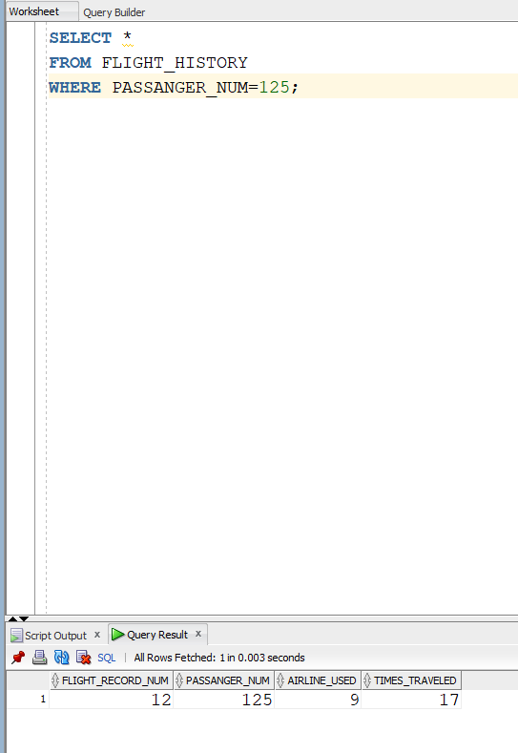

1. Total hours that a specific aircraft has served during a specific time interval.

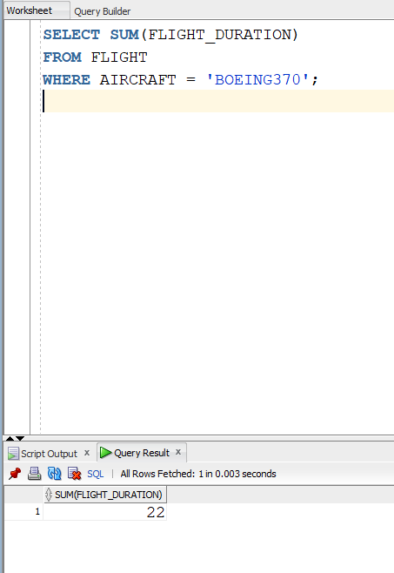

1. Total number of aircrafts belonging to a specific airline.

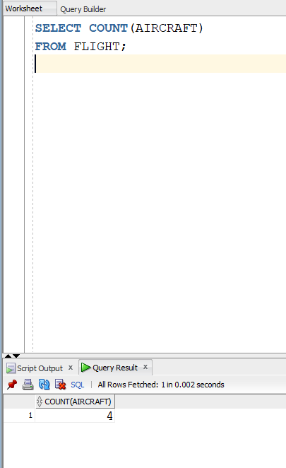

1. Total number of hours that a specific passenger has travelled during a specific time interval.

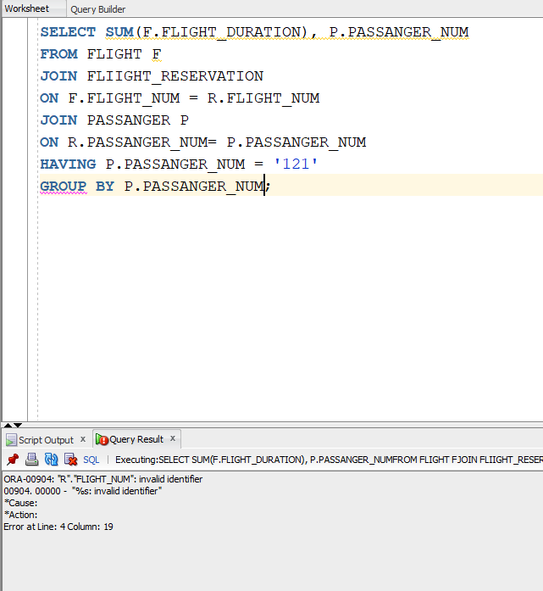

1. Total number of hours that a specific airline has been running during a specific time interval.

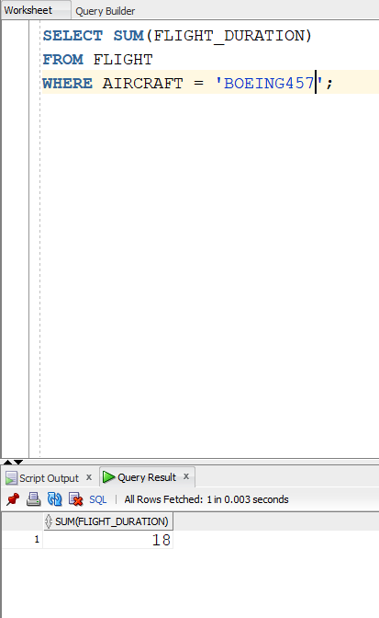

1. List of all passengers who flew to a specific city during a specific time interval.

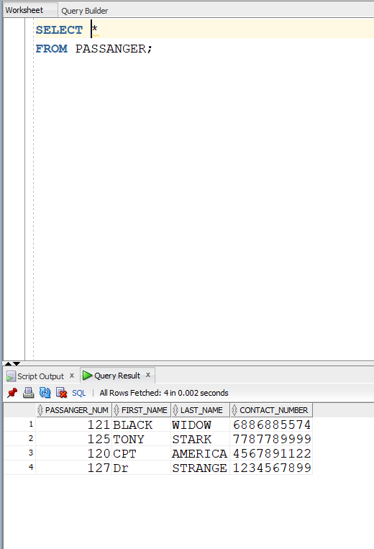

1. Most visited city during the last month.

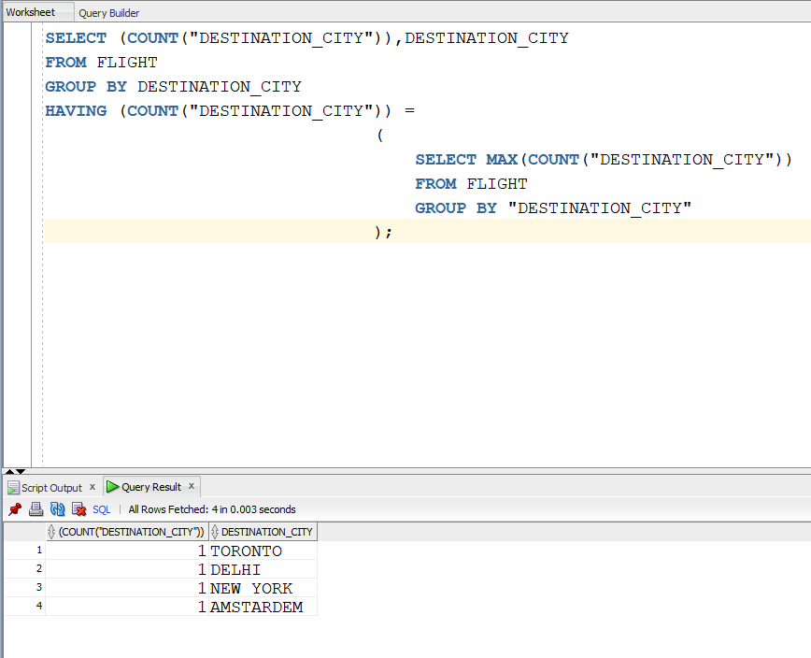

1. List of aircrafts that have not been in used from a specific source location.

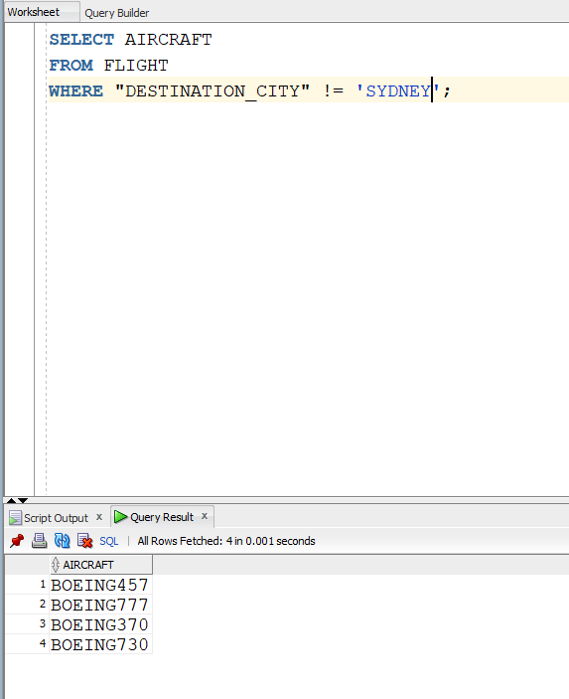

1. List of airlines that run flight from a specific source to a destination.

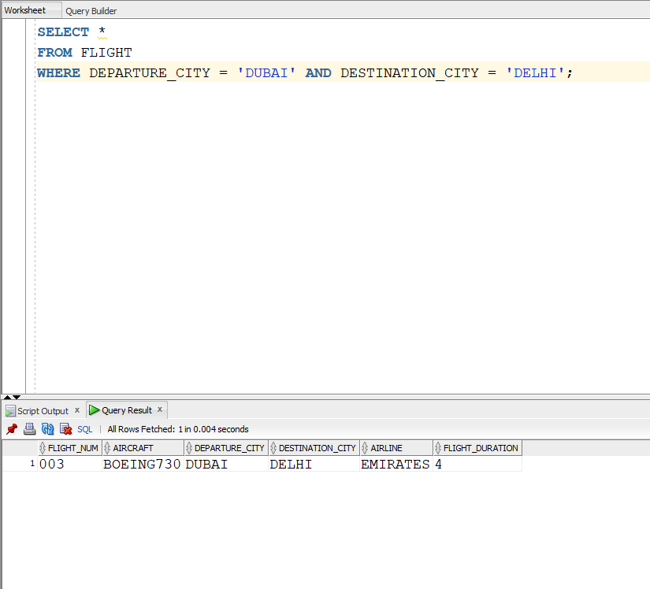

1. The list of all options that a passenger can have when travelling from a source to a destination. This includes a connecting flight, for instance, a passenger is travelling from Toronto to Delhi and there is no direct flight, therefore, you have to find the options for this passenger.

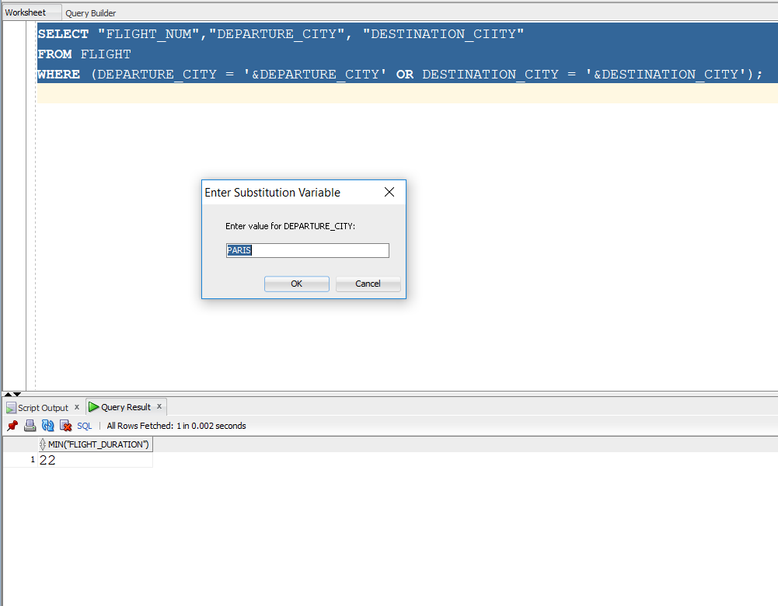

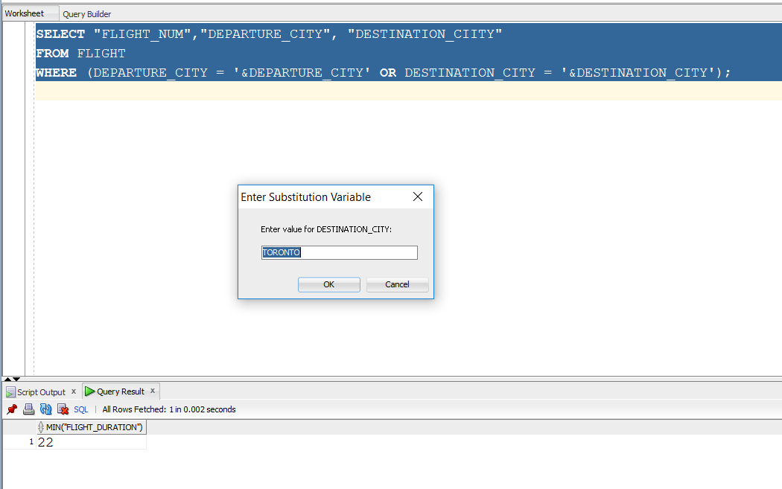

1. What is the minimum number of hours that it will take for a passenger to travel from a source city to a destination city. Again, consider the connecting flights as mentioned in item number 9, e.g. travelling from Toronto to Delhi.

