INPATIENT DISCHARGE DATA NOTES:
The 2011FY dataset is the third full year of data reported using only the CHARS UB04 system and the CMS 837 4010A1 file format with state added elements. The data were formatted to meet confidentiality and reporting requirements.

DRG and DRG_FWD: DOH uses the 3M version of the Medicare grouper. The DRG field is the date sensitive DRG (Version 28 of MS-DRG [01/2011-09/2011] or V29 MS-DRG [10/2011-12/2011]). The DRG_FWD is the discharge as grouped using the MS-DRG version 29.

HOSPITAL PROVIDED NOTES:
None

The following fields are based on 2011FY forward mapped DRG V29(DRG-FWD):
DRG-WT: Washington State Specific DRG weights.
AVG_LOS: DRG-FWD average length of stay.
OUTLIER: Outlier based on charges or length of stay.
EXCLUDE: Excluded from weighting process for various reasons
MDC-FWD: Forward mapped Major diagnostic category
DRG_POA: Present on Admission affected DRG
MDC_POA: Present on Admission affected MDC

Pub2011 Field Names in order

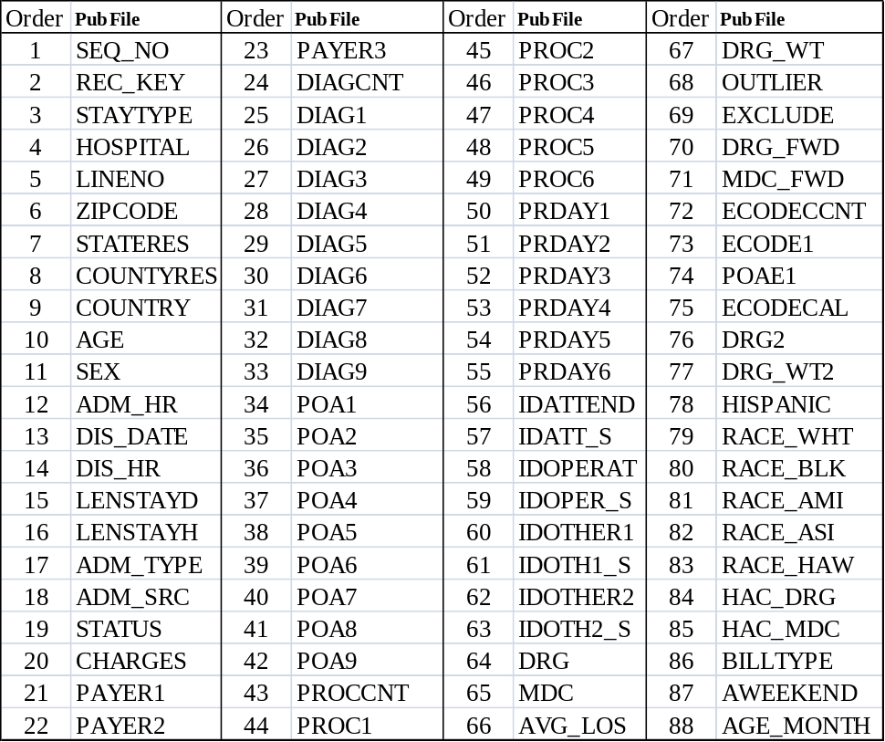

Please note there are separate tables for all reported diagnosis, procedures, E codes, and revenue data. See the end of these notes for comments on those tables.

NOTES FOR EACH DATA ELEMENT

SEQUENCE NUMBER
There are 648,384 sequence numbers in order starting with 2011000001.

RECORD KEY
There are no values out of range or missing.

STAY TYPES
There are no values out of range or missing. 1 = Inpatient. Observation records which are coded as 2 are in other files.

HOSPITAL
There are no values out of range or missing. See HospitalDirectory2011.xls. The Unspecified is for certain records which need the facility id redacted.

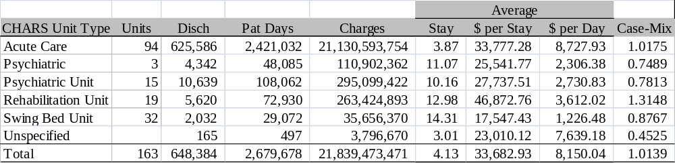

LINENO
There is one record with no values. Also note that Revenue code data is no longer rolled up for those discharges with more than 40 codes. There are 2,441 discharges with more than 40 revenue codes. There is an average of 14.0 revenue codes per discharge.

ZIP CODE
There are 562 records with different issues as described in the table.
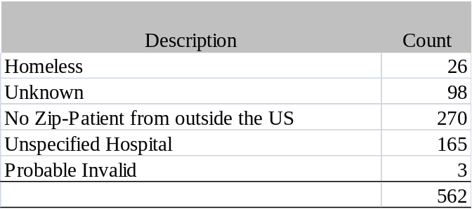
The rest of the values are valid zip code ranges.

STATE RESIDENCE
There are 371 records with value (XX), either because the patient was from outside the United States or the zip code was 99999 – unknown or in error. Those in error appear on the respective hospitals errors to be corrected list. The rest of the values are all valid state or other (Military) codes.

COUNTY RESIDENCE
There are 21,389 records with no value (00) because the zip code was outside Washington State. There are 192 values of “99” out of range or missing or redacted and the zip code error appears on the respective hospitals errors to be corrected list.

COUNTRY CODE
There are 648,114 records with no value because the patient was from inside the United States. There are 270 discharges with a country code other than US. There are no out of range values because they are coded as “US”.

AGE
There are no values missing; 4 are greater than 107. The aggregate volume by single age is normal. Age group of 0 has 13.7% of the discharges (Newborns are included).

SEX
There is one value out of range. The aggregate volume by sex is normal.

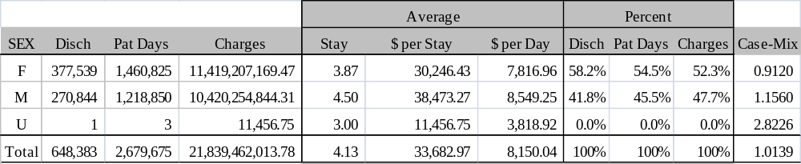

ADMISSION HOUR
There are no values missing. Hour 05 had the largest volume with 5.9%.

DISCHARGE DATE
There are no values out of range or missing.
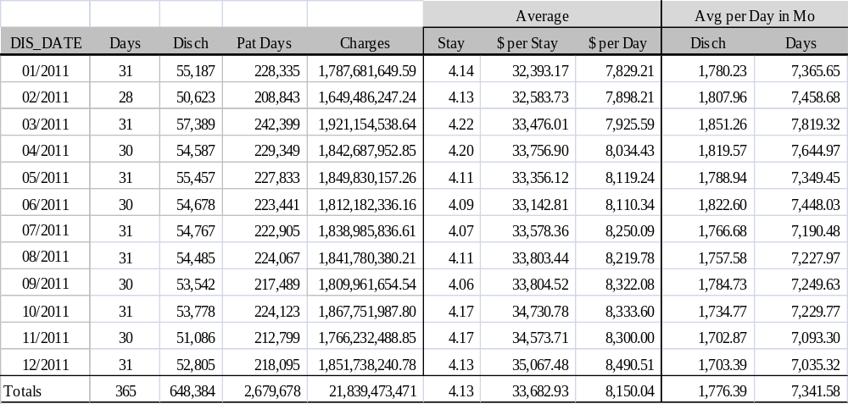

DISCHARGE HOUR
There are no values missing. Hour 13 had the largest volume with 13.8%.

LENGTH OF STAY – DAYS (LENSTAYD)
There are no values missing or out of range. There are 7 discharges with length of stay that is greater than 365 days. The aggregate volume by length of stay appears normal. LOSD of 4 or less constitute 76.2% of discharges.

LENGTH OF STAY – HOURS (LENSTAYH)
There are 117,039 records with no value, for one of two reasons, the length of stay was too long to have a useful stay in hours or the hospitals gave us a discharge hour that was before the admission hour for a same day discharge (See Discharge Hour). Hours of more than 140 are not listed. 53 Hours has the largest volume with 1.36%.

ADMIT TYPE
There is one value out of range.

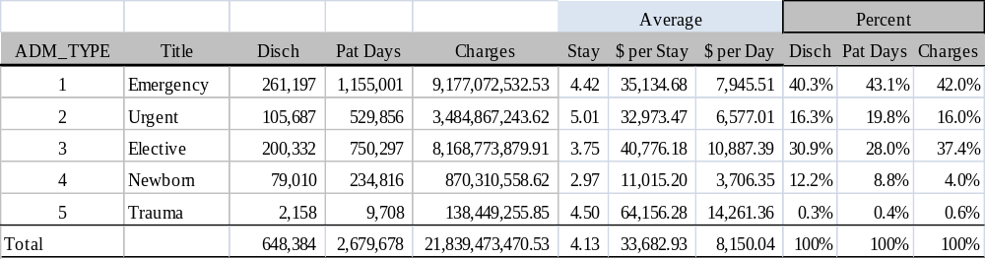

ADMIT SOURCE (POINT OF ORIGIN)
There are no values missing or out of range.

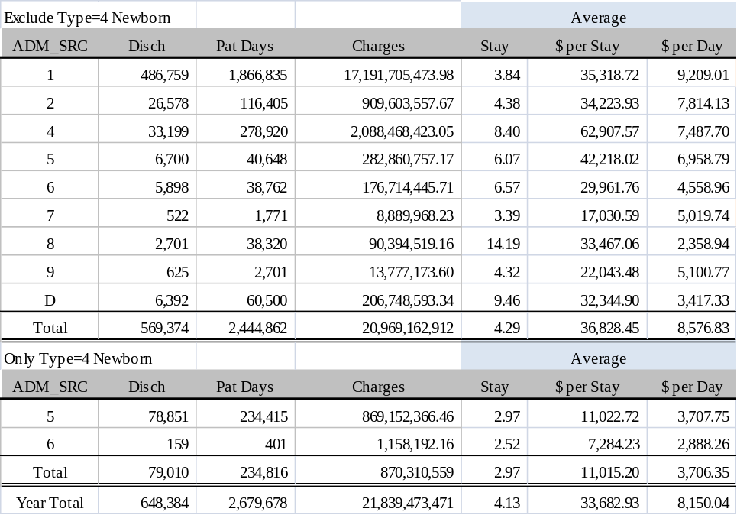

DISCHARGE STATUS
There are no values out of range. None are missing.

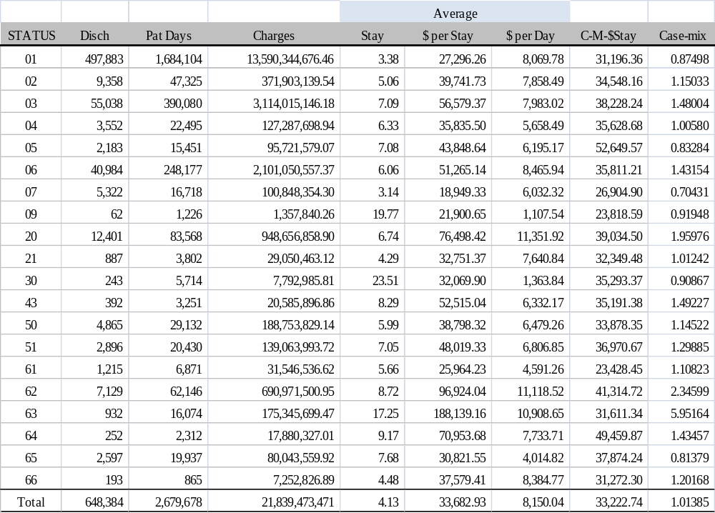

CHARGES
There are no discharges whose total charges value is zero or negative. There are 359 records where the charges are less than $1 thousand. There are 259 records where the charges are more than $1 million. There are no records where the detail does not match the totals.

PAYER 1
There are no records with an out of range value.

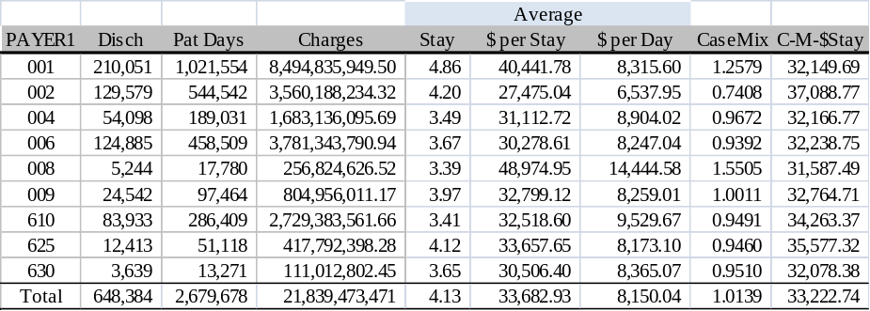

PAYER 2
There are 196,200 values in this field which is a normal volume.

PAYER 3
There are 13,611 values in this field which is a normal volume.

DIAGNOSIS CODE COUNT (DIAGCNT)
There is 1 record with an out of range value (null) which was on the respective hospitals error rpt.

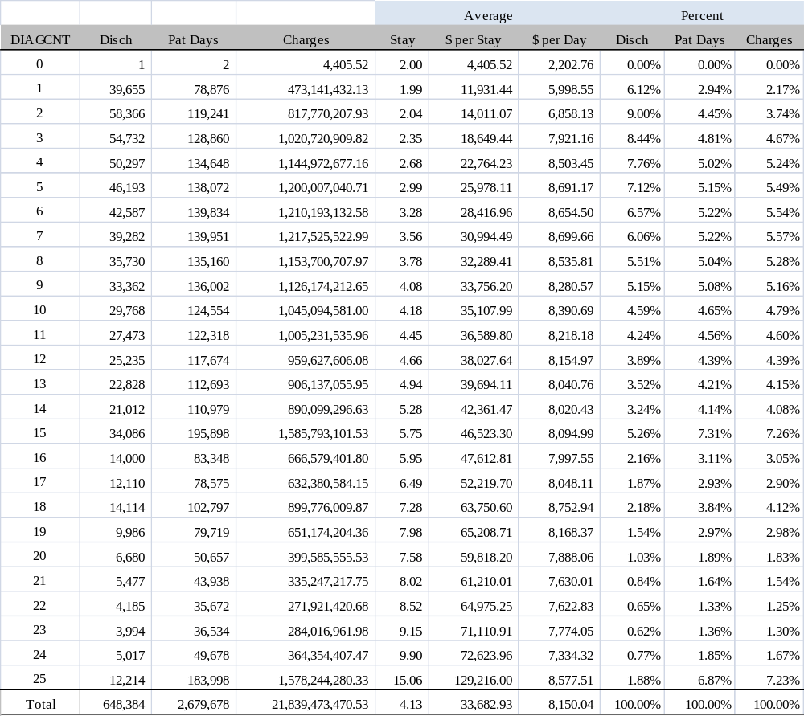

DIAGNOSES CODES – PRINCIPAL AND OTHER (DIAG1-DIAG9)
There is 1 record with an out of range value (null). Fields are edited for presence of values and validity of value according to discharge date and version of ICD9-CM by 3M grouper software. Further analysis is inconclusive without access to individual patient medical records. NOTE: There is a separate table called C or SDIAG2011 that has all the diagnosis codes (up to 25) in the same sequence that they were reported to us. With the 837 file format we are able to accept up to 25 total diagnosis codes including the principal. The UB-04 paper form has room for 16.
Below are the top 30 principle diagnosis codes by discharge volume.

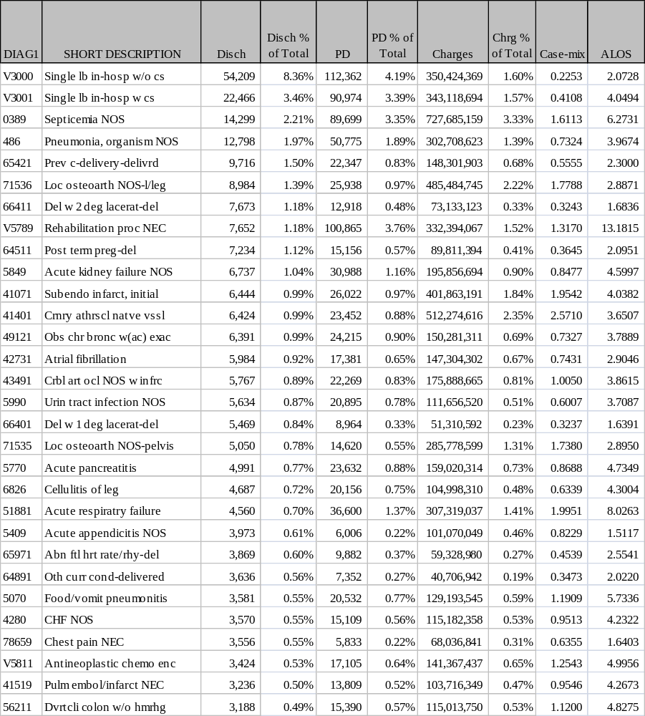

PRESENT ON ADMISSION–PRINCIPAL DIAGNOSIS & OTHER (POA1-POA9)
There are 31,798 missing values in the POA of the principal diagnosis field. Some ICD-9 codes are exempt and so null or 1 is a valid qualifier. NOTE: There is a separate table called C or SDIAG2011 that has all the POA codes (up to 25) in the same sequence that they were reported to us.

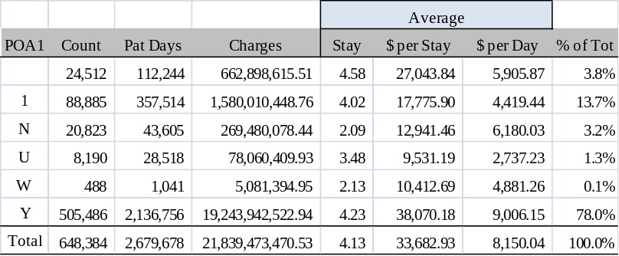

PROCEDURE CODE COUNT (PROCCNT)
There are 239,816 records which do not have a procedure code. This is a normal volume. There are 24,778 records with 7 or more procedures. For those discharges with a procedure code there is an average of 2.6 per discharge.

PROCEDURES CODES (PROC1-PROC6)
There are 243,505 records which do not have a procedure code. This is a normal volume. There are no out of range values. Fields are edited for presence of values and validity of value according to discharge date and version of ICD9-CM. Further analysis is inconclusive without access to individual patient medical records. NOTE: There is a separate table called C or SPPROC2011 that has all the procedure codes (up to 25) in the same sequence that they were reported to us.

PROCEDURES DAY (PRDAY1-PRDAY6)
There are 242,176 records which do not have a PRDAY1 code. This is a normal volume. There are 2,360 procedures without a procedure date. NOTE: There is a separate table called C or SPPROC2011 that has all the procedure day (up to 25) in the same sequence that they were reported to us. Hospitals report the actual day of the procedure to CHARS which is converted to the day within the stay.

ATTENDING PHYSICIAN
There are 165 records which do not have an identification code. These are errors which the respective hospitals did not correct. There are no other missing values.

ATTENDING PHYSICIAN – SOURCE
There are 165 discharges with no value and 3 discharges with Other ID. There are values which are not valid identification codes.

OPERATING PHYSICIAN
There are 239,937 discharges with no value. This is a normal volume.

OPERATING PHYSICIAN - SOURCE
There are 239,937 discharges with no values and no discharges with Other ID.
These are values which are not valid identification codes.

OTHER PROVIDER - 1
There are 445,311 discharges with no values in this element. This is a normal.

OTHER PROVIDER – 1 - SOURCE
There are 445,313 discharges with no values in this file. There no discharges with Other ID. These are values which are not valid identification codes.

OTHER PROVIDER - 2
There are 591,914 discharges with no value in this file.

OTHER PROVIDER – 2 - SOURCE
There are 600,802 discharges with no values in this file. There are no discharges with Other ID. There are values which are not valid identification codes.

DRG – DATE SENSITIVE (DRG)
MS-DRG V28 – January through September 2011
There are 7 cases grouped as DRG 999 (Ungroupable) and 4 cases as DRG 998 because these uncorrected records are missing a principal diagnosis or have problems with the combination of diagnosis codes listed. There are no other out of range or missing values. These uncorrected errors appeared on the respective hospitals errors to be corrected list but were not corrected by the hospital.

MS-DRG V29 – October through December 2011
There is 1 case grouped as DRG 999 (Ungroupable) and 0 cases as 998 because these uncorrected records are missing a principal diagnosis or have problems with the combination of diagnosis codes listed. There are no other out of range or missing values. These uncorrected errors appeared on the respective hospitals errors to be corrected list but were not corrected by the hospital.

MDC – DATE SENSITIVE (MDC)
MS-DRG V28 – January through September 2011
There are 7 cases grouped as MDC 00 (Ungroupable) because these uncorrected records are missing a principal diagnosis or have problems with the combination of diagnosis codes listed. There are no other out of range or missing values. These uncorrected errors appeared on the respective hospitals errors to be corrected list but were not corrected by the hospital. DRG Version 27 was used.

MS-DRG V29 – October through December 2011
There is 1 cases grouped as MDC 00 (Ungroupable) because these uncorrected records are missing a principal diagnosis or have problems with the combination of diagnosis codes listed. There are no other out of range or missing values. These uncorrected errors appeared on the respective hospitals errors to be corrected list but were not corrected by the hospital. DRG Version 28 was used.

DRG and MDC relationship with Pre-MDC–calculated using MS-DRG V29
Patients having Heart Transplant or Implant of Heart Assist System, ECMO, or Tracheostomies with MV 96+ Hours or PDX Except Face, Mouth, Neck, Liver Transplant or Intestinal Transplant, Allogeneic Bone Marrow Transplant, Lung Transplant, Simultaneous Pancreas/Kidney Transplant, Pancreas Autologous Bone Marrow Transplant, Pancreas Transplant, Transplant Tracheotomy for Face, Mouth and Neck Diagnosis, categorized as PRE MDC (00), and are assigned by the DRG Grouper into the following DRGs independent of the MDC of the principal diagnosis.

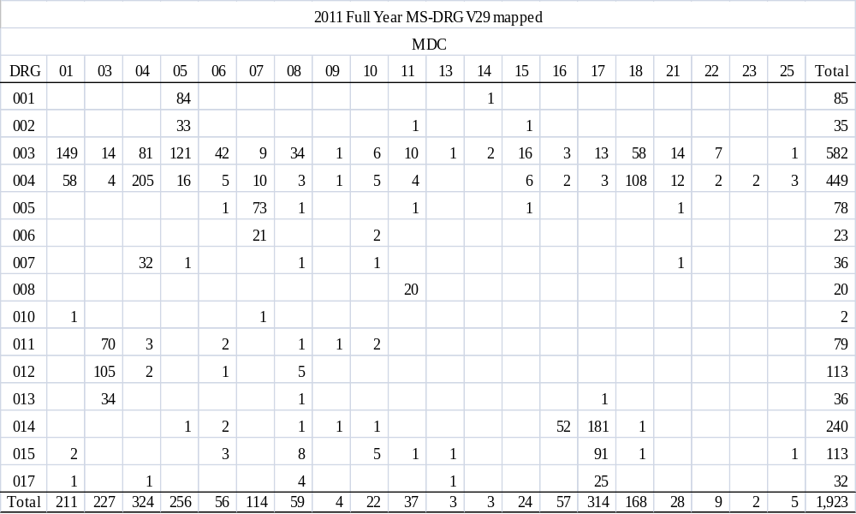

AVERAGE LENGTH OF STAY–calculated using forward mapped MS-DRG V29
There are 1,761 discharges without an average length of stay because the assignment could not be calculated for one of several reasons including the ICD9 code was split or there were 10 or fewer cases. The values were calculated using 2011 full year data. The minimum was 1 and the maximum was 48 days.

DIAGNOSIS RELATED GROUP WEIGHT–calculated using forward mapped MS-DRG V29
There are 1,761 discharges without a Diagnosis Related Group Weight because the assignment could not be calculated for one of several reasons including the ICD9 code was split or there were 10 or fewer cases. The values were calculated using 2011 full year forward mapped data.

OUTLIER–calculated using forward mapped MS-DRG V29
There are 28,250 discharges with an Outlier code due to high or low charges or high or low length of stay or combination of the two. This means the discharge was not used to calculate the DRG weight or average length of stay. There are nine different outlier codes. See the file layout for more explanations.

EXCLUDE–calculated using forward mapped MS-DRG V29
There are 42,477 discharges with an Exclude code. This means the discharge was not used to calculate the DRG weight or average length of stay. There are six different exclude codes. The codes relate to patient transfer, Group Health patients and DRG volumes. See the file layout for more explanations.

DRG – FORWARD MAPPED
MS-DRG V29 – All of 2011– (Oct-Dec will be the same as date sensitive)
There are 1,669 cases grouped as MDC 00 DRG 999 (Ungroupable) because these uncorrected records are missing a principal diagnosis or have problems with the combination of diagnosis codes listed or the ICD9 code was not valid October 1, 2011. There is no other out of range or missing values. These uncorrected errors appeared on the respective hospitals errors to be corrected list but were not. DRG Version 29 is used.

MDC – FORWARD MAPPED
MS-DRG V29 – All of 2011 – (Oct-Dec will be the same as date sensitive)
There are 1,669 cases grouped as MDC 00 (Ungroupable) because these uncorrected records are missing a principal diagnosis or have problems with the combination of diagnosis codes listed or the ICD9 code was not valid October 1, 2011. There is no other out of range or missing values. These uncorrected errors appeared on the respective hospitals errors to be corrected list but were not corrected by the final deadline. DRG Version 29 is used.

EXTERNAL CAUSE OF INJURY CODE COUNT (ECODECNT)
There are 543,594 records which do not have a value which is a normal volume. There are 104,790 discharges with values in this file. This is a normal volume.

EXTERNAL CAUSE OF INJURY CODE (ECODE1)
There are 543,594 records which do not have a value which is a normal volume. There are 104,790 records with values. NOTE: There is a separate table called C or SECODE2011 that has all the ECODES (up to 6) in the same sequence that they were reported to us.

PRESENT ON ADMISSION – E-CODE (POAE1)
There are 568,889 records which do not have a value which is a normal volume. There are 79,495 values in the principal E-code field; there are POA values for “other” diagnosis codes. NOTE: There is a separate table called C or SECODE2011 that has all the POAE (up to 6) in the same sequence that they were reported to us.

EXTERNAL CAUSE OF INJURY CODE - DOH CALCULATED (ECODECAL)
There are 541,657 records which do not have a value which is a normal volume. There are 102,820 values in the ECODECAL field. These values are calculated by DOH staff based on the diagnosis codes. See the file layout for more information.

DIAGNOSIS RELATED GROUP – 2
No Longer used after 2002

DIAGNOSIS RELATED GROUP – 2 - WEIGHT
No Longer used after 2002

HISPANIC
WHITE, BLACK, AMERICAN INDIAN, ASIAN, HAWIAN PACIFIC ISLANDER
The columns in the table below should be read separately.

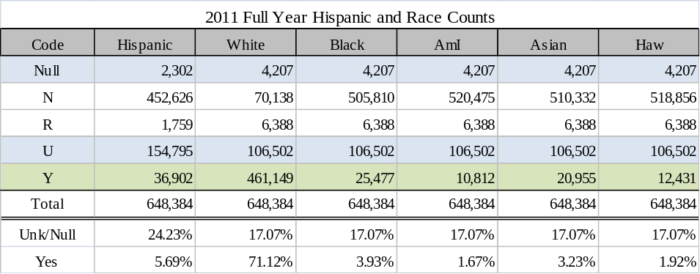

DIAGNOSIS RELATED GROUP-PRESENT ON ADMISSION – DRG_POA
This field presents the MS-DRG DRG_FWD with the Present on Admission/Hospital Acquired Condition (POA/HAC) code taken into consideration.

MAJOR DIAGNOSTIC CATAGORY-PRESENT ON ADMISSION – MDC_POA
This field presents the MS-DRG MDC_FWD with the Present on Admission/Hospital Acquired Condition (POA/HAC) code taken into consideration.

BILL TYPE (BILLTYPE)
NUBC codes used to indicate type of bill. Distribution is normal.

WEEKEND INDICATOR – (AWEEKEND)
DOH generated indicator – 0 = weekday and 1 = weekend admission.

AGE IN MONTHS (AGE_MONTH)
There is a normal distribution.
SUBSIDIARY TABLES

DIAGNOSIS CODE TABLE INFORMATION (SDIAG2011 or CDIAG2011)
There are 5,909,218 diagnosis codes for the 648,384 discharges or an average of 8.6 per discharge. There is 1 discharge with no diagnosis. There are 12,214 discharges with 25 diagnosis codes.

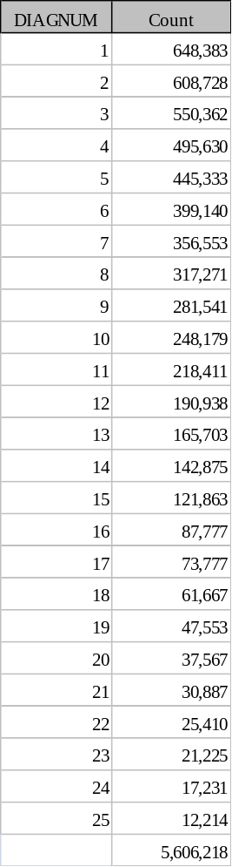

PROCEDURE CODE TABLE INFORMATION (SPPROC2011 or CPPROC2011)
There are 1,025,175 procedure codes for the 648,384 discharges or an average of 1.61 per discharge. A total of 408,568 discharges have at least one procedure. Of those with at least one procedure codes there are an average of 2.6 per discharge. There are 196 discharges with 25 procedure codes.

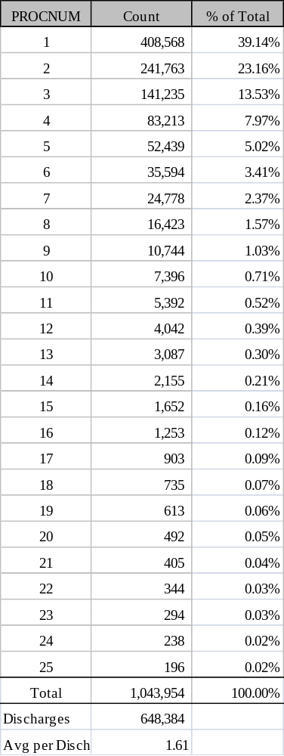

ECODE TABLE INFORMATION (SECODE2011 or CECODE2011)
There are 133,111 Ecodes for the 648,384 discharges or an average of .20 per discharge. A total of 104,790 discharges have at least one Ecode. Of those with at least one Ecode there is an average of 1.3 per discharge.

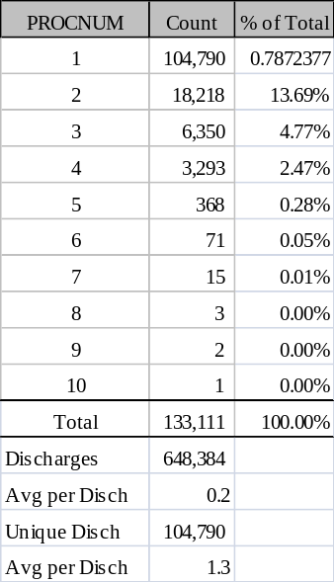

REVENUE CODE TABLE INFORMATION (SREV2011 or CREV2011)
Fields are edited for presence of values and validity of value according to the CHARS system revenue tables. Further analysis is inconclusive without access to individual patient medical records.
There are 9,106,385 revenue codes for the 648,384 discharges or an average of 14.0 per discharge.
There is a minimum of two revenue codes required per record (“001 Total Charge” and a bed stay revenue code). There were 2,590 discharges with two revenue codes. There is one record with zero revenue codes.

