OBSERVATION DISCHARGE DATA NOTES:

Observation Stays

When CHARS was first developed there were basically two types of patients: inpatients and outpatients including emergency department. Since that time, however, a third category of patients has been created. These are known as “observation” patients. Some observation patients may be similar to outpatients in that their lengths of stay at the hospital can be measured in hours. Other observation patients are more like inpatients; their lengths of stay can be a full day – or longer. Up until May 2007 CHARS only collected data on inpatients. Observation patients with lengths of stay exceeding a day or more were previously not reported to CHARS. This situation becomes even more concerning because the designation of a patient as either an inpatient or an observation patient is based upon each patient’s payer’s criteria. Hence, one patient may be deemed an inpatient by their payer and have their data reported to CHARS, while another patient with exactly the same clinic conditions and treatments – but with a different payer – may be deemed an observation patient and did not have their data reported to CHARS in the past.

If a patient is first admitted to observation and is later transferred to inpatient, then the information for both time periods should be submitted into one combined record, so there should not be duplication.

The data for inpatient and observation are available in separate files. A description of the file names is listed at the end of this document. Observation stays differ from inpatient in a few ways:
- HCPCS codes and day of service are reported in the revenue file.

Not Generated for Observation
- MS-DRG or MDC
- Case-Mix
- Outlier
- Excluded

Notes from Hospitals: None

Pubo2011 Field Names in order

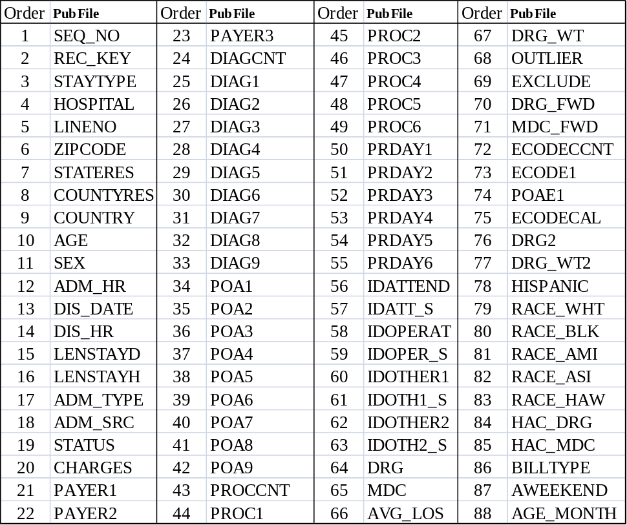

The data was formatted to meet confidentiality and reporting requirements.

For records with diagnosis and/or procedure codes related to abortion, data in the following fields is redacted: Hospital (UNS), Zipcode (blank), Countyres (99), Idattend (blank), Idoperat (blank), Idother1 (blank), and Idother2 (blank).

NOTES FOR EVERY DATA ELEMENT

SEQUENCE NUMBER
There are 94,364 sequence numbers in order starting with 2011648385 and ending with 2011742748.

RECORD KEY
There are no values out of range or missing. All discharges were submitted in the UB04 format.

STAY TYPES
There are no values out of range or missing. (2 = Observation)

HOSPITAL
There are no values out of range or missing. 91 hospitals have data with 1,041 out of 1,092 possible months reported. Certain records have had the license number changed to UNS or unspecified.

LINENO
There are no values out of range or missing. The range is two (the minimum) with 998 records and the largest is 462 with one record. There is an average of 22.3 per record. There are a total of 2,103,094 revenue codes.

ZIP CODE
There are 101 values out of range or missing and these are because the country code is used or the code was redacted. The country information is reported in the Country column. There were 4 records with 99998 (Homeless) and 14 had 99999 (Unknown) for zip code.

STATE RESIDENCE
There are 99 records with value (XX), either because the patient was from outside the United States or the zip code was 99999 – unknown or in error. Those in error appear on the respective hospitals errors to be corrected list but were not corrected. Certain records were redacted. The rest of the values are all valid state codes.

COUNTY RESIDENCE
There are 3,227 records with no value (00) because the zip code was outside Washington State. There are 20 records with value of 99, unknown or redacted.

COUNTRY CODE
There are 94,279 records with no value because the patient was from inside the United States. There are 85 records with country codes.

AGE
There are no values missing; two were greater than 107.

SEX
There are no values missing; There are no “U” or unknown.

ADMISSION HOUR
There are no values out of range or missing.

DISCHARGE DATE
There are no values out of range or missing.

DISCHARGE HOUR
There are no values out of range or missing. The hour with the most volume is hour 13.

LENGTH OF STAY - DAYS
There are no values missing. There are 327 records with stays longer than seven days. The total is 128,152 for an average LOS of 1.4

LENGTH OF STAY - HOURS
Of the data reported there are 2,404 out of range values (zero hours). There are discharges with negative hours that we changed to 0. This is caused because some hospitals default to hour 00 or 01 for discharge hour which is earlier than the admission hour. Hours of more than 140 are not shown.

ADMIT TYPE
There are no values missing however there are 974 out of range values (9 = Unknown). This is an acceptable value per NUBC.

ADMIT SOURCE
There are no values missing and there are no out of range values.

DISCHARGE STATUS
There are no values missing and there are no out of range values.

CHARGES
There are no total Charges where the value is zero. There are 103 records where the charges are more than $100,000. There are 6,753 records with less than $1,000 in charges.

PAYER 1
There are no values missing and there are no out of range values.

PAYER 2
There are 67,079 with no value which is a normal volume. Of those reported there are no out of range values.

PAYER 3
There are 92,125 with no value which is a normal volume. Of those reported there are no out of range values.

DIAGNOSIS CODE COUNT (DIAGCNT)
There are 307 discharges missing a diagnosis code (---- or ZZZZ or null).

DIAGNOSES CODES – PRINCIPAL AND OTHER (DIAG1-DIAG9)
There are 305 values missing. There are invalid codes in this field. We do not edit this field for valid ICD-9 codes.
NOTE: There is a separate table called C or SDIAGo2011 that has all the diagnosis codes (up to 25) in the same sequence that they were reported to us.

PRESENT ON ADMISSION–PRINCIPAL DIAGNOSIS & OTHER (POA1-POA9)
There are 91,053 values missing in the principal diagnosis field POA; there are POA values for “other” diagnosis codes. NOTE: There is a separate table called C or SDIAGo2011 that has all the POA codes (up to 25) in the same sequence that they were reported to us. We do not edit this field for valid POA codes.

PROCEDURE CODE COUNT (PROCCNT)
There are 76,060 with a value of zero which is a normal volume. If there is a procedure, hospitals will report it within the revenue code data using CPT codes.

PROCEDURES CODES (PROC1-PROC6)
There are 76,060 records which do not have a procedure code. This is a normal volume. Further analysis is inconclusive without access to individual patient medical records. NOTE: There is a separate table called C or SPPROCo2011 that has all the procedure codes (up to 25) in the same sequence that they were reported to us.

PROCEDURES DAY (PRDAY1-PRDAY6)
There are 76,109 records which do not have a procedure day. NOTE: There is a separate table called C or SPPROCo2011 that has all the procedure day (up to 25) in the same sequence that they were reported to us.

ATTENDING PHYSICIAN
There are 16 records which do not have an identification code. These are uncorrected errors and appeared on the respective hospitals errors to be corrected list but were not corrected. There are no other missing values. There are values which are not valid identification codes.

ATTENDING PHYSICIAN – SOURCE
There are 16 discharges with no value.

OPERATING PHYSICIAN
There are 64,325 discharges with no value. This is a normal volume.

OPERATING PHYSICIAN - SOURCE
There are 64,325 discharges with no value.

OTHER PROVIDER - 1
There are 77,656 discharges with no value. This is a normal volume.

OTHER PROVIDER – 1 - SOURCE
There are 77,656 discharges with no value.
OTHER PROVIDER - 2
There are 89,353 discharges with no value. This is a normal volume.

OTHER PROVIDER – 2 - SOURCE
There are 89,990 discharges with no value.

DRG – DATE SENSITIVE (DRG)
This field is not calculated for Observation Stays

MDC – DATE SENSITIVE (MDC)
This field is not calculated for Observation Stays

AVERAGE LENGTH OF STAY–calculated using forward mapped MS-DRG
This field is not calculated for Observation Stays

DIAGNOSIS RELATED GROUP WEIGHT–calculated using forward mapped MS-DRG
This field is not calculated for Observation Stays

OUTLIER–calculated using forward mapped MS-DRG
This field is not calculated for Observation Stays

EXCLUDE–calculated using forward mapped MS-DRG
This field is not calculated for Observation Stays

DRG – FORWARD MAPPED
This field is not calculated for Observation Stays
MDC – FORWARD MAPPED
This field is not calculated for Observation Stays

EXTERNAL CAUSE OF INJURY CODE COUNT (ECODECNT)
There are 83,000 records with no value which is a normal volume.

EXTERNAL CAUSE OF INJURY CODE (ECODE1)
There are 83,000 discharges with no value. This is a normal volume. NOTE: There is a separate table called C or SECODoE2011 that has all the ECODES (up to 8) in the same sequence that they were reported to us.

PRESENT ON ADMISSION – E-CODE (POAE1)
There are 92,569 discharges with no value. NOTE: There is a separate table called C or SECODEo2011 that has all the ECODES in the same sequence that they were reported to us.

EXTERNAL CAUSE OF INJURY CODE - DOH CALCULATED
There are 82,366 discharges with no value. These values are calculated by DOH staff based on the diagnosis codes.

DIAGNOSIS RELATED GROUP – 2
This field is not calculated for Observation Stays.
No Longer used after 2002

DIAGNOSIS RELATED GROUP – 2 - WEIGHT
This field is not calculated for Observation Stays.
No Longer used after 2002

HISPANIC
170 blank and 23,609 unknown
WHITE
584 blank and 14,207 unknown
BLACK
584 blank and 14,207 unknown
AMERICAN INDIAN
584 blank and 14,207 unknown
ASIAN
584 blank and 14,207 unknown
HAWIAN PACIFIC ISLANDER
584 blank and 14,207 unknown

BILL TYPE (BILLTYPE)
NUBC codes used to indicate type of bill. Distribution is normal.

WEEKEND INDICATOR – (AWEEKEND)
AWEEKEND | Count | PD | CHARGES
0 | 72,752 | 98,495 | 811,366,873
1 | 21,612 | 29,657 | 213,701,999

AGE IN MONTHS (AGE_MONTH)
There is a normal distribution.

SUBSIDIARY TABLES

DIAGNOSIS CODE TABLE INFORMATION (SDIAGo2011 or CDIAGo2011)
There are 622,097 diagnosis codes for the 94,364 discharges for an average of 6.6 per discharge.

PROCEDURE CODE TABLE INFORMATION (SPPROCo2011 or CPPROCo2011)
There are 30,124 procedure codes for the 94,364 discharges for an average of .32 per discharge.

ECODE TABLE INFORMATION (SECODEo2011 or CECODEo2011)
There are 15,484 Ecodes for the 94,364 discharges for an average of .16 per discharge.

REVENUE CODE TABLE INFORMATION (SREVo2011 or CREVo2011)
Fields are edited for presence of values and validity of value according to the CHARS system revenue tables. Further analysis is inconclusive without access to individual patient medical records.
There are 2,103,094 revenue codes for the 94,364 discharges or an average of 22.3 per discharge.

