The research question is to study the influence of top management characteristics of listed companies on the level of business sales.

**Zhang Jiayu 2020 11 1274**

# 1 Introduction

From the shallow to the deep, this study explores the current situation of the management of listed companies from different perspectives, including the following three parts:

(1) Statistical comparison of the salaries of executives with overseas and non-overseas backgrounds

(2) Return to the relationship between the gender ratio of senior managers and the income and operation of enterprises.

(3) To compare the relationship between the top management team with women and the non-top management team with women and the relationship between the stock price and the development of the enterprise.

* (4) Using DEA model to score the management (input-output) level of A-share listed companies, overall research.

Data source: Guotai Junan Database-Company Research-Annual Table of Basic Information of Listed Companies (20201.1-2023.3.1), Three Major Statements/Person Research-Personal Profile of Directors, Supervisors and Senior Management (2021)

# 2. Implementation ideas

## 2.1 Data consolidation

Firstly, the three financial statements and the basic information of listed companies are consolidated, and then the consolidated financial statements and the processed executive characteristics data are merged and sorted according to the securities code and year, so as to obtain a complete file with industry, executive characteristics and financial data for follow-up research.

## Research on the Specific Problems of 2.2

2.2.1 Statistics to Compare the Compensation of Executives with Overseas Background

The purpose of this study is to verify whether the level of executive compensation is positively correlated with overseas development experience. The results are shown in Table 1:

Table 1: Relationship between executive compensation and their overseas development experience

According to the average and median of the total salary of tabstat with overseas background, it can be found that for the average and median salary, the salary of executives with overseas background is higher than that of executives with overseas background, while the average and median salary of executives with domestic background is lower.

The Return of 2.2.1 to Female Executives and the Relationship between Stock Price and Business Development

The purpose of this study is to investigate the relationship between the proportion of female executives and corporate performance and risk by analyzing the female executives in Chinese listed companies.

The design point of this problem is to calculate the proportion of female executives in the top management team of each enterprise. Through experiments, it is found that the use of collapse (sum) can easily count the number of executives of different genders in each enterprise, but there is a certain complexity in calculating the proportion. Therefore, the final method is to use bys (), total (). The egen generates the number of people of different genders by enterprise, calculates the gender ratio and stores it in a table, and then merges the gender ratio table with the executive financial table to obtain the gender-inclusive ratio table sorted by year and security code.

The original intention of this study is to reproduce the hypothesis verification of the gender ratio on the volatility in the article of the effect of female executives on the volatility of corporate performance [1]. However, in this actual operation, the precise variables such as the gender ratio and the standard deviation of ROA, ROE and Size may not be significant due to the insufficient sample size. Therefore this research finally take the year, the profession as the control variable, the stock price-management relations (t + 1 year EPS change rate return management cash flow ratio) as the dependent variable to study, and through the significance test.

Number of senior executives of different gender

In fact, statistics show that the number and ratio of women in the senior management team of listed companies are at a low level, which may affect the final analysis results. The following figures show the statistical results and relationships in multiple directions.

Descriptive statistics Table 1

Correlation coefficient and significance test

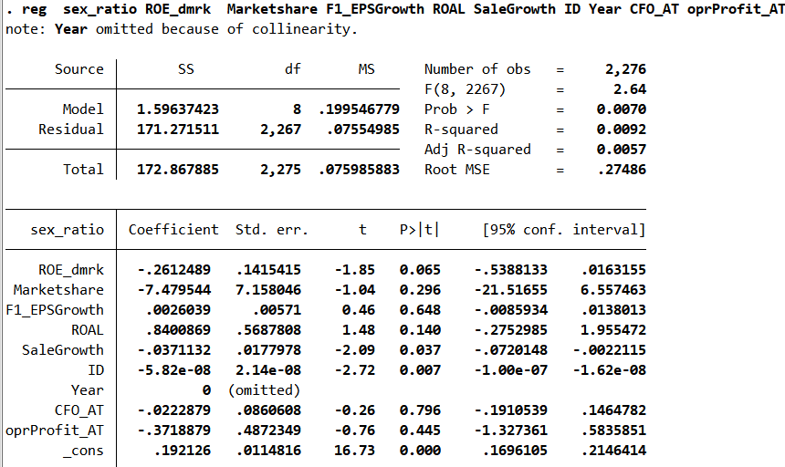

Statistical table of gender ratio, ROE, market share and other indicators

The Relationship between Sex Ratio and ROE, Market Share of Operating Profit

There is a negative correlation between gender ratio and ROE, but a positive correlation between gender ratio and the proportion of operating profit to total assets. An increase of 1% in the sex ratio and a decrease in the ROE _ dmrk-% in 0.005 and% in 营业利润占资产比例上升0.0028.

表格

Comparing the influence of the presence or absence of women in the top management team on the stock-price management relationship, we find that for most industries, the sales revenue under the pure male top management team has a greater impact on the stock price growth, which may indicate that the management volatility under the leadership of the male top management team is greater.

In short, according to the regression results, it can be found that the increase in the proportion of women will not significantly lead to the improvement of stock prices or operating efficiency, but according to the impact of female executives on the volatility of corporate performance [1], when the sample size is large enough, it can be found that the impact of the proportion of female executives on the volatility of corporate performance is U-shaped. This may be due to women's conservative risk preference. Especially when the post-2020 market is in the economic downturn or the company is in a sensitive industry, the risk-averse tendency of female executives is conducive to reducing unnecessary losses and improving the stability of corporate performance, rather than expanding profits.

* * * Finally, we use the consolidated industry and report data to try DEA input-output of A-share enterprises, and evaluate the performance indicators of management level of A-share enterprises.

Research tools: use stata and DEA SOLVER PRO 15 plug-ins downloaded from the web. The following is an example of Industry 1 efficiency result。

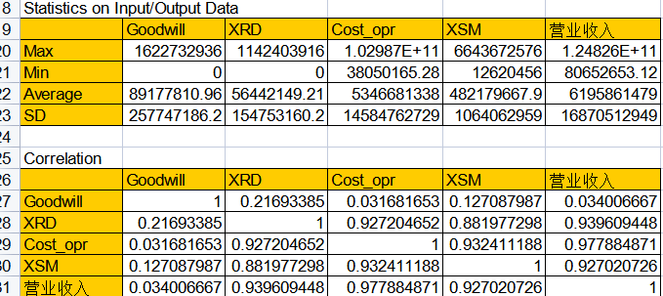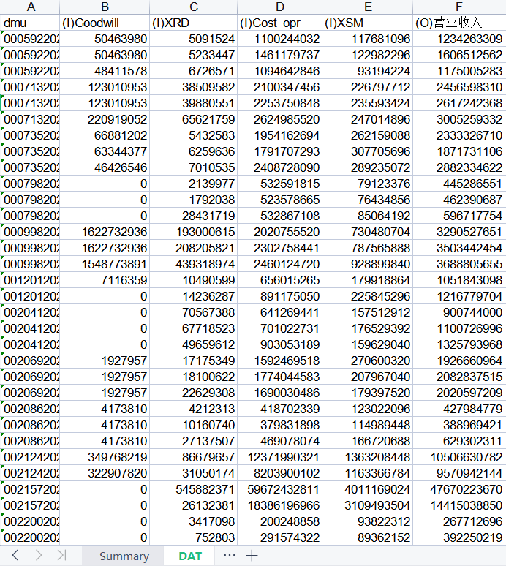

Research train of thought: DEA input-output analysis is carried out in different industries (except the financial industry). Goodwill, R & D expenditure, operating costs, sales and management expenses are taken as the input variables in DEA analysis, and operating income is taken as the only output variable. Enterprise efficiency value is calculated through DEA analysis. Further, DEA Solver is used to calculate the efficiency value by industry using CCRI, and then the obtained efficiency result by industry xls is imported. Then, enterprise scale, market share, free cash flow and year are used as control variables to regress enterprise efficiency. Finally, the evaluation index (enterprise efficiency minus the predicted value) is generated, the DEA evaluation index and regression residual of A-share enterprises are descriptively counted, and the evaluation table of enterprise management index is generated. According to the comparison between the scores of enterprises and p50, it can be concluded that the enterprise is higher or lower than the market median, in order to improve the management level.

