Jubilee Registration Webapp

# Software Requirement Specification

# Scope:

The webapp will facilitate a webpage to collect participants’ registration information and to inform the participant about the payment process. It will provide registration committee options to view and print registered participants.

# Requirements:

1. A registration form to submit participant information.
2. Process payment through bKash using an intermediary moderator.
3. Show payment information to the participant along with amount needed to be paid.
4. An admin portal to administer registration process.
5. Functionality to print list of registered participant’s information batch-wise.

# Webapp usage and payment process:

1. The participant will submit necessary information in the webpage.
2. bKash payment details and SMS instruction will be shown.
   1. bKash payment details: bKash number and amount to pay.
   2. SMS instruction: Participant needs to send a SMS to a moderator mentioning their registration ID and bKash Transaction ID.  
      Example: SMS “regid:230 TraxID:BFH23K89D” to 017********.
3. The moderator will insert participant’s transaction information in the webapp. Participant will be valid after moderator inserts the payment information and marks it as valid.
4. Moderator will send a confirmation SMS to participant after inserting payment details.  
   Example: SMS “Registration Confirmed” to participant’s number.
5. Moderator sends a confirmation SMS.

Figure 1 Payment Process

# Hosting Cost:

|  |  |  |  |
| --- | --- | --- | --- |
| No. | Item | Price (US Dollar) | Price (BDT) [$1=84BDT] |
| 1. | Domain Name | $15 | 1260 |
| 2. | Hosting (3 months) | $32.85 | 2759.4 |
| 3. | Estimated Tax | $7.15 | 600.6 |
| Total | | $55 | 4620 |

# Preview:

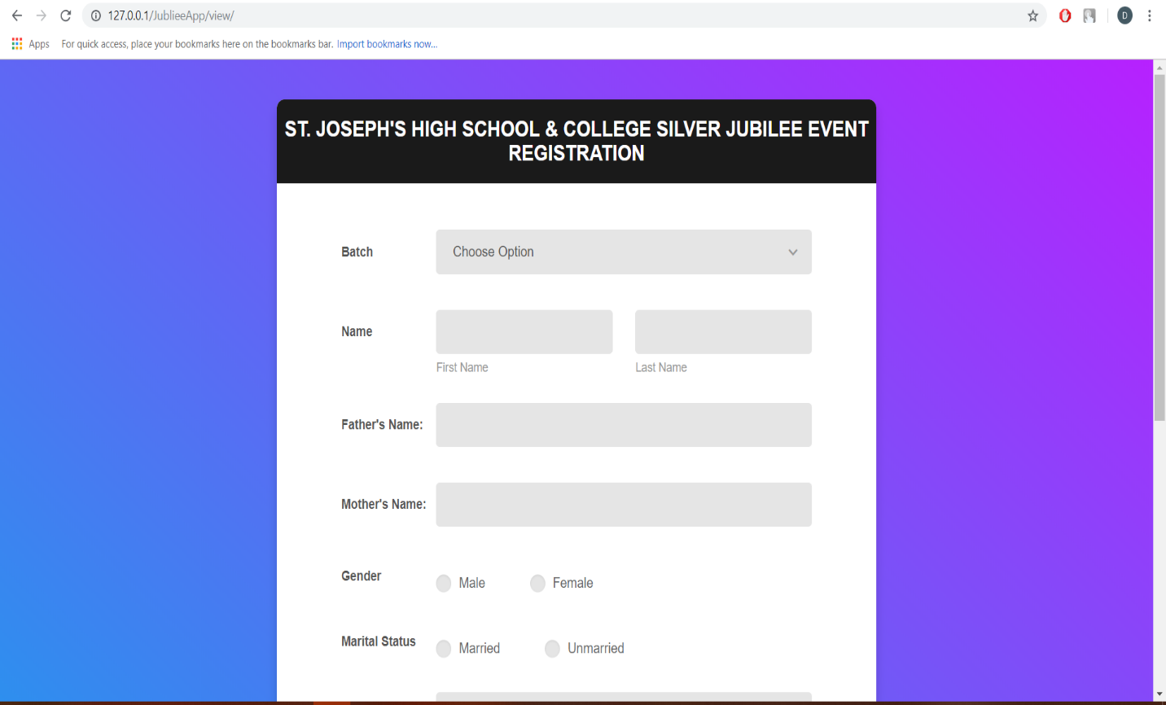

­­­­­­­­­­­­­­­­­­­­_______________________

Client’s Signature