**Queue Data Structure**

A **Queue Data Structure**is a fundamental concept in computer science used for storing and managing data in a specific order. It follows the principle of “**First in, First out**” **(FIFO)**, where the first element added to the queue is the first one to be removed. Queues are commonly used in various algorithms and applications for their simplicity and efficiency in managing data flow.

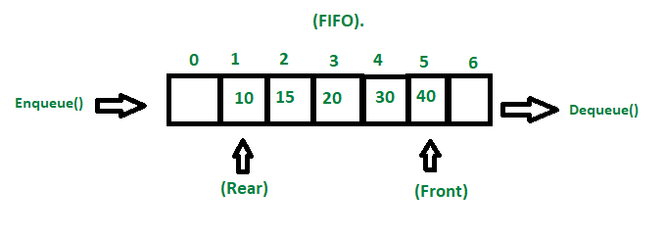

## **Basic Operations of Queue Data Structure**

* **Enqueue (Insert)**: Adds an element to the rear of the queue.
* **Dequeue (Delete)**: Removes and returns the element from the front of the queue.
* **Peek**: Returns the element at the front of the queue without removing it.
* **Empty**: Checks if the queue is empty.
* **Size**: Finds the number of elements in the queue.

## **Applications of Queue**

* **Task scheduling** in operating systems
* **Data transfer** in network communication
* **Simulation** of real-world systems (e.g., waiting lines)
* **Priority queues** for event processing queues for event processing

**Implementation**

* **Using Arrays**
* **Using Linked List**