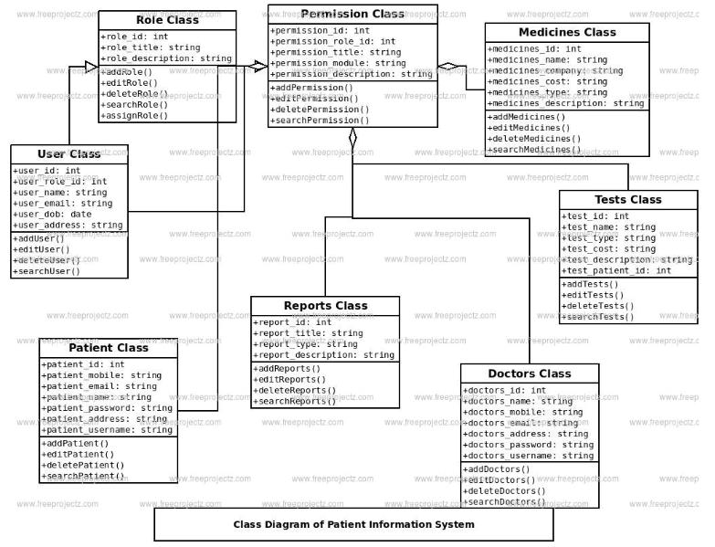

Use:Class

RoleClass PennissionClass   
_ _ inwrn135:nn1n:1n'

ro:ein‘{it inprnjasannr02910:1n1   
ro:e ‘1Z1E'slrln: +pprujssunn7171::sTrlnq ro.edescrlutxun:strlnu +nnrnjssznnman .1sfrtnq

ndUelE   
-ediLRol

MedicinesClass   
.mcdluLnt'r 1nr   
iflP-f‘lli'lu rh'lr'i":   
-|Pd1F1nP= 'n' I --.ig

aaaMecznesi)   
esMec;nes[   
+daleteHeULL1nesfl

LsaatMeULLinesfl

53

—USEI -UJ>:'I

HJSL'I

int

id:Lat

Email:SIeg

TestsClass

nnnrnfifiiSTring «firirillfierfl

bFHITUfiPr

J-{u- '

bsearchUser:

str1nq   
strlnu

;_Ia   
us5_wuld:bLlin

efid'ebs:sl-inu JEC'Huu:Jiu

‘nolnTsvafisnT[J

ReportsClass

1a:Lnt   
:Llle:

(Hie.   
desu

lPLP70RPporTfiIJ no.1What-5mm~. I21

5 '.rLug string

ttnsrpaTiPnT1m: ifiT +=1flfHPfifCHI   
+9dztiefifsfil

‘EEH'LH'EEtSEI

DoctorsClass

r-dl‘n‘TE!rfi

<|-.i'__'   
fidl’ll’EfiS:   
PR'SS'M'GI’IJI   
username:

+sddDULLulsh   
-eu-LLJLLu:sT   
bdulutuflunLuv

ClassDiagramofPatientInformationSystem