INTERNATIONAL CYBERSECURITY AND DIGITAL FORENSICS ACADEMY (ICDFA)
Course 1: GRC101 - Introduction to Governance, Risk, and Compliance

Week 3 Lab Assignment: Risk Assessment and Compliance Fundamentals

Student Name: JOY ORILADE
Date: 28th Jan, 2026
Instructor: Com Idris Aminu

Task 1: Qualitative Risk Assessment.
Analysis: Discuss the relationship between Likelihood, Impact, and the resulting Risk Score.
Likelihood (Probability): is the probability that a risk event might occur, it ranges from the ranges of 1-5 and 5 being the highest certainty that the likelihood of the risk event will occur is high while 1 being the lowest
Impact: is the potential consequences if the risk event occur. It ranges from 1-5 and 5 being the highest and the impact of the risk to an organization will be severe and 1 being low impact to the organization.
Risk Score: it is the overall level of risk and it is used to prioritize risks level with the core ranges is 12-25 being at critical level and the priority level and there is need for an immediate action required. While 1-3 being at low level and the priority level and it just to monitor and review periodically and there is no need for immediate action
Risk score = Probability (Likelihood) × Impact.
Score range | Priority level
12 - 25 | Critical
8 - 11 | High
4 - 7 | Medium
1 3 | Low
A moderate likelihood + high impact risk (e.g., data breach) can be more dangerous than a high likelihood + low impact risk.This is why high impact like 5, risks often rise to the top, even if they occur less frequently.
- Prioritization
1. R001 - Ransomware Attack
Risk Score: 12 and the priority level is Critical which require immediate actions
Likelihood: 3 is Moderate
Impact: 4 is High
Financial Impact (SLE): $5,000,000
Justification: Ransomware is one of the most dangerous cyber threats, as even if the ransom is paid the attacker might not release the affected data. It targets customer databases, which are organization critical assets. The combination of realistic likelihood and severe impact places this risk in the Critical category.
2. R005 - Data Breach
Risk Score: 10 is High
Likelihood: 2 is Low
Impact: 5 is High
Financial Impact (SLE): $10,000,000
Justification: A breach of customer data represents the highest financial and reputational impact on the organization. The likelihood is lower, the extreme impact makes this a top priority.
3. R004 - System Failure
Risk Score: 9 is High
Likelihood: 3 is Moderate
Impact: 3 is Moderate
Financial Impact (SLE): $1,000,000
Justification: The email system supports organization communications. This risk is operationally important and at such, the system failures often impacting security, productivity, and customer trust.

Evidence: Insert a clear screenshot of your Excel sheet showing the Risk ID, Probability, Impact, Risk Score, and the newly assigned Priority Level columns.
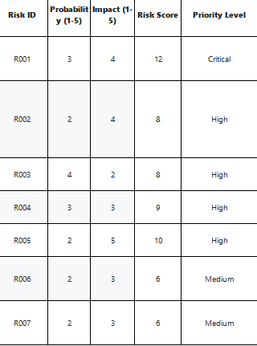

Task 2: Quantitative Risk Assessment (ALE).
- Definitions
Single Loss Expectancy (SLE): is the financial impact of a single risk event, which is provided by the Financial Impact.
Annualized Loss Expectancy (ALE): is the expected monetary loss for an asset due to a risk over a one-year period.
Annual Rate of Occurrence (ARO) is the estimated frequency of a risk event occurring per year.
- Analysis: Identify the risk with the highest ALE. Explain what this value means to the organization in terms of financial planning and budget allocation for security controls.
The risk with the highest ALE is the insider threat.
A high ALE indicates the amount of financial loss the organization is expected to incur each year which is $10,000,000 for insider threat if the risk is not managed or mitigated.
For budget allocation for security controls, more resources should be allocated to insider threat to the security control so as to reduce the financial loss annually because reducing this risk will have a greater impact on the finances of the organization and protecting the loss from recurring.
Evidence: Insert a clear screenshot of your Excel sheet showing the Risk ID, Financial Impact (SLE), ARO, and the calculated ALE columns.
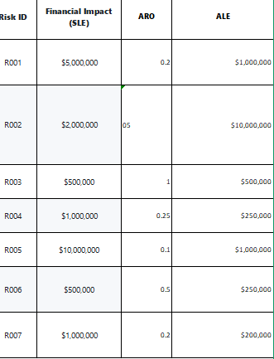
Task 3: Risk Treatment Strategy Analysis.
Evaluation: Discuss the relationship between Current Controls and the Treatment Strategy.
The current controls informed the treatment strategy by how the likelihood and impact of the risks are being managed or mitigated. In all the cases the strategy is perfect for the selected control like encryption, access control, backups etc.
Recommendation: Detail your proposed alternative strategy from step 2, providing a clear justification for why your alternative is superior to the current plan.
For insider threat, the treatment strategy should be improved from reduce to mitigate. Although access control treatment strategy is not bad but it can be strengthened with insider threat awareness and education training for employee of the organization as most insider threat can be accidental, regularly or periodic security awareness training can mitigate the risk.
Evidence: Insert a clear screenshot of your Excel sheet showing the Risk ID, Current Controls, Treatment Strategy, Treatment Rationale, and Proposed Alternative Strategy columns.
