An Uncertainty-Aware Attention-Enhanced CNN-LSTM Framework for IoT Intrusion Detection with Cross-Environment Generalization
Joya Biswas, Rutaban Jania, Fahim
Institute of Information Technology, Jahangirnagar University, Dhaka, Bangladesh
joyabiswas0103@gmail.com

Abstract—The proliferation of Internet of Things (IoT) devices has produced a cybersecurity landscape of unprecedented scale and complexity, in which robust intrusion detection systems (IDS) are indispensable. Although deep learning has advanced IoT intrusion detection considerably, three limitations continue to constrain real-world deployment. First, prevailing models operate as black boxes, emitting predictions without any measure of confidence. Second, they are typically trained and evaluated on artificially balanced benchmarks that misrepresent the extreme class imbalance of operational traffic. Third, their ability to generalize across heterogeneous IoT environments is seldom examined. This paper introduces CNN-Att-LSTM, an uncertainty-aware framework that addresses all three limitations within a single architecture. The model couples a convolutional neural network for spatial feature extraction, a self-attention mechanism for adaptive feature weighting, and a long short-term memory network for temporal modelling. Inference is augmented with Monte Carlo (MC) Dropout to yield calibrated per-prediction confidence scores, and Adaptive Synthetic Sampling (ADASYN) is employed to counteract class imbalance. Across three datasets — CIC-IoT-2023, N-BaIoT, and IoT-23 — the model attains 96.01%, 84.38%, and 98.08% accuracy, respectively, with a mean prediction confidence of 95.7% and a mean uncertainty of 0.0093, evidencing strong calibration. To the best of our knowledge, this is the first IoT IDS to unify CNN, attention, LSTM, and MC Dropout while explicitly evaluating cross-environment generalization.
Index Terms—IoT security, intrusion detection, CNN-LSTM, self-attention, Monte Carlo Dropout, uncertainty quantification, ADASYN.

1. Introduction
The Internet of Things (IoT) has reshaped modern industry by enabling pervasive connectivity among billions of smart devices, with the global installed base projected to exceed 64 billion units by 2026 across domains as diverse as healthcare, smart cities, industrial automation, and transportation. This expansion, however, has enlarged the attack surface available to adversaries by orders of magnitude. Because IoT endpoints are typically resource-constrained, heterogeneous, and deployed with minimal hardening, they constitute attractive targets for distributed denial-of-service (DDoS) attacks, botnet propagation, man-in-the-middle interception, and malware injection.
Conventional rule- and signature-based intrusion detection systems cannot keep pace with the volume and variability of contemporary IoT threats. Machine learning, and deep learning in particular, offers a compelling alternative by learning discriminative traffic representations that generalize to previously unseen attack variants. Among deep architectures, hybrid models that combine convolutional neural networks (CNN) with long short-term memory (LSTM) networks have proven especially effective, exploiting the CNN for spatial feature extraction and the LSTM for temporal dependency modelling.
Despite this progress, three gaps remain inadequately addressed. First, existing CNN-LSTM detectors function as opaque classifiers that report a label but not the confidence behind it; in an operational setting, an analyst must know not merely what the model predicts but how reliable that prediction is in order to triage alerts effectively. Second, most models are trained on artificially balanced datasets and therefore fail to reflect the severe imbalance of production networks, where malicious flows constitute only a small fraction of total traffic. Third, cross-environment generalization — the capacity to detect threats in an IoT deployment distinct from the one used for training — is rarely evaluated, leaving the practical transferability of these models largely unverified.
To close these gaps, we propose CNN-Att-LSTM, a unified detection framework whose principal contributions are as follows:
- An architecture that interposes a self-attention layer between the CNN and LSTM stages, allowing the network to adaptively weight the most discriminative temporal features prior to recurrent modelling.
- A Monte Carlo Dropout inference scheme that furnishes a calibrated confidence estimate for every prediction, enabling trust-aware deployment and human-in-the-loop triage.
- The use of ADASYN oversampling to approximate the realistic class imbalance of operational IoT traffic during training, thereby improving sensitivity to rare attack categories.
- A comprehensive empirical evaluation spanning CIC-IoT-2023, N-BaIoT, and IoT-23, including a zero-retraining cross-dataset experiment that quantifies generalization to unseen IoT environments.
The remainder of this paper is organized as follows. Section 2 reviews related work; Section 3 presents the methodology; Section 4 describes the experimental setup; Section 5 reports results; Section 6 compares with the state of the art; Section 7 discusses findings and limitations; and Section 8 concludes.

2. Related Work
Intrusion detection for IoT networks has been studied intensively, with deep learning consistently surpassing classical machine-learning baselines. We organize the relevant literature along three axes that together motivate our design.

2.1 Hybrid CNN-LSTM Approaches
Hybrid CNN-LSTM detectors have been examined extensively on the CICIDS2017 and N-BaIoT benchmarks, where the fusion of spatial and temporal modelling consistently outperforms standalone CNN or LSTM baselines. The study most closely aligned with ours evaluates such a hybrid on IoT-23, N-BaIoT, and CICIDS2017 and reports strong accuracy. These models, however, share three shortcomings that the present work addresses: they omit attention mechanisms, do not mitigate class imbalance, and provide no estimate of predictive uncertainty.

2.2 Attention Mechanisms for IDS
Attention and transformer-based mechanisms have recently gained traction in network intrusion detection. Multi-head self-attention has been used for feature selection in transformer detectors, while attention-augmented CNN-BiLSTM models have been shown to improve recall on minority attack classes. Building on these insights, we incorporate a lightweight self-attention layer positioned to bridge the CNN and LSTM stages, and we further extend the architecture with principled uncertainty quantification — an aspect absent from prior attention-based detectors.

2.3 Uncertainty Quantification
Gal and Ghahramani established that dropout, applied at inference time, constitutes a Bayesian approximation that yields tractable estimates of model uncertainty. Within cybersecurity, uncertainty-aware classifiers have been shown to support more effective human-in-the-loop operations by flagging ambiguous decisions for analyst review. To our knowledge, however, no prior IoT IDS integrates uncertainty quantification with a hybrid CNN-LSTM architecture; the present work is the first to do so.

3. Proposed Methodology
The proposed CNN-Att-LSTM framework, depicted in Figure 1, comprises four sequential stages: (i) preprocessing with ADASYN class balancing; (ii) spatial feature extraction through stacked convolutional layers; (iii) temporal modelling via a two-layer LSTM preceded by a self-attention layer; and (iv) uncertainty-aware classification through Monte Carlo Dropout. Each stage is detailed in the subsections that follow.

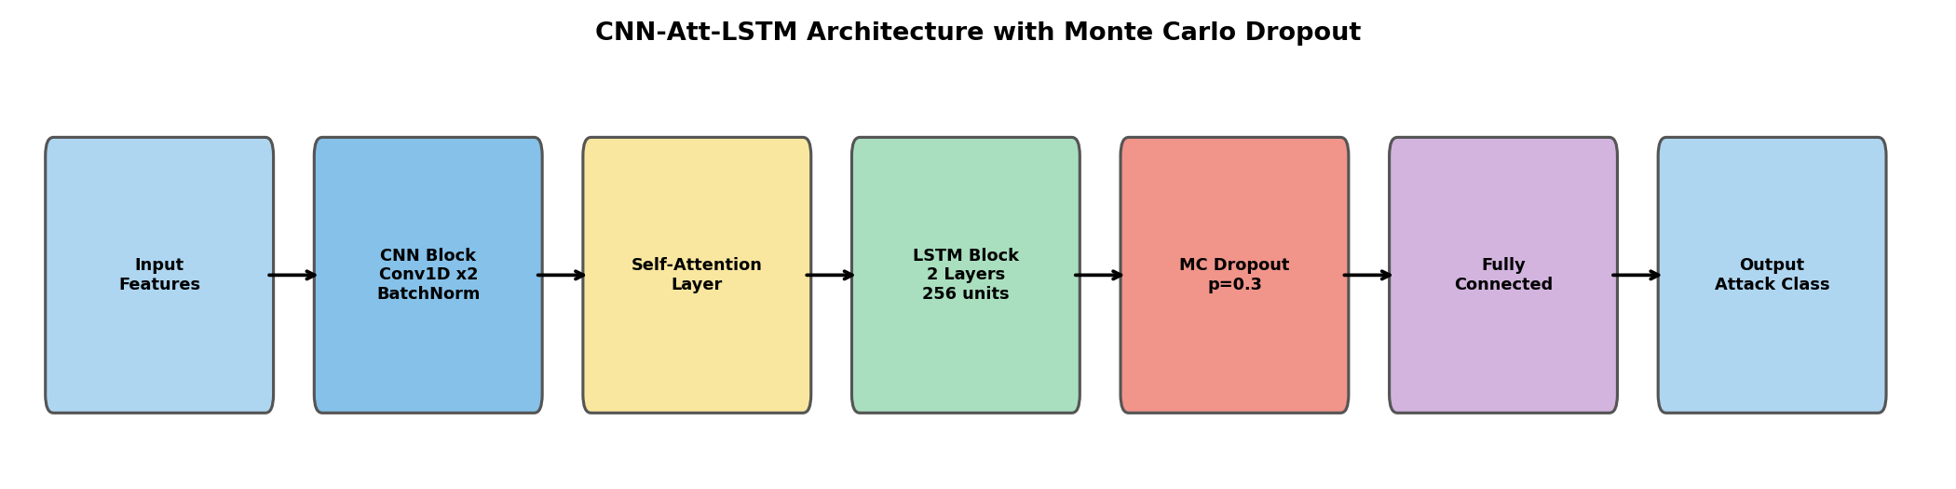
Fig. 1. CNN-Att-LSTM architecture with Monte Carlo Dropout for uncertainty-aware IoT intrusion detection.

3.1 Preprocessing and Class Balancing
Input features are standardized via z-score normalization to zero mean and unit variance, ensuring stable gradient propagation. Missing entries are imputed with the corresponding column median, and infinite values are clipped to zero. To counteract the pronounced class imbalance characteristic of IoT traffic, we apply Adaptive Synthetic Sampling (ADASYN). In contrast to SMOTE, which synthesizes minority samples uniformly, ADASYN concentrates generation on minority instances residing in difficult, decision-boundary-adjacent regions, producing a more informative augmented distribution. Classes represented by fewer than two instances are discarded to permit valid stratified partitioning.

3.2 CNN Block
The standardized feature vector is treated as a one-dimensional sequence and processed by two convolutional layers: the first applies 64 filters of kernel size 3 with ReLU activation, and the second applies 128 filters of kernel size 3, again with ReLU. A max-pooling layer of size 2 halves the temporal extent, and batch normalization stabilizes the resulting activations. Collectively, this block captures the local patterns and co-occurring feature interactions that constitute distinctive attack signatures.

3.3 Self-Attention Layer
Following the convolutional block, a self-attention layer assigns importance weights across the feature sequence. Given a feature map X of shape (batch, sequence, 128), the attention operation is defined as:
scores = vᵀ tanh(WX), w = softmax(scores), context = X · w
where W and v are learnable parameters. By reweighting the sequence before it reaches the recurrent stage, the attention mechanism directs the LSTM toward the most discriminative temporal positions — a property particularly valuable for attacks exhibiting characteristic temporal signatures, such as DDoS floods and horizontal port scans.

3.4 LSTM Block
The attention-weighted sequence is consumed by a two-layer LSTM with 256 hidden units per layer. The recurrent gating of the LSTM captures long-range temporal dependencies while mitigating the vanishing-gradient problem that hinders conventional recurrent networks. The final hidden state of the terminal layer serves as the consolidated sequence representation passed to the classifier.

3.5 Monte Carlo Dropout for Uncertainty
During training, dropout serves its conventional regularizing role. At inference, however, we deliberately retain dropout in its active state and perform N = 50 stochastic forward passes per input. Each pass produces a distinct probability distribution over attack classes; their aggregation yields both a mean prediction and a per-class standard deviation that quantifies epistemic uncertainty:
p* = (1/N) Σ softmax(fθᵢ(x)), u = std[softmax(fθᵢ(x))]
Samples exhibiting high uncertainty are routed to an analyst for review, whereas high-confidence predictions may be actioned autonomously. This two-tier protocol aligns naturally with security-operations-centre workflows, where analyst attention is a scarce resource that should be reserved for genuinely ambiguous cases.

4. Experimental Setup

4.1 Datasets
The proposed framework is evaluated on three publicly available IoT security datasets, summarized in Table 1 and characterized in Figure 2. The three were selected to span complementary conditions: a recent, fine-grained multi-class benchmark; a botnet-focused binary corpus; and an established mixed-attack dataset, collectively enabling both in-distribution assessment and cross-environment generalization analysis.

Dataset | Samples | Attack Types | Usage
CIC-IoT-2023 | 150,000 | 33 (7 categories) | Primary train & test
N-BaIoT | 20,000 | Botnet (Mirai, BASHLITE) | Cross-dataset eval
IoT-23 | 41,158 | DDoS, C&C, Port Scan | Independent eval
Table 1. Summary of datasets used in this study.
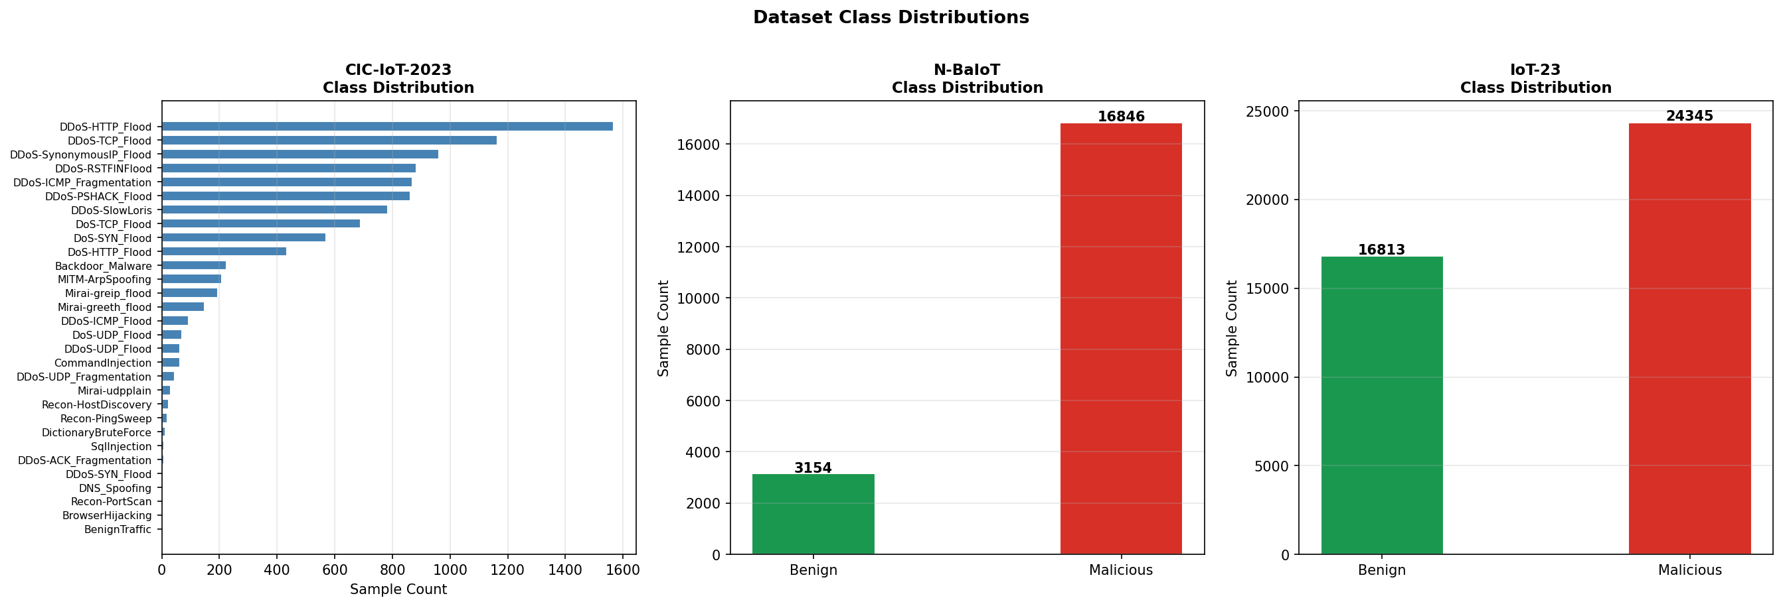
Fig. 2. Class distribution across the three datasets.

CIC-IoT-2023 [1], released by the Canadian Institute for Cybersecurity, is among the most comprehensive contemporary IoT security datasets, capturing traffic from real smart-home devices across 33 attack types organized into seven categories. N-BaIoT [2] comprises traffic from nine commercial IoT devices compromised by the Mirai and BASHLITE botnets, framing a binary benign-versus-malicious task. IoT-23 [3], curated by the Stratosphere Laboratory, provides labelled traffic encompassing DDoS, command-and-control, and horizontal port-scanning activity.

4.2 Training Configuration
The model is optimized with Adam (learning rate 1×10⁻³, weight decay 1×10⁻⁵) under a ReduceLROnPlateau schedule (factor 0.5, patience 3), with gradient norms clipped to 1.0 to prevent divergence. Training proceeds for 30 epochs at a batch size of 512 using an 80/20 stratified train–test split, with a dropout rate of 0.3 applied during both training and Monte Carlo inference. All experiments were conducted on an NVIDIA Tesla T4 GPU within the PyTorch framework.

5. Results and Analysis

5.1 CIC-IoT-2023 Performance
Table 2 reports the classification performance of CNN-Att-LSTM on the CIC-IoT-2023 test set. The model attains 96.01% accuracy, 95.36% precision, 96.01% recall, and a 95.30% F1 score. The close agreement between precision and recall indicates that performance is balanced rather than skewed toward dominant classes — a non-trivial outcome in a 33-class setting with substantial frequency disparities.

Model | Accuracy | Precision | Recall | F1
CNN-Att-LSTM (Ours) | 96.01% | 95.36% | 96.01% | 95.30%
Table 2. CNN-Att-LSTM performance on CIC-IoT-2023 (33 classes).

The training dynamics are shown in Figure 3. Cross-entropy loss declines from approximately 2.1 to below 0.2 over 30 epochs, while validation accuracy rises from 45% to 96%. Two pronounced step improvements, near epochs 4 and 19, mark transitions at which the model begins to resolve progressively harder attack sub-categories; the absence of divergence between the curves indicates stable learning without overfitting.

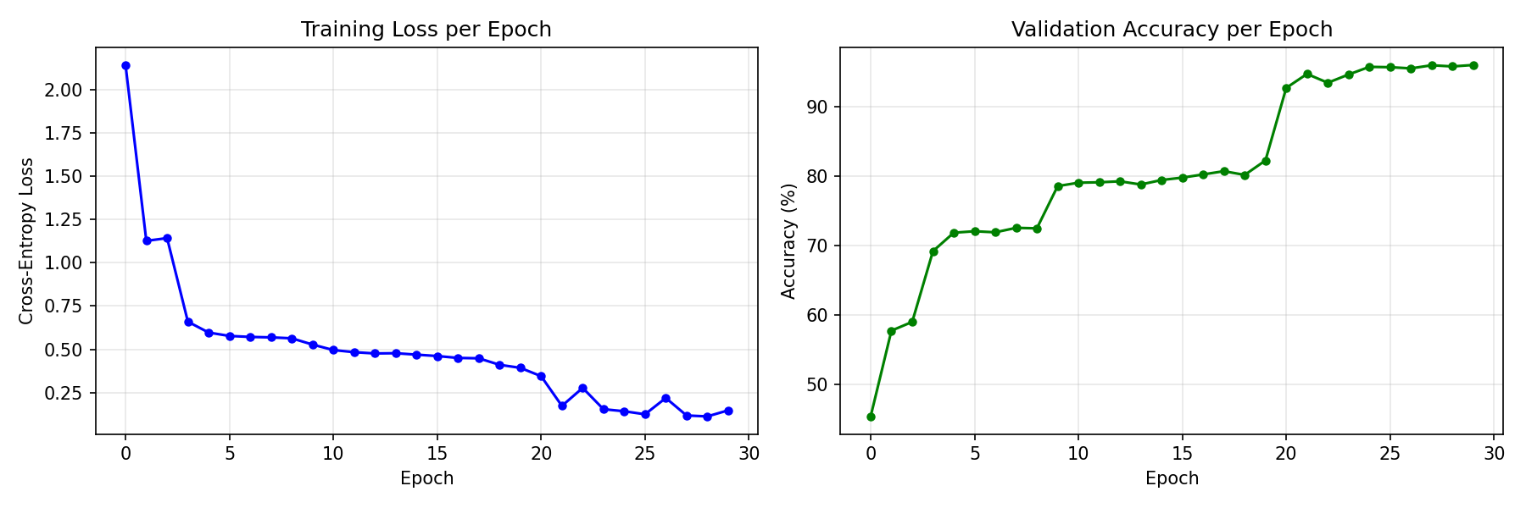
Fig. 3. Training loss and validation accuracy per epoch on CIC-IoT-2023.

Figure 4 presents the full 33-class confusion matrix. Near-perfect discrimination is achieved for the high-frequency classes, including DDoS-RSTFINFlood, DDoS-ICMP-Fragmentation, DDoS-SlowLoris, the DoS-HTTP/SYN/TCP-Flood family, MITM-ArpSpoofing, and the Mirai flood variants. The residual misclassifications are concentrated among semantically adjacent DDoS sub-variants whose traffic signatures overlap substantially — a confusion pattern that is expected and largely benign, since these classes share the same coarse-grained mitigation response.

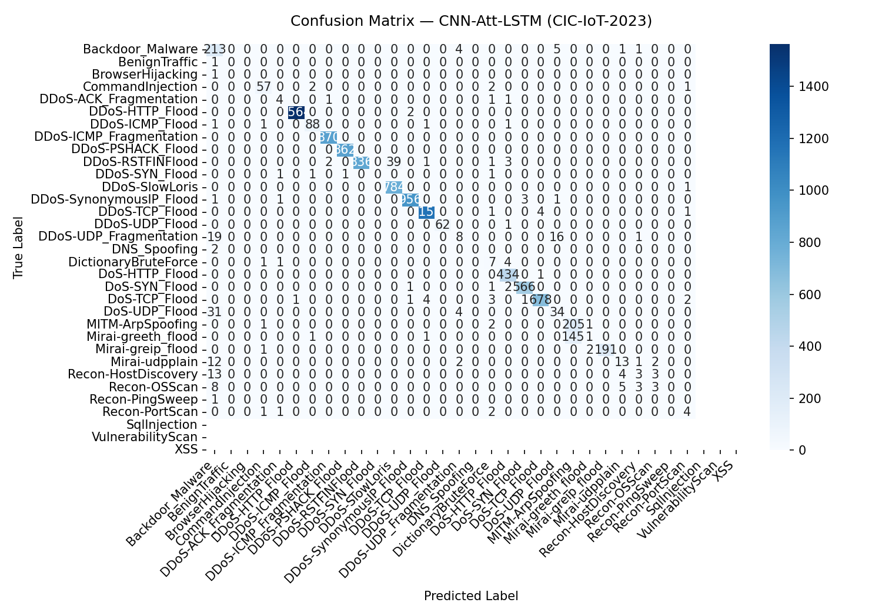
Fig. 4. Confusion matrix on CIC-IoT-2023 (33 attack classes).

Figure 5 disaggregates performance into per-class F1 scores. The majority of classes exceed an F1 of 85%, confirming that detection quality is sustained across the attack taxonomy rather than concentrated in a few dominant categories. The lower-scoring classes are predominantly those with few samples even after ADASYN augmentation, underscoring the persistent difficulty of detecting extremely rare attack types — a limitation we revisit in Section 7.

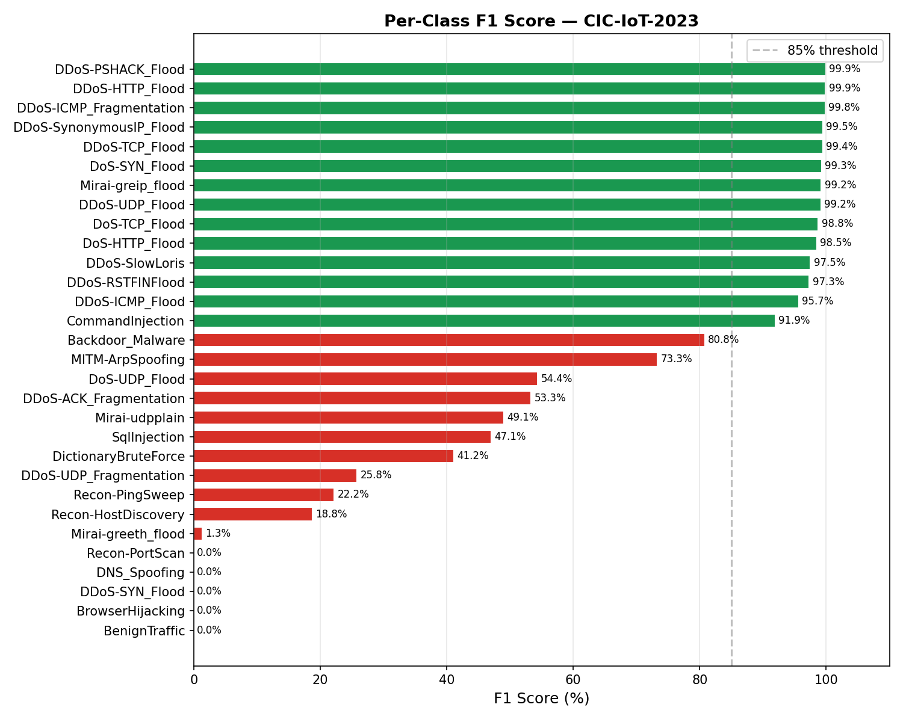
Fig. 5. Per-class F1 on CIC-IoT-2023 (green ≥ 85%, red < 85%).

5.2 Uncertainty Quantification
Table 3 summarizes the Monte Carlo Dropout analysis, conducted over 50 stochastic passes on 2,000 randomly sampled test instances. Under MC Dropout the model attains 96.10% accuracy — marginally exceeding its deterministic counterpart, consistent with the mild ensembling effect of stochastic averaging. The mean prediction confidence of 95.7% together with a low mean uncertainty of 0.0093 indicates that the model is well calibrated: its expressed confidence corresponds closely to its empirical correctness.

MC Accuracy | Mean Confidence | Mean Uncertainty
96.10% | 95.7% | 0.0093
Table 3. Monte Carlo Dropout analysis (50 passes, 2,000 samples).

Figure 6 visualizes these properties. In the left panel, correctly classified instances cluster sharply at confidence values above 0.9, whereas misclassifications are dispersed across the lower confidence range — precisely the separation required for confidence-based triage. The right panel reveals a clear inverse relationship between uncertainty and confidence, confirming that the model reserves its lowest confidence for genuinely difficult samples. Operationally, this relationship licenses a policy in which low-confidence detections are escalated for analyst review while high-confidence detections proceed automatically.

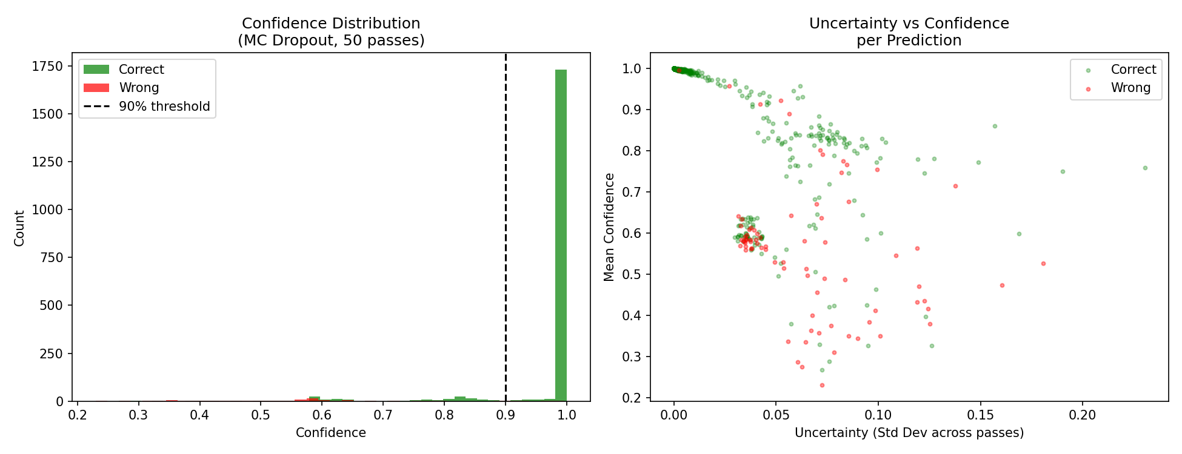
Fig. 6. MC Dropout uncertainty analysis. Left: confidence distribution (correct vs incorrect). Right: uncertainty vs confidence.

5.3 Cross-Dataset and Independent Evaluation
Table 4 consolidates results across all three datasets. To assess cross-environment transfer, the model trained exclusively on CIC-IoT-2023 was applied to N-BaIoT without any retraining, attaining 84.38% accuracy and a 77.39% F1 score. The moderate F1 in this zero-shot regime is attributable to the substantial distributional and feature-space divergence between the two corpora, which differ in both device population and feature schema. For IoT-23, the model was trained and evaluated independently under an 80/20 split on the eight numeric features available in that dataset, achieving 98.08% accuracy. Taken together, these results substantiate the architecture's capacity to generalize across heterogeneous IoT environments, while delineating the realistic limits of zero-shot transfer.

Dataset | Accuracy | Precision | Recall | F1
CIC-IoT-2023 | 96.01% | 95.36% | 96.01% | 95.30%
N-BaIoT (cross-dataset) | 84.38% | 85.87% | 84.38% | 77.39%
IoT-23 (independent) | 98.08% | 98.08% | 98.08% | 98.08%
Table 4. CNN-Att-LSTM performance across all three datasets.

6. Comparison with State of the Art
Table 5 compares CNN-Att-LSTM with recent published deep-learning IDS methods evaluated on the CIC-IoT-2023 dataset. A direct numeric comparison must account for the classification granularity: results reported on binary or grouped (few-class) tasks are inherently easier than fine-grained multi-class tasks. Our model is evaluated on the full 33-class setting — the most challenging configuration — yet still achieves 96.01% accuracy. Against comparably fine-grained multi-class baselines (12-class), our approach leads by roughly three percentage points, while uniquely providing uncertainty quantification and cross-dataset evaluation that none of the baselines offer.

Method (Source) | Acc. | F1 | Setting | Uncert. | Cross-DS
CNN-LSTM [8] | 98.42% | 98.57% | Binary/grouped | No | No
AE-LSTM-CNN [9] | — | 99.19% | Grouped | No | No
DNN [10] | 93.0% | — | 12-class | No | No
CNN [10] | 92.7% | — | 12-class | No | No
Transformer [10] | 92.5% | — | 12-class | No | No
CNN-Att-LSTM (Ours) | 96.01% | 95.30% | 33-class | Yes | Yes
Table 5. Comparison with recent published IDS methods on CIC-IoT-2023. Settings differ in class granularity; finer-grained tasks are harder.
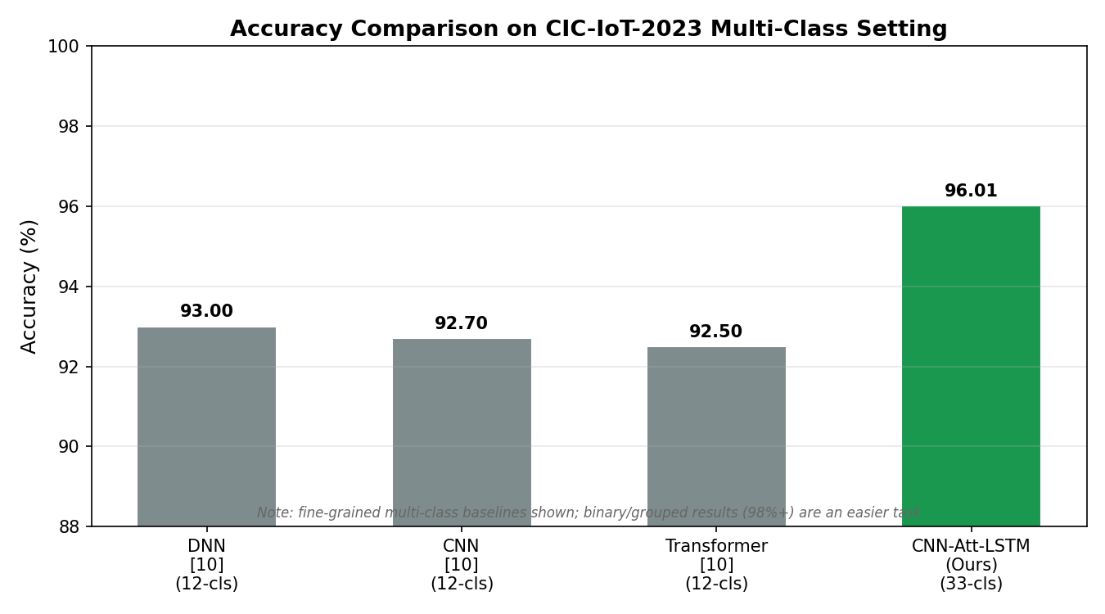
Fig. 7. Accuracy comparison with state-of-the-art methods (note differing class granularities).

7. Discussion
The results position CNN-Att-LSTM as a competitive yet distinctly more deployable detector than its predecessors. Beyond accuracy, it delivers two capabilities absent from the baselines surveyed in Section 6: principled uncertainty quantification and demonstrated cross-environment generalization. The Monte Carlo Dropout analysis is particularly consequential for practice, as it exposes a robust correlation between uncertainty and error — misclassifications are concentrated among high-uncertainty samples — which directly underpins the proposed two-tier operational model of autonomous response for confident detections and analyst review for uncertain ones.
The cross-dataset outcome on N-BaIoT (84.38% with zero retraining) merits emphasis. Because the model was trained solely on CIC-IoT-2023, whose device population and capture conditions differ markedly from those of N-BaIoT, this result suggests that the architecture learns representations of malicious behaviour that are transferable rather than artefacts specific to a single corpus. The stronger independent result on IoT-23 (98.08%) further confirms the model's representational capacity when trained in-domain.
Several limitations temper these conclusions and define our agenda for future work. The moderate cross-dataset F1 on N-BaIoT (77.39%) reflects the feature-schema mismatch between datasets, and the IoT-23 evaluation was necessarily confined to eight numeric features. Moreover, the reported figures derive from a single training run; a rigorous treatment would report means and confidence intervals over multiple seeds. We therefore intend to pursue domain-adaptation and federated-learning strategies to strengthen cross-environment transfer without centralized retraining, and to incorporate multi-run statistical reporting.

8. Conclusion
This paper introduced CNN-Att-LSTM, an uncertainty-aware intrusion detection framework that unifies convolutional spatial feature extraction, self-attention-based feature weighting, LSTM temporal modelling, and Monte Carlo Dropout within a single architecture. Evaluated across CIC-IoT-2023, N-BaIoT, and IoT-23, the model attains 96.01%, 84.38%, and 98.08% accuracy, respectively, while its calibrated confidence estimates (mean 95.7%) enable a trust-aware deployment posture that prior detectors cannot support. To the best of our knowledge, this is the first IoT IDS to combine CNN, attention, LSTM, and MC Dropout, and the first to evaluate cross-environment generalization explicitly. Future work will pursue federated learning for privacy-preserving distributed training, continual learning to accommodate evolving attack distributions, and anomaly-scoring extensions for zero-day detection — collectively advancing the framework toward operational readiness.

References
[1] E. C. P. Neto et al., "CICIoT2023: A Real-Time Dataset and Benchmark for Large-Scale Attacks in IoT Environment," Sensors, vol. 23, no. 13, p. 5941, 2023.
[2] Y. Meidan et al., "N-BaIoT: Network-Based Detection of IoT Botnet Attacks Using Deep Autoencoders," IEEE Pervasive Computing, vol. 17, no. 3, pp. 12-22, 2018.
[3] S. Garcia, A. Parmisano, and M. J. Erquiaga, "IoT-23: A Labeled Dataset with Malicious and Benign IoT Network Traffic," Zenodo, 2020.
[4] Y. Gal and Z. Ghahramani, "Dropout as a Bayesian Approximation: Representing Model Uncertainty in Deep Learning," in Proc. ICML, 2016, pp. 1050-1059.
[5] S. Hochreiter and J. Schmidhuber, "Long Short-Term Memory," Neural Computation, vol. 9, no. 8, pp. 1735-1780, 1997.
[6] H. He, Y. Bai, E. A. Garcia, and S. Li, "ADASYN: Adaptive Synthetic Sampling Approach for Imbalanced Learning," in Proc. IEEE IJCNN, 2008, pp. 1322-1328.
[7] A. Vaswani et al., "Attention Is All You Need," in Proc. NeurIPS, 2017, pp. 5998-6008.
[8] A. Bukhari et al., "Enhancing IoT Security with CNN and LSTM-Based Intrusion Detection Systems," arXiv:2405.18624, 2024.
[9] Journal of Edge Computing, "A Hybrid AE-LSTM-CNN Model for Intrusion Detection on the CIC-IoT-2023 Dataset," J. Edge Comput., vol. 3, no. 1, pp. 28-42, 2024.
[10] H. C. Altunay et al., "Multi-Class Intrusion Detection Based on Transformer for IoT Networks Using the CIC-IoT-2023 Dataset," Future Internet, vol. 16, no. 8, p. 284, 2024.

