

Premier University, Chittagong

Faculty of Computer Science & Engineering

Project Proposal

Project Title: Project & Thesis Exhibition

|  |  |
| --- | --- |
| Submitted by:  Md. Shahidul Alam Riyad  Id: 1402710200745  Md. Shahidul Islam  Id: 1402710200753 | Supervised by:  Syed Minhaz Hossain  Assistant Professor,  Department of CSE |

Department of Computer Science & Engineering

April, 2021

Contents

|  |  |  |
| --- | --- | --- |
| 1 | Introduction |  |
| 2 | Objective of the Project |  |
| 3 | History and Background |  |
| 4 | Admin Panel of Software |  |
| 5 | Requirements |  |
| 6 | Progression Timeline |  |
| 7 | References |  |

Introduction : A platform will be created for the students, teachers, guests.

Objective of the Project

Project exhibition where all departments of university projects or thesis papers uploaded and stored with the help of teachers. One can exhibit the application in order to he/she can analyze the project, what will help him/her and who can get a complete idea or hints from the existing project or thesis. One can work on an existing project or thesis to get good results as he/she wants. So our project exhibition will be good enough for you.

History and Background

We store all projects or thesis papers by university approved, Teachers reference, good subject what will help to broad ideas. We categorized projects or thesis papers like iot, web application, wordpress, AI, Android, Ios etc. We also help to find projects via best trend, priority, best rated etc.

Who and how application manage:

Application will be managed by university authority, teachers. Teachers can handover to students to add all details his/her project or thesis papers.

Admin Panel of Software

Super admin can have only 4 modules

**Dashboard** : Super admin dashboard only shows counts how many teachers, students and projects we have.

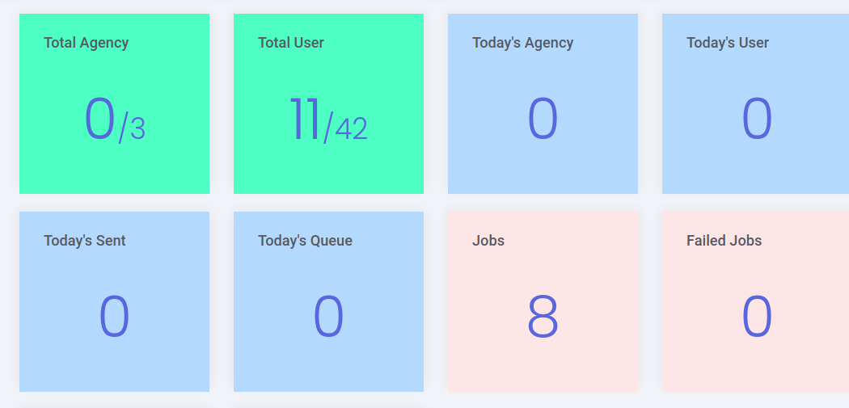

*Demo Example design*

**Students :** This page will show us a list of students. Admin also can log in as a student from the list.

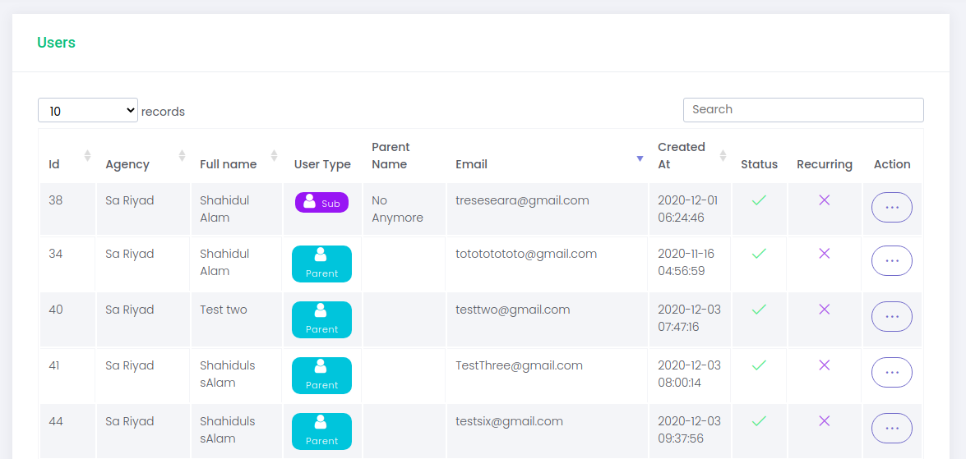

*Demo example design*

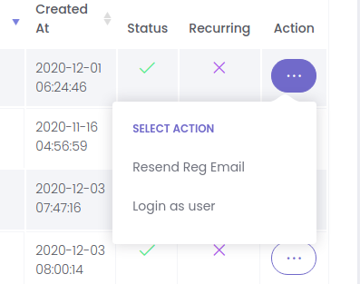

*Demo example design*

**Teachers :** Same as students list. It will also show us teachers, the same as students. Also admin can log in as a teacher from the list.

**Categories :** Super admin will add some categories so that while a student creates a project they can select categories. Super admin also can edit or delete categories. Category delete must be soft delete means if category deleted it won't affect existing projects. Category must contain title, description and an image of the category.

Student Panel of Software

- **Student**

- Students will be registered using name, email, batch, session roll.

**Student can have 3 modules**

**Dashboard :**

Students will have a dashboard that describes his current project progressions.

**My projects :**

This page describes the existing project/thesis status. Students can perform a few actions from this page.

**Create project:** When a student clicks the create project button , a form will be given to the student with few options.

1. Is it a project or thesis?
2. Project/Thesis name.
3. Description.
4. Select category
5. Add some tags to the project.
6. An image (optional) but required if students try to publish it.
7. Visibility : guests, students, only me.

After form submission a project manager page will be open.

**Project Manager Page :** Students perform these things on the project manager page.

1. Assign member. Students can assign other students to the project. Let's say that project collaborator. Project collaborators can also manage the project. Collaborator will be limited by admin settings. Other students will get a notification if they accept, they will be collaborators of the project. They can reject the invitation.
2. Assign a teacher. Students can assign teachers from this page. Teachers also get a notification they can verify and accept. A student can only add one teacher. But a teacher can assign other teachers as sub teachers to the page.They also can reject the invitation.
3. Project content : Students may add some project contents.(The order must be dynamic)
   1. Text contents.
   2. Files.
   3. Images.
   4. Git links.
   5. Embed videos.
4. All changes on the project should be added in a change log.
5. Visibility will be guests, students, only me.

Teacher Panel of Software

**Registration** : Teacher will be registered: using name, email, address,phone,designation,department.

**Dashboard:** Dashboard will show how many proposals, projects are under the teacher.

**Proposals**: This page will show all proposals assigned by students.

**Projects** : This page shows all projects under the teacher. Teachers can manage projects as much as students. All changes on the project should be added in a change log.

Guest Panel of Software

**Dashboard:** Guests will have a dashboard with published projects. They can visit top ranked projects, featured projects or they can search projects with specific tag or context.

**Project page:** They can view projects, reports, rating and feedback. In order to do rating or feedback they must be logged in to our system. But the guest will count as a visitor.