A FIELD PROJECT REPORT ON

ELECTRIC AUTOMOBILES DEFECT SENSORS
Submitted
in partial fulfilment of the requirements for the award of the degree

BACHELOR OF TECHNOLOGY
In
COMPUTER SCIENCE AND ENGINEERING

By
Siva kumar | (241FA04284)
Nikhil sai | (241FA04289)
Ajmal | (241FA04332)
Hari krishna | (241FA04348)
Under the Guidance of
MR.D.KUMAR SIR
Assistant Professor, CSE


Department of Computer Science and Engineering
School of Computing and Informatics
Vignan’s Foundation for Science, Technology and Research (Deemed to be University) Vadlamudi, Guntur, Andhra Pradesh-522213, India.
April – 2026


CERTIFICATE

This is to certify that the field project entitled “ELECTRIC AUTOMOBILES DEFECT SENSORS” is being submitted by (SIVA KUAMR&241FA04284), (NIKHIL SAI& 241FA04289), (AJMAL SHARUK & 221FA04332), and (HARI KRISHNA & 241FA04348) in partial fulfilment of the requirements for the degree of Bachelor of Technology (B.Tech) in Computer Science and Engineering at Vignan’s Foundation For Science Technology & Research (Deemed to be University), Vadlamudi, Guntur District, Andhra Pradesh, India.
This is a bona fide work carried out by the aforementioned students under my guidance and supervision.

Guide

Project Review Committee | Head of the Department



DECLARATION
Date:
We hereby declare that the work presented in the field project titled ”ELECTRICAL AUTO
MOBILES DEFECT SENSORS”, is the result of our own efforts and investigation. This project is being submitted under the supervision of (of Mr. D. KUMAR SIR, Assistant Professor), in partial fulfilment of the requirements for the Bachelor of Technology (B.Tech) degree in Computer Science and Engineering at Vignan’s Foundation for Science, Technology and Research (Deemed to be University), Vadlamudi, Guntur, Andhra Pradesh.

Siva kumar | (241FA04284) | Signature
Nikhil sai | (241FA04289) | Signature
Ajmal | (241FA04332) | Signature
Hari krishna | (241FA04348) | Signature

 |  |  | 
 |  |  | 1
 |  |  | 1
 |  |  | 1  1
 |  |  | 2
2
2
 |  |  | 2
33
3
 |  |  | 3
 |  |  | 33  3
 |  |  | 4
 |  |  | 4
 |  |  | 5
 |  |  | 5
 |  |  | 5
 |  |  | 6
 |  |  | 7
77
7
 |  |  | 7

CHAPTER 1
INTRODUCTION
Introduction

Electric automobiles, commonly known as Electric Vehicles (EVs), are becoming an important part of modern transportation systems due to their environmental benefits and reduced dependence on fossil fuels. Unlike traditional vehicles that use internal combustion engines, electric vehicles operate using electric motors powered by rechargeable battery packs.

Since EVs rely heavily on electrical components such as batteries, motors, controllers, and power electronics, monitoring the health of these components is essential. Any defect in the electrical system may lead to safety risks, performance degradation, or system failure. To overcome these issues, defect detection sensors are integrated into electric automobiles.

Defect sensors continuously monitor parameters such as temperature, voltage, current, motor speed, and insulation leakage. The collected data is analyzed by the Electronic Control Unit (ECU), which identifies abnormal conditions and alerts the user or system. This helps prevent serious failures and improves vehicle safety and efficiency.

The objective of this project is to study the different types of sensors used in electric vehicles and understand how they detect defects in electrical systems.

1.1 Problem Definition

Electric vehicles contain several electrical components such as batteries, motors, controllers, and power circuits. If any of these components develop faults such as overheating, overcurrent, or voltage imbalance, it can lead to system malfunction or safety hazards.

Traditional monitoring systems cannot always detect faults in real time. Without proper monitoring, defects may go unnoticed until they cause major damage. Therefore, there is a need for an intelligent defect detection system that continuously monitors the vehicle’s electrical parameters and provides alerts when abnormal conditions occur.

This project focuses on understanding how sensors can detect faults in electric automobiles and help maintain safe and efficient operation.

1.2 Existing System

In traditional electric vehicle monitoring systems:
- Fault detection is limited and often manual.
- Sensors are not integrated with intelligent monitoring systems.
- Early warnings for system faults are not always available.
- Maintenance is usually performed only after a failure occurs.
Due to these limitations, the existing systems may lead to increased maintenance costs, reduced efficiency, and potential safety risks.

1.3 Proposed System

The proposed system focuses on using multiple sensors to monitor the electrical components of an electric vehicle. These sensors collect real-time data about different parameters such as battery temperature, voltage levels, motor current, and vehicle speed.
The collected data is processed by a monitoring system that identifies abnormal conditions. If a fault is detected, the system generates warning messages to alert the user.
The proposed system offers the following features:
- Continuous monitoring of EV electrical parameters
- Detection of defects such as overheating and overcurrent
- Warning alerts for abnormal conditions
- Improved safety and reliability
- Reduced maintenance costs

1.4 Literature Review
Recent research in electric vehicle technology emphasizes the importance of sensor-based monitoring systems. Modern EVs use multiple sensors integrated with Electronic Control Units (ECUs) to detect faults and improve operational safety.
Studies show that temperature sensors help prevent battery overheating, while voltage and current sensors protect the electrical system from overloading. Speed sensors assist in monitoring vehicle performance and regenerative braking systems.
Advanced research also suggests the integration of smart sensors and artificial intelligence techniques for predictive maintenance and early fault detection in electric vehicles.

CHAPTER 2
SYSTEM REQUIREMENTS

2.1 Hardware Requirements

The hardware components required for this project include:
- Microcontroller (Arduino / ESP32)
- Temperature Sensor
- Voltage Sensor
- Current Sensor
- Speed Sensor
- Computer or Laptop
- Internet connection (optional)
- Display devic2.2 Software Requirements

The software tools used in this project include:

Operating System: Windows / Linux

Programming Languages: HTML, CSS, JavaScript

Web Browser (Chrome / Edge)

Code Editor (Visual Studio Code)

Simulation tools for sensor data testing

2.3 Software Requirements Specification (SRS)

Functional Requirements

Monitor temperature of battery and motor

Monitor voltage levels of battery

Monitor current flow in circuits

Detect brake system faults

Display sensor values on dashboard

Generate warning messages when faults occur

Non-Functional Requirements
- Real-time monitoring capability
- User-friendly interface
- Reliable fault detection
- Efficient system performance

CHAPTER 3
SYSTEM DESIGN

3.1 Modules of System

The system consists of the following modules:

Sensor Module

This module collects data from various sensors such as temperature, voltage, current, and speed sensors.

Data Processing Module

The collected sensor data is processed and analyzed to detect abnormal conditions.

Monitoring Dashboard Module

This module displays the sensor values and system status through a graphical interface.

Fault Detection Module

This module compares sensor values with predefined safe limits and generates alerts when necessary.

3.2 UML Diagrams (Description)
Actors: User, Vehicle System
Use Cases: Monitor Sensors, Detect Faults, Display Status, Generate Alerts.
Class Diagram
Classes include: Sensor, VehicleSystem, FaultDetector, Dashboard, User.
Activity Diagram
Flow:
Sensor Reading → Data Processing → Fault Detection → Display Status → Alert User.
Sequence Diagram
Sensor → Controller → Data Processing → Dashboard → User Notification.

CHAPTER 4
IMPLEMENTATION
<!DOCTYPE html>
<html>
<head>
<title>EV Defect Sensor Monitoring System</title>
<style>
body {
font-family: Arial, sans-serif;
background: #eef2f3;
text-align: center;
padding: 30px;
} .container {
background: white;
padding: 25px;
border-radius: 12px;
width: 500px;
margin: auto;
box-shadow: 0 0 15px gray;}
h2 {
color: #2c3e50;
} .sensor {
margin: 8px 0; }
.warning {
color: red;
font-weight: bold;}
.safe {
color: green;
font-weight: bold;}
button {
padding: 10px 20px;
margin-top: 15px;
cursor: pointer;
background: #3498db;
color: white;
border: none;
border-radius: 5px;
}
button:hover {
background: #2980b9;
}
</style>
</head>
<body>
<div class="container">
<h2>Electric Vehicle Defect Sensor Dashboard</h2>
<div class="sensor">Temperature: <span id="temp">0</span> °C</div>
<div class="sensor">Battery Voltage: <span id="voltage">0</span> V</div>
<div class="sensor">Motor Current: <span id="current">0</span> A</div>
<div class="sensor">Vehicle Speed: <span id="speed">0</span> km/h</div>
<div class="sensor">Brake Status: <span id="brake">Normal</span></div>
<div class="sensor">Insulation Leakage: <span id="leakage">0</span> mA</div>
<h3 id="status" class="safe">System Safe</h3>
<button onclick="checkSensors()">Check All Sensors</button>
</div>
<script>function checkSensors() {
// Simulated sensor values
let temperature = Math.floor(Math.random() * 100);
let voltage = Math.floor(Math.random() * 60);
let current = Math.floor(Math.random() * 50);
let speed = Math.floor(Math.random() * 120);
let brakeFault = Math.random() < 0.2;
// 20% chance brake fault
let leakage = Math.floor(Math.random() * 20);
// Display values
document.getElementById("temp").innerText = temperature; document.getElementById("voltage").innerText = voltage; document.getElementById("current").innerText = current; document.getElementById("speed").innerText = speed; document.getElementById("brake").innerText = brakeFault ? "Brake Fault!" : "Normal"; document.getElementById("leakage").innerText = leakage;
let status = document.getElementById("status");
// Fault Conditions
if (temperature > 60) {
status.innerText = "Warning: Motor Overheating!";
status.className = "warning";
} else if (voltage < 40) {
status.innerText = "Warning: Low Battery Voltage!";
status.className = "warning";
} else if (current > 35) {
status.innerText = "Warning: Over Current Detected!";
status.className = "warning";
}
else if (brakeFault) {
status.innerText = "Warning: Brake System Fault!";
status.className = "warning";
} else if (leakage > 10) {
status.innerText = "Warning: Insulation Leakage Detected!";
status.className = "warning";
} else {
status.innerText = "System Safe";
status.className = "safe";}}
</script>
</body>
</html>
CHAPTER 5
RESULTS

5.1 Output Screens (Conceptual)
The implemented system displays sensor values such as temperature, voltage, current, vehicle speed, brake status, and insulation leakage. The system analyzes the sensor values and determines whether the vehicle system is safe or if a fault condition exists.
When sensor values exceed predefined limits, warning messages such as Motor Overheating, Low Battery Voltage, Overcurrent, or Brake Fault are displayed.
This helps in identifying potential defects in the electric automobile system.
5.2 Output Screens
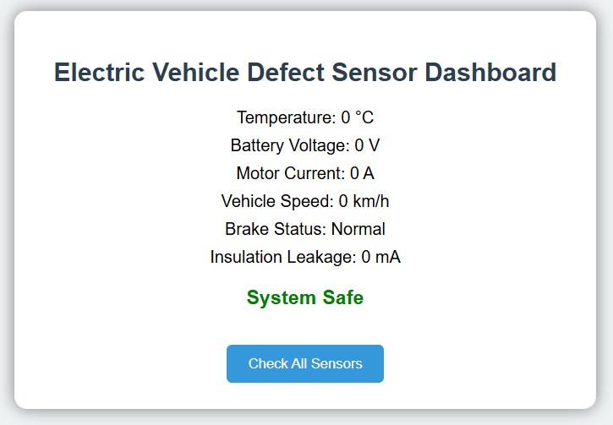
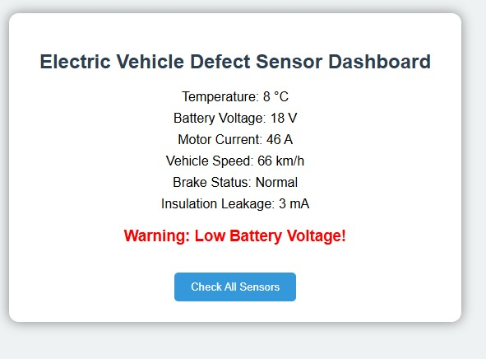
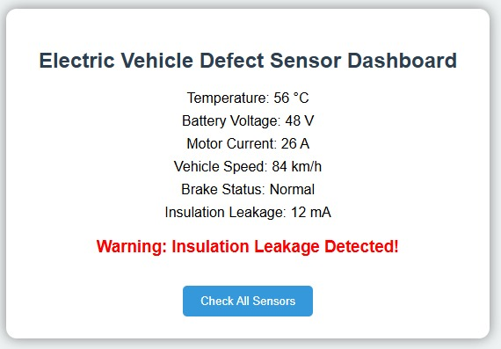
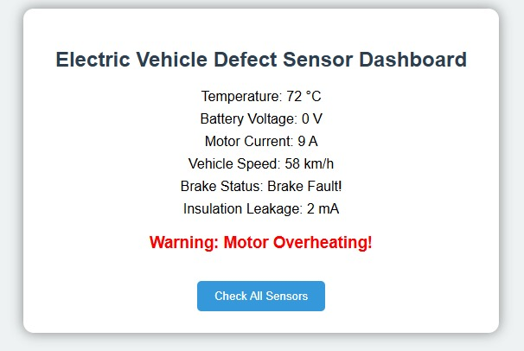

Deployment:
https://github.com/Joyboy486/FP

CHAPTER 6
CONCLUSION
Electric automobiles are an important part of future transportation systems. However, the safety and reliability of these vehicles depend on proper monitoring of electrical components.
This project studies the role of defect detection sensors in electric vehicles. Sensors such as temperature, voltage, current, and speed sensors help detect faults and prevent serious damage to the vehicle system.
By implementing sensor-based monitoring systems, electric vehicles can achieve improved safety, better performance, and reduced maintenance costs. Future advancements may include smart sensors, IoT integration, and AI-based predictive maintenance for more advanced fault detection.

CHAPTER 7
REFERENCES
- Electric Vehicle Technology Explained – James Larminie & John Lowry
- Research Papers on Electric Vehicle Sensor Systems (IEEE)
- Arduino Sensor Documentation
- Electric Vehicle Battery Management System Studies
- Online resources on EV fault detection systems

