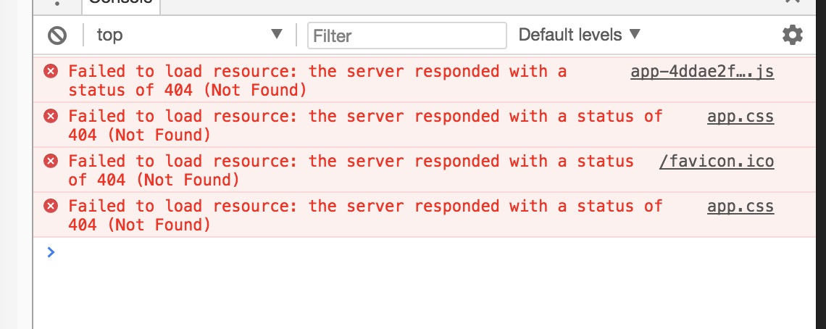

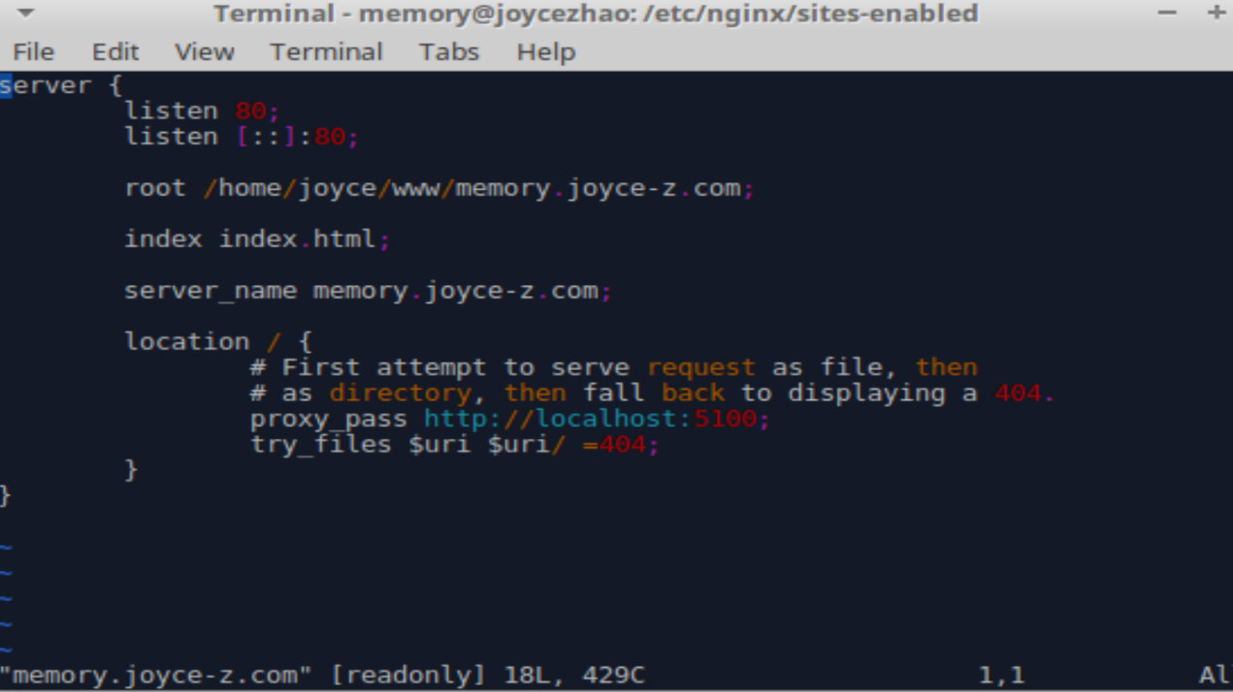

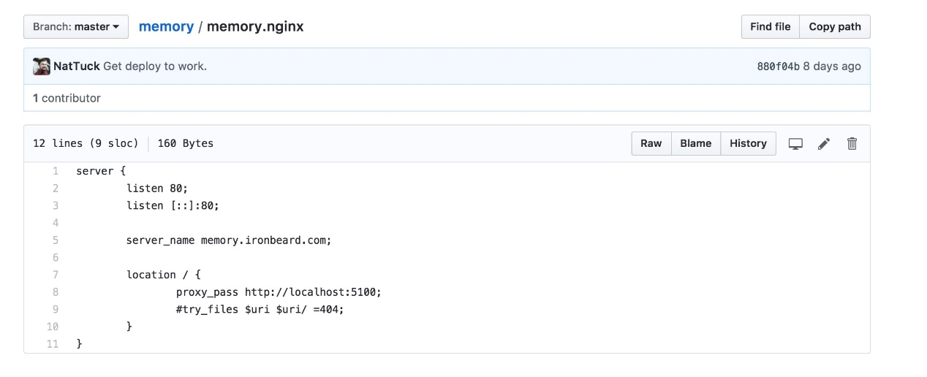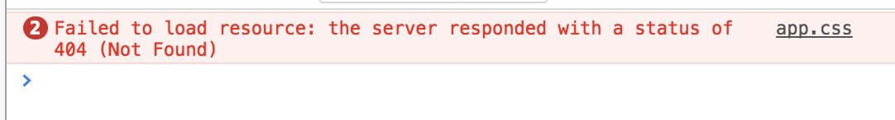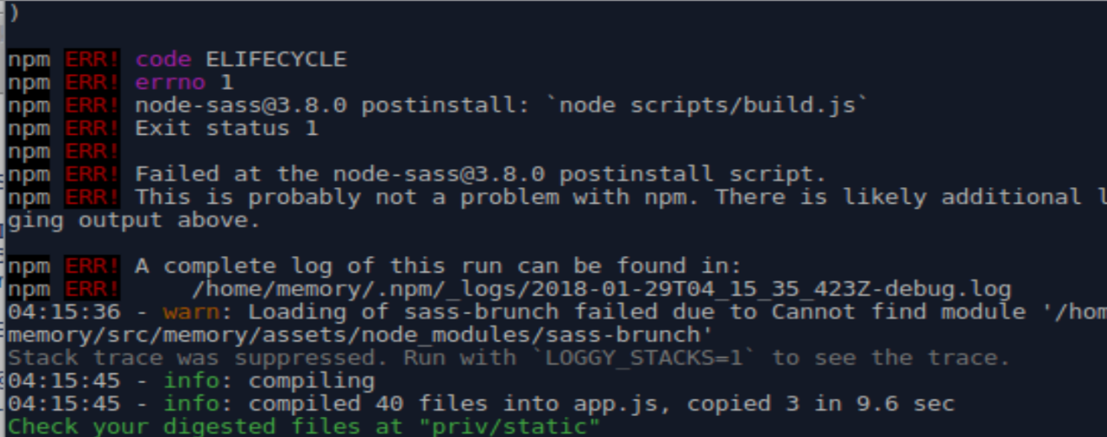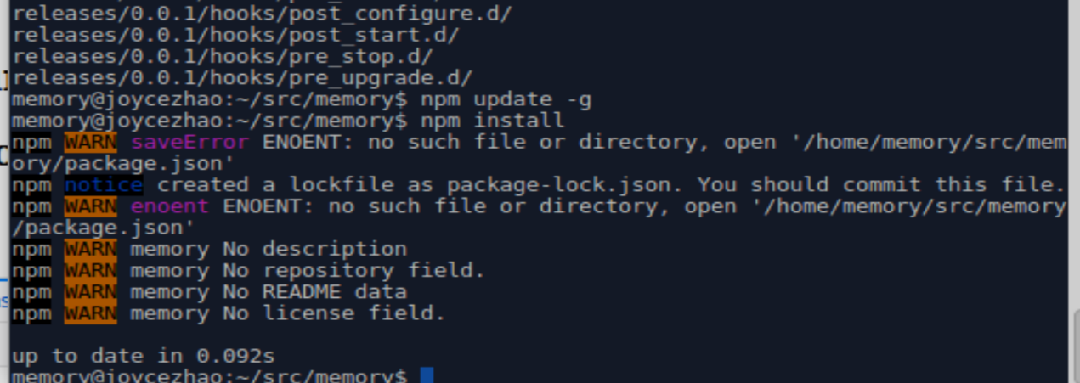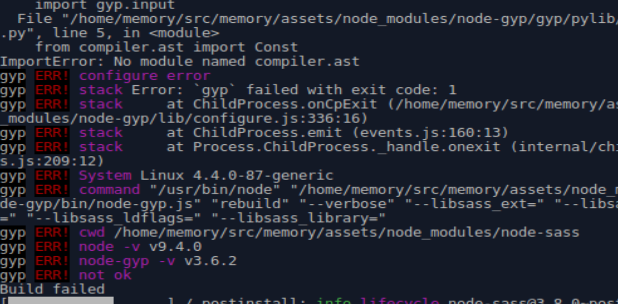

npm update -g

npm install

npm install -g brunch

npm rebuild node-sass

cd my_app

npm init

apt-get install build-essential

apt-get install gcc

apt-get install pkg-config

apt-get install g++ gyp

wget https://raw.githubusercontent.com/XadillaX/aliyun-ons/master/binding.gyp

npm install node-gyp

https://piazza.com/class/jbri1u23q9yx6?cid=151