UNIVERSITI MALAYSIA SARAWAK
Faculty of Computer Science and Information Technology
TMA3084 Software Engineering Laboratory | Semester 1, 2026/2027
PROJECT PROPOSAL
(Product Requirements Document)
Car Rental Management System (RentEasy)
Group Number / Name | Team 20 - SpringTech
Lab Group / Demonstrator | Group 2
Client / Organisation | Mr. Jayvier Tan Eng Chieh, Director, JC Construcars Company
Lecturer | Mdm. Nurfauza Jali
GitHub Repository | TMA3084-SpringTech-RentEasy
Version / Date | v1.0 (original)

Team Members
No. | Name | Matric No. | Tspi Role | Signature
1 | Andrea Nguang Shi Ya | 103324 | Planning Manager | 
2 | Jocelyn Lee Shuang Shuang | 104561 | Quality / Process Manager | 
3 | Joyce Lau Kai Xin | 104596 | Team Leader, Client Liaison / Developer | 
4 | Lee Xing Ying | 104731 | Development Manager
5 | Rionnalyn Richard | 106148 | Support Manager | 

Declaration
By signing above, we certify that this proposal is our own work, that all external sources, libraries, APIs and AI-assisted content are acknowledged, and that we have not engaged in plagiarism or unauthorised collusion (Peraturan Akademik UNIMAS, Etika Akademik). AI tool usage is recorded in LOGAI.

Table of Contents
Abstract 4
1. Introduction 4
1.1 Client Background 4
1.2 Team Background 5
2. Problem Statement 6
3. Project Objectives & Success Metrics 7
4. Project Perspective 7
4.1 Target Users 7
4.2 System Context and Architecture 8
5. Project Scope 9
5.1 In Scope / Out of Scope 9
5.2 Features and User Stories 10
5.3 AI Feature 12
5.4 Non-Functional Requirements and Constraints 13
5.5 System Environment 13
6. Task Allocation & Team Contribution 14
7. Team Goals 15
8. Expected Results 15
8.1 Working System 15
8.2 Documentation and Artefacts 16
9. Project Planning 16
9.1 Methodology 16
9.2 Submission Schedule 17
9.3 Development Milestones (GitHub) 17
9.4 Risks and Assumptions 18
10. References 19
Appendix A: Client Meeting Evidence 20
A.1 Client Meeting Summary 20
Appendix B: Revision History 21

List of Tables
Table 1: Client Organisation Information 5
Table 2: Team Background 6
Table 3: Summary of Client Problems 7
Table 4: Project Objectives and Success Metrics 7
Table 5: Target Users 8
Table 6: Scope Boundary 10
Table 7: Features and User Stories 12
Table 8: AI Feature Summary 13
Table 9: Non-Functional Requirements and Constraints 13
Table 10: System Environment 14
Table 11: Task Allocation and Contribution 15
Table 12: Team Goals 15
Table 13: Deliverables 16
Table 14: Submission Schedule 17
Table 15: Development Milestones 18
Table 16: Risks and Assumptions 18

List of Figures
Figure 1: Logo of JC Construcars Company 4
Figure 2: Logo of SpringTech 5
Figure 3: High-level System Architecture 8
Figure 4: System Modules Diagram 12
Figure 5: Gantt Chart 18
Figure 6: Photo of Client Meeting 20

Abstract
RentEasy is a mobile solution designed to simplify daily rental and vehicle management. During the initial meeting, the client explained that bookings, vehicle availability, deposits and maintenance are managed through multiple WhatsApp accounts, paper forms and offline Excel sheets. Records are scattered, staff may miss payments, deposit refunds or servicing schedules. This project will develop a Flutter and Dart app connected to a cloud database. Its five modules are Dashboard, Fleet, Rentals, Payments, and Maintenance & Reports. Staff can check vehicle availability, manage bookings, track three-day deposit refund periods, set maintenance reminders and view reports. A Generative AI assistant will answer natural-language questions about stored data, such as vehicle availability on specific dates. RentEasy aims to centralise records, improve efficiency and reduce manual errors.

1. Introduction
Managing a car rental business requires staff to coordinate vehicle availability, bookings, pickup and return schedules, payments, deposits, and maintenance. During the initial meeting, the client explained that these tasks are handled through multiple WhatsApp accounts, manual records and Excel spreadsheets. Since the information is kept across different sources, staff may check several places to find the details. This makes bookings, payments tracking and vehicle returns harder to manage.
To address these issues, this project proposes RentEasy, a car rental management app built with Flutter and Dart. It will bring daily operations and key records into one platform for the owner, management and staff. Centralising information should make routine tasks easier and improve access to business records.

1.1 Client Background

Figure 1: Logo of JC Construcars Company
The client operates a local car rental business focused on providing short-term vehicle rental services to customers. Daily administrative and operational tasks are currently managed internally using manual channels, including WhatsApp accounts, physical paper pickup forms, and offline Excel spreadsheets.
Detail | Information
Organization Name | JC Construcars Company
Year Established | 2021
Nature of Business | Car rental services
Client Contact Person | Jayvier Tan Eng Chieh
Position / Role | Director
Number of Intended Users | 5 or more
Table 1: Client Organisation Information

1.2 Team Background

Figure 2: Logo of SpringTech
SpringTech (Group G02_T20) is a software engineering student team from the Faculty of Computer Science and Information Technology at Universiti Malaysia Sarawak (UNIMAS). Guided by our motto, "Engineered Precision, Delivered with Vision," our team brings together skills in mobile development, cloud backend systems, Generative AI and software quality assurance.
Detail | Information
Team Name | SpringTech (Group G02_Team 20)
Institution | Universiti Malaysia Sarawak (UNIMAS)
Team Motto | "Engineered Precision, Delivered with Vision"
Relevant Skills Summary | Cross-platform mobile development using Flutter and Dart, cloud backend and database management, Generative AI API integration, and TSP-driven software testing.
Table 2: Team Background

2. Problem Statement
ID | Current process / problem | Impact on client | Evidence (source)
P1 | Business data is managed across multiple WhatsApp accounts, manual records, and Excel files. | Staff waste time checking separate sources to locate and update information, making daily workflows difficult to organize. | First Client Meeting Requirements Summary, Section 1: Meeting Overview.
P2 | Vehicle availability, booking periods, pickups, and returns lack a centralized tracking mechanism. | Staff must manually monitor booking schedules and track upcoming vehicle deliveries and returns. | First Client Meeting Requirements Summary, Section 3.3: Rentals.
P3 | Rental payments, deposits, outstanding balances, and refunds are logged manually, requiring a mandatory 3-day checking period prior to refunds. | Staff have to track transaction histories and refund timelines manually to ensure financial accuracy. | First Client Meeting Requirements Summary, Section 3.4: Payments.
P4 | Vehicle service histories, insurance and Road Tax expiry dates, and operational reports are maintained manually. | Staff need to keep records updated, monitor expiry dates, and review the business's operational and financial information. | First Client Meeting Requirements Summary, Section 3.5: Maintenance & Reports.
Table 3: Summary of Client Problems
Proposed solution: A Flutter mobile app that centralizes vehicle, rental, payment, maintenance, and reporting operations into a single system, using AI to let staff query business data using natural language.

3. Project Objectives & Success Metrics
No. | Objective | Solves | Success metric (how we measure) | Priority
O1 | To analyze and document the client's current processes and requirements | All | SRS signed off by client by M1 | High
O2 | To develop a Flutter mobile app with five modules and automated reminders | All | All Must-have FRs pass acceptance tests | High
O3 | To integrate a Generative AI assistant for natural-language business data queries | P1 | ≥80% correct classification on test set | High
O4 | To test and evaluate the system with the client against agreed requirements | All | ≥50 test cases, ≥60% coverage, UAT sign-off | Medium
Table 4: Project Objectives and Success Metrics

4. Project Perspective

4.1 Target Users
User type | Description | Main needs / goals | Device / tech level
Business owner | Owner of JC Construcars Company | - Monitor and review  - Manage vehicle records  - Control staff access | iPhone ; Basic
Staff | Employees of JC Construcars Company who handle day-to-day operations.  (e.g., Admin, accounting, handover staff, mechanic and other operational staff ) | - Create rentals  - Check availability  - Record payment, deposits and receipts  - Record maintenance  - Receive reminders | Mostly iPhones; Basic
Table 5: Target Users

4.2 System Context and Architecture
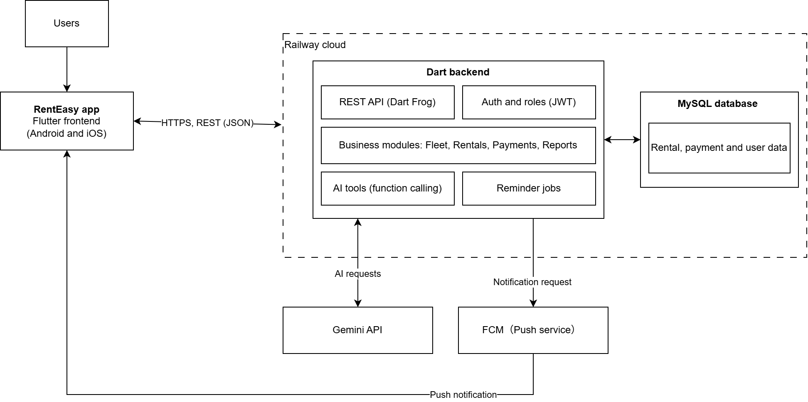
Figure 3: High-level System Architecture
Figure 3 shows the High-level system architecture of the RentEasy app. The app replaces the client’s current WhatsApp- and Excel-based record-keeping process. The owner and staff use it on Android or iOS. The app communicates over HTTPS with a Dart REST API backend. The backend manages login, roles, modules, AI tools and reminders, and MySQL stores the data. Both are hosted on Railway. For the AI assistant, the backend sends the question to the Gemini API, which selects a predefined function. The backend then retrieves relevant MySQL data, and the AI returns the natural-language answer. When a reminder is due, the backend requests FCM to send notification to the app.

5. Project Scope

5.1 In Scope / Out of Scope
In scope (will deliver this semester) | Out of scope (will not deliver)
iOS app for internal staff, and business owner | Standalone Customer Management module
Dashboard, Fleet, Rentals, Payments, and Maintenance and Reports for internal staff and management use | Online payment gateway
Dashboard: Overview of today’s rentals, returns, available vehicles, overdue rentals, outstanding and insurance expiry | Standalone Vehicle Inspection module
Fleet: Add, remove, view, and maintain vehicle records, models, information, service history and insurance details | Real-time GPS tracking inside the application
Rentals: Create rental records, select vehicles based on schedule availability, record customer details, pickup/return dates, outstation info, extra charges, and automatic rental amount calculation | Full customer-facing rental application
Payments: Record cash and bank transfers, customer deposits, refunds, outstanding balances, support a 3-day deposit checking period, and automatic total rental amount calculation | Complex POS system
Maintenance and Reports: Track vehicle maintenance, repairs, engine oil/tyre/brake/battery/AC upkeep, insurance/tax expiry, and generate daily to yearly financial and operational reports | Mileage-based automatic maintenance reminders
Automated reminders for vehicle delivery, return, deposit refunds, and insurance/road tax expiry | Advanced customer promotion and voucher functions
Staff-facing AI assistant/chatbot to query application data using natural language | Advanced AI customer auto-reply to integration/customer-facing automated communication systems
Should Have Features (if time permits): User management/permission controls, downloadable/exportable PDF/Excel reports, and PDF receipt generation
Table 6: Scope Boundary

5.2 Features and User Stories
FR-ID | Module | User story (As a … I want … so that …) | Priority
FR-01 | User Access | As a user, I want to log in securely so that I can access role-based features | Must
FR-02 | User Access | As an owner, I want to manage staff permissions so that I can control what individual users can view and edit | Should
FR-03 | Dashboard | As a staff, I want to view a daily dashboard so that I can monitor rentals, returns, available vehicles, overdue items, and outstanding payments immediately | Must
FR-04 | Dashboard | As an owner, I want to see insurance alerts so that I can ensure compliance without missing renewal dates | Must
FR-05 | Fleet | As a staff, I want to add, update, and remove vehicle records so that fleet data remain accurate and up to date | Must
FR-06 | Fleet | As a staff, I want to view the complete history and maintenance details for an individual vehicle so that I can monitor its usage and condition | Must
FR-07 | Rentals | As a staff, I want to check vehicle availability on a schedule calendar so that I can avoid double-booking | Must
FR-08 | Rentals | As a staff, I want to create a rental record with customer details, pickup/return dates, and outstation flags so that bookings are centralized | Must
FR-09 | Rentals | As a staff, I want to enter the rental price, apply discounts or other applicable charges, and automatically calculate the rental amount so that booking totals are precise | Must
FR-10 | Rentals | As a staff, I want automated delivery reminders so that handovers happened on time | Must
FR-11 | Payments | As a staff, I want to record cash and bank transfer payment, deposits, and refunds so that financial records are accurate | Must
FR-12 | Payments | As a staff, I want to automatically calculate payment totals so that billing is correct | Must
FR-13 | Payments | As a staff, I want to track the 3-day deposit check, so that refunds are issued safely | Must
FR-14 | Payments | As a staff, I want to generate PDF receipts so that customers get payment proof | Should
FR-15 | Maintenance and Reports | As a staff, I want to record vehicle repair, upkeep logs and insurance/road tax so that maintenance is tracked | Must
FR-16 | Maintenance and Reports | As an owner, I want financial summaries so that I can track business profitability | Must
FR-17 | Maintenance and Reports | As an owner, I want to export financial and operational reports in PDF or Excel format so that I can analyze data offline | Should
FR-18 | Maintenance and Reports | As an owner, I want to filter visual reporting charts by specific vehicle categories so that I can analyze fleet profitability by model | Could
FR-AI-01 | AI Assistant | As a staff, I want to query data using natural language so that I can look up info quickly | Must
Table 7: Features and User Stories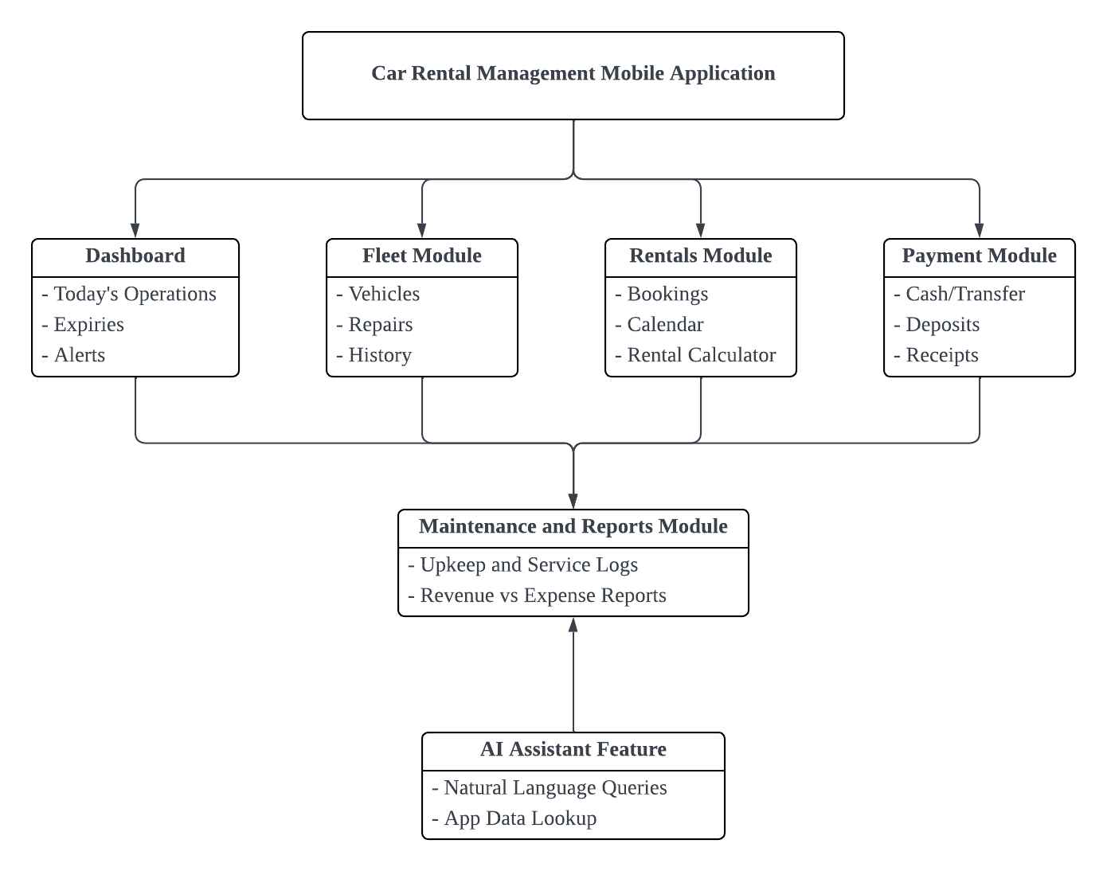
Figure 4: System Modules Diagram

5.3 AI Feature
RentEasy will include an AI-powered Assistant that allows the owner and staff to query vehicle availability, rental records and other relevant information using natural language. It uses Google Gemini API with Function Calling to understand user questions and request data from the MySQL through predefined backend functions. This reduces the need to navigate multiple screens and manually search records.
Item | Description
AI capability | Generative AI-powered Assistant with text and voice input.
User value | Helps solve P1 by allowing the business owner and staff to query vehicle availability and rental records without manually searching multiple records or screens.
Input → Output | Input: A natural language question typed or spoken by the business owner or staff. Voice input is converted into text. Output: An AI-generated answer based on relevant information queried from the application database.
AI service / API | Google Gemini API with Function Calling.
Constraints | - Requires an internet connection to access the cloud AI service.  - AI-generated responses may be inaccurate and should be verified when necessary.  - Retrieved information must follow user access permissions to protect confidential business data.
Table 8: AI Feature Summary

5.4 Non-Functional Requirements and Constraints
NFR-ID | Category | Requirement / constraint | Target
NFR-01 | Performance | The application should load screens and display existing records efficiently. | Main module screens load within 2 seconds under normal network conditions.
NFR-02 | Security | The system must protect confidential business data and prevent unauthorized access. | Require user login and automatically log them out after 15 minutes of inactivity.
NFR-03 | Usability | The interface should allow staff to manage rental information on mobile screens without excessive scrolling or difficult navigation. | At least 80% of test users should be able to complete core tasks successfully without assistance during usability testing.
NFR-04 | Reliability | The system must handle network failures, database errors, and AI API failures without crashing. | All defined failure test cases display an appropriate error message.
Table 9: Non-Functional Requirements and Constraints

5.5 System Environment
Layer | Technology / tool | Justification
Mobile app | Flutter (Dart 3) | Meets the course requirements and supports cross-platform mobile development for Android and IOS.
State management | Provider | Manages application state and shared data between screens.
Backend Framework | Dart Server with REST API | Handles business logic, validates requests, connects the mobile app to the database and provides controlled access to AI services.
Database | MySQL | Stores vehicle, rentals, payment, maintenance and report records.
Cloud Hosting | Railway | Hosts the backend and database in the cloud.
AI service | Gemini API with function Calling | Understand natural language questions and retrieves relevant information from the database.
Version control & CI | GitHub, GitHub Actions | Support collaborative development, branch management, pull requests and automated testing.
Target devices | Android and IOS smartphone | Supports the mobile access for the business owner and staff.
Table 10: System Environment

6. Task Allocation & Team Contribution
Member | TSPi role | Owned features (FR-IDs) | Other responsibilities / contribution
Joyce Lau Kai Xin | Team Leader | FR-15, FR-16 | Weekly meetings, WEEK reports
Lee Xing Ying | Development Manager | FR-05, FR06,  FR-AI-01 | Architecture, code review
Andrea Nguang Shi Ya | Planning Manager | FR-01, FR-02, FR-03, FR-04 | TASK / SCHEDULE, GitHub board
Jocelyn Lee Shuang Shuang | Quality/Process Manager | FR-11, FR-12, FR-13, FR-14 | LOGTEST, CI, coverage
Rionnalyn Richard | Support Manager | FR-07, FR-08, FR-09, FR-10 | Repo setup, LOGAI, tools
Joyce Lau Kai Xin | Client Liaison / Developer | FR-17, FR-18 | Client meetings, UAT
Table 11: Task Allocation and Contribution

7. Team Goals
No. | Team goal | Measure
G1 | Deliver a reliable RentEasy application covering the agreed Must-have features | All Must-have FRs pass; CI green on main before release
G2 | Complete each milestone with traceable engineering evidence | Deliverables meet course deadlines; requirements, GitHub issues/PRs, tests and TSP logs use consistent IDs
G3 | Ensure fair and active participation by all members | Every member owns at least one technical feature, updates assigned issues, and contributes code or a reviewed technical artefact in each sprint
G4 | Maintain client validation and responsible AI use | Seek client feedback at least once every two weeks where possible; record significant AI-assisted work in LOGAI and review/test it before merge
Table 12: Team Goals

8. Expected Results

8.1 Working System
The final deliverable is RentEasy, a Flutter app for the owner and staff of JC Construcars Company. Authorized users can view the dashboard, manage vehicle records and rental availability, create rental, record payments and deposits, track the three-day deposit-checking period, manage maintenance and insurance/road-tax info, and view financial and operational reports. A cloud-based Gemini Generative AI assistant will answer natural-language questions about permitted vehicle and rental data. The backend will validate requests and retrieve records; the AI cannot access the database directly. Release readiness requires the agreed Must-have requirements to pass acceptance tests, at least 50 test cases and 60% code coverage, a passing CI workflow, a reproducible release build and client acceptance.

8.2 Documentation and Artefacts
Deliverable | Submitted with
Project Proposal (original) | Proposal Submission (Week 4)
Revised Proposal and Software Requirements Specification (SRS) | Initial Report (Week 9)
Runnable prototype (4–5 screens), tagged release | Demo 1 (Week 9)
Software Design Specification (SDS), test plan and results (LOGTEST), user manual, maintenance plan, client acceptance form | Final Report (Week 13)
Release APK, demo video (5–10 min), presentation slides | Final Demo 2 (Week 14)
GitHub repository and complete project file | e-Archive (Week 15)
TSPi forms (LOGT, LOGD, LOGAI, SCHEDULE, SUMP, SUMQ, SUMS, SUMTASK, WEEK, PEER) and meeting minutes | Ongoing; compiled in Final Report
Table 13: Deliverables

9. Project Planning

9.1 Methodology
SpringTech will use an iterative Agile approach with two-week development cycles. At the start of each cycle, the team will prioritize user stories and create GitHub Issues with acceptance criteria. Developers will use feature branches, commit small changes, and submit Pull Requests for peer review. Changes will be merged after review and relevant automated checks pass. The Team Leader coordinates decisions and client contact, the Development Manager guides architecture and integration, the Planning Manager tracks tasks and milestones, the Quality/Process Manager leads testing and CI evidence, and the Support Manager meetings, the team will review completed work, blockers, risks and upcoming tasks, updating the relevant TSP logs. Client feedback will be sought regularly to validate requirements and adjust priorities without expanding the agreed scope

9.2 Submission Schedule
Phase | Deliverable | Week | Due
Phase 1: Planning & Development | Proposal Submission | 4 | 16 Oct 2026
 | Proposal Presentation | 5 | 19 – 23 Oct 2026
 | Initial Report | 9 | 16 Nov 2026
 | Demo 1 | 9 | 16 – 20 Nov 2026
Phase 2: Finalisation & Closure | Final Report | 13 | 24 Dec 2026
 | Final Demo 2 | 14 | 28 – 31 Dec 2026
 | e-Archive | 15 | Before 10 Jan 2027
Table 14: Submission Schedule

9.3 Development Milestones (GitHub)
Milestone | Week | Key output | Status
M1 – Scope & Requirements | 4 – 5 | GitHub repo, issue board, CI file; proposal and initial SRS in /docs | Planned
M2 – Design & Prototype | 9 | SDS draft, 4–5 screen prototype, green CI, v0.2.0 tag | Planned
M3 – Product & Verification | 13 | ≥50 tests, ≥60% coverage, AI feature working | Planned
M4 – Final Release & Acceptance | 15 | Release APK v1.0.0, client sign-off, e-Archive | Planned
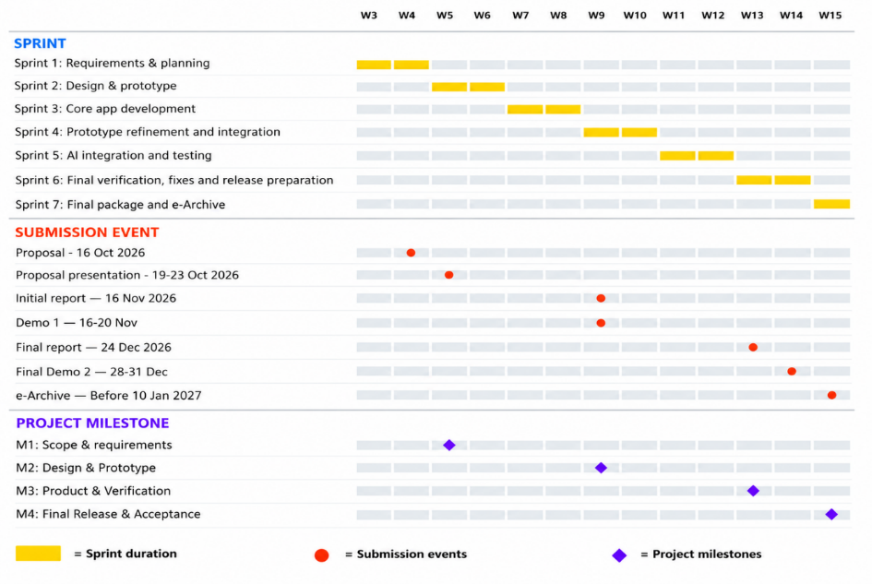
Table 15: Development Milestones

Figure 5: Gantt Chart

9.4 Risks and Assumptions
ID | Risk / assumption | Likelihood | Impact | Mitigation
R1 | Cloud hosting, database and AI API services may incur ongoing costs, which are paid by the client | Medium | High | Confirm expected usage and pricing with the client before deployment. Use free-tier services during development where suitable, monitor usage, and obtain client approval before enabling paid billing
R2 | Insufficient database backups may result in lost rental records | Medium | High | Set up scheduled database backups where supported; test the backup restoration process before handover
R3 | Limited backend and cloud experience may delay the project. The team must confirm whether Dart is allowed; Node.js or Python can be used as alternatives | High | High | Ask the lecturer about the backend choice early. Build a small prototype and use Node.js or Python if Dart is not approved or suitable
Table 16: Risks and Assumptions

10. References
GitHub. (n.d.). About pull requests. GitHub Docs. https://docs.github.com/en
Google. (n.d.-a). Firebase Cloud Messaging. Firebase.
https://firebase.google.com/docs/cloud-messaging
Humphrey, W. S. (1995). A discipline for software engineering. Addison-Wesley
Professional.
Humphrey, W. S. (2000). Introduction to the Team Software Process (TSPi). Addison
Wesley Professional.
JC Construcars Company. (2026). First client meeting requirements summary [Unpublished
project meeting notes].

Appendix A: Client Meeting Evidence

A.1 Client Meeting Summary
Meeting Date: 4 October 2026
Attendees: Mr. Jayvier (client), all team members
Key Discussion Points
- Current Business Process: The client currently uses multiple WhatsApp accounts, paper forms, and offline Excel spreadsheets to manage rental bookings, vehicle availability, customer deposits, payments, and maintenance records.
- Identified Problems: The existing manual process makes it difficult to track daily operations, maintain consistent records, monitor deposit refunds, and keep track of vehicle maintenance.
- Proposed Solution: The team proposed RentEasy, a Flutter mobile application that centralises rental management and vehicle information.
- Proposed Features: The application is intended to include a dashboard, fleet management, rental management, payment and deposit tracking, maintenance management, reminders, and operational reports.
- AI Feature: The team proposed an AI Fleet Assistant to allow authorised staff to ask natural-language questions about vehicle and rental information.
Evidence: 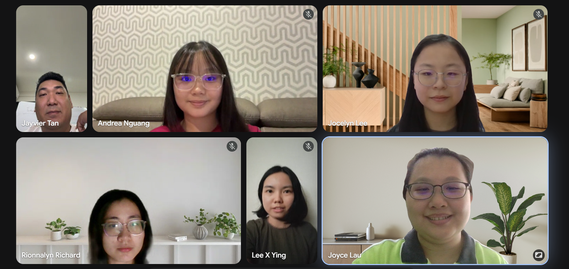
Figure 6: Photo of Client Meeting

Appendix B: Revision History
Version | Date | Changes (e.g. after proposal presentation feedback) | By
1.0 | 16 October 2026 | Initial version of the RentEasy project proposal, including project scope, objectives, team roles, expected results, methodology, schedule, milestones, risks, and references | SpringTech

