Laboratory Activity
Recursion
Objectives
At the end of this activity students are expected to:
- Identify the base case, recursive case, and state the change in recursive algorithm.
- Trace the execution of a recursive binary search algorithm.
- Implement a recursive binary search program that accepts user input.
- Modify a recursive function to display its execution trace.
- Explain how recursive calls return a value to the original caller.
- Understand and apply the three laws of recursion.
Background

There are many representation of recursion in art and nature. For example, fractal patterns are naturally recursive, the Russian Matryoshka dolls is a physical example of a recursion.

In Computing, Recursion is a fundamental technique in computer science, where a function invokes itself one or more times during execution, or by which a data structure relies upon smaller instances of the very same type of structure in its representation. It is an elegant ang powerful technique in performing repetitive tasks. Recursion does not simply repeat the same operation. Instead, a recursive function solves a problem by reducing it to a smaller version of the same problem until it reaches a condition that can be solved directly.

In designing a recursive algorithm, it must follow these 3 laws:

- A recursive algorithm must have a base case.
- A recursive algorithm must change its state and move toward the base case
- A recursive algorithm must call itself, recursively.

A classic recursive algorithm, binary search, is used to efficiently locate a target value within a sorted sequence of elements stored in an array. The binary search algorithm maintains two parameters, low and high, such that the candidate elements have indices from low through high. Initially, low = 0 and high = n - 1. The algorithm then determines the middle element using:

Standard formula;
Mid = [(low+high)/2]

The target value is then compared with array[mid]

Overflow-safe formula;

Mid = [low + (low + high)/2]
In Java, because low and high are integers, integer division is performed and any fractional part is discarded.

Consider the 3 cases:

- If the target is equals the median candidate, then we have found the item we are looking for, and the search terminates successfully.
- If the target is less than the median candidate, then we recur on the first half of the sequence, that is on the interval of indices from low to mid-1.
- If the target is greater than the median candidate, then we recur on the second half of the sequence, that is, on the interval of indices from mid + 1 to high.
An unsuccessful search occurs if low > high, as the interval [low,high] is empty.

Laboratory Activity
Specific Tasks:
Study the given program (In canvas LMS class, Midterm module text file named Binary Search), before proceeding with the tasks. Use the given program as the starting code for the following. Do not rewrite the algorithm from scratch unless instructed.
- In the given program, provide a recursion trace. Illustrate what is happening when the method is called. Recursion Trace: For each recursive call, record the values of low, high, mid, array[mid], and the action taken by the algorithm. Continue until the target is found or low > high.

A recursion trace closely mirrors a programming language’s execution of the recursion. You may use the same example shown in class or by using a table to illustrate. The use of any drawing tools or sites to illustrate the trace is allowed. Paste it below in the output section.

- Modify the given Java program for the Binary Search algorithm so that it accepts a user inputs:
  - the number of elements in the array
  - The elements of the array
  - and the “target value”
The program must perform the recursive binary search and display the array index of the target if it is found, if not, display -1. Screenshot the program and the output and paste it on the output section.
Binary search depends on a sorted sequence, array must be sorted in ascending order before search is performed.

- Modify the function in the program so that it displays the values of low, high, and mid during every recursive call. The trace must clearly show how the search interval becomes smaller after each recursive call.
Example output of the program(this is a fragment and not the whole output):
binarySearch(0, 9, 25)
binarySearch(0, 4, 25)
binarySearch(3, 4, 25)
binarySearch(4, 4, 25)

- Explain how to modify the recursive binary search algorithm so that it returns the index of the target in the sequence or -1 (If the target is not found). In your explanation, identify:
  - the base case that returns the index;
  - the base case that returns -1; and
  - how the recursive call passes its return value back to the previous call.
Note:
The following comment structure should be included in each program:
/* Description: <Describe what this program does briefly>
Programmed by: <your name> <course> <cn> <subject>
Last Modified: <date of latest revision>
Version: <version number>
[Acknowledgements: <list of sites and or sources, generative AI used and with the prompt>]
*/
Test cases:
Input | Expected Output | Your Output
Number of elements: 5  Array: 10 20 30 40 50  Target: 30 | Target found.  Index: 2 | Target found.  Index: 2
Number of elements: 8  Array: 5 10 15 20 25 30 35 40  Target: 10 | Target found.  Index: 1 | Target found.  Index: 1
Number of elements: 15  Array: 3 7 11 15 19 23 27 31 35 39 43 47 51 55 59  Target: 44 | Target not found.  Index: -1 | Target not found.  Index: -1
Number of elements: 1  Array: 25  Target: 10 | Target not found.  Index: -1 | Target not found.  Index: -1
Number of elements: 7  Array: 40 10 70 20 50 30 60  Target: 50 | Sorted array: 10 20 30 40 50 60 70  Target found.  Index: 4 | Target found.  Index: 4
Questions:
Instructions: When answering the questions use a different font color any color except white or something close to white.
1. What are the three laws of recursion? Briefly describe each law.
Base Case – The recursive function must have a stopping condition.
Change of State – Each recursive call must reduce the problem and move closer to the base case.
Recursive Call – The function must call itself to solve a smaller version of the same problem.
2. In the recursive binary search algorithm, what are the purposes of the variables low, high, and mid?
The Purpose of low, high, and mid
low – The starting index of the current search range.
high – The ending index of the current search range.
mid – The middle index used to compare the target with the array element.
3. What are the two conditions that can cause the recursive binary search to stop? Explain what happens in each condition.
Two stopping conditions
- Target found: When array[mid] == target, the function returns the index.
- Target not found: When low > high, the search interval is empty and the function returns -1.

4. Why must the array be sorted before performing binary search? What could happen if an unsorted array is provided?
Binary search removes half of the search space based on ordering. If the array is unsorted, it may search the wrong half and produce incorrect results.
5. In Java, what is the difference between an array's index and its position? Give an example using the following array: { 10, 20, 30, 40, 50 }
Value | Position | Index
10 | 1st | 0
20 | 2nd | 1
30 | 3rd | 2
40 | 4th | 3
50 | 5th | 4
6. A student modifies the recursive binary search program but accidentally writes the recursive call without changing low or high. Explain why this can cause a program to repeatedly call itself without reaching the base case. Which of the three laws has been violated?
If low and high never change, the function repeatedly calls itself with the same values and never reaches the base case. This violates the second law of recursion (change of state).

8. A student claims that: “binary search is better than linear search because binary search checks fewer elements.” Do you agree or disagree? Evaluate the statement and explain at least one situation where linear search may be more appropriate than a binary search.
I agree only when the array is sorted. Linear search is better for small or unsorted arrays because it does not require sorting.
9. The program works correctly when the user enters a sorted array, but produces incorrect results when the user enters an unsorted array.
What happens when the user enters an unsorted array, and how would you modify the program to address the problem?
The program may return the wrong answer. I would implement automatic sorting using Arrays.sort() before searching because it is simple and reliable.
In your answer, consider the following possible approaches:
- require the user to enter the array in sorted order;
- automatically sort the array before searching; or
- use a different searching algorithm.
Identify the approach you would implement and justify your choice.
10. How could you modify the program to automatically sort an unsorted array before performing binary search? What additional problem must you consider if the program is required to return the original index of the target?
Store each value together with its original index (for example, using an object or pair), sort by value, then return the saved original index instead of the sorted position.
11. Recursion can make a program shorter, but it can also make program execution harder to visualize. Based on this activity, when do you think recursion is an appropriate solution to a programming problem, and when might an iterative solution be preferable? Explain your reasoning.
Recursion is appropriate when a problem naturally breaks into smaller subproblems, such as binary search or tree traversal. Iteration is preferable when memory efficiency and simpler execution are more important.

OUTPUT
Task 1 – Recursion Trace
Paste your recursion trace here.
Given program values:
Array = {10, 20, 30, 40, 50, 60, 70}
Target = 50
Recursion Trace Table
Recursive Call | low | high | mid | array[mid] | Action
bSearch(arr,50,0,6) | 0 | 6 | 3 | 40 | Target is greater → search right half
bSearch(arr,50,4,6) | 4 | 6 | 5 | 60 | Target is smaller → search left half
bSearch(arr,50,4,4) | 4 | 4 | 4 | 50 | Target found → return index 4

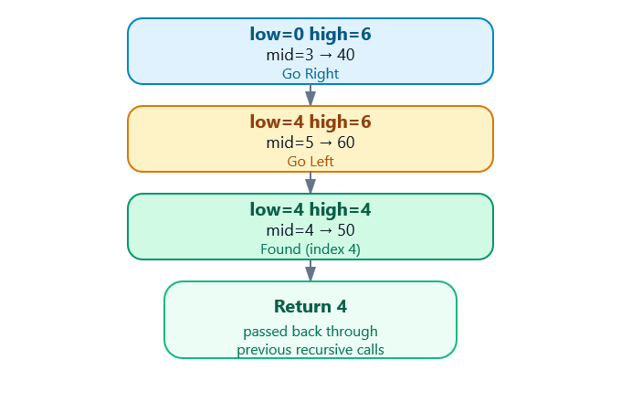

Result: Target 50 is found at index 4.
Task 2 – Modified Binary Search Program
Paste:
- Screenshot of your source code
- Screenshot of a successful search
- Screenshot of an unsuccessful search
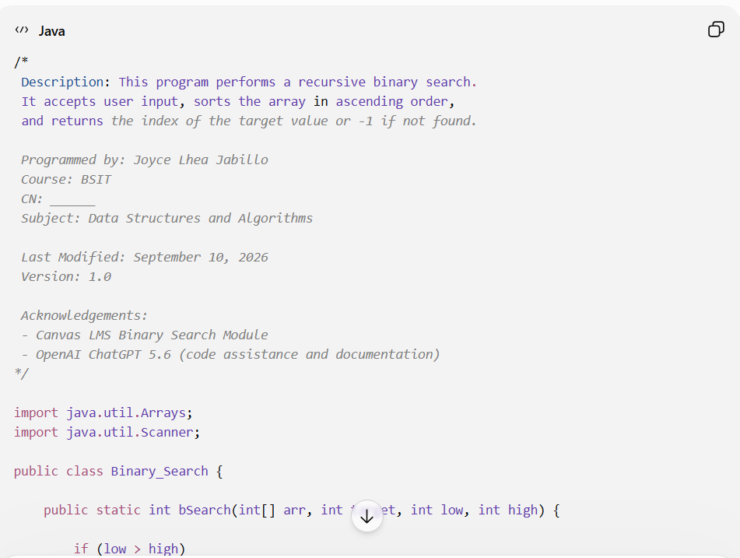
source code
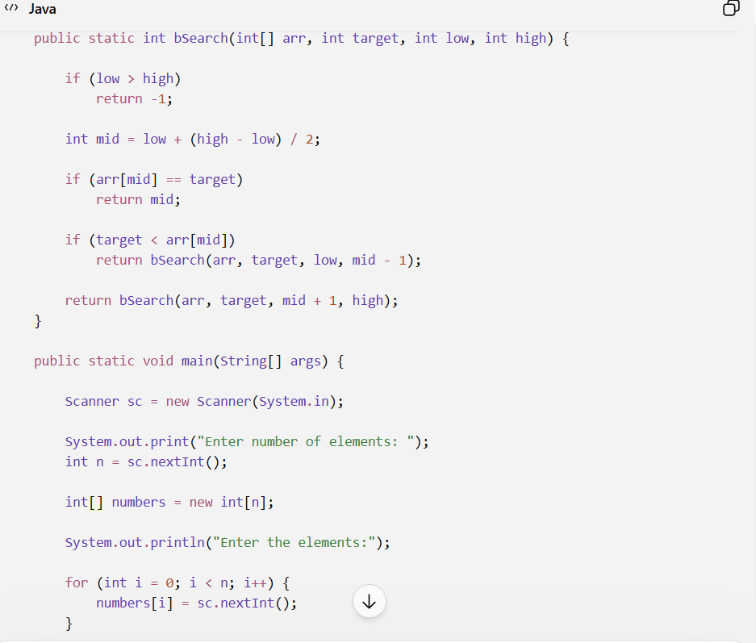

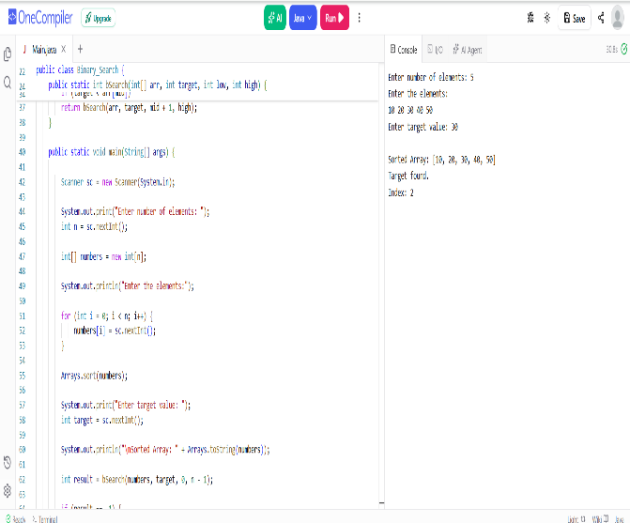
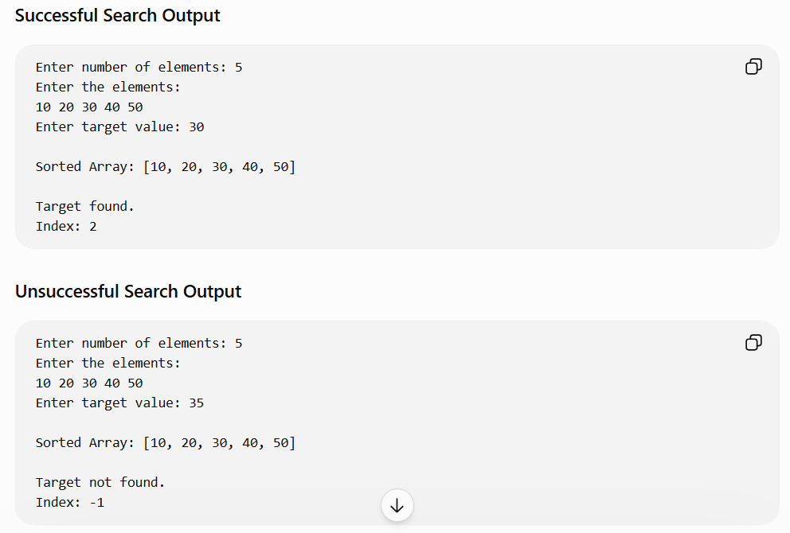
successful search

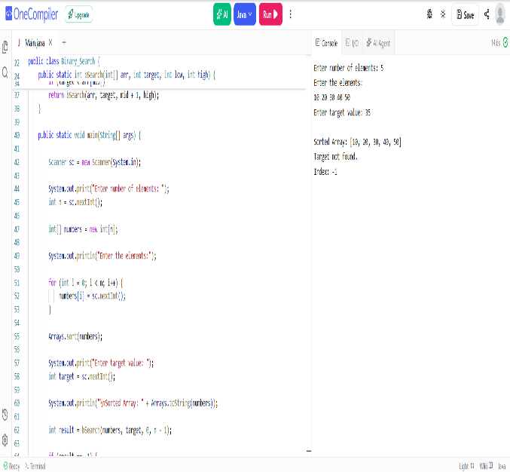
unsuccessful search

Task 3 – Search Trace
Paste:
- Screenshot of your modified source code
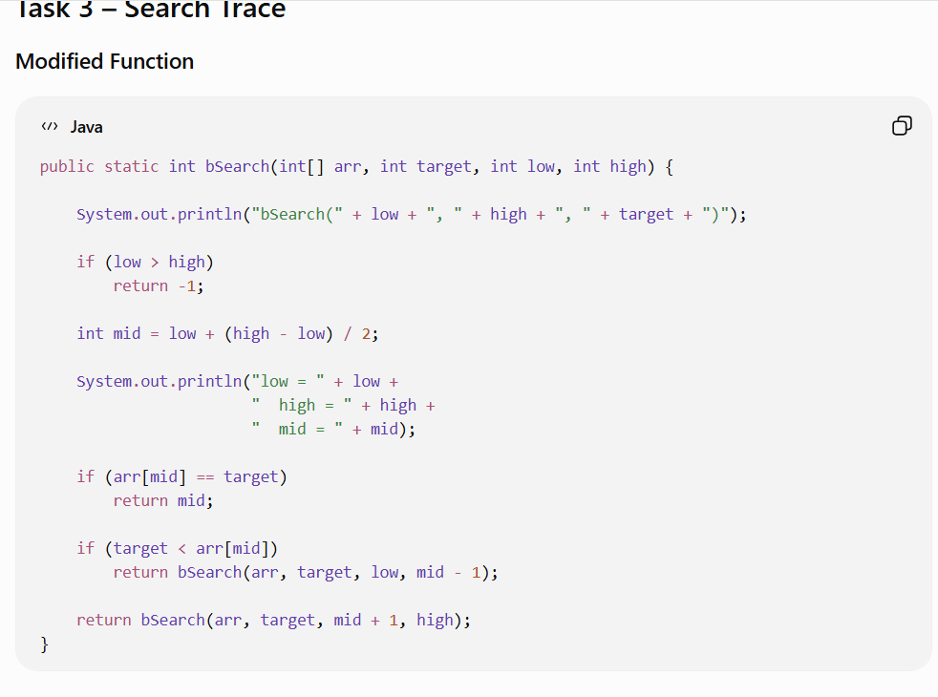
- Screenshot of the program displaying the recursive search trace
modified source code

program displaying the recursive search trace
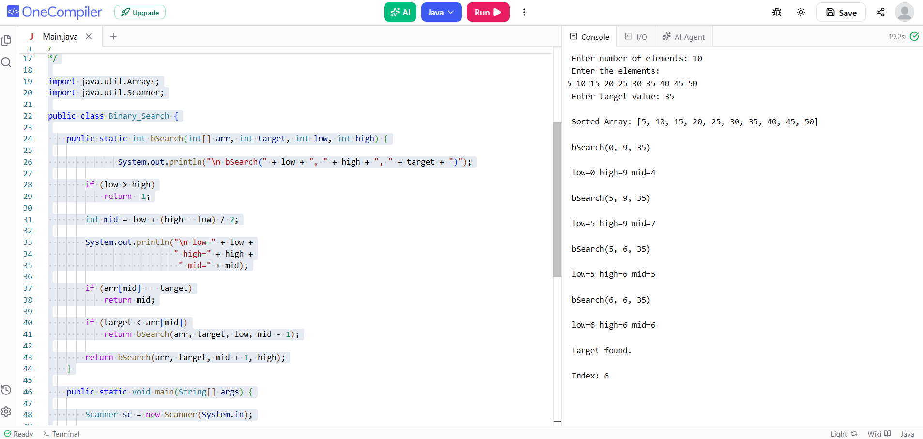

Task 4 – Explanation
Write your explanation here.
The recursive binary search returns either the index of the target or -1 if the target is not found.
1. Base case that returns the index
-When the middle element is equal to the target, the function immediately returns the index.
2. Base case that returns -1
-When low becomes greater than high, the search interval is empty.
3. How the return value is passed back
-The recursive calls use the return keyword.
-When a deeper recursive call returns an index (or -1), that value is passed back through every previous call until it reaches the main() method.

AI DISCLOSURE STATEMENT:
- AI Tool Used: OpenAI ChatGPT 5.6
- Task Performed: Assisted in modifying the Java program, preparing the recursion trace, explanations, and documentation.
- Extent of use: Substantial drafting and formatting.
- Human Verification: I reviewed and verified the program and answers before submission.
- Why and how was AI used in this activity? : To help understand recursion, generate the required modifications, and organize the laboratory activity.
- Estimated Percentage of Work Assisted by AI: Approximately 40%.
- What are the changes you made to the AI-generated output?: Reviewed the code, adjusted formatting, and ensured it followed the instructor’s template.
- What have you learned from using the tool?: I learned how recursive binary search uses base cases, reduces the search interval, and returns values through recursive calls.
Important: You are responsible for understanding and being able to explain every part of your submitted program.

