Table of contents

1. Introduction

1.1 Purpose

1.2 Scope

1.3 Document Outline

1.4 Glossary

1. General Description

2.1 Product / System Functions

2.2 User Characteristics and Objectives

2.3 Operational Scenarios

2.4 Constraints

1. Functional Requirements
2. System Architecture
3. High Level Design
4. Preliminary Schedule

6.1 GANTT Graph

1. Appendices

1. Introduction

## 1.1 Purpose

This document contains the system requirements and analysis of our Social Distancing App. Its purpose is to serve as reference for the system design; and its intended audience are system designers, project coordinator, project supervisor and the CA326 module demonstration panel.

## 1.2 Scope

The goal of this project development is to create an effective Social Distancing Application in association with a coherent analysis of the data.

The application will involve the use of Bluetooth and GPS in tandem to measure the distance between event attendees and ensure that a minimum distance of 2 meters is maintained and respected.

The app will persistently send out Bluetooth pings to others devices and measure the round trip time. While the GPS coordinates will be used to calculate the distance between a users device and another user's device. Should the timing of the round trip fall below a certain threshold indicated within the app, a user will be notified that social distancing measures are not being adhered to and will recommend the user to move at least 2 metres from the user which is within their bubble.

While the users movement will be tracked and monitored, the application will also record any contacts the user may have made during their time at the event to sustain an effective backtracking contact trace. Concise analytics can be made on the data recorded by the application to provide an analysis of the event, and the possible breaches of social distancing guidelines that may initiate a spreader event.

The mobile application will feature a clean and accessible interface for Users, the application will run in the background and will allow a user to run and use any other application on their mobile device with ease. A User may pair up with others users to include them in their social bubble which will avoid any unnecessary calls to recommend a user to move away from their paired user.

## 1.3 Document Outline

Section 2, provides an overview of the purpose of the Contact Tracing App and a non-technical description of the functions which it should be capable of doing once complete.

Section 3, involves the Functional Requirements of the application. It gives a broad description of the various requirements that the application should support and their priority in the design process.

Section 4, displays a diagram of the system architecture of the application.

Section 5, displays diagrams of the high level design involved in the application.

Section 6, involves the creation and maintenance of a GANTT Chart which displays and outlines a preliminary schedule of our tasks between now and the project deadline. It is subject to change based on delays, new features or being ahead of schedule.

## 1.4 Glossary

**Bluetooth:**

Bluetooth is a wireless technology standard used for exchanging data between fixed and mobile devices over short distances using UHF radio waves. It is a standard for the short-range wireless interconnection of mobile phones and other electronic devices.

**GPS:**

Global Positioning System (GPS) is an accurate worldwide navigational and surveying facility based on the reception of signals from an array of orbiting satellites.

**Social Bubble:**

A term describing the social distance area of a person, a person may include others within their social bubble should the circumstances permit, its size is commonly recommended to be at least 2 Metres.

**Contact Tracing:**

Contact tracing identifies people who were in close contact with someone who has COVID-19 (coronavirus). It is done to try to reduce the spread of COVID-19 in the community. Our app will assist in doing the same.

**Super Spreader:**

A super spreader is an individual at high risk, in a populated environment that has come in contact with quite a lot of people. It has been determined that super spreaders make up about 1 in 5 individuals and cause 80% of the spread rate.

2. General Description

## 2.1 Product / System Functions

Mobile technology to support contact tracing was first used in Singapore. The ‘Trace Together’ app used there is downloaded voluntarily and collects data, via Bluetooth, on which other devices have been in close proximity with the user’s device. If a user tests positive for COVID-19, the app enables at-risk individuals to be informed about what to do. Like that app, we’ve taken influence to create an app to track via Bluetooth and GPS and provide concise data on the findings.

The app has two main functions:

1. To be used as a research tool for the analysis of sample data taken from the app itself to monitor the possible spread of COVID-19 among individuals using the app and also to monitor the obedience of the user base to abide by local COVID restrictions and recommendations. The data collected can be displayed graphically to demonstrate possible super spreaders and the accuracy of the app.
2. To be used as a precautionary application at events to monitor the location of an individual in respect to another person based on COVID 19 regulations. Should a person be possibly exposed to COVID-19 they will be notified immediately and provided a set of recommendations that they should follow to get the best possible result in avoiding catching the virus.

## 2.2 User Characteristics and Objectives

A user is not expected to require any extreme expertise when using our application. They are expected to be able to download and install the application from the android app store. Upon opening the application, they will be prompted to provide basic information on themselves and to allow access to notify the user when necessary.

A user should be able to navigate the application with ease, and if necessary, also pair up with any individuals they would consider within their social bubble.

A user can access their location history and monitor any possible breaches of COVID regulations within their bubble, that they should be aware about.

A user may also view their health history of events in the past that may be a culprit to a possible COVID case. A user is recommended but not required to update their health history regularly. Should a user feel any symptoms of COVID it is with great hope that they record this within the daily log and should a test return back positive it is advised that they immediately record this within the app so that all individuals that have been within the users proximity are properly notified.

## 2.3 Operational Scenarios

Use Case 1 - User opens the application for the first time

When entering the application for the first time, a user is prompted to allow the application to send notifications when necessary. Should the user accept, a form will be displayed for the user to fill out some basic information, which includes their name, email, phone number and area of residence. Having accepted the terms and conditions of the application, the users account will be created and redirected to the homepage.

Use Case 2 - User opens the application

When entering the application, the user is greeted by the homepage, however, if it is the first log in of the day, the user will be prompted to enter their current health state and include anything else they may feel like disclosing. Having completed this, the prompt will close, and the user may navigate the home page which will allow access to the rest of the application including news, health history, pairing, events and settings.

Use Case 3 - User contracts COVID-19

The user, when in immediate knowledge of having the virus should update their health history as soon as possible within the application, the health section can be navigated via the homepage or will be prompted if it is the first time they have used the application that day. Upon confirmation of the user being a COVID-19 Patient, all users who have come into close contact with the user will be immediately notified via text and in-app, they will be recommended to follow the guidelines set out by the national government.

Use Case 4 - User views News page

The user decides to view the news page of the application from the navigation bar. This will redirect them to a brand-new part of the application which will display graphed details of COVID-19 in its current state, allowing for filtering to display data from a previous period in time. It will also feature a scrollable news feed which will display health info, news updates and anything important related to COVID-19.

Use Case 5 - Pairing up with a friend

A user is attending an event and accesses the app, they choose Pairing from the navigation bar. This page will display a list of instructions to pair with another User. This will involve a Bluetooth connection from one device to another device to allow communication, a user may select another user via the available user’s interface or manually type in their friends account id to connect. Once the connection has been established, they will be able to move about within one another social bubble with ease. Should a user want to remove a connection they should access the pairing page like before and press the x button beside the user they would like to disconnect from.

## 2.4 Constraints

Lists general constraints placed upon the design team, including speed requirements, industry protocols, hardware platforms, and so forth.

Time Constraints:

The project team may face time constraints during the project development process. The deadline of the final product is the 12th of March 2021. Between now and then a functional prototype/predictive application and substantial analysis on data collected from up on till that period will also be required to be finished in time.

Working with unfamiliar software:

The project will also involve us as a team learning to use unfamiliar software that we have not had the chance of experiencing during our college work and extracurricular activities. As such there will need to be an equal balance between learning and developing as we go along, this will involve planning ahead.

User Requirements:

Will we be able to understand and meet the needs of the end users’ requirements?

for the application within the time frame.

Users will require an android phone, as we do not plan to develop an application for iOS and other mobile phone platforms.

Users will require internet access in order to use the app, and access to Bluetooth and GPS.

The application will rely on user’s honesty on the basis that if a user did test positive for COVID they would follow the proper measures and report that they have COVID so that other users may be informed.

## 

## 

## 

## 

## 3. Functional Requirements

1. The application will notify the user of any breaches of social distancing guidelines

a. *Description* – Using Bluetooth Low Energy (BLE) and GPS tracking, the app will measure the distance between users and notify them when they are within ~2 metres of one another.

b. *Criticality* – Extreme

c. *Technical Issues* – The app will need to utilise BLE and GPS in tandem to send out pings to nearby devices and subsequently measure the round-trip time. The accuracy of this measurement will be imperative.

d. *Risk* – Moderate – Given the criticality of this feature it is important that it is reliable and accurate. The dependency on BLE and GPS also slightly increase the risk.

e. *Dependencies* - None

2. Data will be collected from users and stored for research purposes.

a. *Description* – User data will be obtained and stored in a database. This will include location data, social distancing breaches and COVID cases. The data should be in a form which is conducive to evaluation and graphing.

b. *Criticality* – High

c. *Technical Issues* – Data should be sent to the database in a timely fashion and should be reliable in order to ensure that any subsequent conclusions drawn from this sample data are well founded.

d. *Risks* – Low – This aspect of the implementation should be relatively straightforward and low risk as long as the communication established between the app and the database is reliable.

e. *Dependencies* - 1

3. The user may link with another user within their bubble.

a. *Description* – When two users are attending an event together and are within the same social bubble, functionality will exist to allow these two users to connect their devices so that social distancing notifications are not sent when they are within 2 metres of one another.

b. *Criticality* – Normal

c. *Technical Issues* – Users may need unique identifiers which will be returned when receiving a Bluetooth ping. This will identify the user as being within a social bubble. Transmission of this identifier over Bluetooth will be critical to the success of this feature.

d. *Risks* – Moderate – Ensuring that one user’s instance of an app can identify another’s will be a challenge to implement.

e. *Dependencies* – 1

4. Any possible COVID exposures will be communicated to the user as quickly as possible.

a. *Description* – When a user has tested positive and entered this into the app, immediately the database will be utilised to find others who were within close proximity. These users will be notified of a potential close contact.

b. *Criticality* – Extreme

c. *Technical Issues* – A user’s COVID positive input will begin the process of tracing others at risk.

d. *Risks* – Low – Contact tracing should not pose any risks. With sufficient data collection it will be possible to trace any user’s interactions.

e. *Dependencies* – 1,2

5. Upon first downloading and opening the app, a form will be displayed.

a. *Description* – A form will be displayed requiring permission to send push notifications and subsequently asking for user’s details such as name, email, address etc.

b. *Criticality* – High

c. *Technical Issues* – User interaction with form, storing user data.

d. *Risks* – Low – Push notification permissions and user input should not pose an issue.

e. *Dependencies* – None

## 

## 4. System Architecture

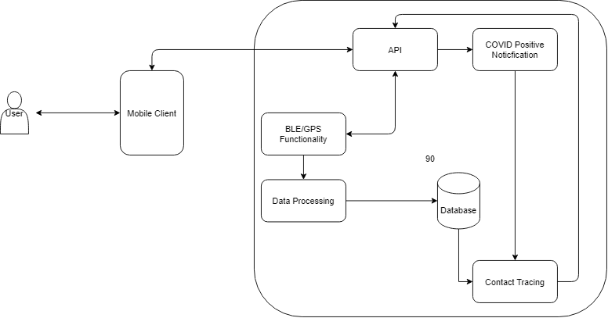

## 5. High-Level Design

Establishing Connection: User opens the application which will redirect them to the homepage, from there they will be prompted to enter health data or submit a request for data on themselves.

User Arguments: The user will be able to submit queries to the database via the application, this can be done by selecting the data they would like such as news, health history and location history.

Receiving Data: The database will log any data submitted to it via the application from a user, all data will be unique and identifiable through a user’s ID.

Returning Data: The database will return back requested data on the queried subject to the application, which will then display the requested information in a formatted form within the application for the user.

Below is a diagram depicting the process:

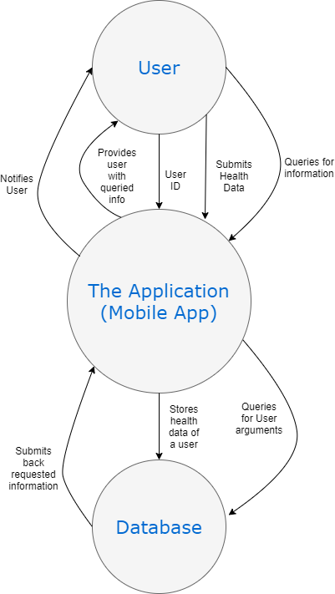

## 6. Preliminary Schedule

The GANTT Chart of our preliminary schedule is displayed below, which was made using draw.io. The chart displays an approximate list of tasks that us as a team will hope to accomplish and dates at which we plan to begin and the date we hope to complete each task by. The tasks are subject to change, and should we be ahead of schedule or behind, necessary changes will be made to amend any of these events. Including the addition of any new features we wish to implement within that time as well.

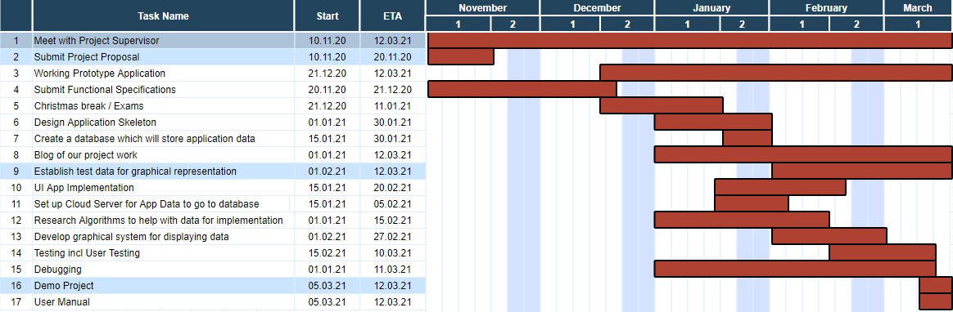

## 7. Appendices

*Ray Walshe Functional Requirements spec:*

<https://www.computing.dcu.ie/~ray/ca326/fspecRV.html>

*Influence and Inspiration was taken from the following documentation:*

<https://labs.ripe.net/Members/becha/ten-requirements-for-the-evaluation-of-contact-tracing-apps>

*Graphs created with draw.io:*

[*https://app.diagrams.net/*](https://app.diagrams.net/)