
Dear Sir/Madam,
RE: Bulk SMS Alphanumeric ID Letter of Authorization
We the undersigned duly authorize Onfon Media to transfer alphanumeric BEAMSMS with the following Mobile Network Operator (s) Safaricom.

Yours sincerely Signature:
Name: SAMUEL MACHARIA
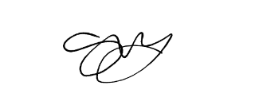 Title: DIRECTOR
Company Stamp/Seal

