Assignment No. 02

Name: Joyce Joseph
Roll No.: BI30

Problem Statement:
To develop any distributed application using CORBA to demonstrate object brokering. (Calculator or String operations).

Tools / Environment:
Java Programming Environment, JDK 1.8

Theory:
The process of writing and implementing the solution, along with the steps required to execute it, is detailed below:

Writing the Implementation:
The initial step involves writing the IDL interface and generating the corresponding Java interface, along with support classes such as the client stub and server skeleton. Following this, concrete server-side implementations for all interface methods need to be developed.

Implementing the Solution:
For demonstration purposes, the "Hello World" Example is employed. This necessitates creating a directory named hello/ for developing sample applications and creating the requisite files within this directory.

Defining the Interface (Hello.idl):
To create a CORBA application, the first task is to specify all objects and their interfaces using the OMG's Interface Definition Language (IDL). Subsequently, server (HelloServer.java) and client (HelloClient.java) implementations are provided to complete the application.

Implementing the Server (HelloServer.java):
The server comprises two main classes: the servant and the server itself. The servant, HelloImpl, serves as the implementation of the Hello IDL interface, with each Hello instance being implemented by a corresponding HelloImpl instance. The servant encompasses methods for each IDL operation, such as sayHello() and shutdown(). The HelloServer class encompasses the server's main() method, which handles initialization, creation of servant instances, and registration of objects in the naming context.

Implementing the Client Application (HelloClient.java):
The client application initializes an Object Request Broker (ORB), obtains a reference to the root naming context, looks up "Hello" in the naming context, and subsequently invokes the object's sayHello() and shutdown() operations.

Building and Executing the Solution:
The Hello World program facilitates learning and experimentation with tasks essential for developing almost any CORBA program using static invocation. This approach employs a client stub for invocation and a server skeleton for the service, applicable when the object's interface is known at compile time.

To run this client-server application on the development machine:
1. Navigate to the directory containing the file Hello.idl.
2. Execute the IDL-to-Java compiler, idlj, on the IDL file to generate stubs and skeletons, ensuring that the path to the java/bin directory is included in the system's path variable.

These outlined steps generate the necessary files for the application, including server-side bindings, client stubs, and skeletons, facilitating the compilation and execution of the solution.

Code:
ReverseModule.idl
module ReverseModule
{
interface Reverse
{
string reverse_string(in string str);
};
};

ReverseClient.java
// client

import ReverseModule.*;

import org.omg.CosNaming.*;

import org.omg.CosNaming.NamingContextPackage.*;

import org.omg. CORBA.*;

import java.io.*;

class ReverseClient

{

public static void main(String args[])

{

Reverse ReverseImpl=null;

try

{

// initialize the ORB

org.omg.CORBA.ORB orb = org.omg.CORBA.ORB.init(args, null);

org.omg.CORBA.Object objRef = orb.resolve_initial_references ("NameService");

NamingContextExt ncRef = NamingContextExtHelper.narrow (objRef);

String name = "Reverse";

ReverseImpl = ReverseHelper.narrow(ncRef.resolve_str(name));

System.out.println("Enter String=");

BufferedReader br = new BufferedReader(new InputStreamReader(System.in));

String str = br.readLine();

String tempStr = ReverseImpl.reverse_string(str);

System.out.println(tempStr);

}

catch (Exception e)

{

e.printStackTrace();

}

}

}

ReverseImpl.java

import ReverseModule.ReversePOA;

import java.lang.String;

class ReverseImpl extends ReversePOA

{

ReverseImpl()

{

super();

System.out.println("Reverse Object Created");

}

public String reverse_string(String name)

{

StringBuffer str=new StringBuffer(name);

str.reverse();

return (("Server Send "+str));

}

}

ReverseServer.java

import ReverseModule.*;

import org.omg.CosNaming.*;

import org.omg.CosNaming.NamingContextPackage.*;

import org.omg.CORBA.*;

import org.omg.PortableServer.*;

class ReverseServer

{

public static void main(String[] args)

{

try

{ // initialize the ORB

org.omg.CORBA. ORB orb = org.omg.CORBA.ORB.init(args, null);

// initialize the BOA/POA

POA rootPOA = POAHelper.narrow(orb.resolve_initial_references("RootPOA"));

rootPOA.the_POAManager().activate();

// creating the calculator object

ReverseImpl rvr = new ReverseImpl();

// get the object reference from the servant class

org.omg.CORBA.Object ref = rootPOA.servant_to_reference(rvr);

System.out.println("Step1");

Reverse h_ref = ReverseModule.ReverseHelper.narrow(ref);

System.out.println("Step2");

org.omg.CORBA.Object objRef = orb.resolve_initial_references("NameService");

System.out.println("Step3");

NamingContextExt ncRef = NamingContextExtHelper.narrow(objRef);

System.out.println("Step4");

String name = "Reverse";

NameComponent path[] = ncRef.to_name(name);

ncRef.rebind(path,h_ref);

System.out.println("Reverse Server reading and waiting....");

orb.run();

}

catch (Exception e)

{

e.printStackTrace();

}

}

}

Output:

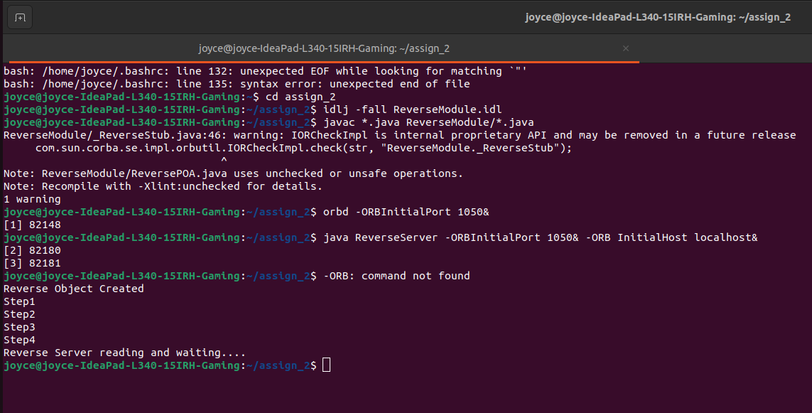

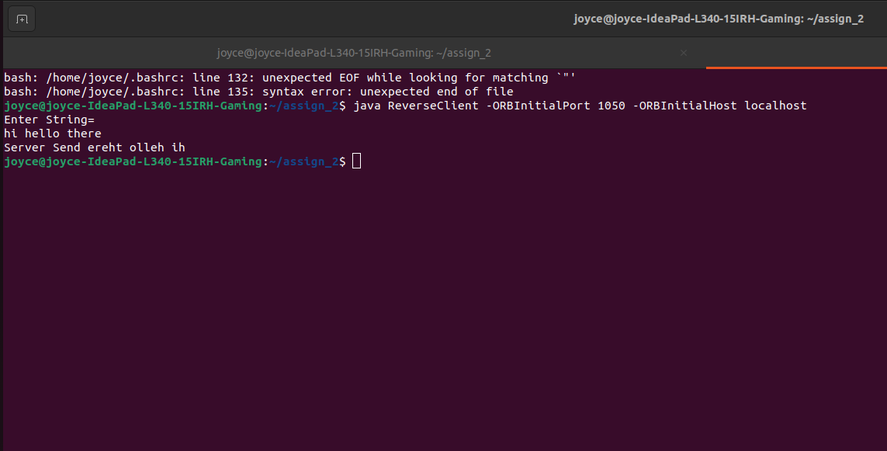
Conclusion:
The process described offers a detailed guide for developing a CORBA application using Java, exemplified through the "Hello World" demonstration. By initially defining interfaces in IDL and generating corresponding Java code, followed by implementing server and client components, developers can construct an efficient distributed system. This approach capitalizes on CORBA's network transparency and Java's implementation transparency, creating a powerful framework for building scalable applications. Through the integration of these technologies, developers gain the capability to create versatile and efficient distributed systems, enhancing their proficiency in distributed computing.

