Assignment No. 03

Name: Joyce Joseph
Roll No.: BI30

Problem Statement:
Develop a distributed system, to find sum of N elements in an array by distributing N/n elements to n number of processors MPI or OpenMP. Demonstrate by displaying the intermediate sums calculated at different processors.

Tools / Environment:
Java Programming Environment, JDK1.8 or higher, MPI Library (mpi.jar), MPJ Express
(mpj.jar)

Theory:
Message passing is a widely recognized technique for implementing parallelism in applications, often referred to as MPI. The MPI interface in Java offers a method for identifying users and reducing startup overhead, facilitating collective communication across shared memory and distributed systems. MPJ is a prominent Java API for implementing MPI, with mpiJava serving as a flexible Java binding for MPJ standards. Currently, developers can create more efficient parallel applications using message passing.

Java provides various pre-built communication packages, such as BSD sockets and Remote Method Invocation (RMI), essential for good communication API. The parallel computing domain primarily focuses on symmetric communication, which involves groups of interacting peers. This symmetric communication model is embodied in the Message Passing Interface standard (MPI).

MPI programs require certain basic elements, such as including the MPI header file and initializing the MPI execution environment using MPI_Init. Each MPI process operates independently in a "share nothing" manner, unaffected by the results of other processes. However, to enable interaction between processes, communicators are essential. MPI allows the creation of multiple communicators within a program, each with its own set of processes. The "MPI_COMM_WORLD" communicator encompasses all concurrent processes within an MPI program.
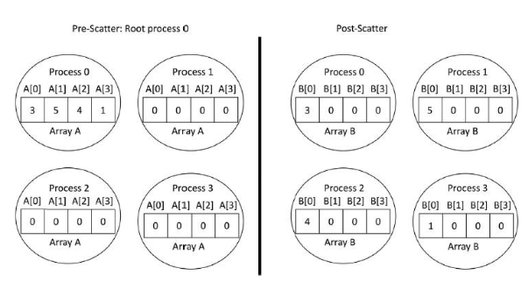
The size of a communicator denotes the number of processes it contains. MPI_Comm_size function retrieves the size of a communicator, while MPI_Comm_rank determines the unique rank of each process within the communicator.

Message passing involves sending and receiving data between processes. MPI_Send transmits data from a source process to a destination process, while MPI_Recv receives data from a source process. Communication collective operations expand interprocess communication to include n-way or all-way data exchanges.

MPJ Express is an open-source Java message passing library designed for parallel applications on multicore processors and compute clusters/clouds. It follows the Single
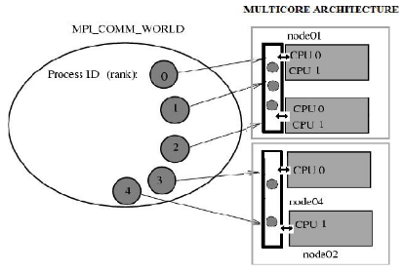
Program Multiple Data (SPMD) programming model and supports communication between individual processors of clusters.
When designing the solution, considerations are made for multi-core architectures, and the MPI program executes based on the supplied processes and available processor cores. Implementation involves installing MPJ Express, writing the parallel Java program, compiling it, and running it in a multi-core configuration. There is substantial interest in parallel programming using Java, facilitated by MPI bindings like mpj, which support multicore architecture, enabling development and execution of parallel programs on personal computers.

Code:
#include <mpi.h>
#include <stdio.h>
#include <stdlib.h>
#include <unistd.h>

// size of array
#define n 10

int a[] = { 1, 2, 3, 4, 5, 6, 7, 8, 9, 10 };

// Temporary array for slave process
int a2[1000];

int main(int argc, char* argv[])
{

int pid, np,
elements_per_process,
n_elements_recieved;
// np -> no. of processes
// pid -> process id

MPI_Status status;

// Creation of parallel processes
MPI_Init(&argc, &argv);

// find out process ID,
// and how many processes were started
MPI_Comm_rank(MPI_COMM_WORLD, &pid);
MPI_Comm_size(MPI_COMM_WORLD, &np);

// master process
if (pid == 0) {
int index, i;
elements_per_process = n / np;

// check if more than 1 processes are run
if (np > 1) {
// distributes the portion of array
// to child processes to calculate
// their partial sums
for (i = 1; i < np - 1; i++) {
index = i * elements_per_process;

MPI_Send(&elements_per_process,
1, MPI_INT, i, 0,
MPI_COMM_WORLD);
MPI_Send(&a[index],
elements_per_process,
MPI_INT, i, 0,
MPI_COMM_WORLD);
}

// last process adds remaining elements
index = i * elements_per_process;
int elements_left = n - index;

MPI_Send(&elements_left,
1, MPI_INT,
i, 0,
MPI_COMM_WORLD);
MPI_Send(&a[index],
elements_left,
MPI_INT, i, 0,
MPI_COMM_WORLD);
}

// master process add its own sub array
int sum = 0;
for (i = 0; i < elements_per_process; i++)
sum += a[i];

// collects partial sums from other processes
int tmp;
for (i = 1; i < np; i++) {
MPI_Recv(&tmp, 1, MPI_INT,
MPI_ANY_SOURCE, 0,
MPI_COMM_WORLD,
&status);
int sender = status.MPI_SOURCE;

sum += tmp;
}

// prints the final sum of array
printf("Sum of array is : %d\n", sum);
}
// slave processes
else {
MPI_Recv(&n_elements_recieved,
1, MPI_INT, 0, 0,
MPI_COMM_WORLD,
&status);

// stores the received array segment
// in local array a2
MPI_Recv(&a2, n_elements_recieved,
MPI_INT, 0, 0,
MPI_COMM_WORLD,
&status);

// calculates its partial sum
int partial_sum = 0;
for (int i = 0; i < n_elements_recieved; i++)
partial_sum += a2[i];

// sends the partial sum to the root process
MPI_Send(&partial_sum, 1, MPI_INT,
0, 0, MPI_COMM_WORLD);
}

// cleans up all MPI state before exit of process
MPI_Finalize();

return 0;
}

Output:

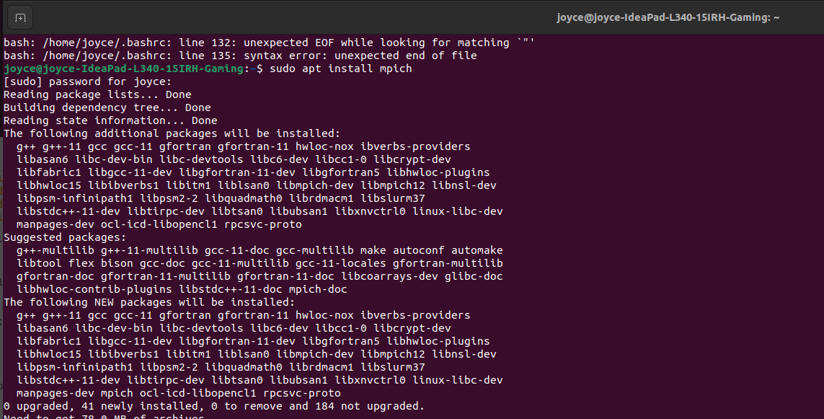
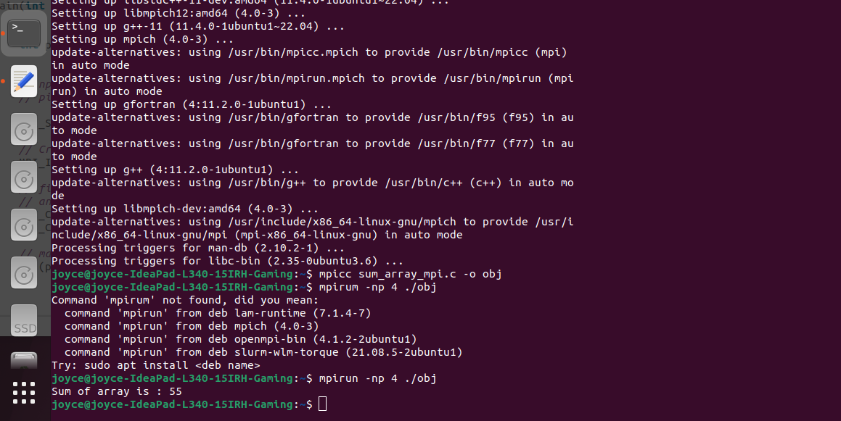
Conclusion:
There has been a large amount of interest in parallel programming using Java. mpj is an MPI binding with Java along with the support for multicore architecture so that user can develop the code on it's own laptop or desktop. This is an effort to develop and run parallel programs according to MPI standard.

