Assignment No. 04

Name: Joyce Joseph
Roll No.: BI30

Problem Statement:
Implement Berkeley algorithm for clock synchronization.

Tools / Environment:
Python3, Eclipse IDE

Theory:
The Berkeley algorithm for clock synchronization is commonly employed in distributed systems, which comprise interconnected computers communicating through a high-speed network. In such systems, hardware and software components coordinate their actions via message passing, with each node capable of sharing its resources. To manage resource conflicts effectively, synchronization is essential, typically achieved through clocks.

Clock synchronization in distributed systems can be categorized into two approaches: External and Internal Clock Synchronization. External clock synchronization involves utilizing an external reference clock, usually UTC (Universal Time Coordination), as a reference for setting and adjusting node times. On the other hand, Internal clock synchronization entails nodes sharing their time with each other and adjusting accordingly.

Clock synchronization algorithms further fall into two types: Centralized and Distributed. In Centralized algorithms, a single time server acts as the reference, propagating time to all nodes. Examples include the Berkeley Algorithm, Passive Time Server, and Active Time Server. Conversely, Distributed algorithms operate without a centralized time server, with nodes adjusting their time based on their local time and the average differences with other nodes. Examples include the Global Averaging Algorithm, Localized Averaging Algorithm, and NTP (Network Time Protocol).

The Berkeley Algorithm, specifically, is utilized for clock synchronization in distributed systems. It assumes that each node lacks an accurate time source or a UTC server. In this algorithm, a master node is elected from a pool of nodes, serving as the main node while the rest act as slaves. The master node periodically pings slave nodes and fetches their clock time using Cristian's Algorithm. It then calculates the average time difference between all received clock times and its own system clock time. This average difference is added to the current time at the master's system clock and broadcasted across the network.

Potential improvements to the Berkeley Algorithm include considering significant outliers in average time difference calculations, ensuring readiness of a secondary leader in case of master node failure, and broadcasting relative inverse time differences to reduce network traversal latency during time calculation at slave nodes.

Code:

# Python3 program imitating a clock server

from functools import reduce
from dateutil import parser
import threading
import datetime
import socket
import time

# datastructure used to store client address and clock data
client_data = {}

''' nested thread function used to receive
clock time from a connected client '''
def startReceivingClockTime(connector, address):

while True:
# receive clock time
clock_time_string = connector.recv(1024).decode()
clock_time = parser.parse(clock_time_string)
clock_time_diff = datetime.datetime.now() - \
clock_time

client_data[address] = {
"clock_time" : clock_time,
"time_difference" : clock_time_diff,
"connector" : connector
}

print("Client Data updated with: "+ str(address),
end = "\n\n")
time.sleep(5)

''' master thread function used to open portal for
accepting clients over given port '''
def startConnecting(master_server):

# fetch clock time at slaves / clients
while True:
# accepting a client / slave clock client
master_slave_connector, addr = master_server.accept()
slave_address = str(addr[0]) + ":" + str(addr[1])

print(slave_address + " got connected successfully")

current_thread = threading.Thread(
target = startReceivingClockTime,
args = (master_slave_connector,
slave_address, ))
current_thread.start()

# subroutine function used to fetch average clock difference
def getAverageClockDiff():

current_client_data = client_data.copy()

time_difference_list = list(client['time_difference']
for client_addr, client
in client_data.items())

sum_of_clock_difference = sum(time_difference_list, \
datetime.timedelta(0, 0))

average_clock_difference = sum_of_clock_difference \
/ len(client_data)

return average_clock_difference

''' master sync thread function used to generate
cycles of clock synchronization in the network '''
def synchronizeAllClocks():

while True:

print("New synchronization cycle started.")
print("Number of clients to be synchronized: " + \
str(len(client_data)))

if len(client_data) > 0:

average_clock_difference = getAverageClockDiff()

for client_addr, client in client_data.items():
try:
synchronized_time = \
datetime.datetime.now() + \
average_clock_difference

client['connector'].send(str(
synchronized_time).encode())

except Exception as e:
print("Something went wrong while " + \
"sending synchronized time " + \
"through " + str(client_addr))

else :
print("No client data." + \
" Synchronization not applicable.")

print("\n\n")

time.sleep(5)

# function used to initiate the Clock Server / Master Node
def initiateClockServer(port = 8080):

master_server = socket.socket()
master_server.setsockopt(socket.SOL_SOCKET,
socket.SO_REUSEADDR, 1)

print("Socket at master node created successfully\n")

master_server.bind(('', port))

# Start listening to requests
master_server.listen(10)
print("Clock server started...\n")

# start making connections
print("Starting to make connections...\n")
master_thread = threading.Thread(
target = startConnecting,
args = (master_server, ))
master_thread.start()

# start synchronization
print("Starting synchronization parallelly...\n")
sync_thread = threading.Thread(
target = synchronizeAllClocks,
args = ())
sync_thread.start()

# Driver function
if __name__ == '__main__':

# Trigger the Clock Server
initiateClockServer(port = 8080)

# Python3 program imitating a client process

from timeit import default_timer as timer
from dateutil import parser
import threading
import datetime
import socket
import time

# client thread function used to send time at client side
def startSendingTime(slave_client):

while True:
# provide server with clock time at the client
slave_client.send(str(
datetime.datetime.now()).encode())

print("Recent time sent successfully",
end = "\n\n")
time.sleep(5)

# client thread function used to receive synchronized time
def startReceivingTime(slave_client):

while True:
# receive data from the server
Synchronized_time = parser.parse(
slave_client.recv(1024).decode())

print("Synchronized time at the client is: " + \
str(Synchronized_time),
end = "\n\n")

# function used to Synchronize client process time
def initiateSlaveClient(port = 8080):

slave_client = socket.socket()

# connect to the clock server on local computer
slave_client.connect(('127.0.0.1', port))

# start sending time to server
print("Starting to receive time from server\n")
send_time_thread = threading.Thread(
target = startSendingTime,
args = (slave_client, ))
send_time_thread.start()

# start receiving synchronized from server
print("Starting to receiving " + \
"synchronized time from server\n")
receive_time_thread = threading.Thread(
target = startReceivingTime,
args = (slave_client, ))
receive_time_thread.start()

# Driver function
if __name__ == '__main__':

# initialize the Slave / Client
initiateSlaveClient(port = 8080)

Output:
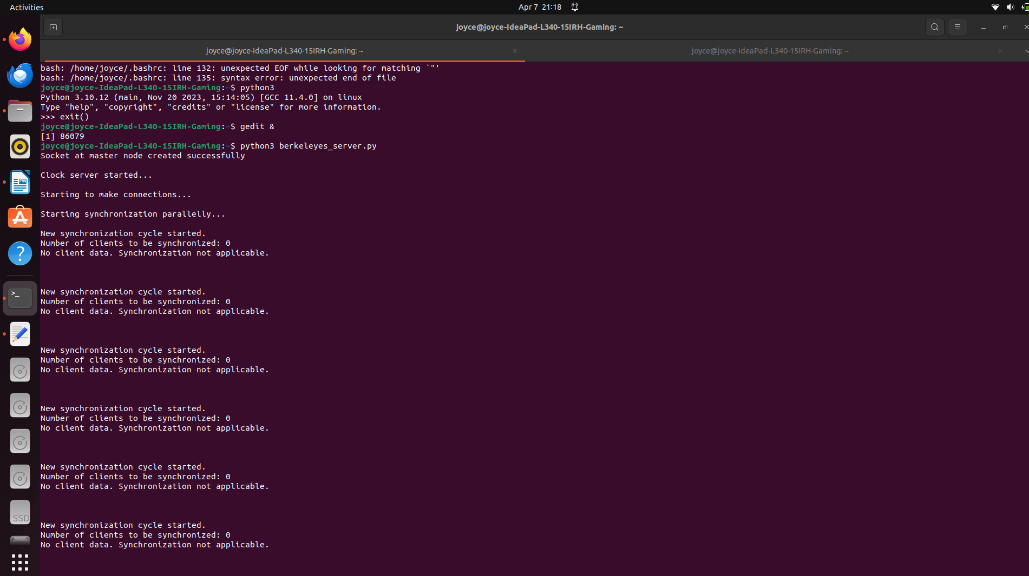

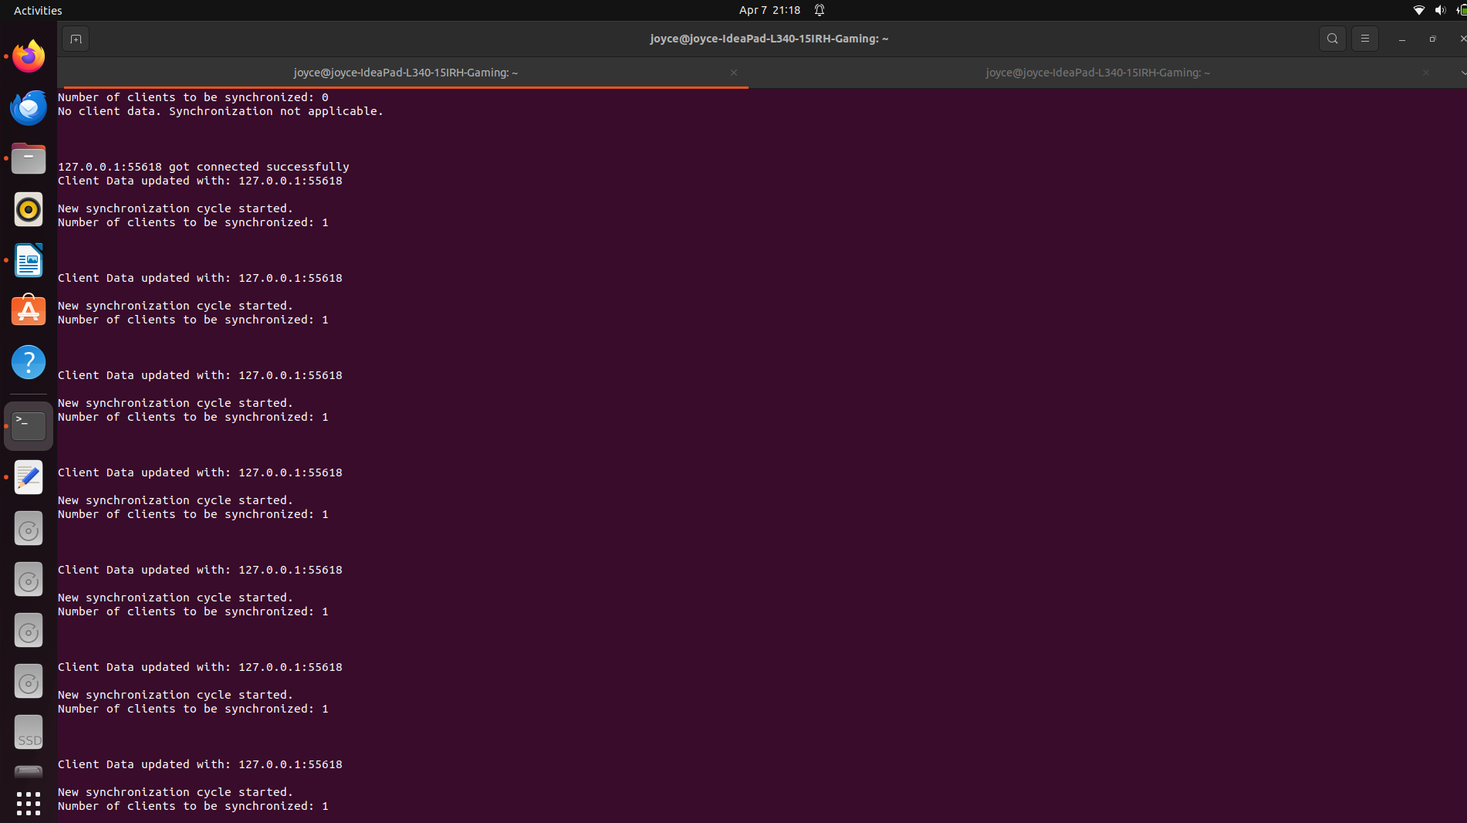
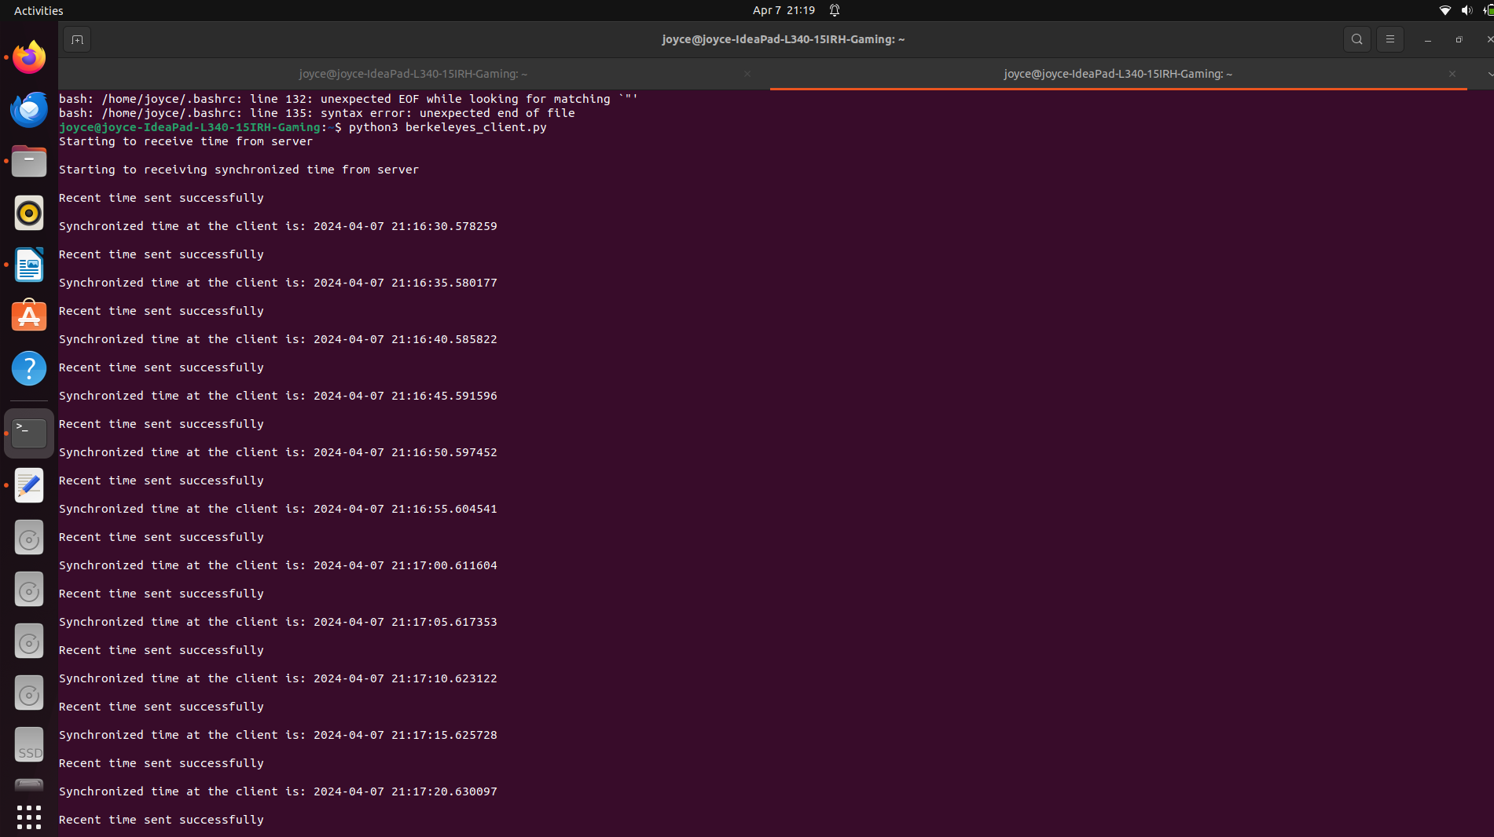
Conclusion:
Thus, we have implemented the Berkeley algorithm for clock synchronization.

