ASSIGNMENT NO.05
Name: Joyce Joseph
RollNo:. BI30
Problem Statement:
Implement token ring based mutual exclusion algorithm.
Tools/Environment:
Java Programming Environment, JDK 1.8
Theory :
Process synchronization encompasses a range of techniques aimed at coordinating the execution of multiple processes. These methods become crucial in scenarios where processes need to pause or wait for others to complete certain actions or when shared resources, such as files or database fields, demand exclusive access. Coordinating access to these resources ensures fairness and prevents conflicts among processes.
In some cases, resource modifications can be executed atomically, typically facilitated by a single remote procedure call or web service. However, in more complex scenarios, multiple concurrent requests from different servers may vie for the same resource. Distributed transactions exemplify such situations, where clients must request and release locks on resources to maintain exclusive access.
In the context of centralized systems, ensuring exclusive access to shared code often involved mechanisms like test and set locks in hardware, or semaphores, messages, and condition variables in software. Meanwhile, mutual exclusion in distributed systems assumes consensus on how resources or critical sections are identified, and processes can be uniquely distinguished across the system.
Effective mutual exclusion algorithms must meet three critical properties: safety, ensuring that only one process accesses a resource at any given time; liveness, ensuring that processes can make progress without waiting indefinitely; and fairness, guaranteeing that each process has a fair chance to access the resource without experiencing starvation.
These algorithms fall into three main categories:
1. Centralized algorithms: These rely on a central coordinator to grant access to resources. When a process seeks access, it sends a request to the coordinator, which either grants access or blocks the requesting process until the resource becomes available. While straightforward to implement, this approach suffers from a single point of failure and can become a bottleneck in systems with a high number of processes.
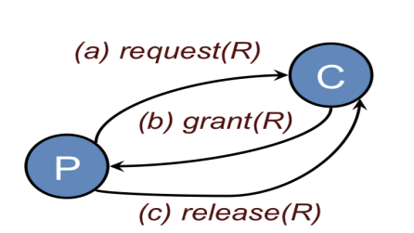

2. Tokenbased algorithms: In this approach, a token circulates among processes in a logical ring. Only the process holding the token can access the resource, ensuring mutual exclusion. However, if the token is lost, it must be regenerated, which can be challenging to detect.
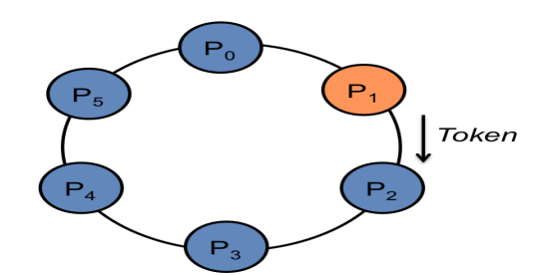

3. Contention based algorithms: These leverage distributed algorithms to resolve conflicts when multiple processes seek access to the same resource.

Process synchronization techniques are essential for coordinating the execution of multiple processes, particularly in scenarios where exclusive access to shared resources is required. By implementing effective mutual exclusion algorithms, systems can ensure fairness, prevent conflicts, and enable efficient resource utilization across distributed environments.
Code:
import java.io.*;
import java.util.*;

class tokenring {

public static void main(String args[]) throws Throwable {
Scanner scan = new Scanner(System.in);
System.out.println("Enter the num of nodes:");
int n = scan.nextInt();
int m = n - 1;
// Decides the number of nodes forming the ring
int token = 0;
int ch = 0, flag = 0;
for (int i = 0; i < n; i++) {
System.out.print(" " + i);
}
System.out.println(" " + 0);
do{
System.out.println("Enter sender:");
int s = scan.nextInt();
System.out.println("Enter receiver:");
int r = scan.nextInt();

if(s>=n || r>=n)
{
System.out.print("Invalid entry");
}
else
{
System.out.println("Enter Data:");
String a;
a = scan.next();
System.out.print("Token passing:");
for (int i = token, j = token; (i % n) != s; i++, j = (j + 1) % n) {
System.out.print(" " + j + "->");
}
System.out.println(" " + s);
System.out.println("Sender " + s + " sending data: " + a);
for (int i = s + 1; i != r; i = (i + 1) % n) {
System.out.println("data " + a + " forwarded by " + i);
}
System.out.println("Receiver " + r + " received data: " + a +"\n");
token = r;
}

do{
try {
if( flag == 1)
System.out.print("Invalid Input!!...");
System.out.print("Do you want to send again?? enter 1 for Yes and 0 for No : ");
ch = scan.nextInt();
if( ch != 1 && ch != 0 )
flag = 1;
else
flag = 0;
} catch (InputMismatchException e){
System.out.println("Invalid Input");
}
}while( ch != 1 && ch != 0 );
}while( ch == 1 );
}
}

Output:
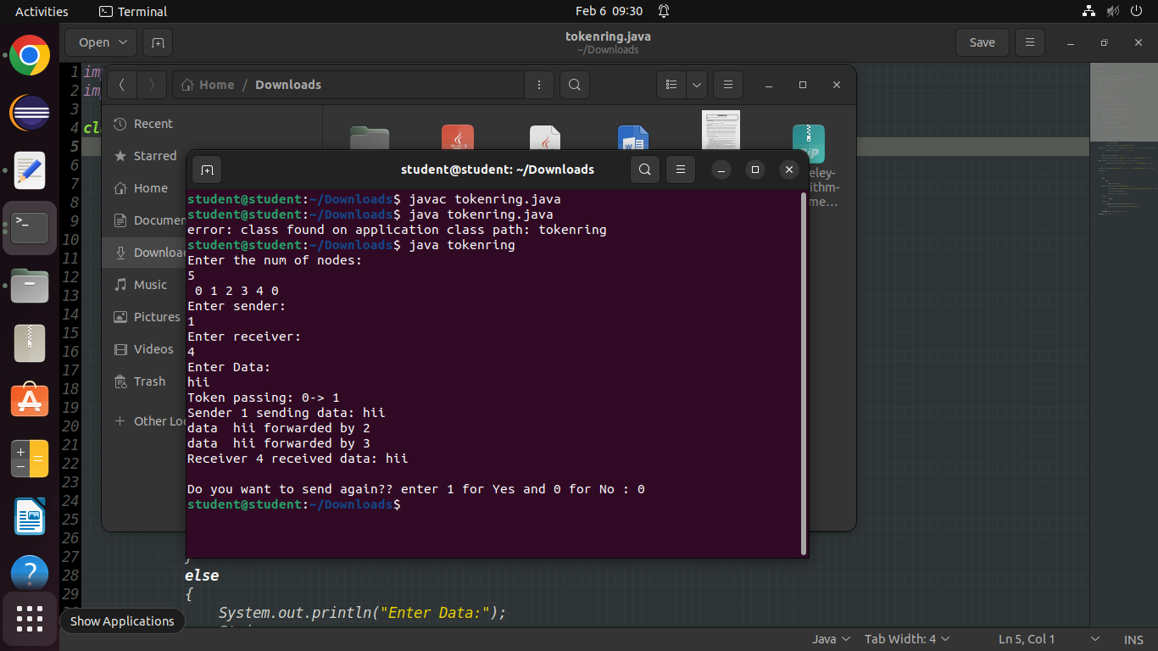
Conclusion:
In this way Token Ring algorithm has been implemented. This algorithm is easy to implement and verify but the biggest drawback of this algorithm is that if a token is lost, it will have to be generated. Determining that a token is lost can be difficult.

