A Flow chart is a presentation that give a symbolic or graphical chart. Flow chart represent by a different symbol and give a short description of every process or every chart that you made. Every chart symbol has arrows that showing the direction of the chart. We have different flow chart symbols and every symbol have different meanings. The most common flow chart symbols are terminator, process, decision, connector, data, document. Flow chart help us to clarify on how we use things and how they could be improved and then assists the process of the chart to be easy to use and understand the flow chart.

Example of Flow Chart:

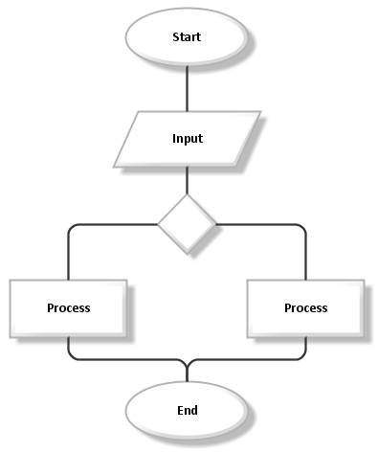

Pseudocode could be a helpful factor to find out as a result of it focuses on the building block ideas of programming languages while not you having to stress regarding whether or not your mistreatment the right words. Once you know the logic of writing, the remainder is simply filling in your pseudocode with the syntax of a selected artificial language in a very heap of how, pseudocode is analogous to the mockups you created within the style. For example, the vending machine it is program work to a people. It probably writes by using pseudocode. It’s better to know how pseudocode works to be easy to understand. The purpose of using pseudocode is an efficient key for an algorithm. It is used in planning an algorithm with sketching out the structure of the program before the actual coding takes place. Pseudocode is simple structure and readability to make it easier to modify. The pseudocode allows programmers to work in different computer languages to talk to others they can be reviewed by groups easier than the real code.

Example of Pseudocode:

