**Title**

**Fully Automated Measurement of Pulse Wave Velocity from Routine Cardiac MR Studies**

**Abstract**

**Introduction**: Aortic pulse wave velocity (PWV) is a prognostic biomarker for cardiovascular disease, which can be measured by dividing the aortic path length by the pulse transit time. However, current MRI techniques require special sequences and time-consuming manual analysis. We aimed to fully automate the process using deep learning to measure PWV from standard sequences, facilitating PWV measurement in routine clinical and research scans.

**Methods**: A deep learning (DL) model was developed to generate high-resolution 3D aortic segmentations from routine 2D trans-axial SSFP localizer images, and the centerlines of the resulting segmentations were used to estimate the aortic path length. A further DL model was built to automatically segment the ascending and descending aorta in phase contrast images, and pulse transit time was estimated from the sampled flow curves. Quantitative comparison with trained observers was performed for path length, aortic flow segmentation and transit time, either using an external clinical dataset with both localizers and paired 3D images acquired or on a sample of UK Biobank subjects. Potential application to clinical research scans was evaluated on 1053 subjects from the UK Biobank.

**Results**: Aortic path length measurement was accurate with no major difference between the proposed method (125 ± 19mm) and manual measurement by a trained observer (124 ± 19mm) (P=0.88). Automated phase contrast image segmentation was similar to that of a trained observer for both the ascending (Dice vs manual: 0.96) and descending (Dice 0.89) aorta with no major difference in transit time estimation (proposed method= 23.5 ± 10.8ms, manual = 22.9 ± 11.5ms; P=0.43). 949 of 1053 (90%) UK Biobank subjects were successfully analyzed, with a median PWV of 6.3m/s, increasing 25% per decade of age and 7% higher per 10mmHg higher systolic blood pressure.

**Conclusions**: We describe a fully automated method for measuring PWV from standard cardiac MR localizers and phase contrast images. The method is robust and can be applied to routine clinical scans, and could unlock the potential of measuring PWV in large-scale clinical and population studies. All models and deployment code will be published online.

1. **Introduction**

Aortic pulse wave velocity (PWV) – the speed that arterial pulse propagates along the aorta – is a non-invasive marker of arterial stiffness and an established independent predictor of cardiovascular disease [1]. PWV can identify early signs of aortic remodeling that are associated with major causes of cardiovascular disease where treatment of risk factors can significantly prolong life [2,3].

Several methods of measuring PWV exist [4,5]. Measurement of carotid-femoral is the current clinical gold standard [6] but inaccuracies in path length determination is a recognized limitation[7], while MRI or CT imaging is the gold standard for path length assessment [7]. Calculation of PWV requires the distance a pulse waveform travels (i.e. the *path length*) and the time taken to travel that distance (i.e. the *pulse transit time*) [5]. These metrics can easily be obtained by MR imaging using a combination of anatomical imaging (for path length) and phase contrast imaging (for transit time) [5,8,9]. However, the most accurate method of measuring path length requires time-consuming, contrast-enhanced 3D MR sequences. Consequently, these sequences are not routinely performed in standard clinical exams or in large population studies, such as the UK Biobank [10,11].

Here, we present a fully automated pipeline to estimate PWV from a standard cardiac MR exam without the need for additional or specialized 3D sequences. We achieve this by extending our previous work [12], which uses deep learning (DL) to create high-resolution 3D aortic segmentations from a trans-axial stack of bright-blood localizer images with low through-plane resolution. These 3D segmentations can be used to extract an aortic centerline and calculate the path length (distance along the centerline between ascending and descending aortic flow measurements). As a stack of localizers is routinely acquired in almost all CMR exams [13], this method enables path length to be estimated in most subjects. Furthermore, we developed DL segmentation of the ascending and descending aorta in the phase contrast flow images, allowing fully automated measurement of pulse transit time.

The aims of this study were: 1) to validate our DL method of estimating path lengths by comparing to reference standard measurement from manually segmented 3D MR data; 2) to compare our DL phase contrast segmentations to manually segmented data from a small subset of the UK Biobank data; and 3) to explore the utility of our complete PWV method in a larger subset of the UK Biobank by exploring the association of pulse wave velocity with relevant clinical correlates.

**2. Methods**

The proposed pipeline is illustrated in Figure 1. Pulse wave velocity was calculated as the quotient of the path length along the aorta and the pulse transit time along the path length:

In the following sections we describe each component in turn. Python code for training and inference is available at <https://github.com/JoyceYJ01/Automated-PWV-measurement-pipeline/>

Figure 1: Overview of the automatic pipeline for calculation of pulse wave velocity.

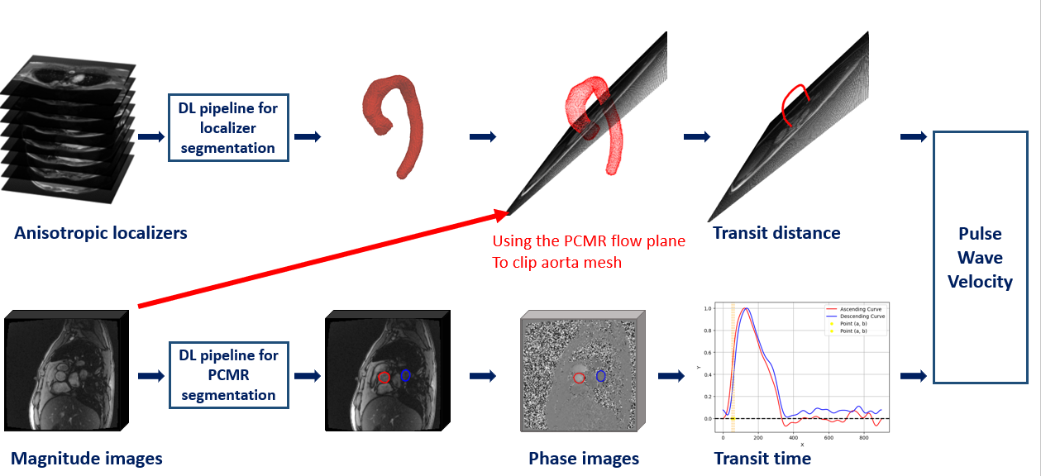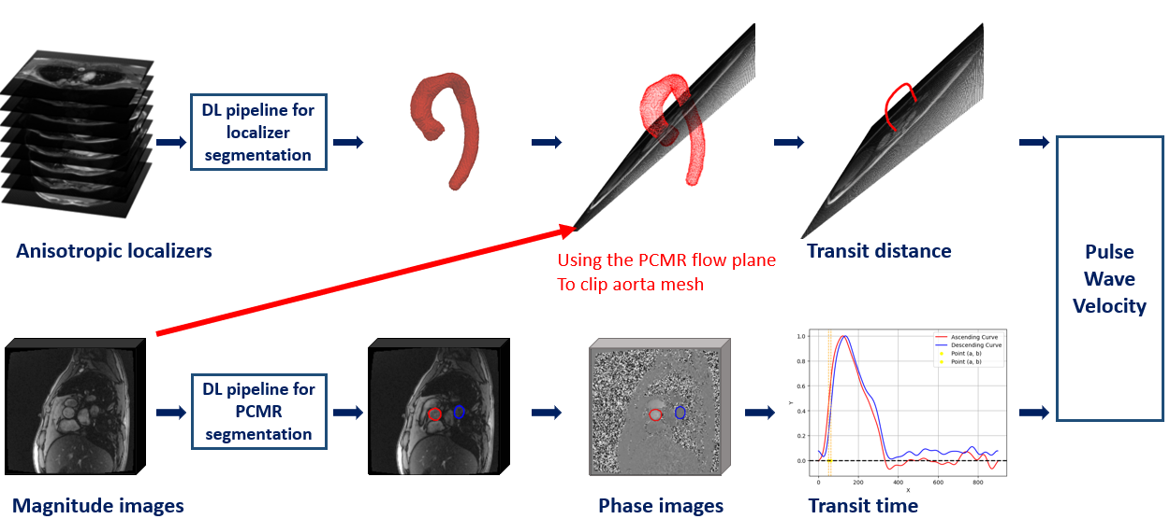

**2.1 Path length measurement**

To measure the path length between two points in the aorta, we first created a 3D segmentation mesh of the aorta using only a trans-axial stack of anisotropic localizers.

**2.1.1 Training data for aortic segmentation**

We retrained our previously published model using only publicly available data to permit full open-source release of the code and model. The following two data sources were used:

**HVSMR** : We used images and publicly released aortic segmentations from the open-source Whole-Heart and Great Vessel Segmentation from 3D Cardiovascular MRI in Congenital Heart Disease dataset (HVSMR 2.0 [14] - <https://figshare.com/articles/dataset/HVSMR-2_0_orig_/25226360>). This data contains 60 whole-heart cardiovascular MR images of children and young adults with differing severity of congenital heart disease (CHD). We excluded 11 subjects due to complex congenital heart disease (e.g. single ventricle, AO-PA anastomosis, etc.) leaving 49 for training. Images were acquired using a respiratory-navigated, prospective ECG-gated, steady-state free precession (SSFP) sequence during free-breathing [14]. MRI sequencing details are described in the Supplement.

**MMWHS**: We also used images from 22 adult patients from the Multi-Modality Whole Heart Segmentation dataset (MMWHS [15] - [Multi-Modality Whole Heart Segmentation Challenge](https://zmiclab.github.io/zxh/0/mmwhs/)). These subjects also were imaged using a respiratory-navigated, prospective ECG-gated, SSFP sequence during free-breathing [15,16]. MRI sequencing details are described in the Supplement. This data was manually segmented by a CMR imaging specialist (VM; > 20 years of experience).

All images were resampled to an isotropic resolution of 0.8 × 0.8 × 0.8 mm3 using linear interpolation [17] prior to training.

**2.1.2 Deep learning approach for aortic segmentation**

We used a previously described network framework based on a U-net architecture, Adam optimizer, and categorical cross-entropy loss [12]. In this approach, simulated 2D anisotropic localizers were generated by resampling the 3D isotropic cardiac MR data described in 2.1.1. These simulated localizers were then paired with high-resolution 3D segmentations described in 2.1.1.

Figure 2: Overview of the measurement of the path length

**2.1.3 Measuring path length from aortic segmentation**

The approach to path length calculation is illustrated in Figure 2. The DL segmentations were first post-processed to remove any isolated ‘islands’ using the largest connected component extraction algorithm [18,19]. The processed 3D masks were then converted to polygonal meshes (needed for centerline extraction) using the marching cubes algorithm [20].

The aortic meshes were then truncated at the intersection with the phase contrast imaging plane and small holes and self-intersections in the mesh were removed using the meshfix algorithm [21] implemented in PyVista [22]. The 3D centerline of this section of the aorta was calculated using the centerline extraction algorithm of the Vascular Modeling Toolkit (VMTK) package [23]. The aortic path length was then taken as the length of this centerline.

**2.2 Pulse transit time measurement**

Figure 3 illustrates the approach to pulse transit time measurement. We describe each component in turn, below.

~~

Figure 3: Overview of pulse transit time calculation. The ascending aorta (red) and descending (blue) is segmented on the magnitude image in each frame of the cardiac cycle. The segmentations are used to mask the corresponding phase images to create a flow curve for each of the ascending (red curve) and descending (blue curve) aorta. The time delay between the two inflection points represent the pulse transit time.

**2.2.1 Training data for phase contrast image segmentation**

Training data consisted of 2D phase contrast images containing both the ascending and descending aorta, from 86 subjects randomly chosen from the UK Biobank (30 reconstructed frames, matrix = 192 × 192, resolution = 1.77 × 1.77 × 6 mm3). Ground truth (GT) segmentations of the ascending and descending aorta on the magnitude series were created by a clinician (RD, 9 years of experience) using the semi-automatic tool in CVI42 v3.9 (Circle CVI, Montreal) with manual correction as needed.

**2.2.2 Deep learning for automated aortic phase contrast image segmentation**

Figure 4: DL model structure for automated ascending and descending aortic phase contrast imagesegmentation.

We employed a 3D U-Net 3+ [24] that we have previously used for phase contrast image segmentation[25] (Figure 4). The architecture features five scales with two layers per block in both the encoder and decoder, incorporating batch normalization in each block. Only magnitude images were used for training and all 30-time frames were zero-padded and stacked into a 3D image of size 32 × 192 × 192. Padding was necessary because the 3D U-Net 3+ structure we used has a depth of 5 and a pool size of 2.

Each phase contrastmagnitude series was paired with the corresponding multi-class segmentation mask (segmentations of both the ascending and descending aorta in the same image) and randomly split with a 3:1 ratio for training and validation. Data augmentation was performed during training by random rotations of between ± 60 degrees. No additional cropping or resizing of images was performed during training or testing.

The Focal Tversky loss [26] was optimized using the Adam optimizer [27] with a learning rate of 0.001, reduced to 0.0005 after 120 epochs. The stopping criterion was defined as no decrease in validation loss for 20 epochs. Resulting segmentation masks were post-processed to keep only the largest connected component separately for each class.

**2.2.3 Calculating pulse transit time**

Segmentations of ascending and descending area were trained and tested on the magnitude series. Then, ascending and descending aortic flow curves were produced by taking the average blood velocity over all pixels in the segmentation masks for each time frame of corresponding phase series. To calculate pulse transit time, both flow curves were first band-pass filtered with a Fourier smoothing algorithm implemented in Scipy [19] and then normalized. The inflection points (i.e. the peak of the first derivative) of systolic ejection curves in the ascending and descending aorta were calculated and the time between the inflection points used as the transit time (see Figure 3).

**2.4** **Validation**

**2.4.1 Aortic path length validation**

We validated the 3D path length estimation using an independent data set collected from The Royal Free Hospital (research ethics committee reference: 06/Q0508/124). The cohort consisted of 10 adult patients referred for a cardiac MR scan as part of routine clinical care[12] who required a protocol that included of 3D isotropic whole heart data (resolution = 1.6 × 1.6 × 1.6 mm3) and a stack of 2D anisotropic localizers (resolution = 1.6 × 1.6 × 10 mm3). The 3D whole heart data were segmented by an experienced cardiac imaging specialist (VM, > 20 years of experience) and the resultant meshes were used as ground truth (GT). The localizers were processed by the automatic pipeline (as described above), outputting a predicted mesh. Comparison between the ground truth and predication required the two meshes to be aligned using the iterative closest point (ICP) algorithm [28]. The centerlines for both meshes, were calculated as described above using the phase contrast image plane to define the start and end. The predicted centerlines were compared to ground truth centerlines using: 1) path length, 2) average symmetric surface distance (ASSD), and 3) Hausdorff distance.

**2.4.2 Aortic pulse transit time**

We validated the pulse transit time measurement using 20 randomly selected subjects from the UK Biobank imaging study (fully independent from training data) [22]. Phase contrast images containing both the ascending and descending aorta from these subjects were stacked and padded to the same size as the training data. Ground truth segmentations on the magnitude series were created on the ascending and descending aorta by a clinician (RD, 9 years of experience) using the semi-automated tool in CVI42 v3.9 (Circle CVI) with manual correction applied where necessary.

Agreements between the DL segmentation results with ground truth manual segmentations were measured using Dice score. In addition, transit time estimated from manual and automatic segmentations were compared quantitively.

**2.4.3 Generalisation and performance in population cohort**

The automated pipeline was further applied to a larger dataset randomly selected from the UK Biobank imaging sub-study. Out of the selected 1200 subjects, subjects were excluded if: 1) localizers and/or phase contrast images were not available (87 subjects), 2) localizer images did not cover the aortic arch (53 subjects), or 3) phase contrast images were incorrectly planned (7 subjects). The remaining 1,053 cases were processed for testing the performance of the using automatic pipeline – see figure 5.

Results from each following step were assessed visually and each processing failure was categorized as: aortic path length error or pulse transit time failure. Specifically, errors were categorized as follows:

1. Path length error:
   1. Segmentation: all segmentations were visually checked by overlaying masks on the MR images to identify mis-segmentations.
   2. Centerline measurement: all centerlines, overlaid with the truncated tubular meshes were visualized to identify incorrect centerlines.
2. Pulse transit time error:
   1. Segmentation: all phase contrast imaging segmentations were visually checked to identify mis-segmentations.
   2. Transit time: flow curve and inflection points were visually inspected for each subject, to identify incorrect transit times.
3. Physiological implausibility: Subjects with negative or large PWV (> 35 ms) were excluded in the following clinical analysis even where the segmentation appeared correct.

Figure 5: Flow diagram showing cases excluded and included in the qualitative evaluation.

**2.5 Large scale application to population cohort**

We investigated the utility of our method for application to large datasets by analyzing the PWV results from the 1053 subset UK biobank subjects described above. We studied the association with known correlates of PWV, including age, sex, systolic blood pressure (SBP) and diastolic blood pressure (DBP)[1,29]. The clinical correlates (age, sex, SBP, DBP and heart rate) were downloaded directly from the UK Biobank and these data were not used in the training and previous validation.

**2.6 Statistical analysis**

All continuous variables are presented as mean ± standard deviation if normally distributed and median [interquartile range] otherwise. Normality was checked by the Shapiro-Wilk test. To compare the path length and transit time measured by DL model against the manual segmentation, a paired t-test was used for normal variables, and a Wilcoxon signed-rank test was used for the non-normal variables. Bland-Altman plots were also used to show the differences between measurements. A Spearman’s rank correlation coefficient (ρ) was used to assess the monotonic relationship between PWV and clinical covariates. Logarithmic transformation was applied to PWV values due to its right-skewness, and linear regression was used to model the association between log(PWV) and age or SBP and the coefficients interpreted as % change per x unit. A Mann-Whitney U-test was used to compare non-normal samples. All analyses were performed using the SciPy library (v1.9.1) [18] and Statsmodels library [30] in Python (version 3.8.5) with a p-value <0.05 considered statistically significant.

# **3.Results**

On a dedicated workstation (24-core CPU, 64 GB RAM, NVIDIA GeForce RTX 4090 GPU), training times for the DL models were 3.5h for the 3D aortic segmentation, and 3.7h for phase contrast segmentation. Inference times, combined for both models took 6-8 seconds per subject on the same machine.

**3.1 Aortic path length**

There were no visible differences in aortic centerlines generated by our DL method based on localizers and those from manually segmentations of 3D whole heart data – see figure 6. The centerlines average symmetric surface distance (ASSD) distance was 1.8 ± 0.5mm and the Hausdorff distance was 3.9 ± 1.4mm. The worst case had a Hausdorff distance of 6.8mm, caused by a mismatch in the starting point of the centerline.

When used to calculate path lengths, a good agreement was found between our DL method based on 2D localizers and from manual segmentations of the 3D whole heart data (125 ± 19mm vs 124 ± 19mm, P=0.88); there was no significant bias (mean difference 0.12mm), with limits of agreement less than ± 5mm (Figure 7).

Figure6. The best, median, and worst centerline length measurement from deep learning (DL) segmentation compared to ground truth (GT).

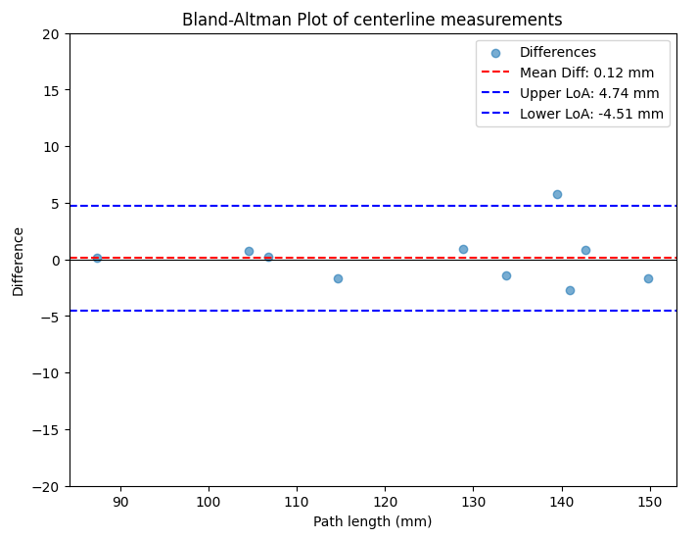

Figure 7: Bland Altman plot for centerline length measured by DL and clinician segmentations.

**3.2 Pulse transit time measurement**

Segmentation accuracy of the phase contrast images from the DL model was high, with a Dice score of 0.96 [0.96–0.96] for the ascending aorta and 0.89 [0.87–0.92] for the descending aorta.

The pulse transit time measurements from the DL model also showed good agreement with manual segmentations. The mean transit time was 23.5 ± 10.8ms for the DL model, compared to 22.9 ± 11.5ms for the ground truth (P = 0.43). The bias was less than 1ms, and the limits of agreement were within 8ms (Figure 8).

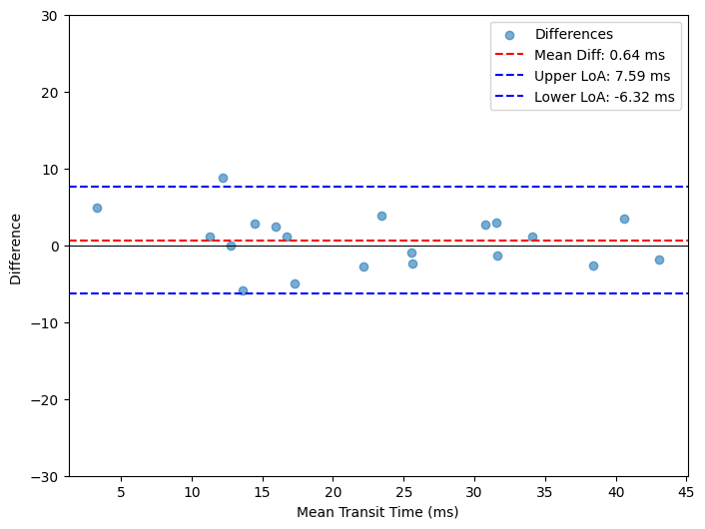

Figure 8: Bland-Altman plots of pulse transit time measured by DL model vs GT on 20 Biobank subjects.

**3.3 Pipeline performance in UK Biobank**

Of 1,053 available UK Biobank cases, 949 cases (90%) were successfully processed, with 104 (10%) exhibiting processing failures. Most of these failures came from the localizer segmentation model 76 (7%), and 28 (3%) from correct path length but incorrect transit time measurement – see Figure 9.

Figure 9: Breakdown of processing failures of the pipeline applied to UK Biobank images.

Of the 76 localizer mis-segmentations: 43 were due to incomplete segmentations (4%) and 33 due to over-segmentation (3%). Incomplete segmentation resulted in failure of centerline creation, while over segmentation produced incorrect centerlines. In the 43 incomplete segmentations, the majority of the cases were due to unusual aortic anatomy or poor image quality (38 cases, 3.6%). In the other 5 cases, the aortic phase contrast image plane had been planned very close to the aortic annulus and thus didn’t intersect with the aortic root segmentation. Examples of each type of incorrect path length measurement are illustrated in Figure 10.

Figure 10: Example of different types of incorrect path length measurement. If the phase contrast imaging plane intersected with the mesh only once, the automatic centerline creation would fail; while if the phase contrast imaging plane intersected with the mesh more than twice, the automatic centerline algorithm would calculate the shortest path between two closest open ends, resulting in incorrect (shorter) path length measured.

Pulse transit time measurement failure refers to values that appeared unrealistic or well outside the expected physiological normal range. For cases with correct path length measurement, we found 9 cases (1%) where there was mis-segmentation on the phase contrast images and 19 cases (2%) with unrealistic transit times. Unrealistic transit times are the cases where the segmentations of phase contrast images looked accurate, but the transit time calculated from the ascending and descending aortic flow curves was very small or even negative, resulting in very large or negative PWV values. We excluded cases of abnormal PWV results from further analysis, which were outside physiologically plausible limits (>35 m/s or <0 m/s).

**3.3.3 Application to large datasets: association between PWV and clinical correlates**

Of the 957 UK Biobank subjects used for analysis, 46% were men, the median age was 64 years [58 -70], while 95.9% White, 1.8% Indian, 0.9% other Asian ethnicity, and 1.4% other ethnicity.

The association between PWV and clinical covariates is shown in Figure 11. The PWV was slightly higher in males compared to females but did not reach statistical significance (male vs female: (6.30 [4.90 - 8.55] m/s) vs 6.26 [4.74 - 8.99] m/s; P=0.9). Aortic PWV was positively correlated to age (ρ=0.38; P<0.001), and positively correlated with SBP (ρ=0.28, P<0.001). In linear regression, a 10-year higher age was associated with a 24.6% (18.4%, 25.5%) higher PWV, and PWV was 6.7% (4.8%, 8.2%) higher per 10mmHg higher SBP. There were weak correlations between aortic PWV and diastolic blood pressure (ρ=0.07; P=0.05), and pulse rate (ρ=0.08; P=0.03).

Figure 11. The association between log(PWV) with age, SBP, DBP, pulse rate, and distribution between genders.

# **Discussion**

We have described a fully automated pipeline for estimating aortic PWV from cardiac MRI from routinely available data. We have shown that the method is quick (6-8 seconds on a mid-range computer), needs no human interaction, and is robust with an overall 90% success rate. The method works on standard CMR studies without the need for additional sequences, potentially allowing it to be used routinely in clinical care and enabling the retrospective analysis of PWV from large-scale cohorts that have undergone CMR.

The pipeline demonstrated good performance on the validation data, with no significant difference in aortic path length measurement or pulse transit time measured by DL and manual segmentations. These results show that the pipeline can achieve an accuracy that is comparable to manual measurements.

When applied to a large cohort of UK Biobank data, the overall error rate for our proposed method was 10%. Most errors (7%) were due to mis-segmentation in the aortic path length as the centerline extraction method was sensitive to breaks in the aortic mesh. These errors cause an irregular or broken centerline but are easy to identify and potentially amenable to automatic quality control. Phase contrast segmentation errors were rare (<1%), but pulse transit time extraction from the flow curves occasionally produced physiologically implausible pulse wave velocities (2%). This has been reported in previous studies [1,31] and is probably due to inherent issues with phase contrast MR accuracy, due to the limited temporal resolution (typically 30 frames per heartbeat) [32].

To the best of our knowledge, this is the first time that transit-time based aortic PWV has been measured using cardiac MR images in the UK Biobank. We found no major difference in PWV by sex in keeping with previously reported results [33]. PWV also increased with age; similar findings have been widely reported previously (e.g. [1,34,35]) and reflect increasing aortic stiffness with age. Finally, PWV positively correlated with SBP in keeping with previous studies [34,36]. Our ability to replicate these previously observed correlations provide some reassurance about the validity and utility of our method.

It should be possible to easily apply this method to the entire imaging sub-study of the UK Biobank of 100,000 subjects with 60,000 repeat scans. This would allow investigation of more clinical correlates with aortic stiffness, as well as genome-wide association studies. Access to such a large dataset could also allow us to establish normative reference ranges, which could be conditioned to clinical covariates, such as age or sex, undertake observational epidemiological analyses, or characterize genome-wide associations with PWV and perform Mendelian randomization studies to study causality[37] and identify potential therapeutic drug targets[38].

PWV has proven utility for prognostication [2,39] and for identifying early disease [1,5,40] using MRI (e.g. [1,5]), tonometry[41], and Doppler ultrasound (e.g. [40]). However, the application of PWV has so far been largely limited to research studies or specialist clinics. We hope that by fully automating the analysis on standard CMR scans, its clinical use could be broadened.

Our ultimate aim is to develop PWV as a standard biomarker in cardiac MR for clinical care, but many steps are needed before this is realized. A primary challenge is robustness: the subjects described here mostly had normal aortic valve function and no LVOT obstruction, so further training would be needed to cope with diseases like aortic stenosis. The measurement must also be sufficiently robust to noise, artifacts and parameters such as patient movement between the localizer and phase contrast imaging acquisition. A normal reference range for PWV would also need to be established in order to contextualize the results from CMR.

# **Limitations**

This was a retrospective proof-of-concept study. Quantitative analysis of each step was only performed on a relatively small set of subjects (n=10 for path length measurement, and n=20 for pulse transit time measurement). A failure rate of 10% is too high for blinded application to large population studies so methods of robust and automatic quality control will require development.

# **Conclusions**

We present a fully automated method of measuring pulse wave velocity from standard cardiac MR localizers without the need for additional sequences. No user interaction is needed in the workflow making this method potentially suitable for measuring PWV in routine clinical scans. This approach could unlock the potential of measuring PWV retrospectively in large clinical and population studies.

**Acknowledgements**

This work was supported by a  British Heart Foundation PhD studentship ([FS/4yPhD/F/20/34134](https://www.sciencedirect.com/science/article/pii/S0730725X24002340#gts0005)) and a BHF Accelerator award (AA/18/6/34223); UK Research and Innovation …... ADH receives support from the British Heart Foundation, the Horizon 2020 and Horizon Europe Programmes of the European Union, the National Institute for Health Research University College London Hospitals Biomedical Research Centre, the UK Medical Research Council, the National Institute for Health Research, the Wellcome Trust, and works in a unit that receives support from the UK Medical Research Council. RhHD was funded by the UCLH Biomedical Research Centre (BRC). This research was conducted using the UK Biobank Resource under Application Number [71702](https://www.sciencedirect.com/science/article/pii/S0730725X24002340#gts0020).

**References**

[1] Ohyama Y, Ambale-Venkatesh B, Noda C, Kim JY, Tanami Y, Teixido-Tura G, et al. Aortic Arch Pulse Wave Velocity Assessed by Magnetic Resonance Imaging as a Predictor of Incident Cardiovascular Events: The MESA (Multi-Ethnic Study of Atherosclerosis). Hypertension 2017;70:524–30. https://doi.org/10.1161/HYPERTENSIONAHA.116.08749.

[2] Cavalcante JL, Lima JAC, Redheuil A, Al-Mallah MH. Aortic stiffness: Current understanding and future directions. J Am Coll Cardiol 2011;57:1511–22. https://doi.org/10.1016/j.jacc.2010.12.017.

[3] Mancini GBJ, Dahlöf B, Díez J, Cohn JN. Surrogate markers for cardiovascular disease: Structural markers. Circulation 2004;109. https://doi.org/10.1161/01.CIR.0000133442.99186.39.

[4] Negoita M, Hughes AD, Parker KH, Khir AW. Non-invasive technique for determining local pulse wave velocity in humans ascending aorta. Comput Cardiol (2010) 2017;44:1–4. https://doi.org/10.22489/CinC.2017.218-036.

[5] Wentland AL, Grist TM, Wieben O. Review of MRI-based measurements of pulse wave velocity: a biomarker of arterial stiffness. Cardiovasc Diagn Ther 2014;4:193–206. https://doi.org/10.3978/j.issn.2223-3652.2014.03.04.

[6] Townsend RR, Wilkinson IB, Schiffrin EL, Avolio AP, Chirinos JA, Cockcroft JR, et al. Recommendations for Improving and Standardizing Vascular Research on Arterial Stiffness: A Scientific Statement from the American Heart Association. Hypertension 2015;66:698–722. https://doi.org/10.1161/HYP.0000000000000033.

[7] Spronck B, Terentes-Printzios D, Avolio AP, Boutouyrie P, Guala A, Jerončić A, et al. 2024 Recommendations for Validation of Noninvasive Arterial Pulse Wave Velocity Measurement Devices. Hypertension 2024;81:183–92. https://doi.org/10.1161/HYPERTENSIONAHA.123.21618.

[8] Van Engelen A, Silva Vieira M, Rafiq I, Cecelja M, Schneider T, De Bliek H, et al. Aortic length measurements for pulse wave velocity calculation: Manual 2D vs automated 3D centreline extraction. J Cardiovasc Magn Reson 2017;19:32. https://doi.org/10.1186/s12968-017-0341-y.

[9] Dietenbeck T, Craiem D, Rosenbaum D, Giron A, De Cesare A, Bouaou K, et al. 3D aortic morphology and stiffness in MRI using semi-automated cylindrical active surface provides optimized description of the vascular effects of aging and hypertension. Comput Biol Med 2018;103:101–8. https://doi.org/10.1016/j.compbiomed.2018.10.006.

[10] Petersen SE, Matthews PM, Francis JM, Robson MD, Zemrak F, Boubertakh R, et al. UK Biobank’s cardiovascular magnetic resonance protocol. J Cardiovasc Magn Reson 2016;18:8. https://doi.org/10.1186/s12968-016-0227-4.

[11] Littlejohns TJ, Sudlow C, Allen NE, Collins R. UK Biobank: Opportunities for cardiovascular research. Eur Heart J 2019;40:1158–66. https://doi.org/10.1093/eurheartj/ehx254.

[12] Jiang Y, Punjabi K, Pierce I, Knight D, Yao T, Steeden J, et al. A machine learning algorithm for creating isotropic 3D aortic segmentations from routine cardiac MR localizers. Magn Reson Imaging 2025;115:110253. https://doi.org/10.1016/j.mri.2024.110253.

[13] Kramer CM, Barkhausen J, Bucciarelli-Ducci C, Flamm SD, Kim RJ, Nagel E. Standardized cardiovascular magnetic resonance imaging (CMR) protocols: 2020 update. J Cardiovasc Magn Reson 2020;22:1–18. https://doi.org/10.1186/s12968-020-00607-1.

[14] Pace DF, Contreras HTM, Romanowicz J, Ghelani S, Rahaman I, Zhang Y, et al. HVSMR-2.0: A 3D cardiovascular MR dataset for whole-heart segmentation in congenital heart disease. Sci Data 2024;11:1–11. https://doi.org/10.1038/s41597-024-03469-9.

[15] Zhuang X, Shen J. Multi-scale patch and multi-modality atlases for whole heart segmentation of MRI. Med Image Anal 2016;31:77–87. https://doi.org/10.1016/j.media.2016.02.006.

[16] Zhuang X, Li L, Payer C, Štern D, Urschler M, Heinrich MP, et al. Evaluation of algorithms for Multi-Modality Whole Heart Segmentation: An open-access grand challenge. Med Image Anal 2019;58:101537. https://doi.org/10.1016/j.media.2019.101537.

[17] The SciPy community. SciPy Interpolation Tutorial n.d. https://docs.scipy.org/doc/scipy/tutorial/interpolate.html.

[18] Oliphant TE. Python for Scientific Computing. Comput Sci Eng 2007;9:10–20.

[19] Virtanen P, Gommers R, Oliphant TE, Haberland M, Reddy T, Cournapeau D, et al. SciPy 1.0: fundamental algorithms for scientific computing in Python. Nat Methods 2020;17:261–72. https://doi.org/10.1038/s41592-019-0686-2.

[20] Lorensen WE, Cline HE. MARCHING CUBES : A HIGH RESOLUTION 3D SURFACE CONSTRUCTION ALGORITHM General Electric Company Corporate Research and Development Schenectady , New York 12301 creates triangle models of constant density surfaces from 3D medical data . Using a divide-and-co 1987;21:163–9.

[21] Attene M. A lightweight approach to repairing digitized polygon meshes. Vis Comput 2010;26:1393–406. https://doi.org/10.1007/s00371-010-0416-3.

[22] Sullivan C, Kaszynski A. PyVista: 3D plotting and mesh analysis through a streamlined interface for the Visualization Toolkit (VTK). J Open Source Softw 2019;4:1450. https://doi.org/10.21105/joss.01450.

[23] Antiga L, Piccinelli M, Botti L, Ene-Iordache B, Remuzzi A, Steinman DA. An image-based modeling framework for patient-specific computational hemodynamics. Med Biol Eng Comput 2008;46:1097–112. https://doi.org/10.1007/s11517-008-0420-1.

[24] Huang H, Lin L, Tong R, Hu H, Zhang Q, Iwamoto Y, et al. UNet 3+: A Full-Scale Connected UNet for Medical Image Segmentation. ICASSP, IEEE Int Conf Acoust Speech Signal Process - Proc 2020;2020-May:1055–9. https://doi.org/10.1109/ICASSP40776.2020.9053405.

[25] Yao T, Clair NS, Miller GF, Investigators F, Steeden JA, Rathod RH. MultiFlow : A unified deep learning framework for multi-vessel classification , segmentation and clustering of phase-contrast MRI validated on a multi-site single ventricle patient cohort n.d. https://arxiv.org/pdf/2502.11993.

[26] Abraham N, Khan NM. A novel focal tversky loss function with improved attention u-net for lesion segmentation. Proc - Int Symp Biomed Imaging 2019;2019-April:683–7. https://doi.org/10.1109/ISBI.2019.8759329.

[27] Kingma DP, Ba JL. Adam: A method for stochastic optimization. 3rd Int Conf Learn Represent ICLR 2015 - Conf Track Proc 2015:1–15.

[28] Besl PJ, McKay ND. Method for registration of 3-D shapes. Sens Fusion IV Control Paradig Data Struct 1992;1611:586–606. https://doi.org/10.1117/12.57955.

[29] O’Rourke MF, Safar ME, Dzau V. The Cardiovascular Continuum extended: Aging effects on the aorta and microvasculature. Vasc Med 2010;15:461–8. https://doi.org/10.1177/1358863X10382946.

[30] Seabold S, Perktold J. Statsmodels: Econometric and Statistical Modeling with Python. Proc 9th Python Sci Conf 2010:92–6. https://doi.org/10.25080/majora-92bf1922-011.

[31] Shahzad R, Shankar A, Amier R, Nijveldt R, Westenberg JJM, De Roos A, et al. Quantification of aortic pulse wave velocity from a population based cohort: A fully automatic method. J Cardiovasc Magn Reson 2019;21:1–14. https://doi.org/10.1186/s12968-019-0530-y.

[32] Fogel MA, Li C, Nicolson SC, Spray TL, Gaynor JW, Fuller S, et al. Comparison bymagnetic resonance phase contrast imaging of pulse-wave velocity in patients with single ventricle who have reconstructed aortas versus those without. Am J Cardiol 2014;114:1902–7. https://doi.org/10.1016/j.amjcard.2014.09.032.

[33] Lu Y, Kiechl SJ, Wang J, Xu Q, Kiechl S, Pechlaner R, et al. Global distributions of age- and sex-related arterial stiffness: systematic review and meta-analysis of 167 studies with 509,743 participants. EBioMedicine 2023;92:1–15. https://doi.org/10.1016/j.ebiom.2023.104619.

[34] Kim EJ, Park CG, Park JS, Suh SY, Choi CU, Kim JW, et al. Relationship between blood pressure parameters and pulse wave velocity in normotensive and hypertensive subjects: Invasive study. J Hum Hypertens 2007;21:141–8. https://doi.org/10.1038/sj.jhh.1002120.

[35] Monnier M. Changes in pulse wave velocity with age in man: a longitudinal series over 20 years. Experientia 1987;43:378–81. https://doi.org/10.1007/BF01940417.

[36] Turgutkaya A, Aşçı G. The association between hba1c and arterial stiffness among non-diabetic patients with chronic kidney disease. J Vasc Bras 2021;20:2–7. https://doi.org/10.1590/1677-5449.200245.

[37] Nikhil Paliwal, Albert Henry, Chris Finan, Rhodri Davies, Alun Hughes, Bryan Williams, Anders Malarstig TL and AH. Genome-wide association study of aortic stiffness derived from deep learning in CMR images of 45,789 individuals identifies loci linked with cell-matrix structure. Circulation 2024;150:1.4141107. https://doi.org/https://doi.org/10.1161/circ.150.suppl_1.4141107.

[38] Schmidt AF, Finan C, Gordillo-Marañón M, Asselbergs FW, Freitag DF, Patel RS, et al. Genetic drug target validation using Mendelian randomisation. Nat Commun 2020;11. https://doi.org/10.1038/s41467-020-16969-0.

[39] Pereira T, Costa T. Determinants of Arterial Stiffness and Vascular Aging in the Older Adult. Int J Cardiovasc Sci 2020;33:349–56. https://doi.org/10.36660/ijcs.20190068.

[40] Najjar SS, Scuteri A, Shetty V, Wright JG, Muller DC, Fleg JL, et al. Pulse Wave Velocity Is an Independent Predictor of the Longitudinal Increase in Systolic Blood Pressure and of Incident Hypertension in the Baltimore Longitudinal Study of Aging. J Am Coll Cardiol 2008;51:1377–83. https://doi.org/10.1016/j.jacc.2007.10.065.

[41] Ben-Shlomo Y, Spears M, Boustred C, May M, Anderson SG, Benjamin EJ, et al. Aortic pulse wave velocity improves cardiovascular event prediction: An individual participant meta-analysis of prospective observational data from 17,635 subjects. J Am Coll Cardiol 2014;63:636–46. https://doi.org/10.1016/j.jacc.2013.09.063.