**Experiment Summary**

1. Three queries we used

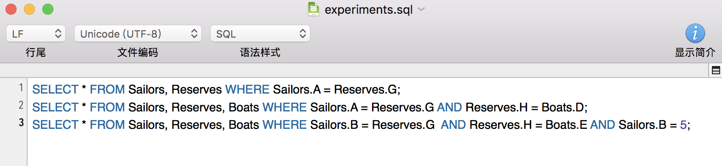

1. A description of data we used

* Schema: same schema as sample input
* Tuples numbers: 6000 for each table
* Each attribute value was chosen uniformly at random in the range 0 to 1000

1. The number of pages we used as buffer size for the sort in the SMJ case

**Graph:**