Computer Networks Practical 4
Practical 4 program, execution record, and output screenshot.
Repository
github.com/dhruv0075/CN-LAB-2

Code

4.py
INF = 999999

n = int(input("Enter number of nodes: "))

nodes = []

for i in range(n):
nodes.append(chr(65 + i))

cost = []

for i in range(n):
row = []

for j in range(n):
if i == j:
row.append(0)
else:
row.append(INF)

cost.append(row)

print("Enter -1 if nodes are not connected")

for i in range(n):
for j in range(i + 1, n):

value = int(input(nodes[i] + " to " + nodes[j] + ": "))

if value != -1:
cost[i][j] = value
cost[j][i] = value

dist = []
next_hop = []

for i in range(n):

dist.append(cost[i].copy())

row = []

for j in range(n):

if i == j:
row.append(i)

elif cost[i][j] != INF:
row.append(j)

else:
row.append(-1)

next_hop.append(row)

def print_table(title):

print("\n", title)

for i in range(n):

print("\nRouting Table for", nodes[i])
print("Destination\tDistance\tNext Hop")

for j in range(n):

if dist[i][j] == INF:
d = "INF"
else:
d = dist[i][j]

if next_hop[i][j] == -1:
h = "-"
else:
h = nodes[next_hop[i][j]]

print(nodes[j], "\t\t", d, "\t\t", h)

print_table("INITIAL ROUTING TABLES")

changed = True

while changed:

changed = False

old = []

for i in range(n):
old.append(dist[i].copy())

for x in range(n):

for v in range(n):

if cost[x][v] != INF and x != v:

for y in range(n):

new_dist = cost[x][v] + old[v][y]

if new_dist < dist[x][y]:

dist[x][y] = new_dist
next_hop[x][y] = v
changed = True

print_table("FINAL ROUTING TABLES")

Execution output screenshot
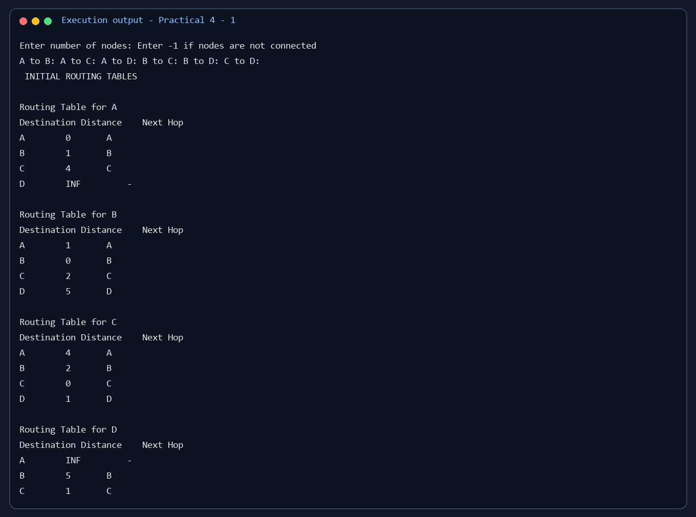

Output screenshot 2
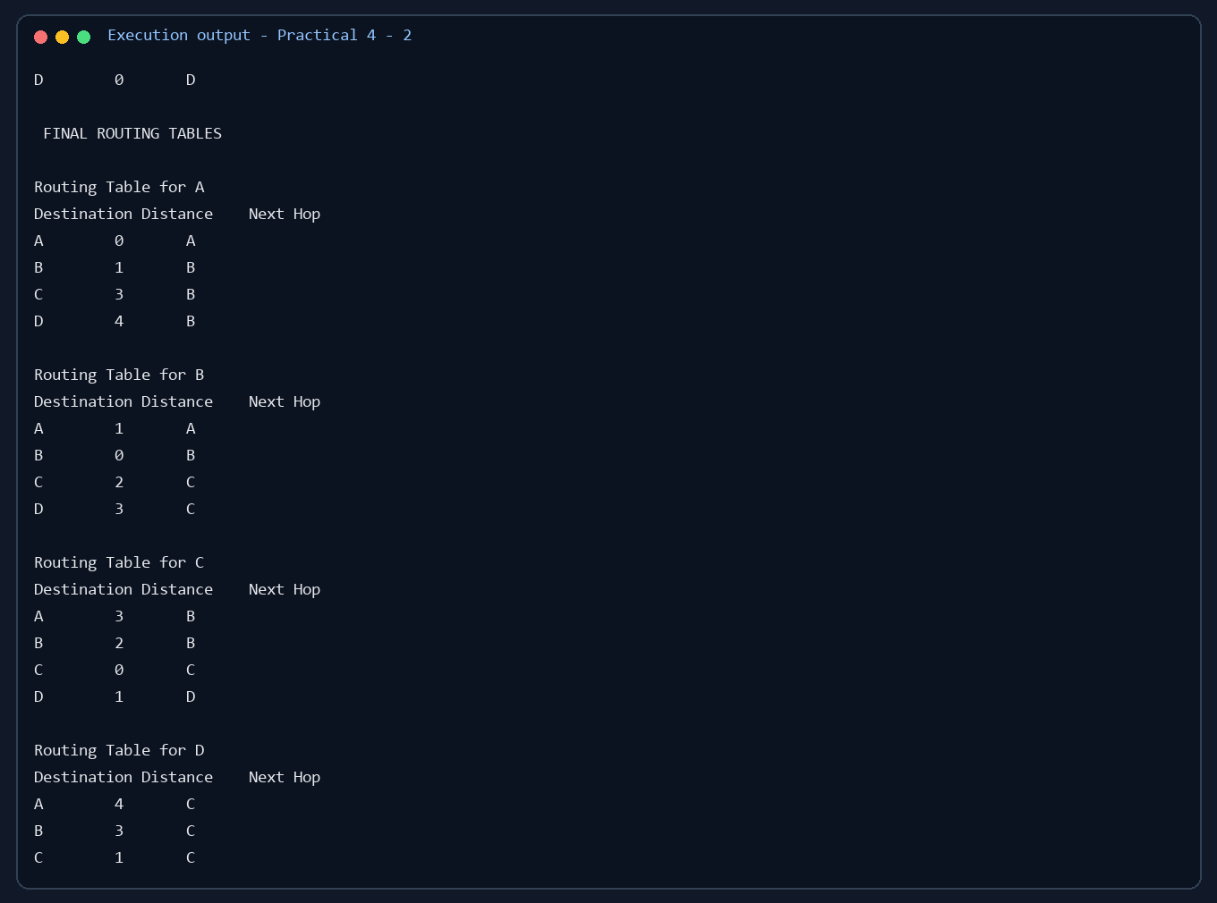

Output screenshot 3


