Computer Networks Practical 5
Practical 5 program, execution record, and output screenshot.
Repository
github.com/dhruv0075/CN-LAB-2

Code

5-both
"""
Assignment 5: TCP Server and Client - INTERACTIVE INPUT MODE
Type your messages in the input box that appears!
Perfect for Google Colab

HOW TO USE:
1. Run this entire cell
2. Input boxes will appear - type your messages there!
"""

import socket
import threading
import time
from datetime import datetime

# ==================== TCP SERVER ====================
class TCPServer:
def __init__(self, host='127.0.0.1', port=12345):
self.host = host
self.port = port
self.server_socket = None
self.running = False

def start(self):
try:
print("=" * 50)
print(" TCP SERVER INITIALIZATION")
print("=" * 50)

self.server_socket = socket.socket(socket.AF_INET, socket.SOCK_STREAM)
self.server_socket.setsockopt(socket.SOL_SOCKET, socket.SO_REUSEADDR, 1)

# Auto port retry
max_retries = 5
for attempt in range(max_retries):
try:
self.server_socket.bind((self.host, self.port))
break
except OSError:
if attempt < max_retries - 1:
self.port += 1
else:
raise

print(f"\n✅ Socket bound to {self.host}:{self.port}")
self.server_socket.listen(5)
print(f"✅ Server listening on port {self.port}")

self.running = True

# Start accepting connections in thread
accept_thread = threading.Thread(target=self.accept_connections)
accept_thread.daemon = True
accept_thread.start()

except Exception as e:
print(f"❌ Server failed: {e}")
self.running = False

def accept_connections(self):
while self.running:
try:
self.server_socket.settimeout(1.0)
client_socket, client_address = self.server_socket.accept()

print(f"\n✅ Client connected from {client_address}")

# Handle client in thread
client_thread = threading.Thread(
target=self.handle_client,
args=(client_socket, client_address)
)
client_thread.daemon = True
client_thread.start()

except socket.timeout:
continue
except:
if self.running:
pass

def handle_client(self, client_socket, address):
try:
# Send welcome message
welcome = "Welcome to TCP Server! Commands: TIME, DATE, HELLO, QUIT"
client_socket.send(welcome.encode())

while self.running:
client_socket.settimeout(30.0)
data = client_socket.recv(1024)

if not data:
break

message = data.decode().strip()
print(f"\n📩 Received from client: {message}")

response = self.process_request(message)

if response == "DISCONNECT":
client_socket.send("Goodbye!".encode())
break

client_socket.send(response.encode())
print(f"📤 Sent to client: {response}")

except:
pass
finally:
client_socket.close()

def process_request(self, request):
cmd = request.upper()

if "TIME" in cmd:
return f"Server time: {datetime.now().strftime('%H:%M:%S')}"
elif "DATE" in cmd:
return f"Server date: {datetime.now().strftime('%Y-%m-%d')}"
elif "HELLO" in cmd:
return "Hello from TCP Server! 👋"
elif "QUIT" in cmd or "EXIT" in cmd:
return "DISCONNECT"
else:
return f"Echo: {request}"

def stop(self):
self.running = False
if self.server_socket:
try:
self.server_socket.close()
except:
pass

# ==================== TCP CLIENT ====================
class TCPClient:
def __init__(self, host='127.0.0.1', port=12345):
self.host = host
self.port = port
self.client_socket = None
self.connected = False

def connect(self):
try:
self.client_socket = socket.socket(socket.AF_INET, socket.SOCK_STREAM)
self.client_socket.settimeout(5.0)

self.client_socket.connect((self.host, self.port))

# Receive welcome message
welcome = self.client_socket.recv(1024).decode()
print(f"\n✅ Connected! Server says: {welcome}\n")

self.connected = True
return True

except Exception as e:
print(f"❌ Connection failed: {e}")
return False

def send(self, message):
if not self.connected:
print("❌ Not connected!")
return None

try:
print(f"\n💬 You: {message}")
self.client_socket.send(message.encode())

# Receive response
self.client_socket.settimeout(5.0)
response = self.client_socket.recv(1024).decode()
print(f"📨 Server: {response}\n")

return response

except Exception as e:
print(f"❌ Error: {e}")
return None

def close(self):
if self.client_socket:
try:
self.client_socket.close()
except:
pass
self.connected = False

# ==================== INTERACTIVE MODE ====================
def run_interactive_tcp():
"""Run TCP with interactive input"""
print("\n" + "*" * 60)
print(" TCP INTERACTIVE MODE - Type Your Messages!")
print("*" * 60)

# Start server
print("\n🚀 Starting server...")
server = TCPServer('127.0.0.1', 12345)
server.start()

time.sleep(1)

if not server.running:
print("❌ Server failed to start")
return

print(f"\n✅ SERVER READY on port {server.port}")

# Connect client
print("\n🔗 Connecting client...")
client = TCPClient('127.0.0.1', server.port)

if not client.connect():
server.stop()
return

print("=" * 60)
print("📋 AVAILABLE COMMANDS:")
print(" - TIME : Get server time")
print(" - DATE : Get server date")
print(" - HELLO : Get greeting")
print(" - QUIT : Exit")
print(" - Or type anything else to echo it back!")
print("=" * 60)

# Interactive loop
while True:
try:
# THIS IS WHERE YOU TYPE! 👇
message = input("\n💬 Type your message (or 'quit' to exit): ")

if not message.strip():
continue

response = client.send(message)

if response and ("Goodbye" in response or message.upper() in ["QUIT", "EXIT"]):
print("\n👋 Closing connection...")
break

except KeyboardInterrupt:
print("\n\n⚠️ Interrupted by user")
break
except EOFError:
# Colab specific: when input() doesn't work, switch to demo mode
print("\n⚠️ Interactive input not available in this environment")
print("🤖 Switching to demo mode...\n")

demo_messages = ["HELLO", "TIME", "DATE", "Testing TCP", "QUIT"]
for msg in demo_messages:
client.send(msg)
time.sleep(0.5)
break

# Cleanup
client.close()
server.stop()

print("\n" + "*" * 60)
print(" ✅ Session completed!")
print("*" * 60)

# ==================== RUN IT ====================
if __name__ == "__main__":
run_interactive_tcp()

Execution output screenshot
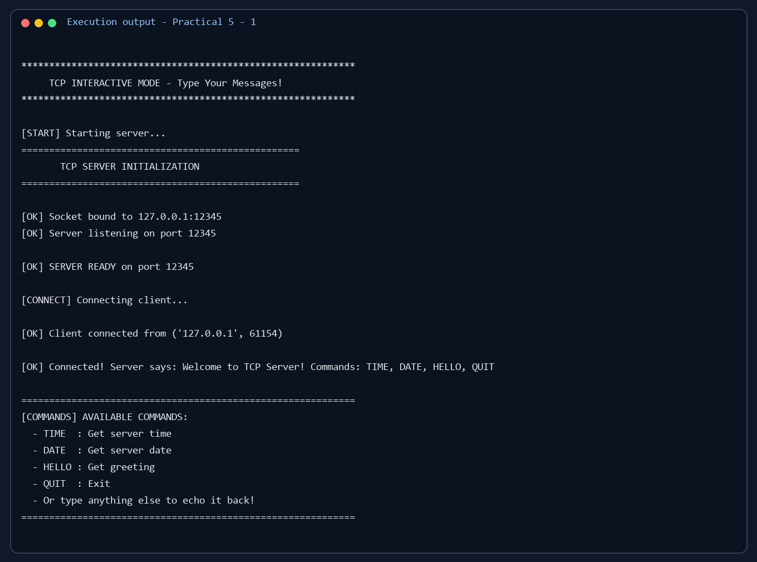

Output screenshot 2
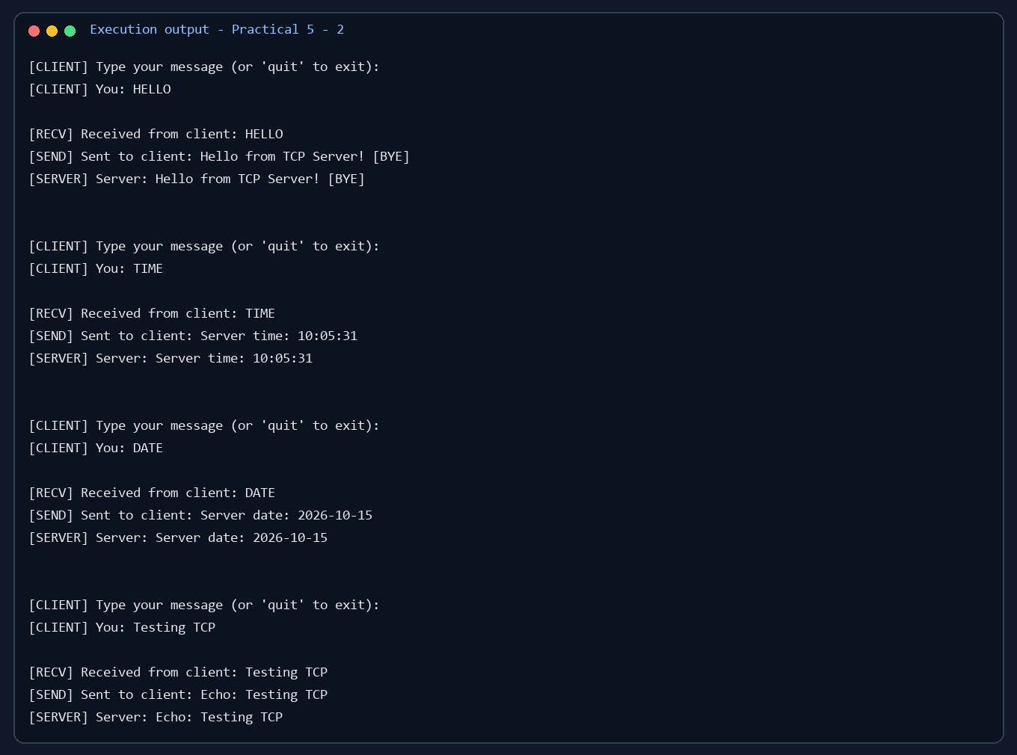

Output screenshot 3
