Computer Networks Practical 6
Practical 6 program, execution record, and output screenshot.
Repository
github.com/dhruv0075/CN-LAB-2

Code

UDP client (6-udpclient.py)
import socket

# Create UDP socket
client_socket = socket.socket(socket.AF_INET, socket.SOCK_DGRAM)

# Server address
server_address = ("localhost", 9998)

print("UDP Client started...")

while True:

print("\n1. Uppercase to Lowercase")
print("2. Lowercase to Uppercase")
print("3. Reverse String")

choice = input("Enter your choice: ")

message = input("Enter a string: ")

# Combine choice and message
data = choice + "|" + message

# Send data to server
client_socket.sendto(data.encode(), server_address)

# Receive response
data, server_address = client_socket.recvfrom(1024)

print("Server response:", data.decode())

again = input("\nDo you want to continue? (yes/no): ")

if again.lower() == "no":
break

client_socket.close()

UDP server (6-udpserver.py)
import socket

# Create UDP socket
server_socket = socket.socket(socket.AF_INET, socket.SOCK_DGRAM)

# Server address and port
server_address = ("localhost", 9998)

# Bind socket
server_socket.bind(server_address)

print("UDP Server started...")
print("Server is waiting for client...")

while True:

# Receive data from client
data, client_address = server_socket.recvfrom(1024)

message = data.decode()

# Separate choice and message
choice, message = message.split("|", 1)

print("\nClient connected from:", client_address)
print("Message received:", message)

# Perform operation
if choice == "1":
result = message.lower()

elif choice == "2":
result = message.upper()

elif choice == "3":
result = message[::-1]

else:
result = "Invalid choice"

# Send result back to client
server_socket.sendto(result.encode(), client_address)

print("Response sent:", result)

Execution output screenshot
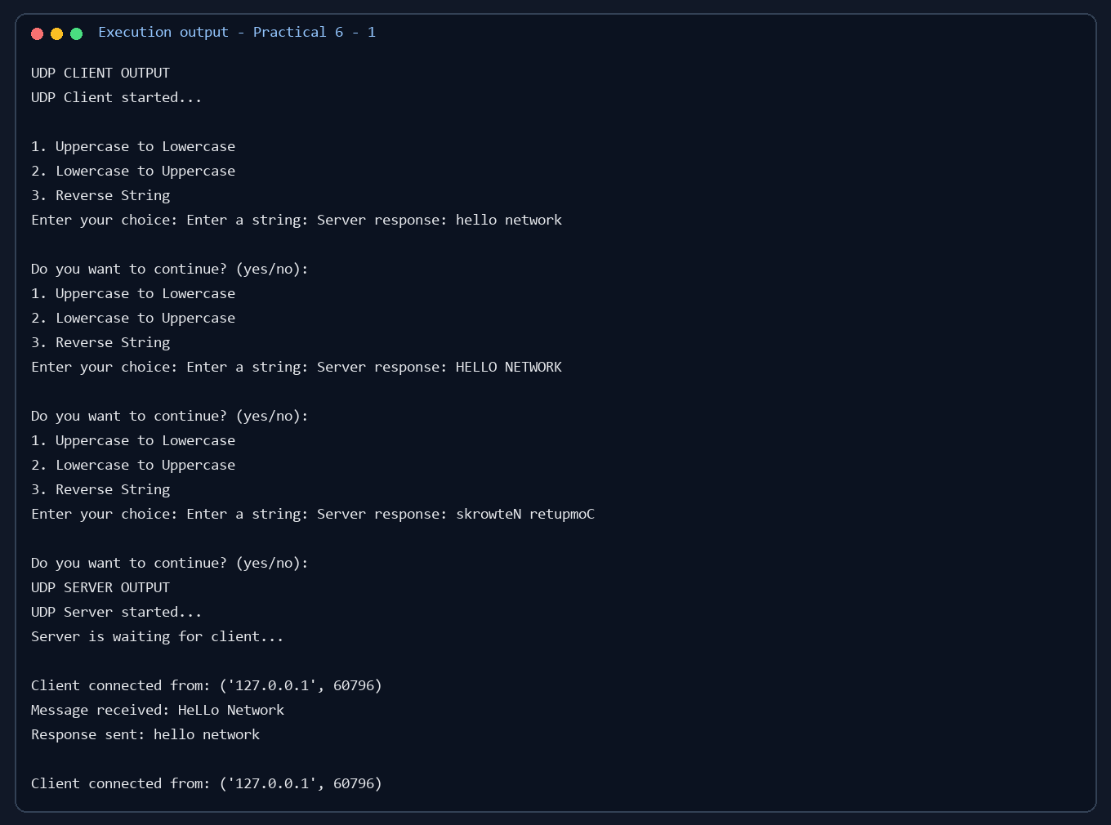

Output screenshot 2
