**ASSIGNMENT 10**

Consider the following tables:

MATCH (match_id, team1, team2, ground, mdate, winner)

PLAYER (p_id, lname, fname, country, yborn, bplace, ftest)

BATTING (match_id, p_id, mts, order, out_type, fow, nruns, nballs, fours, sixes)

BOWLING (match_id, p_id, novers, maidens, nruns, nwickets)

1.Draw the appropriate ER, EER and Relational model for the given data.

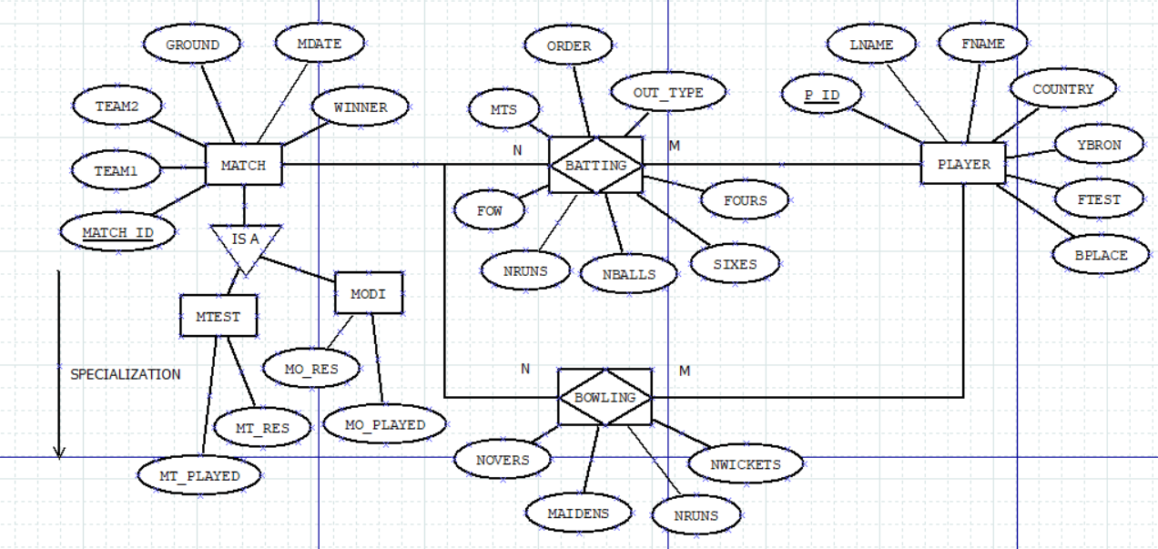

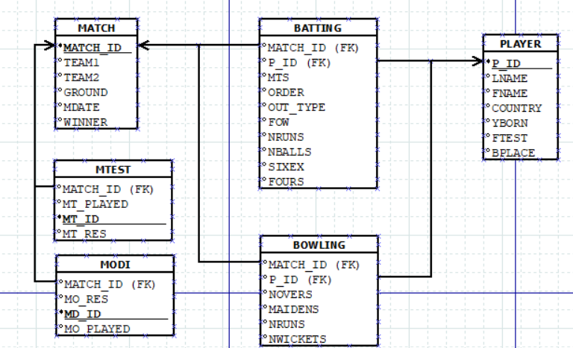

CREATE TABLE MATCH(MATCH_ID VARCHAR2(10) PRIMARY KEY, TEAM1 VARCHAR2(20) NOT NULL, TEAM2 VARCHAR2(20) NOT NULL, GROUND VARCHAR2(20), MDATE DATE, WINNER NUMBER CONSTRAINT M1 CHECK(WINNER IN (1,2)));

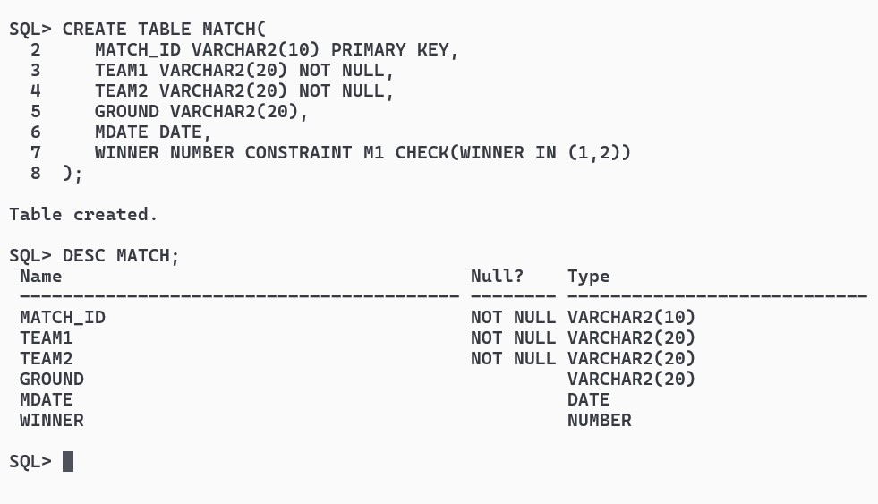

CREATE TABLE PLAYER (P_ID VARCHAR2(10) PRIMARY KEY, LNAME VARCHAR2(20), FNAME VARCHAR2(20), COUNTRY VARCHAR2(20), YBORN NUMBER, BPLACE VARCHAR2(20), FTEST NUMBER);

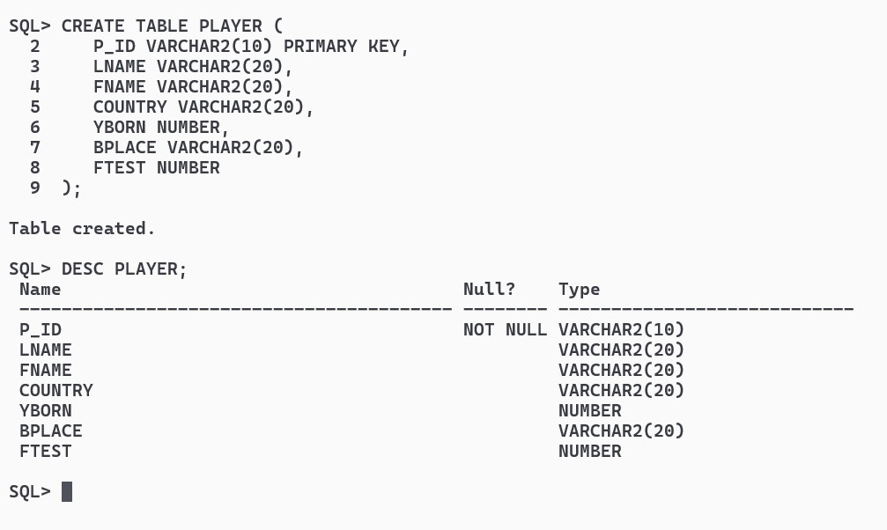

CREATE TABLE BATTING (MATCH_ID VARCHAR2(10), P_ID VARCHAR2(10), MTS NUMBER, BATTING_ORDER NUMBER, OUT_TYPE VARCHAR2(20), FOW VARCHAR2(20), NRUNS NUMBER, NBALLS NUMBER, FOURS NUMBER, SIXES NUMBER, CONSTRAINT BFK1 FOREIGN KEY (P_ID) REFERENCES PLAYER(P_ID) ON DELETE CASCADE, CONSTRAINT BFK2 FOREIGN KEY (MATCH_ID) REFERENCES MATCH(MATCH_ID) ON DELETE CASCADE);

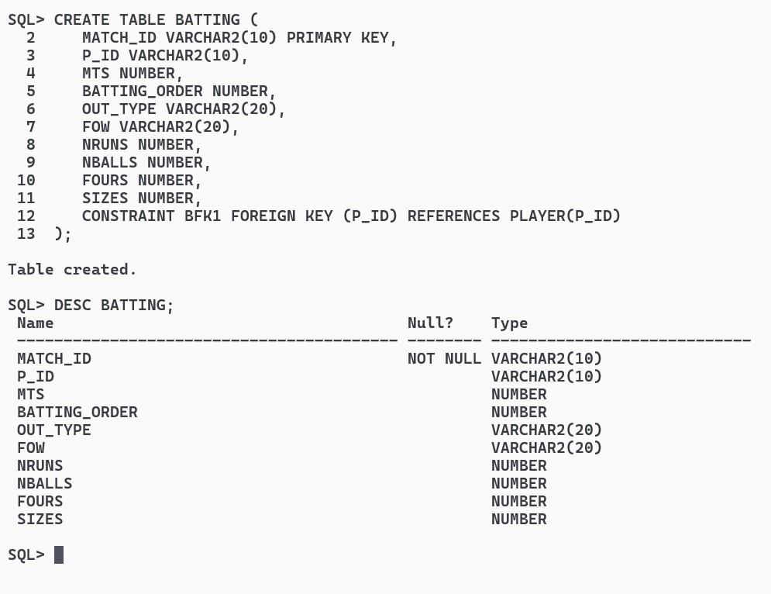

CREATE TABLE BOWLING (MATCH_ID VARCHAR2(10), P_ID VARCHAR2(10), NOVERS NUMBER, MAIDENS NUMBER, NRUNS NUMBER, NWICKETS NUMBER, CONSTRAINT BWFK1 FOREIGN KEY (MATCH_ID) REFERENCES MATCH(MATCH_ID) ON DELETE CASCADE, CONSTRAINT BWFK2 FOREIGN KEY (P_ID) REFERENCES PLAYER(P_ID) ON DELETE CASCADE);

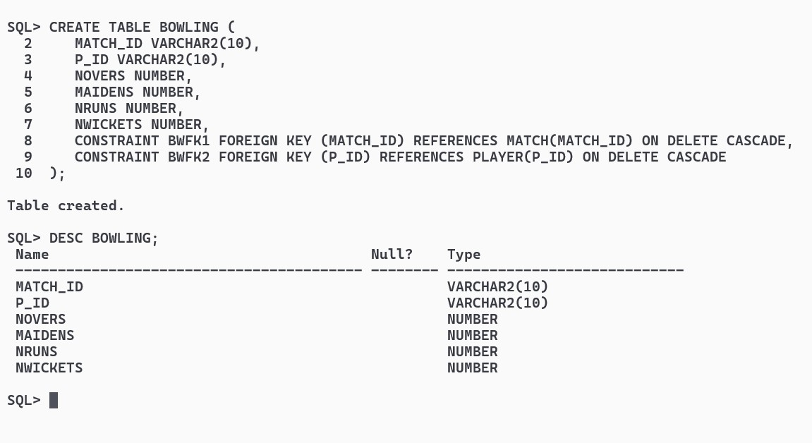

INSERT ALL

INTO MATCH VALUES ('M1', 'Australia', 'India', 'Sydney', TO_DATE('01-01-2023', 'DD-MM-YYYY'), 1)

INTO MATCH VALUES ('M2', 'India', 'Australia', 'Sydney', TO_DATE('05-01-2023', 'DD-MM-YYYY'), 2)

INTO MATCH VALUES ('M3', 'Australia', 'England', 'Melbourne', TO_DATE('10-01-2023', 'DD-MM-YYYY'), 1)

INTO MATCH VALUES ('M4', 'England', 'Australia', 'Sydney', TO_DATE('15-01-2023', 'DD-MM-YYYY'), 2)

INTO MATCH VALUES ('M5', 'Australia', 'India', 'Sydney', TO_DATE('20-01-2023', 'DD-MM-YYYY'), 1)

SELECT * FROM DUAL;

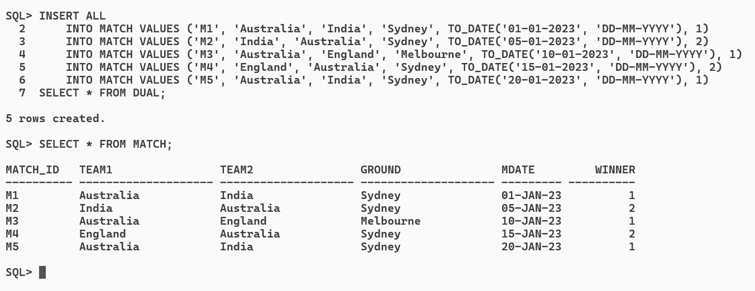

INSERT ALL

INTO PLAYER VALUES ('27001', 'Smith', 'Steven', 'Australia', 1988, 'Sydney', 40)

INTO PLAYER VALUES ('27002', 'Kohli', 'Virat', 'India', 1988, 'Delhi', 55)

INTO PLAYER VALUES ('27003', 'Root', 'Joe', 'England', 1990, 'Sheffield', 50)

INTO PLAYER VALUES ('27004', 'Warner', 'David', 'Australia', 1986, 'Sydney', 45)

INTO PLAYER VALUES ('27005', 'Stokes', 'Ben', 'England', 1991, 'London', 60)

SELECT * FROM DUAL;

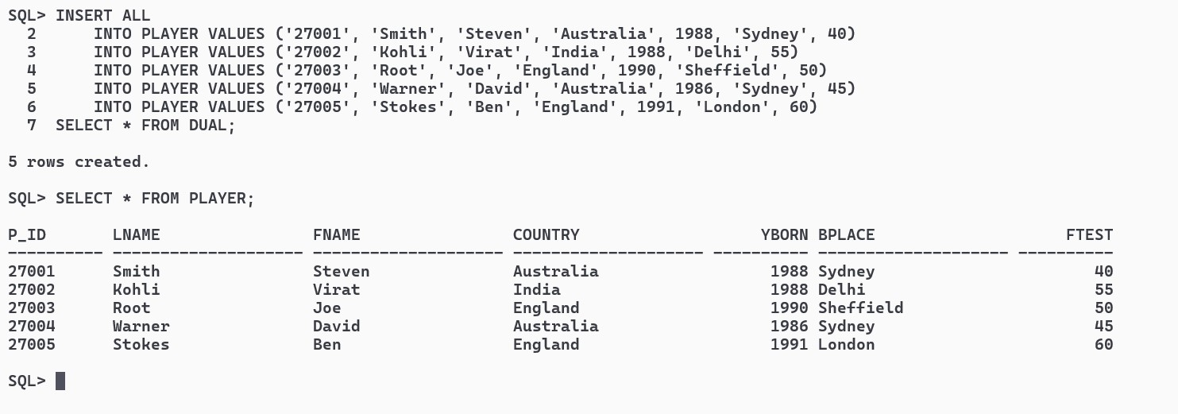

INSERT ALL

INTO BATTING VALUES ('M1', '27001', 1, 1, 'Not out', NULL, 80, 100, 8, 1)

INTO BATTING VALUES ('M1', '27002', 1, 2, 'Caught', '20/1', 30, 40, 4, 0)

INTO BATTING VALUES ('M2', '27003', 1, 3, 'LBW', '30/2', 25, 35, 3, 0)

INTO BATTING VALUES ('M2', '27004', 1, 4, 'Not out', NULL, 90, 110, 10, 2)

INTO BATTING VALUES ('M3', '27005', 1, 5, 'Run out', '50/3', 45, 55, 6, 0)

SELECT * FROM DUAL;

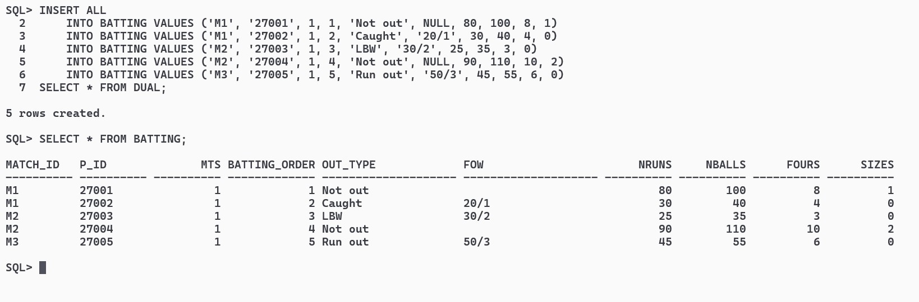

INSERT ALL

INTO BOWLING VALUES ('M1', '27001', 10, 2, 60, 2)

INTO BOWLING VALUES ('M1', '27002', 8, 1, 45, 1)

INTO BOWLING VALUES ('M2', '27003', 9, 0, 55, 1)

INTO BOWLING VALUES ('M2', '27004', 10, 3, 40, 2)

INTO BOWLING VALUES ('M3', '27005', 9, 1, 65, 0)

SELECT * FROM DUAL;

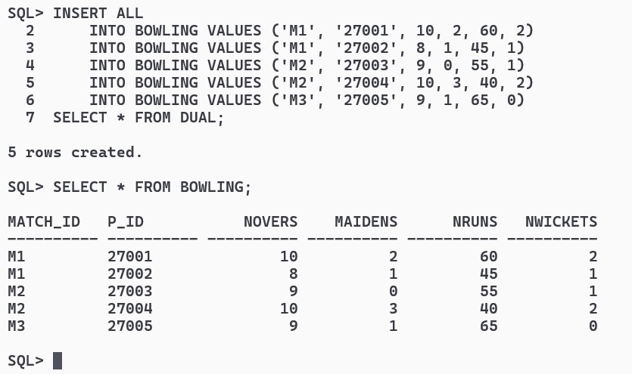

2.Write SQL expressions for the following:

i)Find match ids of those matches in which player 27001 bats and makes more runs than he made at every match he played at Sydney.

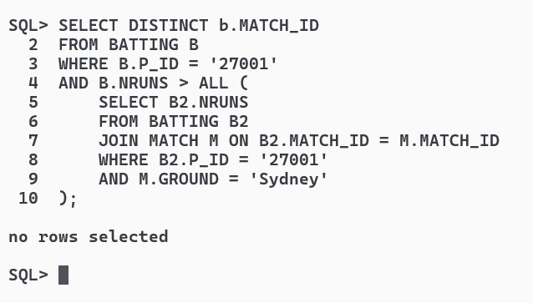

ii)Find player ids of players who have scored more than 30 in every ODI match that they have batted.

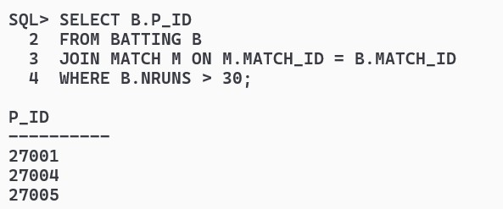

iii)Find the ids of players that had a higher average score than the average score for all players when they played in Sri Lanka.

