React uses a **Virtual DOM**, which is an in-memory representation of the actual DOM in the browser. When a user interacts with the app (e.g., clicking a button, typing in a form), React updates the Virtual DOM and compares it to the real DOM. This process is called **reconciliation**, and it helps React efficiently update only the parts of the UI that have changed, rather than re-rendering the entire page.

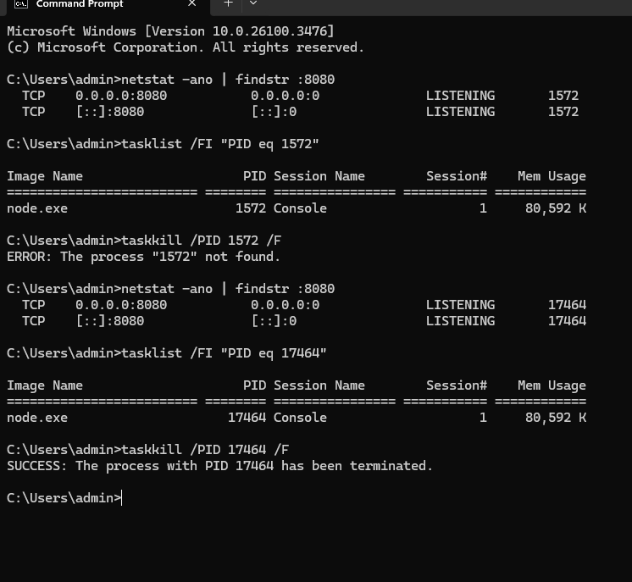

netstat -ano | findstr :8080

tasklist /FI "PID eq 24660"

taskkill /PID 24660 /F

After stripe setup we need to configure webhook that will inform our backend server after the payment status based on this we can placer order or discard.

We can get webhook in stripe web page. We can download local listener.

We will use it in local system so we will download the webhook cli and configure the environment variables.

After that we can login webhook using our cli. Then we can get the webhook signing secret key with our backend url. 