WEEK 3 ASSIGNMENT
Unsupervised Learning and Clustering Analysis
Customer Segmentation Using K-Means Clustering

Name: JOYDEEP DAS
Dataset: Mall Customers
Tools: Python, Pandas, NumPy, Matplotlib, Seaborn, Scikit-learn
Clustering Method: K-Means
Dataset Size: 200 customers

1. Introduction
Unsupervised learning is a type of machine learning where an algorithm looks for patterns or groups in data without being given predefined target labels. In this Week 3 task, K-Means clustering is used to segment mall customers according to their annual income and spending score. The purpose is not to predict a known outcome, but to discover groups of customers who show similar purchasing characteristics.
The Mall Customers dataset is a small, publicly available educational dataset containing 200 customers and five columns: CustomerID, Gender, Age, Annual Income (k$), and Spending Score (1-100). The dataset was created for customer-segmentation learning and is commonly used to demonstrate K-Means clustering.
For clustering, Annual Income and Spending Score were selected as the primary features because they directly represent two important dimensions of customer purchasing behaviour. Age and Gender were retained for later cluster profiling rather than used as the main distance variables. This makes the resulting segments easier to explain in business terms.

2. Objective
- Understand the structure and quality of the customer dataset.
- Prepare appropriate numerical features for unsupervised learning.
- Use the Elbow Method and Silhouette Score to evaluate candidate values of k.
- Apply K-Means clustering and identify meaningful customer segments.
- Visualize the resulting clusters and their centroids.
- Profile each cluster using age, income, spending score, and gender composition.
- Discuss possible business implications while recognizing that the dataset is educational and not a complete real-world customer database.

3. Dataset Description
The dataset contains 200 observations. Each observation represents one mall customer. The original public dataset describes CustomerID, Gender, Age, Annual Income (k$), and Spending Score (1-100); the spending score is an assigned measure of customer behaviour and spending nature. citeturn0search7turn1view0
Variable | Type | Use in Analysis
CustomerID | Integer | Identifier; not used for clustering
Gender | Categorical | Profiling
Age | Integer | Profiling
Annual Income (k$) | Integer | Clustering feature
Spending Score (1-100) | Integer | Clustering feature

4. Initial Data Inspection
The first step was to inspect the shape, data types, duplicate records, missing values, and descriptive statistics. The dataset has 200 rows and five columns. The supplied public version contains no missing values in the five fields, so no imputation was required. CustomerID is an identifier and was excluded from distance calculations because its numerical value has no behavioural meaning.

Descriptive statistics for numerical variables
Index | count | mean | std | min | 25% | 50% | 75% | max
Age | 200.00 | 38.85 | 13.97 | 18.00 | 28.75 | 36.00 | 49.00 | 70.00
Annual Income (k$) | 200.00 | 60.56 | 26.26 | 15.00 | 41.50 | 61.50 | 78.00 | 137.00
Spending Score (1-100) | 200.00 | 50.20 | 25.82 | 1.00 | 34.75 | 50.00 | 73.00 | 99.00

5. Exploratory Data Analysis
The distributions show that annual income ranges from 15 to 137 thousand dollars, while spending score ranges from 1 to 99. The scatter plot of income against spending score is especially useful because it gives an early visual indication that customers are not distributed randomly: there are areas of low-income/high-spending, high-income/low-spending, and high-income/high-spending customers, along with a larger middle region.
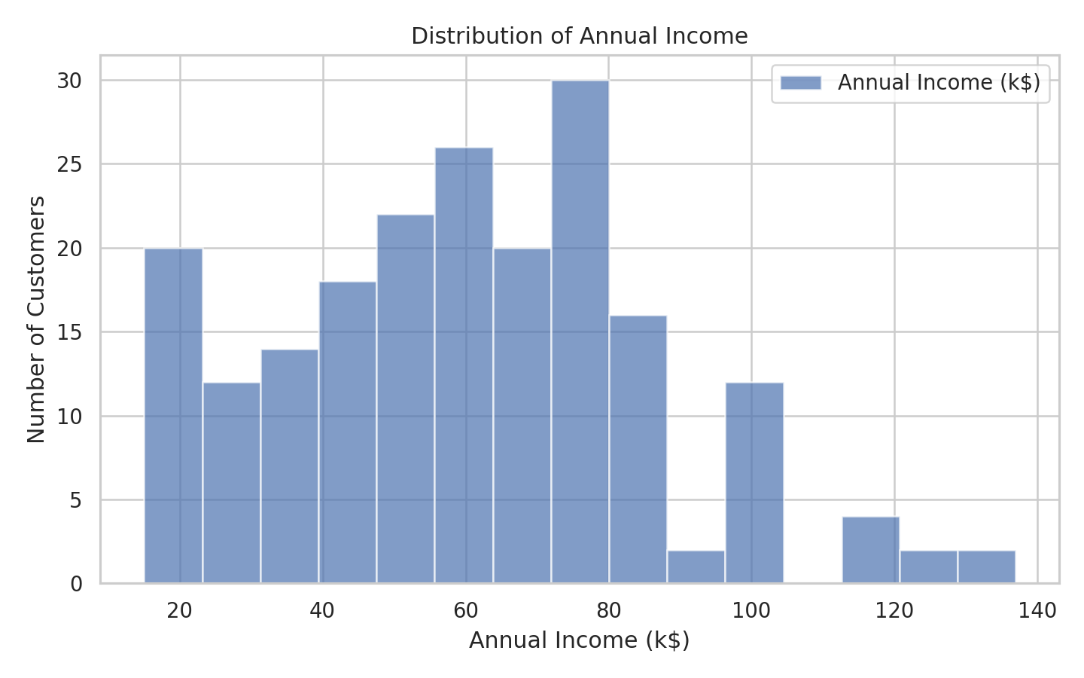
Figure 1. Distribution of annual income.
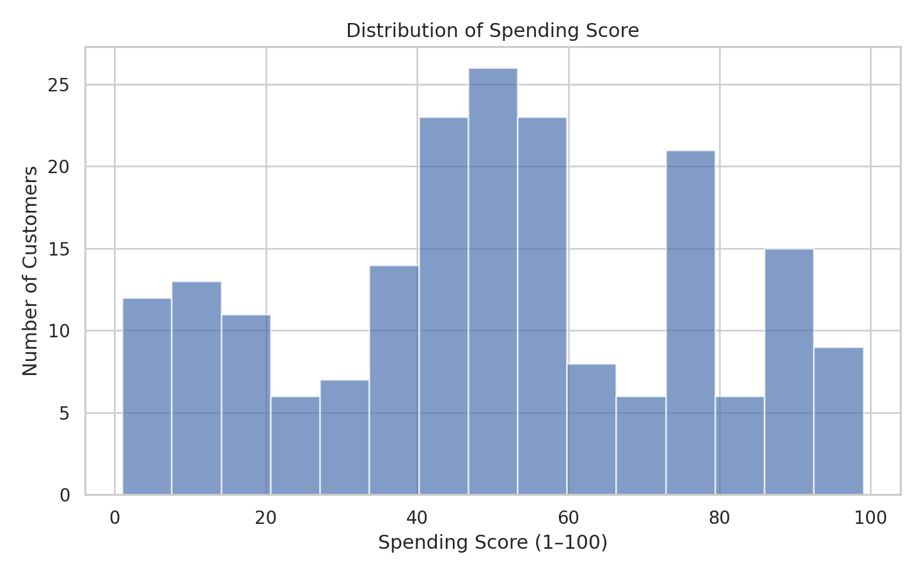
Figure 2. Distribution of spending score.
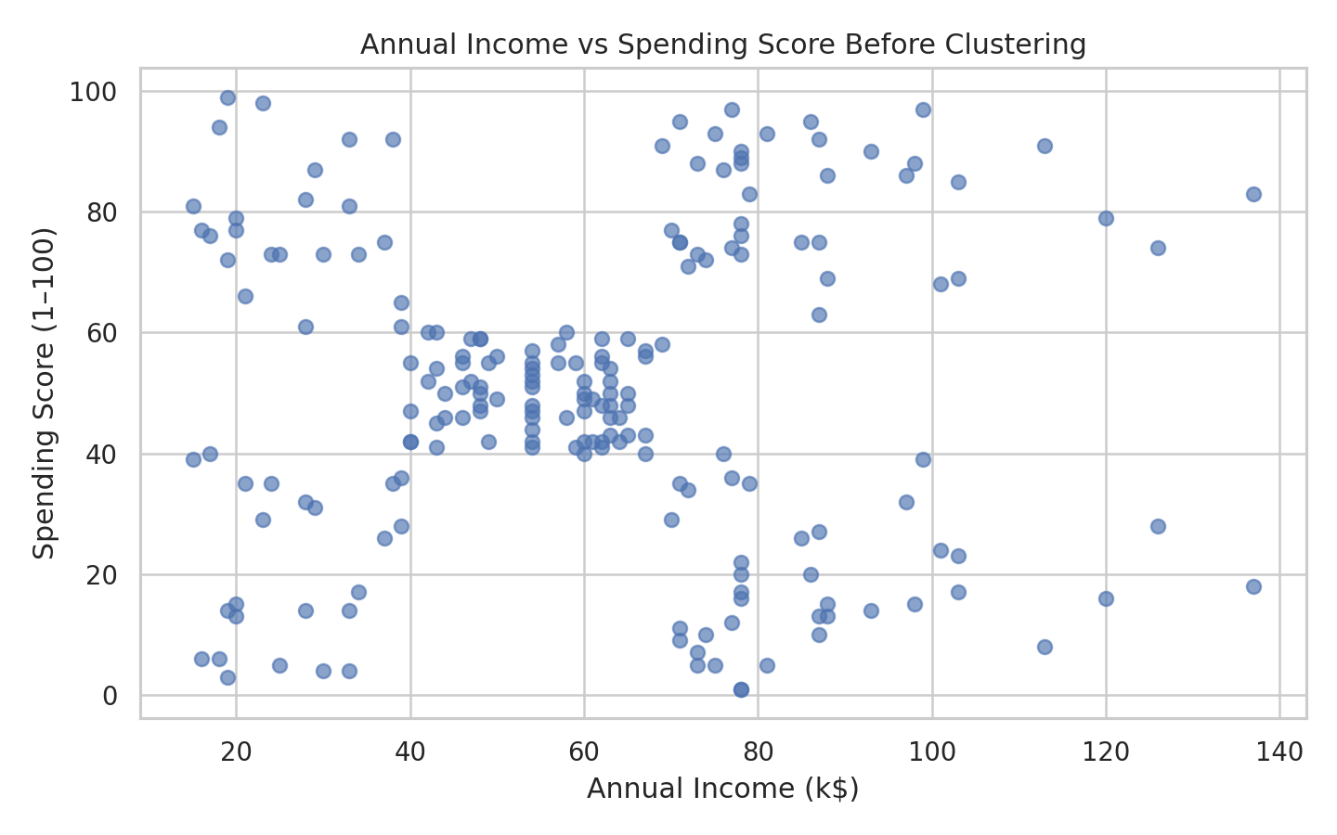
Figure 3. Annual income versus spending score before clustering.

6. Data Preprocessing
Only Annual Income and Spending Score were used as the clustering variables. CustomerID was removed from the model inputs because it is only an identifier. Gender and Age were not used to create the clusters; instead, they were kept for interpretation after clustering.
Standardization was applied using StandardScaler. This transforms each selected feature to approximately zero mean and unit variance. Scaling is important because K-Means uses distance calculations, and features measured on different scales can otherwise contribute unequally to the distance. The scikit-learn KMeans implementation uses cluster centroids and allows the number of clusters to be specified through n_clusters.
from sklearn.preprocessing import StandardScaler
features = ['Annual Income (k$)', 'Spending Score (1-100)']
scaler = StandardScaler()
X_scaled = scaler.fit_transform(df[features])

7. Choosing the Number of Clusters
Choosing k is one of the most important decisions in K-Means. Two complementary diagnostics were used: the Elbow Method and the Silhouette Score. The Elbow Method plots inertia (within-cluster sum of squared distances) for different values of k. As k increases, inertia normally decreases; the useful point is where additional clusters begin to provide smaller improvements.
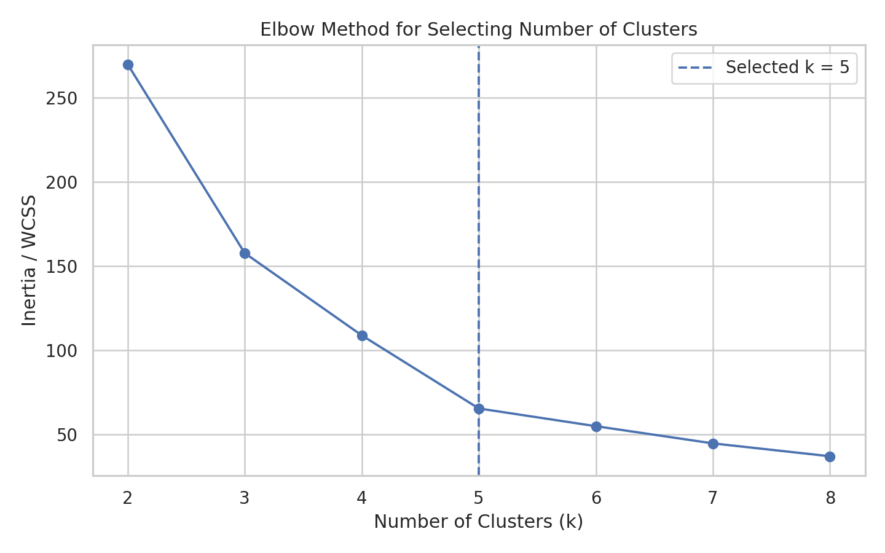
Figure 4. Elbow Method for candidate values of k.
The Silhouette Score provides a second perspective on separation and compactness. Its values range from -1 to 1; values closer to 1 indicate stronger separation, values around 0 indicate overlapping boundaries, and negative values can indicate questionable assignments. For k=5, the average silhouette score in this analysis is 0.555. Across k=2 to 8, the highest tested silhouette score was 0.555 at k=5. Although the silhouette diagnostic is useful, cluster selection should also consider interpretability and the visible structure in the data.
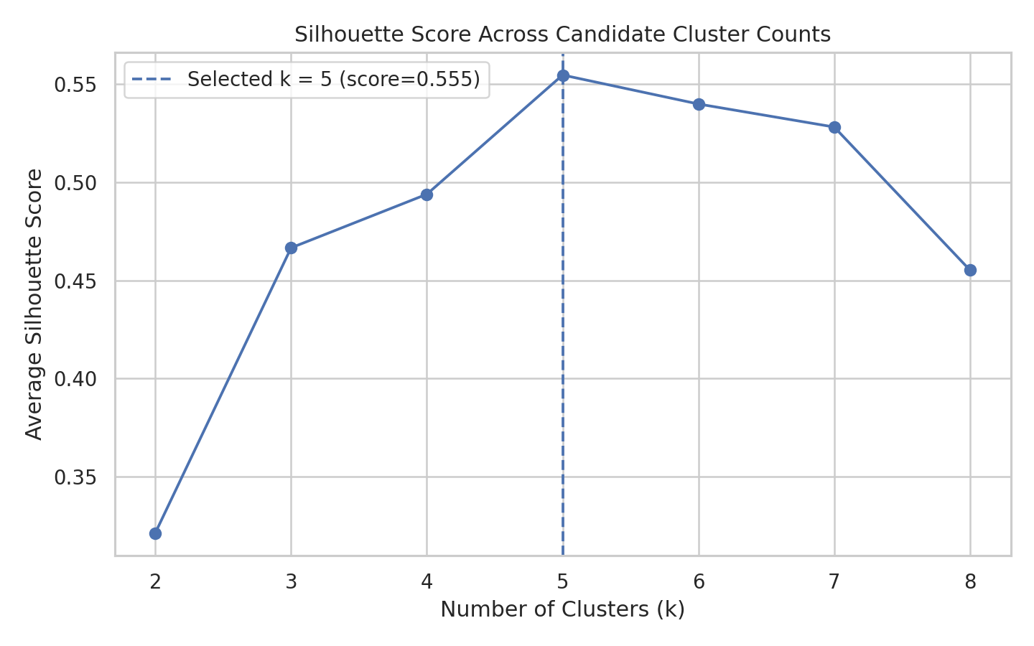
Figure 5. Silhouette scores for candidate cluster counts.

Model-selection diagnostics
k | Inertia | Silhouette Score
2 | 269.69 | 0.32
3 | 157.70 | 0.47
4 | 108.92 | 0.49
5 | 65.57 | 0.55
6 | 55.06 | 0.54
7 | 44.86 | 0.53
8 | 37.23 | 0.46

Based on the clear elbow around five groups, the visual separation in the income-spending space, and the interpretability of five customer segments, k=5 was selected for the final K-Means model.

8. K-Means Clustering Method
The final model was fitted with five clusters, k-means++ initialization, 10 initializations, a maximum of 300 iterations, and random_state=42 for reproducibility. The model assigns each customer to the nearest centroid and repeatedly updates centroids until the solution converges.
from sklearn.cluster import KMeans
kmeans = KMeans(
n_clusters=5,
init='k-means++',
n_init=10,
max_iter=300,
random_state=42
)
df['Cluster'] = kmeans.fit_predict(X_scaled)

9. Cluster Visualization
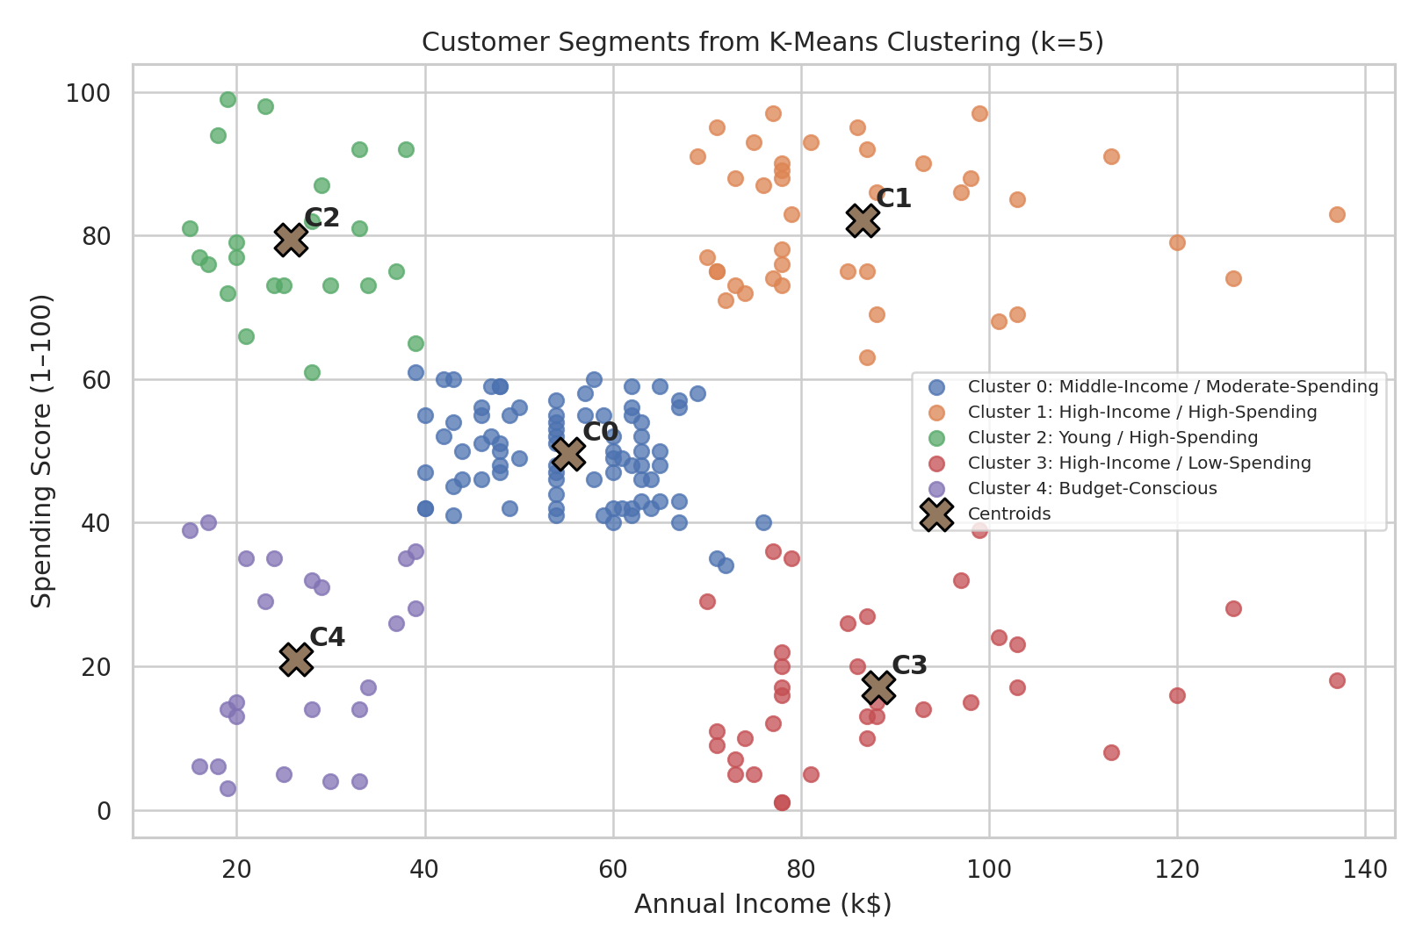
Figure 6. K-Means customer clusters and centroids.
The scatter plot shows five groups in the two-dimensional feature space. The X-shaped markers represent the K-Means centroids. The clusters are separated mainly by combinations of income and spending behaviour rather than by a single variable.

10. Cluster Characteristics

Final cluster profile
Cluster | Segment | Customers | Customer Share (%) | Average Age | Average Income (k$) | Average Spending Score | Female (%) | Male (%)
0 | Middle-Income / Moderate-Spending | 81 | 40.5% | 42.72 | 55.30 | 49.52 | 59.3% | 40.7%
1 | High-Income / High-Spending | 39 | 19.5% | 32.69 | 86.54 | 82.13 | 53.8% | 46.2%
2 | Young / High-Spending | 22 | 11.0% | 25.27 | 25.73 | 79.36 | 59.1% | 40.9%
3 | High-Income / Low-Spending | 35 | 17.5% | 41.11 | 88.20 | 17.11 | 45.7% | 54.3%
4 | Budget-Conscious | 23 | 11.5% | 45.22 | 26.30 | 20.91 | 60.9% | 39.1%

Cluster 0: Middle-Income / Moderate-Spending
This segment contains 81 customers (40.5% of the dataset). The average age is 42.7 years, average annual income is 55.3 thousand dollars, and average spending score is 49.5. The gender composition is approximately 59.3% female and 40.7% male.
Interpretation: This group sits closer to the middle of the income and spending ranges. It can be treated as a broad mainstream segment, although additional customer-level data would be needed for more specific targeting.

Cluster 1: High-Income / High-Spending
This segment contains 39 customers (19.5% of the dataset). The average age is 32.7 years, average annual income is 86.5 thousand dollars, and average spending score is 82.1. The gender composition is approximately 53.8% female and 46.2% male.
Interpretation: These customers combine relatively high income with high spending scores. In a business setting, they may be suitable for premium product communication, loyalty benefits, and personalized offers.

Cluster 2: Young / High-Spending
This segment contains 22 customers (11.0% of the dataset). The average age is 25.3 years, average annual income is 25.7 thousand dollars, and average spending score is 79.4. The gender composition is approximately 59.1% female and 40.9% male.
Interpretation: This segment combines lower-to-middle income with high spending scores. The group may respond to affordable products, promotions, trend-oriented campaigns, and frequent engagement.

Cluster 3: High-Income / Low-Spending
This segment contains 35 customers (17.5% of the dataset). The average age is 41.1 years, average annual income is 88.2 thousand dollars, and average spending score is 17.1. The gender composition is approximately 45.7% female and 54.3% male.
Interpretation: These customers have relatively high income but lower spending scores. Their behaviour may indicate limited engagement, different preferences, or less frequent purchasing. A business could study this group further before designing targeted communication.

Cluster 4: Budget-Conscious
This segment contains 23 customers (11.5% of the dataset). The average age is 45.2 years, average annual income is 26.3 thousand dollars, and average spending score is 20.9. The gender composition is approximately 60.9% female and 39.1% male.
Interpretation: These customers show comparatively lower income and lower spending scores. Value-oriented products, discounts, bundles, or practical promotions may be relevant when designing a business experiment.
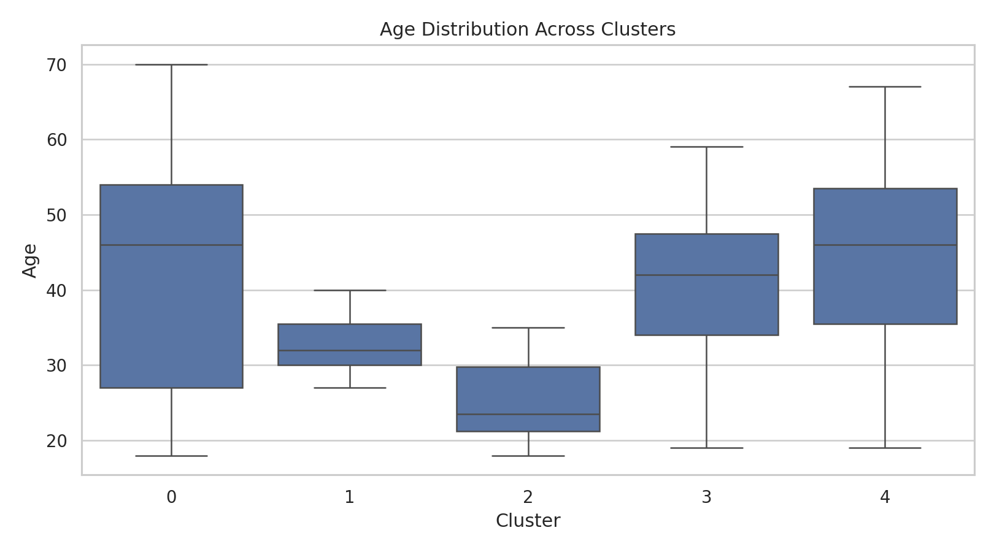
Figure 7. Age distribution across the five clusters.
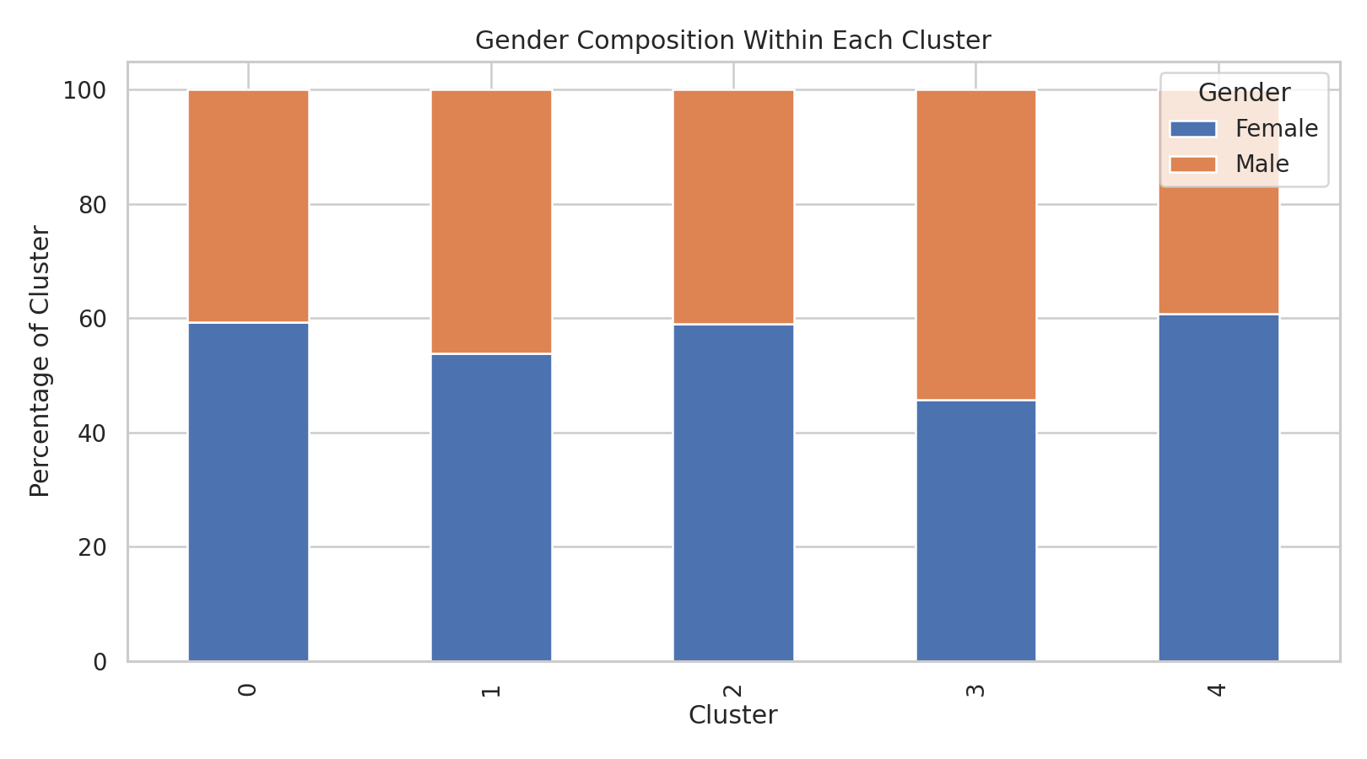
Figure 8. Gender composition within each cluster.

11. Business and Research Implications
The main practical value of clustering is that it turns a large collection of individual customer records into a smaller number of understandable behavioural groups. A mall could use these segments as a starting point for testing different marketing approaches, such as premium loyalty benefits for high-income/high-spending customers, value promotions for budget-conscious customers, or engagement campaigns for high-income customers who currently spend less.
These implications should be treated as hypotheses rather than guaranteed outcomes. The dataset does not include transaction history, product categories, visit frequency, customer lifetime value, location, or actual profit. Therefore, a real business would need additional data and controlled experiments before acting on any segmentation strategy.

12. Critical Discussion
K-Means is useful here because the selected variables are numerical and the visual data structure contains relatively compact groups. It is also easy to explain because each cluster is represented by a centroid. However, K-Means has limitations. It requires the number of clusters to be selected in advance, is sensitive to feature scaling, and works best when clusters are reasonably compact and separated. Different random seeds, feature choices, or preprocessing decisions can produce different assignments.
Another important limitation is that cluster numbers themselves have no inherent meaning. Cluster 0 is not automatically better, larger, or more important than Cluster 4. The descriptive names used in this report were assigned only after examining the centroid values and cluster profiles.

13. Reproducibility and Code Quality
The analysis uses a fixed random_state=42, explicit feature selection, StandardScaler, and clearly defined K-Means parameters. The workflow can be reproduced by loading the same CSV file, applying the same preprocessing steps, fitting K-Means, and generating the same cluster labels up to the normal label-number permutation issue.
# Complete core workflow
import pandas as pd
from sklearn.preprocessing import StandardScaler
from sklearn.cluster import KMeans
from sklearn.metrics import silhouette_score
df = pd.read_csv('Mall_Customers.csv')
features = ['Annual Income (k$)', 'Spending Score (1-100)']
X = df[features]
scaler = StandardScaler()
X_scaled = scaler.fit_transform(X)
kmeans = KMeans(
n_clusters=5,
init='k-means++',
n_init=10,
max_iter=300,
random_state=42
)
labels = kmeans.fit_predict(X_scaled)
df['Cluster'] = labels
score = silhouette_score(X_scaled, labels)
print('Silhouette Score:', score)
print(df.groupby('Cluster')[features].mean())

14. Limitations
- The dataset has only 200 customers and is intended primarily for learning and demonstration.
- The spending score is an assigned score rather than a raw monetary spending amount.
- Only income and spending score were used for clustering, so other customer characteristics are not represented in the distance calculation.
- K-Means assumes a particular type of cluster geometry and may not capture every possible customer structure.
- The business recommendations are hypotheses and should not be treated as proven causal effects.

15. Conclusion
This project applied unsupervised learning to segment 200 mall customers using K-Means clustering. After checking the data and standardizing Annual Income and Spending Score, candidate values of k were compared using the Elbow Method and Silhouette Score. A five-cluster solution was selected for the final analysis, with a silhouette score of 0.555. The resulting segments show clear differences in income and spending behaviour, and Age and Gender were then used to provide additional descriptive context.
The most important lesson from the analysis is that clustering is not finished when the algorithm produces labels. The useful part comes from examining the cluster profiles, visualizing the separation, and translating the numerical differences into understandable customer characteristics. At the same time, the results should be viewed as exploratory because the dataset is small and educational. A real customer-segmentation project would require richer transaction and behavioural data, validation on new observations, and business testing.

16. References
- Vijay Choudhary. Mall Customer Segmentation Data, Kaggle. Public educational dataset containing 200 mall customers.
- MoustafaMohamed01. Mall-Customer-Segmentation-Data, GitHub. Public repository containing the Mall_Customers.csv dataset and example K-Means workflow.
- Scikit-learn documentation. KMeans API and clustering implementation.
- Scikit-learn documentation. Selecting the number of clusters with silhouette analysis on KMeans clustering.
Dataset/source page: https://www.kaggle.com/vjchoudhary7/customer-segmentation-tutorial-in-python
Dataset mirror used for verification: https://github.com/MoustafaMohamed01/Mall-Customer-Segmentation-Data
Scikit-learn KMeans: https://scikit-learn.org/stable/modules/generated/sklearn.cluster.KMeans.html
Scikit-learn silhouette analysis: https://scikit-learn.org/stable/auto_examples/cluster/plot_kmeans_silhouette_analysis.html

Appendix A: Suggested 30–35 Hour Work Plan
Activity | Estimated Hours
Dataset selection and problem understanding | 3
Data loading and quality checks | 4
Exploratory analysis and visualization | 5
Feature selection and preprocessing | 4
K-Means experiments and k selection | 5
Cluster profiling and interpretation | 5
Report writing and figure preparation | 5
Code review, reproducibility, and final editing | 3

Total planned effort: approximately 34 hours. The estimate is aligned with the assignment expectation of approximately 30–35 hours and includes analysis, visualization, interpretation, and documentation.

