WEEK 4 ASSIGNMENT
Supervised Learning Model Implementation
Breast Cancer Classification Using Logistic Regression

Name: JOYDEEP DAS
Dataset: Breast Cancer Wisconsin (Diagnostic)
Task Type: Binary Classification
Model: Logistic Regression
Dataset Size: 569 samples × 30 features

1. Introduction
Supervised learning uses labelled examples to learn a relationship between input variables and a known target. For this Week 4 task, a binary classification problem was selected: predicting whether a breast tumour observation is classified as malignant or benign from numerical measurements of cell nuclei.
The Breast Cancer Wisconsin (Diagnostic) dataset is provided directly by scikit-learn and is a copy of the UCI dataset. It contains 569 samples, 30 real-valued predictive features, and two classes: malignant and benign.
Logistic Regression was selected because the target is binary, the inputs are numerical, the model is efficient, and its coefficients provide an interpretable way to examine relationships between standardized predictors and predicted class.

2. Problem Definition and Objective
Problem statement: Given 30 numerical measurements derived from digitized images of breast-cell nuclei, build a model that predicts whether an observation belongs to the malignant or benign class.
- Prepare the dataset for supervised learning.
- Explore class balance and important feature relationships.
- Split the data using stratification.
- Standardize numerical features without data leakage.
- Train a Logistic Regression classifier.
- Validate using 5-fold stratified cross-validation.
- Evaluate with accuracy, precision, recall, F1-score, ROC-AUC, and a confusion matrix.
- Discuss interpretation, limitations, and possible improvements.

3. Dataset Description
The dataset contains 569 observations and 30 numeric predictive attributes. The features describe characteristics such as radius, texture, perimeter, area, smoothness, compactness, concavity, concave points, symmetry, and fractal dimension. The measurements include mean, standard error, and worst/largest versions of these characteristics, producing 30 feature columns.

Dataset overview
Item | Value
Samples | 569
Predictive features | 30
Classes | 2
Malignant samples | 212
Benign samples | 357
Missing values | 0
Duplicate rows | 0

4. Data Preparation and Feature Engineering
The dataset is already numerical, so categorical encoding is not required. The target is coded as 0 for malignant and 1 for benign. No missing values or duplicate rows were found.
All 30 predictors were standardized. This is useful because the raw measurements have different numerical ranges. A Pipeline was used so that scaling is learned only from training data during each cross-validation fold, preventing preprocessing leakage.
from sklearn.pipeline import Pipeline
from sklearn.preprocessing import StandardScaler
from sklearn.linear_model import LogisticRegression
model = Pipeline([
('scaler', StandardScaler()),
('logistic', LogisticRegression(max_iter=5000, random_state=42))
])

5. Exploratory Data Analysis
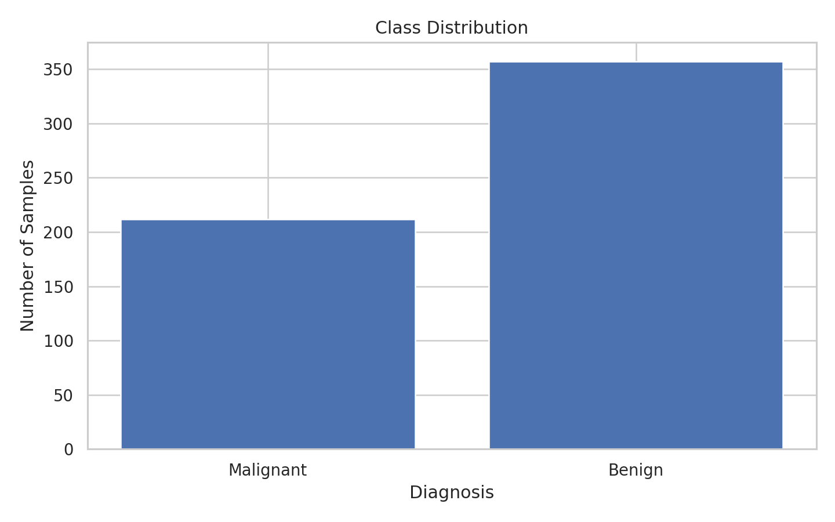
Figure 1. Distribution of the two target classes.
The dataset contains 357 benign observations and 212 malignant observations. The classes are therefore not perfectly balanced, so several metrics are reported rather than relying only on accuracy.
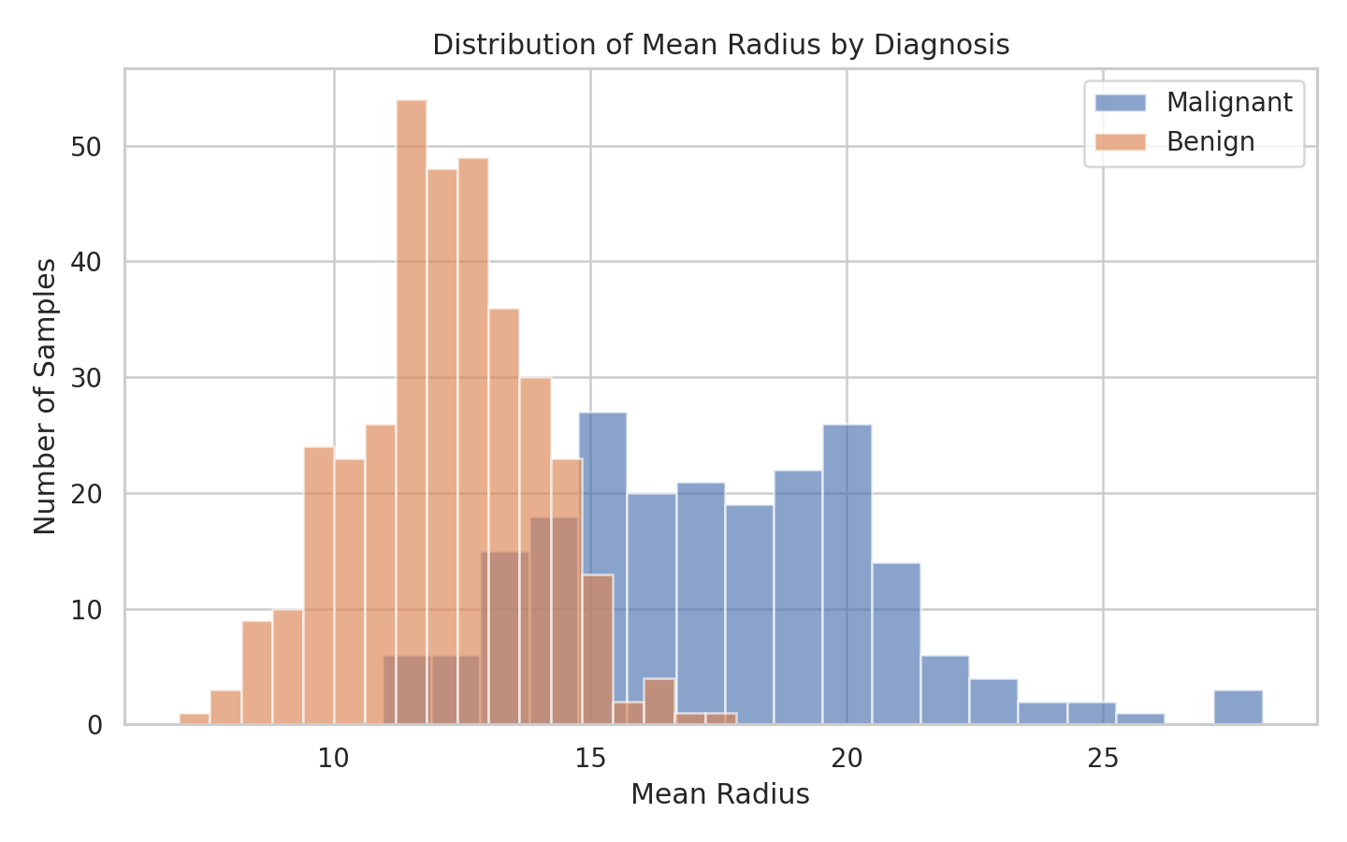
Figure 2. Distribution of mean radius by diagnosis.
The mean-radius distributions show visible differences between the classes. This indicates that the measured cell characteristics contain predictive information, while also showing that no single feature perfectly separates the classes.
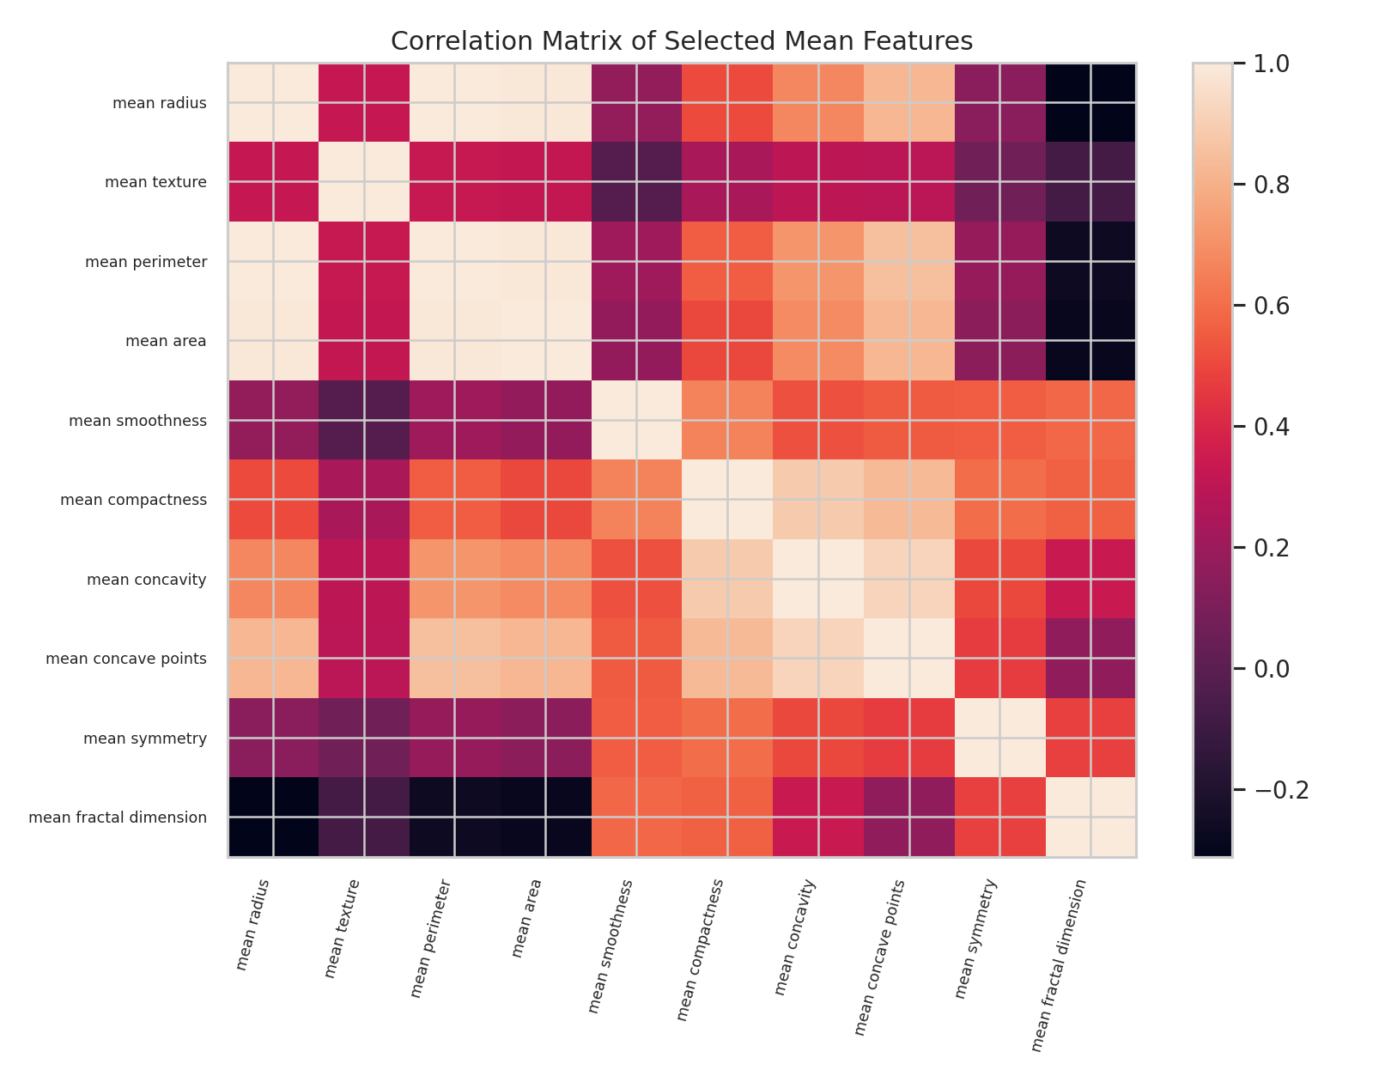
Figure 3. Correlation matrix of selected mean features.
Several size-related variables are strongly correlated. This can make individual Logistic Regression coefficients harder to interpret in isolation, even when the overall predictive performance is strong.
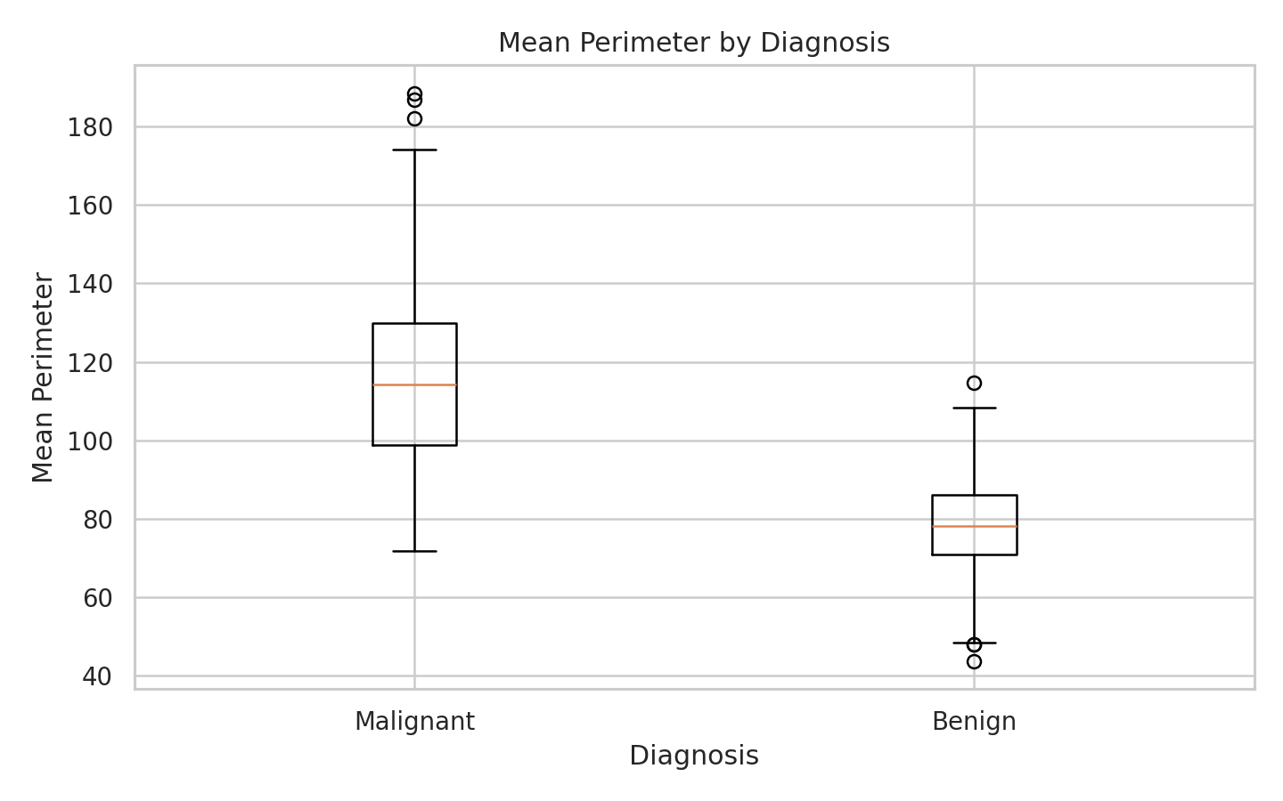
Figure 4. Mean perimeter by diagnosis.

6. Train-Test Split
The dataset was split into 80% training data and 20% test data. Stratification preserved approximately the same class proportions in both subsets. The test set was kept separate until final evaluation.
from sklearn.model_selection import train_test_split
X_train, X_test, y_train, y_test = train_test_split(
X, y, test_size=0.20,
stratify=y, random_state=42
)

7. Model Selection: Logistic Regression
Logistic Regression is appropriate for a binary target because it estimates class probabilities and converts them into predictions using a classification threshold. It is also a useful baseline because it is efficient and its coefficients can be inspected after standardization.
model.fit(X_train, y_train)
y_pred = model.predict(X_test)
y_prob = model.predict_proba(X_test)[:, 1]

8. Cross-Validation
Five-fold Stratified Cross-Validation was applied to the training data. The pipeline performs scaling separately within each fold. Multiple metrics were recorded so that model performance could be evaluated from several perspectives.

Five-fold cross-validation results
Metric | Mean CV Score | Std. Deviation
Accuracy | 0.9780 | 0.0098
Precision | 0.9795 | 0.0162
Recall | 0.9860 | 0.0131
F1 | 0.9825 | 0.0078
Roc_AUC | 0.9959 | 0.0050

9. Test-Set Evaluation

Final test-set performance
Metric | Test Score
Accuracy | 0.9825
Precision | 0.9861
Recall | 0.9861
F1 Score | 0.9861
ROC-AUC | 0.9954

On the held-out test set, the model achieved accuracy=0.982, precision=0.986, recall=0.986, F1=0.986, and ROC-AUC=0.995. These metrics should be interpreted together.
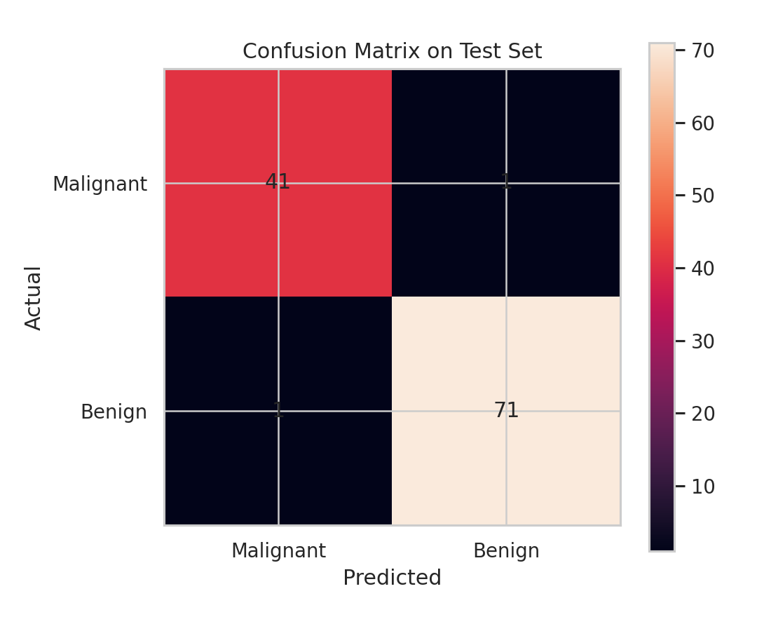
Figure 6. Confusion matrix on the held-out test set.
The confusion matrix contains 41 true negatives, 1 false positives, 1 false negatives, and 71 true positives under the dataset's 0=malignant, 1=benign coding. The false-negative count therefore represents malignant observations classified as benign. This is an educational model and should not be treated as a clinical diagnostic tool.
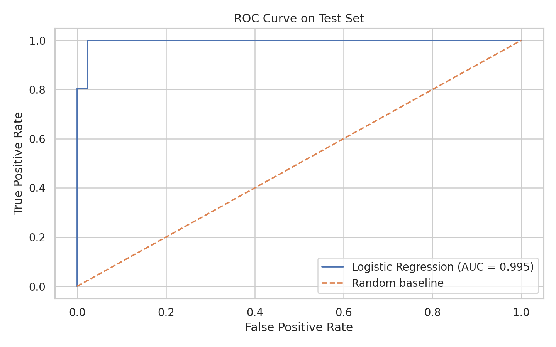
Figure 5. ROC curve on the held-out test set.
The ROC curve compares true-positive rate and false-positive rate over different thresholds. ROC-AUC summarizes ranking performance across thresholds.

10. Feature Interpretation
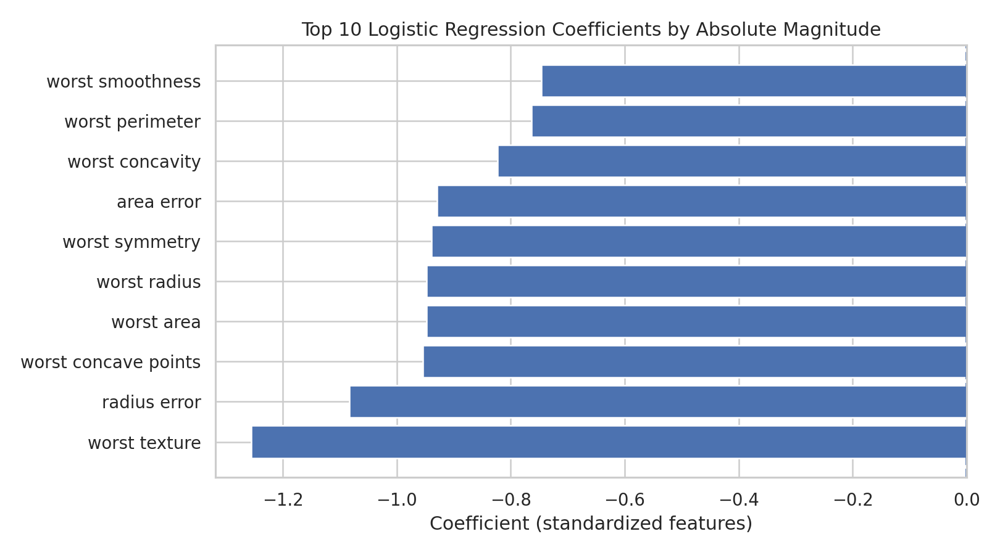
Figure 7. Ten Logistic Regression coefficients with the largest absolute magnitude.
Because the predictors were standardized, coefficient magnitudes are more comparable than they would be on the original scales. Since 1 represents benign, a positive coefficient is associated with higher model log-odds of the benign class, while a negative coefficient is associated with higher log-odds of the malignant class, holding other model terms constant.

Largest coefficients by absolute magnitude
Feature | Coefficient
worst texture | -1.2551
radius error | -1.0830
worst concave points | -0.9537
worst area | -0.9478
worst radius | -0.9476
worst symmetry | -0.9392
area error | -0.9291
worst concavity | -0.8232
worst perimeter | -0.7632
worst smoothness | -0.7466

Coefficient interpretation must remain cautious because several predictors are correlated. A large coefficient does not establish causation.

11. Model Strengths
- Clear binary classification objective.
- Publicly documented numerical dataset.
- Leakage-safe preprocessing through a Pipeline.
- Stratified cross-validation rather than a single validation split.
- Multiple evaluation metrics and confusion-matrix analysis.
- Efficient model with interpretable coefficients.

12. Model Limitations
- The dataset is small compared with many modern ML applications.
- Many predictors are correlated, complicating coefficient interpretation.
- Logistic Regression may not capture nonlinear interactions.
- A single held-out test set can still produce sampling variation.
- The benchmark dataset does not establish clinical suitability.
- Accuracy alone would not fully describe classification errors.

13. Possible Improvements
- Compare Random Forest, SVM, and Gradient Boosting with the same validation strategy.
- Tune regularization strength using GridSearchCV or LogisticRegressionCV.
- Use repeated stratified cross-validation to examine metric stability.
- Investigate feature selection or dimensionality reduction.
- Evaluate probability calibration if probabilities are important.
- Use an independent external dataset for final validation.

14. Complete Reproducible Code
from sklearn.datasets import load_breast_cancer
from sklearn.model_selection import train_test_split, StratifiedKFold, cross_validate
from sklearn.pipeline import Pipeline
from sklearn.preprocessing import StandardScaler
from sklearn.linear_model import LogisticRegression
from sklearn.metrics import accuracy_score, precision_score, recall_score, f1_score, roc_auc_score
data = load_breast_cancer(as_frame=True)
X, y = data.data, data.target
X_train, X_test, y_train, y_test = train_test_split(
X, y, test_size=0.20, stratify=y, random_state=42
)
model = Pipeline([
('scaler', StandardScaler()),
('logistic', LogisticRegression(max_iter=5000, random_state=42))
])
cv = StratifiedKFold(n_splits=5, shuffle=True, random_state=42)
cv_results = cross_validate(
model, X_train, y_train, cv=cv,
scoring=['accuracy','precision','recall','f1','roc_auc']
)
model.fit(X_train, y_train)
y_pred = model.predict(X_test)
y_prob = model.predict_proba(X_test)[:, 1]
print("Accuracy:", accuracy_score(y_test, y_pred))
print("Precision:", precision_score(y_test, y_pred))
print("Recall:", recall_score(y_test, y_pred))
print("F1:", f1_score(y_test, y_pred))
print("ROC-AUC:", roc_auc_score(y_test, y_prob))

15. Conclusion
This project implemented a complete supervised-learning workflow for binary classification using the Breast Cancer Wisconsin (Diagnostic) dataset. The data was explored, checked for quality issues, split using stratification, standardized inside a Pipeline, and modeled using Logistic Regression.
The final model achieved test accuracy of 0.982 and ROC-AUC of 0.995. Five-fold cross-validation on the training set produced mean ROC-AUC of 0.996 ± 0.005. The analysis demonstrates that a strong supervised-learning workflow requires careful preprocessing, validation, multiple metrics, error analysis, and interpretation—not just a single accuracy number.
Future work could compare nonlinear algorithms, tune hyperparameters, reduce feature redundancy, test probability calibration, and evaluate the model on independent data.

16. References
- Scikit-learn: Breast Cancer Wisconsin (Diagnostic) dataset documentation.
- Scikit-learn: LogisticRegression API documentation.
- Scikit-learn: cross-validation and model-evaluation documentation.
- Scikit-learn: ROC-AUC documentation.
- UCI Machine Learning Repository: Breast Cancer Wisconsin (Diagnostic) dataset.
https://scikit-learn.org/stable/modules/generated/sklearn.datasets.load_breast_cancer.html
https://scikit-learn.org/stable/modules/generated/sklearn.linear_model.LogisticRegression.html
https://scikit-learn.org/stable/modules/generated/sklearn.model_selection.cross_val_score.html
https://scikit-learn.org/stable/modules/generated/sklearn.metrics.roc_auc_score.html
https://archive.ics.uci.edu/dataset/17/breast+cancer+wisconsin+diagnostic

Appendix A: Suggested 30–35 Hour Work Plan
Activity | Estimated Hours
Problem definition and dataset study | 3
Data inspection and exploratory analysis | 5
Preprocessing and feature engineering | 4
Model implementation | 4
Cross-validation and metric analysis | 5
Visualization and error analysis | 4
Report writing and code documentation | 6
Final review and reproducibility check | 3

Total planned effort: approximately 34 hours, consistent with the assignment expectation.

