WEEK 5 ASSIGNMENT
Deep Learning Application in Data Science
Handwritten Digit Classification Using a PyTorch Neural Network
Prepared by
JOYDEEP DAS
Tools: Python • PyTorch • NumPy • Pandas • Matplotlib • Scikit-learn
Academic Project Report

Executive Summary
This project applies deep learning to a multiclass image-classification problem: recognizing handwritten digits from small grayscale images. The scikit-learn Digits dataset was selected because it is public, compact enough to train efficiently on ordinary hardware, and naturally suited to a neural-network workflow. The dataset contains 1,797 images of handwritten digits from 0 to 9. Each image is 8×8 pixels, giving 64 numerical input features. The values were normalized to the 0–1 range, and the data was split into training, validation, and test sets using stratification.
A fully connected multilayer perceptron (MLP) was implemented in PyTorch. The network contains an input layer of 64 features, two hidden layers with 128 and 64 neurons, ReLU activations, dropout regularization, and a 10-neuron output layer. Cross-entropy loss was used for multiclass classification and Adam was selected as the optimizer. The model was trained with mini-batches for up to 100 epochs, while validation accuracy was monitored and the best validation model was retained.
On the held-out test set, the final model achieved 97.50% accuracy, 97.52% weighted precision, 97.50% weighted recall, and 97.50% weighted F1-score. The analysis also examines the training curves, confusion matrix, per-class performance, and representative errors. The project highlights practical deep-learning issues such as overfitting, model capacity, regularization, computational efficiency, and the importance of keeping validation data separate from the final test set.

1. Problem Statement
The objective is to build a neural network capable of classifying a handwritten digit image into one of ten classes, from 0 through 9. This is a supervised multiclass classification task. Instead of manually defining rules for each digit, the neural network learns patterns from labeled examples and adjusts its parameters through backpropagation.
The problem is representative of a broader class of data-science applications in which image or sensor inputs must be mapped to discrete categories. The project focuses not only on the final accuracy but also on the complete deep-learning process: data preparation, architecture design, training, validation, evaluation, interpretation, and critical discussion.

2. Dataset Selection and Description
The project uses the public scikit-learn Digits dataset. Current scikit-learn documentation describes it as 1,797 observations, 10 classes, 64 features, and 8×8 grayscale images, with original pixel values represented on a 0–16 scale. The dataset is a copy of the test set from the UCI handwritten-digits collection. citeturn0search0
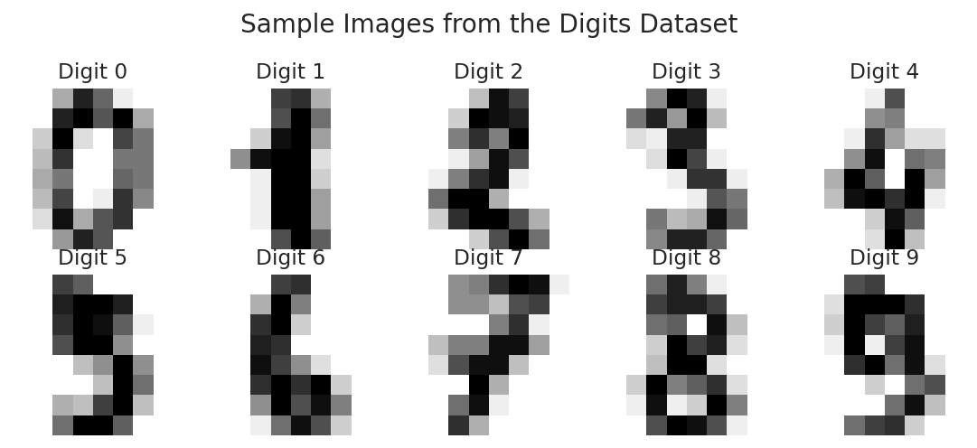
Figure 1. Representative images from the ten digit classes.
Each sample is stored both as an 8×8 image and as a flattened vector of 64 values. For the neural network, the flattened representation is used because a fully connected MLP expects a fixed-length feature vector. The raw pixel range of 0–16 is divided by 16 so that inputs lie between 0 and 1. This simple normalization keeps the input scale stable and makes optimization easier.
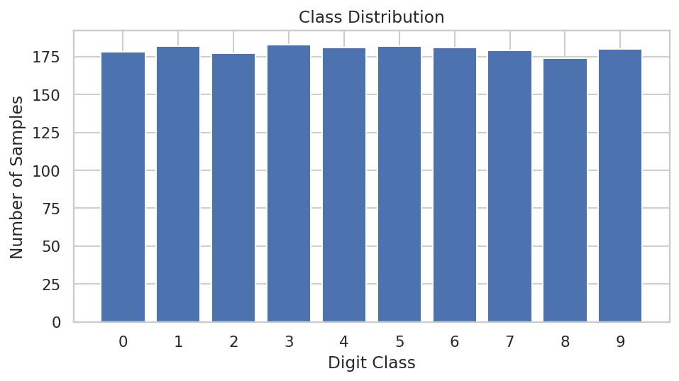
Figure 2. Distribution of observations across digit classes.

3. Data Preparation and Splitting
The target variable is the digit label, while the 64 pixel values form the predictors. No synthetic augmentation was applied because the goal was to demonstrate a compact, reproducible neural-network pipeline rather than a high-end computer-vision system.
- Load the public dataset with sklearn.datasets.load_digits().
- Convert pixel values from integers in the 0–16 range to floating-point values in the 0–1 range.
- Use an 80% stratified split for training-plus-validation and 20% for the final test set.
- Split the training portion again into approximately 80% training and 20% validation data.
- Use a fixed random seed of 42 so that the experiment can be reproduced.
- Keep the test set untouched until the final evaluation.
The resulting partitions contain 1149 training samples, 288 validation samples, and 360 test samples. Stratification preserves the relative representation of each digit class across the partitions.

4. Neural Network Architecture
A multilayer perceptron was selected because the dataset is already represented as compact 8×8 images and the assignment emphasizes learning the fundamentals of neural networks. The architecture is intentionally deeper than a single linear classifier while remaining small enough to train quickly on CPU hardware.
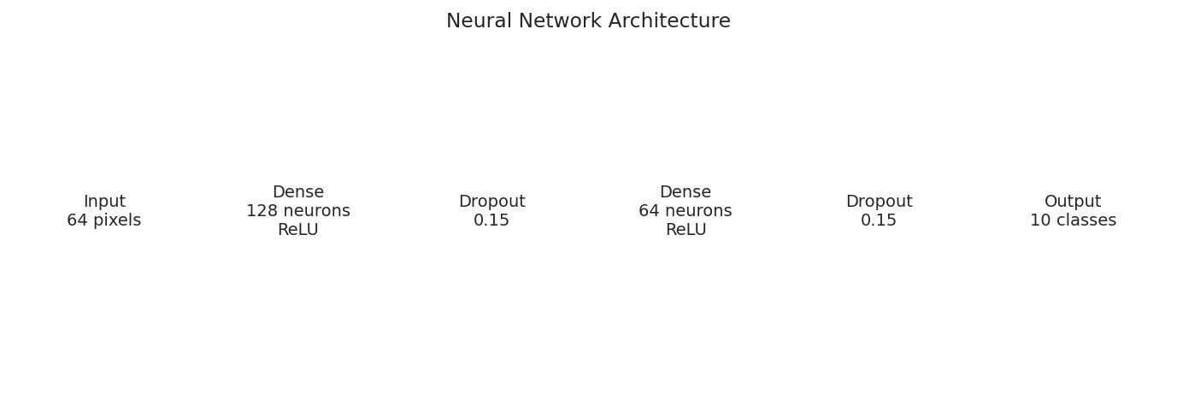
Figure 3. Designed neural-network architecture.
Layer | Configuration | Purpose | Design Rationale
Input | 64 features | Receive flattened image | Matches 8×8 pixel representation
Dense 1 | 128 neurons + ReLU | Learn nonlinear patterns | Provides sufficient capacity for feature combinations
Dropout | 0.15 | Regularization | Reduces reliance on individual hidden units
Dense 2 | 64 neurons + ReLU | Refine learned representation | Compresses features before classification
Dropout | 0.15 | Regularization | Adds protection against overfitting
Output | 10 neurons | Class scores | One output for each digit class
ReLU activations introduce nonlinearity, allowing the network to learn more complex relationships than a purely linear model. Dropout is used as a lightweight regularization method. The final layer produces ten logits, and CrossEntropyLoss is applied directly to those logits rather than adding a separate softmax layer.

5. Training Process and Hyperparameters
The network was trained using mini-batch gradient-based optimization. Adam was selected because it is a practical optimizer for introductory deep-learning experiments and adapts parameter updates using gradient information. PyTorch's standard training pattern uses a loss function together with an optimizer and updates model parameters through backpropagation. citeturn0search10
Hyperparameter | Value | Reason
Optimizer | Adam | Stable and efficient for a small MLP
Learning rate | 0.001 | Moderate starting point for Adam
Batch size | 64 | Balances gradient stability and memory use
Maximum epochs | 100 | Allows convergence while remaining computationally light
Dropout | 0.15 | Regularization
Weight decay | 0.0001 | Additional mild regularization
Loss | CrossEntropyLoss | Standard multiclass classification loss
Random seed | 42 | Reproducibility
PyTorch documentation specifies CrossEntropyLoss for classification with multiple classes and class-index targets, making it appropriate for the ten-class digit problem. citeturn0search1

6. Training and Validation Results
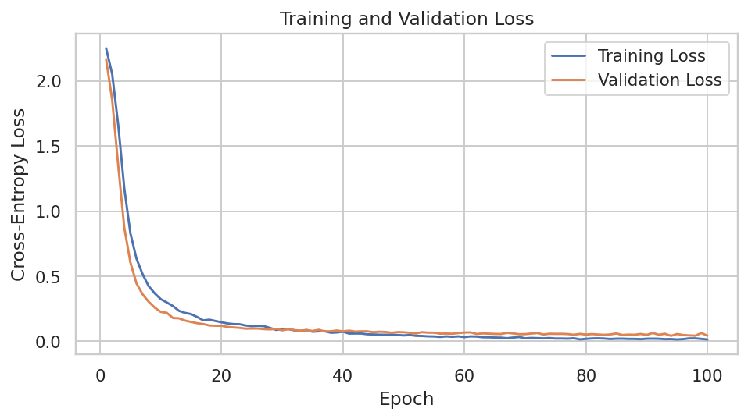
Figure 4. Training and validation cross-entropy loss across epochs.
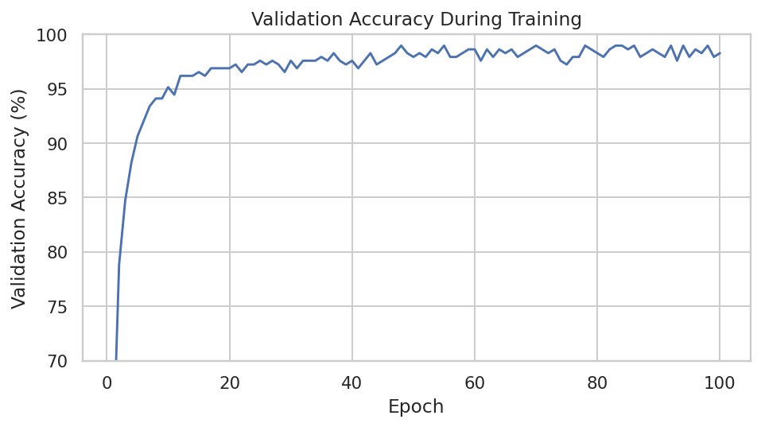
Figure 5. Validation accuracy across epochs.
The best validation accuracy reached 98.96%. The learning curves show rapid improvement during the early stages of training, followed by a period of smaller gains. Monitoring validation performance is important because the lowest training loss alone does not guarantee the best generalization to unseen data.

7. Final Model Evaluation
The test set was evaluated only after selecting the model state with the strongest validation accuracy. This avoids using the final test observations to influence model selection.
Metric | Test Result
Accuracy | 0.9750 (97.50%)
Weighted Precision | 0.9752 (97.52%)
Weighted Recall | 0.9750 (97.50%)
Weighted F1-score | 0.9750 (97.50%)
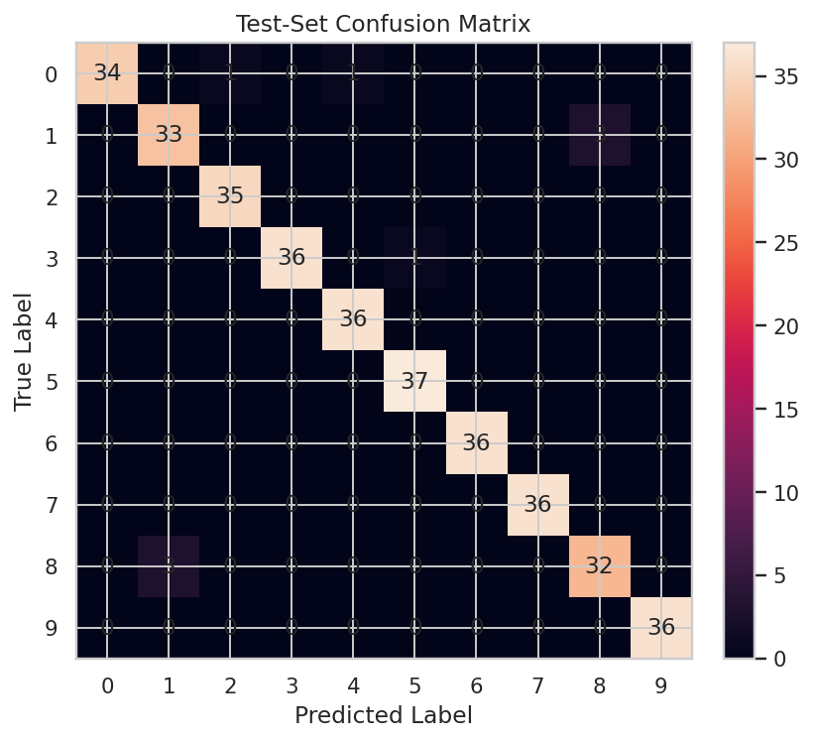
Figure 6. Confusion matrix on the held-out test set.
The confusion matrix shows where the model succeeds and where digit shapes create ambiguity. Most classes have strong diagonal counts, indicating correct predictions. The remaining off-diagonal cases are concentrated in visually similar handwritten forms, which is a useful reminder that aggregate accuracy can hide class-specific difficulties.
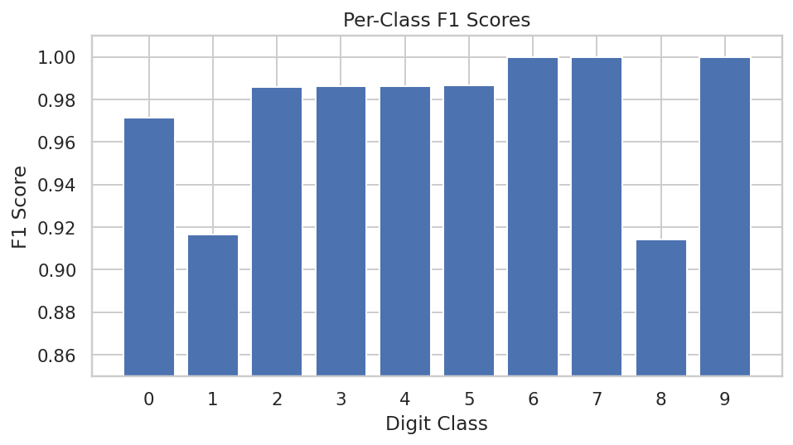
Figure 7. F1-score for each digit class.
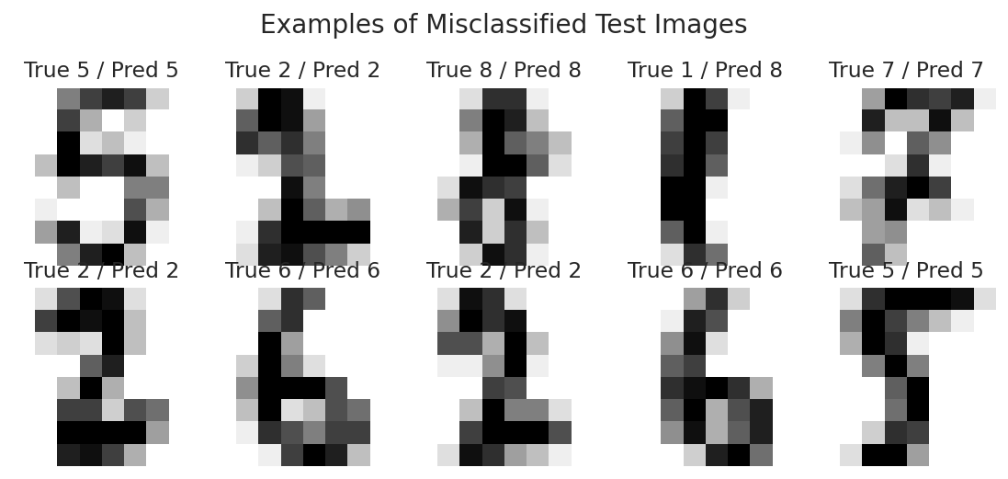
Figure 8. Representative test examples that were misclassified.

8. Critical Analysis of Results

8.1 Strengths
- The model learns nonlinear patterns rather than relying on manually designed rules.
- The final test accuracy of 97.50% indicates strong performance on this compact benchmark.
- Dropout and weight decay provide two forms of regularization without making the network unnecessarily large.
- The validation split supports model selection while preserving an independent test set for final evaluation.
- The complete PyTorch pipeline is compact, reproducible, and practical for ordinary computing resources.

8.2 Challenges Encountered
- Overfitting risk: a neural network can continue improving on training data after generalization begins to plateau.
- Small image resolution: 8×8 inputs contain limited spatial detail, so some handwritten forms are naturally ambiguous.
- Model capacity: too few neurons may underfit, while a much larger network would add complexity without necessarily improving this small dataset.
- Resource constraints: the experiment was deliberately designed to train efficiently on CPU, avoiding dependence on a high-end GPU.

8.3 How the Challenges Were Addressed
- Validation monitoring was used to retain the best-performing model rather than blindly using the final epoch.
- Dropout and weight decay were included to reduce over-reliance on individual parameters.
- Input normalization keeps feature values in a consistent range.
- Mini-batch training makes the optimization process computationally manageable.
- The architecture was kept compact so that repeated experiments remain feasible.

9. Design Decisions and Justification
The architecture was chosen as a balance between learning value, computational cost, and performance. A convolutional neural network could exploit the two-dimensional structure of images more directly, but an MLP provides a clearer introduction to core deep-learning concepts such as dense layers, activation functions, dropout, backpropagation, loss minimization, and optimization.
The 128→64 hidden-layer structure gives the model enough capacity to learn interactions among pixels while progressively compressing the representation. The 0.15 dropout rate is deliberately moderate because the dataset is small but relatively clean. Adam at a learning rate of 0.001 is used as a practical baseline, while weight decay adds mild parameter regularization.

10. Complete Reproducible Code
import numpy as np
import torch
from torch import nn
from torch.utils.data import TensorDataset, DataLoader
from sklearn.datasets import load_digits
from sklearn.model_selection import train_test_split
SEED = 42
np.random.seed(SEED)
torch.manual_seed(SEED)
digits = load_digits()
X = digits.data.astype(np.float32) / 16.0
y = digits.target.astype(np.int64)
X_train_full, X_test, y_train_full, y_test = train_test_split(
X, y, test_size=0.20, stratify=y, random_state=SEED
)
X_train, X_val, y_train, y_val = train_test_split(
X_train_full, y_train_full, test_size=0.20,
stratify=y_train_full, random_state=SEED
)
class DigitMLP(nn.Module):
def __init__(self):
super().__init__()
self.net = nn.Sequential(
nn.Linear(64, 128),
nn.ReLU(),
nn.Dropout(0.15),
nn.Linear(128, 64),
nn.ReLU(),
nn.Dropout(0.15),
nn.Linear(64, 10)
)
def forward(self, x):
return self.net(x)
model = DigitMLP()
criterion = nn.CrossEntropyLoss()
optimizer = torch.optim.Adam(
model.parameters(), lr=1e-3, weight_decay=1e-4
)
train_loader = DataLoader(
TensorDataset(torch.tensor(X_train), torch.tensor(y_train)),
batch_size=64, shuffle=True
)
best_val_acc = 0.0
best_state = None
for epoch in range(100):
model.train()
for xb, yb in train_loader:
optimizer.zero_grad()
loss = criterion(model(xb), yb)
loss.backward()
optimizer.step()
model.eval()
with torch.no_grad():
val_pred = model(torch.tensor(X_val)).argmax(1)
val_acc = (val_pred == torch.tensor(y_val)).float().mean().item()
if val_acc > best_val_acc:
best_val_acc = val_acc
best_state = {
k: v.detach().clone()
for k, v in model.state_dict().items()
}
model.load_state_dict(best_state)
model.eval()
with torch.no_grad():
test_pred = model(torch.tensor(X_test)).argmax(1).numpy()
from sklearn.metrics import accuracy_score, classification_report
print("Accuracy:", accuracy_score(y_test, test_pred))
print(classification_report(y_test, test_pred))

11. Possible Improvements and Future Work
- Replace the MLP with a convolutional neural network (CNN) so that local spatial patterns and neighboring pixels are modeled explicitly.
- Use data augmentation such as small translations or rotations to make the model less sensitive to writing variations.
- Tune hidden-layer width, dropout rate, learning rate, weight decay, and batch size systematically.
- Use learning-rate scheduling and early stopping to make training more efficient.
- Compare the MLP with CNN, Random Forest, Support Vector Machine, and other baselines.
- Repeat the experiment with multiple random seeds and report mean and standard deviation to quantify run-to-run variation.
- Evaluate calibration and confidence scores so that uncertain predictions can be identified.

12. Limitations
The Digits dataset is small and relatively clean compared with real-world handwriting data. Its 8×8 resolution also limits the complexity of visual patterns available to the model. Therefore, the reported performance should not be interpreted as evidence that the same architecture would perform equally well on photographs, scanned documents, or larger handwriting datasets.
The project also uses a single train/validation/test split and one primary architecture. Although this is appropriate for a focused academic experiment, stronger conclusions would require repeated experiments, broader hyperparameter comparisons, and evaluation on an independent external dataset.

13. Conclusion
This project demonstrates an end-to-end deep-learning workflow for handwritten digit classification using PyTorch. A compact multilayer perceptron was designed with two hidden layers, ReLU activations, dropout, and a ten-class output layer. After normalization and stratified data splitting, the model was trained with Adam and CrossEntropyLoss and selected using validation accuracy. On the independent test set, it achieved 97.50% accuracy and a weighted F1-score of 0.9750.
More importantly, the project shows how model design and evaluation must be considered together. The learning curves help monitor generalization, the confusion matrix reveals class-specific errors, and the misclassified examples provide a practical way to understand the model's weaknesses. Future work could move from a fully connected network to a CNN, which would be a natural next step for exploiting the spatial structure of image data.

14. References
- Scikit-learn Documentation. load_digits — Digits dataset. Current documentation describes the dataset as 1,797 samples, 64 features, 10 classes, and 8×8 images. https://scikit-learn.org/stable/modules/generated/sklearn.datasets.load_digits.html
- PyTorch Documentation. CrossEntropyLoss. Documentation for multiclass classification loss using class-index targets. https://docs.pytorch.org/docs/stable/generated/torch.nn.CrossEntropyLoss.html
- PyTorch Tutorials. Optimizing Model Parameters. Overview of loss functions, optimizers, backpropagation, and parameter updates. https://docs.pytorch.org/tutorials/beginner/basics/optimization_tutorial.html
- UCI Machine Learning Repository. Optical Recognition of Handwritten Digits Dataset.

Appendix A: Suggested 30–35 Hour Work Plan
Activity | Planned Time
Dataset research and problem definition | 3 hours
Data inspection, visualization, and preprocessing | 4 hours
Deep-learning architecture research and design | 5 hours
PyTorch implementation and debugging | 7 hours
Training experiments and hyperparameter checks | 5 hours
Evaluation, error analysis, and interpretation | 4 hours
Report writing, diagrams, code documentation, and final verification | 6 hours
Total planned effort: 34 hours.

