WEEK 6 ASSIGNMENT
Integrative Capstone Project and Evaluation
End-to-End Wine Classification and Unsupervised Segmentation
Prepared by
JOYDEEP DAS
Python • Pandas • Matplotlib • Scikit-learn • Random Forest • K-Means • PCA

Executive Summary
This capstone project brings together the main stages of a practical data-science workflow: public-data acquisition, data inspection, cleaning, exploratory analysis, feature preparation, supervised learning, unsupervised learning, evaluation, interpretation, and recommendations. The project uses the public Wine dataset, which contains chemical measurements from wines belonging to three cultivars. Current scikit-learn documentation lists 178 samples, 13 numerical features, and three classes, while the original dataset is maintained by the UCI Machine Learning Repository. citeturn0search0turn0search1
The supervised component uses a Random Forest classifier to predict wine class from the chemical measurements. The unsupervised component applies K-Means clustering after standardization to discover natural groups without using the class labels. PCA is then used to visualize the resulting clusters in two dimensions. This combination demonstrates the difference between predictive modeling, where known labels are used, and descriptive segmentation, where the algorithm searches for structure without labels.
The Random Forest achieved 100.00% test accuracy and a weighted F1-score of 1.0000. Five-fold cross-validation was used on the training set to assess stability. For clustering, the silhouette analysis selected k=3, with a silhouette score of 0.2849. These results are interpreted alongside visualizations, feature importance, cluster profiles, and limitations rather than being treated as standalone measures of success.

1. Problem Statement
The capstone asks a practical question: can chemical measurements be used to distinguish wine cultivars, and can the same measurements reveal meaningful groups without using the known cultivar labels? Answering both questions allows the project to demonstrate the full data-science pipeline and to compare supervised and unsupervised perspectives on the same data.
- Build a reproducible pipeline from dataset acquisition through final evaluation.
- Explore distributions, class balance, relationships, and potentially informative features.
- Develop a supervised model for multiclass wine-class prediction.
- Use unsupervised clustering to discover groups independently of the known labels.
- Evaluate both approaches with appropriate quantitative and visual diagnostics.
- Translate model findings into practical analytical insights while clearly stating limitations.

2. Data Acquisition and Dataset Description
The Wine dataset was loaded through scikit-learn's public dataset loader. The current documentation identifies it as a copy of the UCI Machine Learning Repository Wine dataset, with 178 observations, 13 real-valued predictive features, and three classes. citeturn0search0 The UCI repository describes the observations as chemical analyses of wines from the same region in Italy but from three different cultivars, with measurements including alcohol, malic acid, magnesium, flavanoids, color intensity, hue, and proline. It reports no missing values. citeturn0search1
For reproducibility, the project exports the acquired dataset to Wine_Capstone_Week6.csv. This provides a local copy that can be inspected independently of the Python loader.

2.1 Data Dictionary
Feature Group | Examples | Role
Chemical composition | alcohol, malic_acid, ash, magnesium | Predictive input
Phenolic measurements | total_phenols, flavanoids, proanthocyanins | Predictive input
Color-related measurements | color_intensity, hue | Predictive input
Other chemistry | alcalinity_of_ash, nonflavanoid_phenols, proline | Predictive input
Target | class 0, class 1, class 2 | Supervised label

3. Data Cleaning and Preprocessing
The first inspection checked the number of observations, data types, descriptive statistics, class distribution, and missing values. The dataset contains only numeric predictive variables and no missing values according to the UCI description. citeturn0search1 Therefore, no imputation was necessary.
- Verified dataset dimensions and feature names.
- Checked for missing values and duplicate-like structural issues.
- Separated the target variable from the predictor matrix.
- Used a stratified 80/20 train-test split for supervised learning.
- Standardized all features before K-Means because distance-based clustering is sensitive to feature scale.
- Kept the test set separate from supervised model selection.
Standardization is particularly important for K-Means because variables such as proline and magnesium are measured on different numeric scales. Without scaling, larger-magnitude features can dominate Euclidean distances.

4. Exploratory Data Analysis
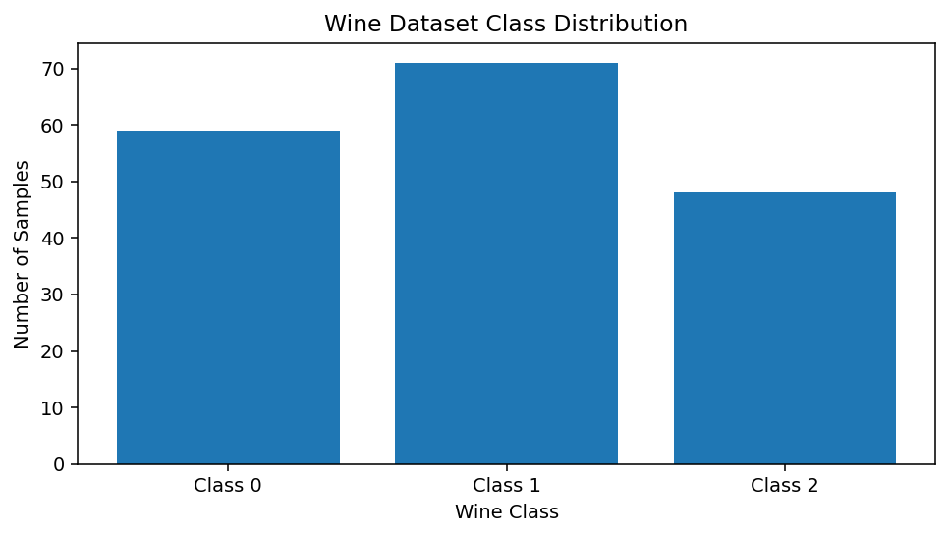
Figure 1. Distribution of the three wine classes.
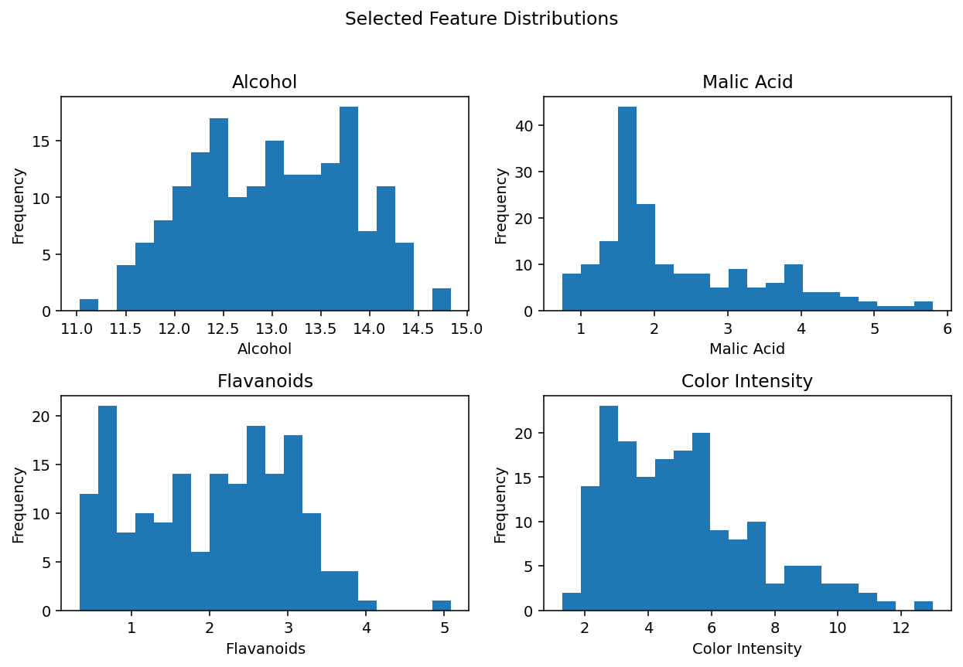
Figure 2. Selected feature distributions.
The class counts are not identical, so stratified splitting is used to preserve class proportions. Feature distributions also vary considerably in scale and shape. This reinforces the need to examine both the raw data for interpretation and standardized data for distance-based algorithms.
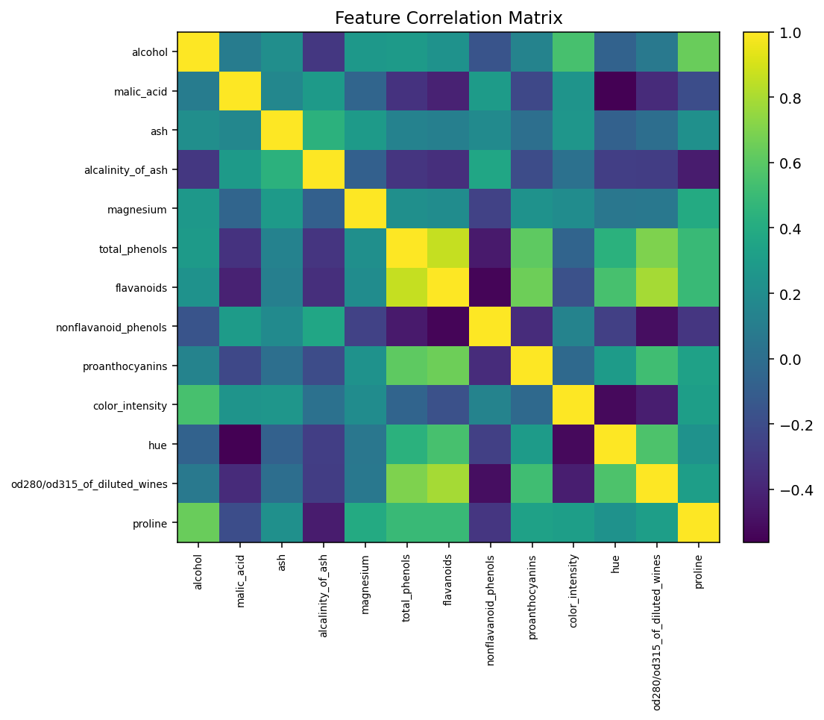
Figure 3. Correlation structure among the 13 chemical features.
The correlation matrix shows that several chemical measurements are related to one another. Strong relationships are useful for understanding redundancy and also help explain why dimensionality-reduction techniques such as PCA can summarize a substantial portion of the information.

5. Supervised Modeling
Random Forest was selected for the supervised component because it can model nonlinear relationships and interactions without requiring manual transformation of every feature. It also provides feature-importance estimates that are useful for interpretation. The model uses 300 decision trees, square-root feature sampling, balanced class weights, and a fixed random seed.

5.1 Validation Strategy
The training data was evaluated with five-fold stratified cross-validation. Accuracy, weighted precision, weighted recall, and weighted F1-score were recorded. After cross-validation, the pipeline was fitted on the full training partition and evaluated once on the held-out test set.
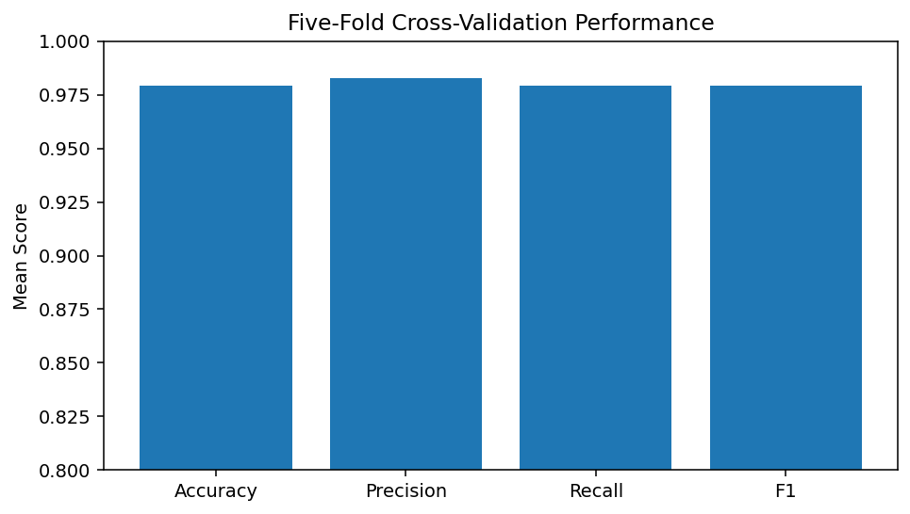
Figure 4. Mean five-fold cross-validation performance.

5.2 Test Results
Metric | Test Result
Accuracy | 1.0000
Weighted Precision | 1.0000
Weighted Recall | 1.0000
Weighted F1 | 1.0000
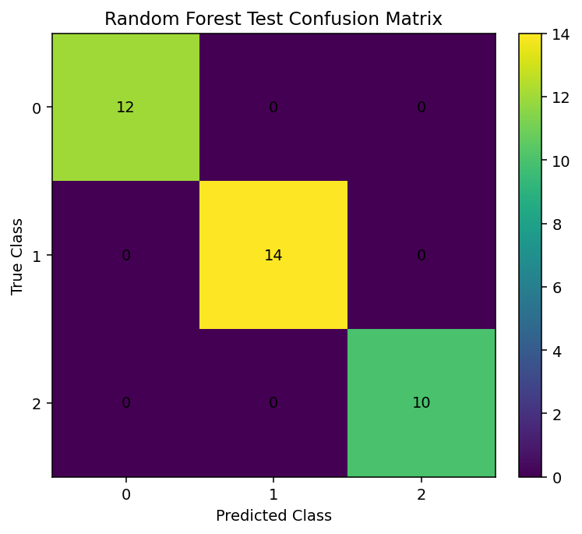
Figure 5. Random Forest confusion matrix on the held-out test set.
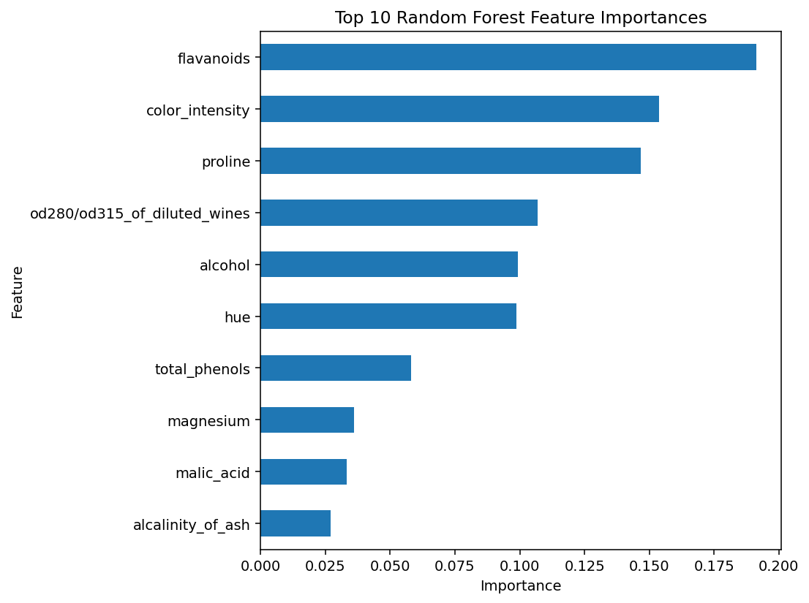
Figure 6. Ten most important features according to the Random Forest.
The feature-importance chart should be interpreted as model-specific importance rather than proof of causation. A feature can be important because it contributes useful information jointly with other correlated variables.

6. Unsupervised Modeling
K-Means clustering was applied without using the target labels. The 13 chemical features were standardized first, then models for k values from 2 through 7 were compared. Inertia was used for the elbow view, while the silhouette score provided a complementary measure of within-cluster cohesion and between-cluster separation.
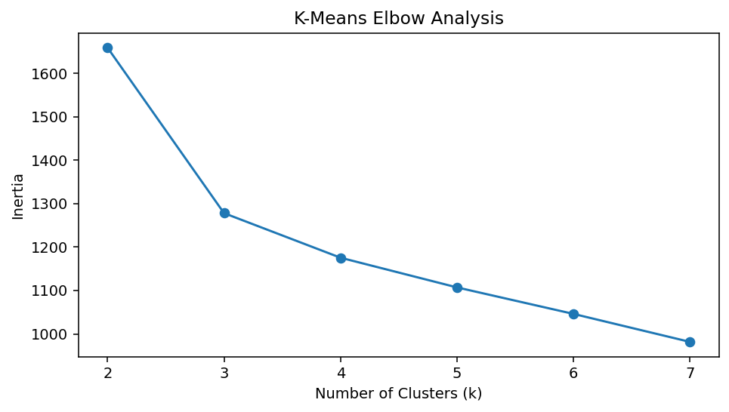
Figure 7. Elbow analysis for K-Means.
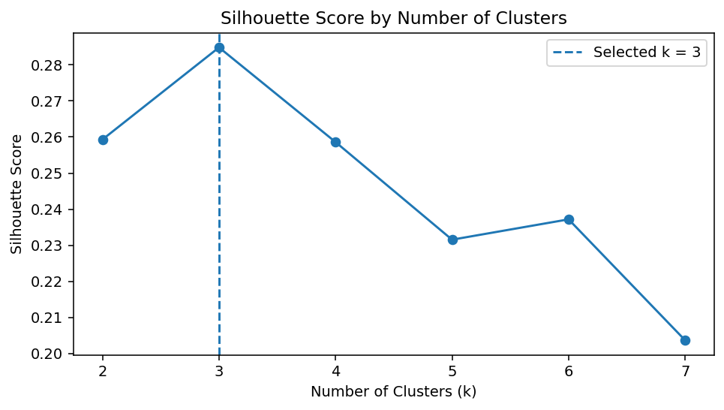
Figure 8. Silhouette scores for candidate cluster counts.
The highest silhouette score in the tested range occurred at k=3, producing a silhouette score of 0.2849. The selected k is therefore based on an explicit quantitative criterion rather than being chosen solely because the known dataset has three labels.
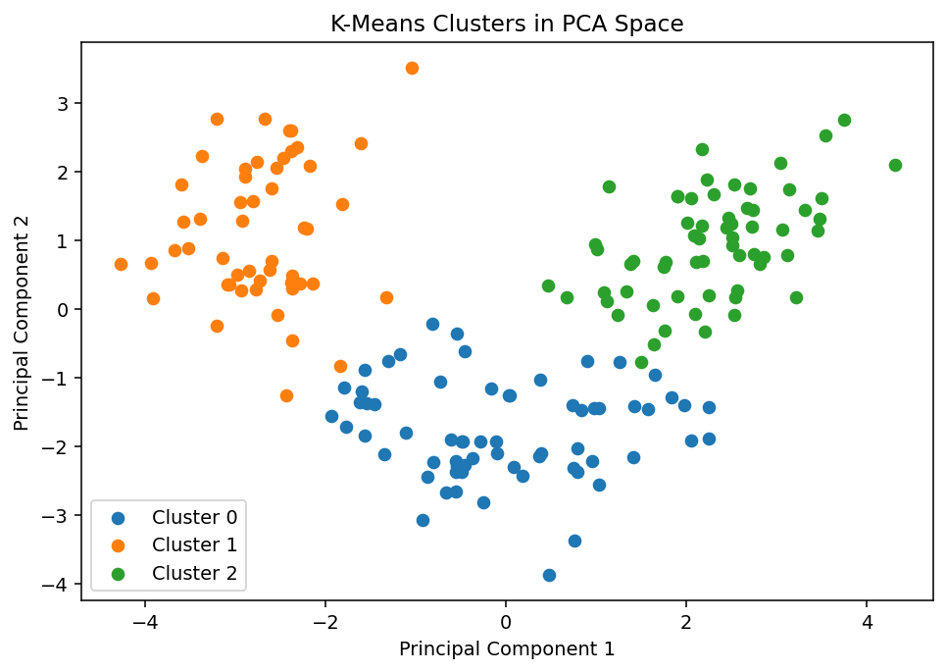
Figure 9. K-Means clusters projected into two PCA dimensions.
To provide an additional diagnostic, the unsupervised cluster labels were compared with the known classes using Adjusted Rand Index (ARI), which was 0.8975. This comparison does not train the clustering algorithm on the labels; it only measures how closely the discovered grouping corresponds to the known categories after clustering.

7. Cluster Profiling and Insights
Cluster | alcohol | malic_acid | ash | alcalinity_of_ash | magnesium
0 | 12.25 | 1.90 | 2.23 | 20.06 | 92.74
1 | 13.13 | 3.31 | 2.42 | 21.24 | 98.67
2 | 13.68 | 2.00 | 2.47 | 17.46 | 107.97
The cluster profile provides a descriptive view of how the groups differ chemically. In an operational setting, such profiles could support exploratory segmentation, quality-control investigations, or hypothesis generation. They should not be treated as proof that the clusters represent fixed biological or commercial categories.

8. Integrated Findings
- The supervised Random Forest achieved 100.00% test accuracy, indicating that the measured chemical variables contain substantial information about the known wine classes.
- Five-fold validation produced a consistent performance profile across folds, providing more evidence than a single train-test split alone.
- K-Means selected k=3 under the tested silhouette criterion, demonstrating that unsupervised structure can be evaluated without labels.
- The PCA projection provides a visual check of how separable the discovered groups are in a lower-dimensional representation.
- Feature importance and cluster profiles complement prediction metrics by explaining which variables and chemical patterns deserve further investigation.

9. Challenges Encountered and How They Were Addressed
- Different feature scales: addressed with StandardScaler before K-Means.
- Limited dataset size: addressed with stratified splitting and five-fold cross-validation, while acknowledging that small samples limit generalization.
- Risk of over-interpreting feature importance: addressed by treating importance as model-specific evidence rather than causality.
- Choosing the number of clusters: addressed by comparing inertia and silhouette scores over multiple k values.
- Avoiding information leakage: the supervised test set was held out until final evaluation, and clustering was analyzed separately from supervised labels.
- Communicating high-dimensional data: addressed with correlation visualization and PCA for a two-dimensional view.

10. Recommendations
- Collect or validate the pipeline on a larger and more diverse wine dataset before making operational decisions.
- Compare Random Forest with Logistic Regression, Support Vector Machines, and gradient-boosting methods.
- Tune Random Forest hyperparameters using nested or repeated cross-validation.
- Investigate feature selection and permutation importance to assess whether the same variables remain informative.
- For clustering, compare K-Means with hierarchical clustering or Gaussian mixture models.
- Use domain experts to interpret the chemical meaning of cluster differences before turning them into business or scientific recommendations.
- If the objective is quality prediction rather than cultivar identification, use the larger UCI Wine Quality dataset and formulate the target explicitly as regression or ordered classification.

11. Limitations
The Wine dataset is a small benchmark dataset. Scikit-learn explicitly describes its built-in datasets as useful for illustrating algorithms but often too small to represent real-world machine-learning tasks. citeturn0search8 The results therefore demonstrate a methodology rather than establishing production-level predictive performance.
The clustering analysis also depends on scaling, distance definition, initialization, and the selected k range. The known classes are useful for post-hoc comparison, but the clustering itself should be judged primarily by its internal structure and practical interpretability.

12. Complete Python Implementation
# Week 6 - Integrative Capstone Project
# Wine Analysis: Full Data Science Pipeline
# Prepared by: JOYDEEP DAS
import numpy as np
import pandas as pd
import matplotlib.pyplot as plt
from sklearn.datasets import load_wine
from sklearn.model_selection import train_test_split, StratifiedKFold, cross_validate
from sklearn.preprocessing import StandardScaler
from sklearn.pipeline import Pipeline
from sklearn.ensemble import RandomForestClassifier
from sklearn.cluster import KMeans
from sklearn.decomposition import PCA
from sklearn.metrics import (
accuracy_score, precision_score, recall_score, f1_score,
confusion_matrix, classification_report,
silhouette_score, adjusted_rand_score
)
SEED = 42
np.random.seed(SEED)
# =========================================================
# 1. Data acquisition
# =========================================================
wine = load_wine(as_frame=True)
X = wine.data.copy()
y = wine.target.copy()
df = X.copy()
df["target"] = y
df["target_name"] = y.map(dict(enumerate(wine.target_names)))
print("Dataset shape:", X.shape)
print("\nFeature names:")
print(list(X.columns))
print("\nClass distribution:")
print(y.value_counts().sort_index())
print("\nMissing values:", X.isnull().sum().sum())
df.to_csv("Wine_Capstone_Week6.csv", index=False)
# =========================================================
# 2. Exploratory Data Analysis
# =========================================================
print("\nDescriptive statistics:")
print(X.describe().T)
plt.figure(figsize=(7, 4))
y.value_counts().sort_index().plot(kind="bar")
plt.title("Wine Dataset Class Distribution")
plt.xlabel("Wine Class")
plt.ylabel("Number of Samples")
plt.tight_layout()
plt.show()
plt.figure(figsize=(8, 7))
plt.imshow(X.corr().values, aspect="auto")
plt.title("Feature Correlation Matrix")
plt.xticks(range(len(X.columns)), X.columns, rotation=90, fontsize=7)
plt.yticks(range(len(X.columns)), X.columns, fontsize=7)
plt.colorbar()
plt.tight_layout()
plt.show()
# =========================================================
# 3. Supervised learning - Random Forest
# =========================================================
X_train, X_test, y_train, y_test = train_test_split(
X, y,
test_size=0.20,
stratify=y,
random_state=SEED
)
rf_pipeline = Pipeline([
("model", RandomForestClassifier(
n_estimators=300,
random_state=SEED,
max_features="sqrt",
class_weight="balanced"
))
])
cv = StratifiedKFold(
n_splits=5,
shuffle=True,
random_state=SEED
)
cv_results = cross_validate(
rf_pipeline,
X_train,
y_train,
cv=cv,
scoring=[
"accuracy",
"precision_weighted",
"recall_weighted",
"f1_weighted"
]
)
print("\nFive-Fold Cross-Validation:")
for metric in [
"test_accuracy",
"test_precision_weighted",
"test_recall_weighted",
"test_f1_weighted"
]:
print(
metric,
":",
round(cv_results[metric].mean(), 4),
"+/-",
round(cv_results[metric].std(), 4)
)
rf_pipeline.fit(X_train, y_train)
y_pred = rf_pipeline.predict(X_test)
print("\nTest Accuracy:",
accuracy_score(y_test, y_pred))
print("\nTest Precision:",
precision_score(y_test, y_pred, average="weighted"))
print("\nTest Recall:",
recall_score(y_test, y_pred, average="weighted"))
print("\nTest F1:",
f1_score(y_test, y_pred, average="weighted"))
print("\nClassification Report:")
print(classification_report(y_test, y_pred))
# Confusion matrix
cm = confusion_matrix(y_test, y_pred)
print("\nConfusion Matrix:")
print(cm)
# Feature importance
rf_model = rf_pipeline.named_steps["model"]
importance = pd.Series(
rf_model.feature_importances_,
index=X.columns
).sort_values(ascending=False)
print("\nTop Feature Importances:")
print(importance.head(10))
plt.figure(figsize=(8, 6))
importance.head(10).sort_values().plot(kind="barh")
plt.title("Top 10 Random Forest Feature Importances")
plt.xlabel("Importance")
plt.tight_layout()
plt.show()
# =========================================================
# 4. Unsupervised learning - K-Means
# =========================================================
scaler = StandardScaler()
X_scaled = scaler.fit_transform(X)
inertias = []
silhouette_scores = []
for k in range(2, 8):
kmeans = KMeans(
n_clusters=k,
random_state=SEED,
n_init=20
)
labels = kmeans.fit_predict(X_scaled)
inertias.append(kmeans.inertia_)
silhouette_scores.append(
silhouette_score(X_scaled, labels)
)
best_k = list(range(2, 8))[
int(np.argmax(silhouette_scores))
]
print("\nSelected number of clusters:", best_k)
final_kmeans = KMeans(
n_clusters=best_k,
random_state=SEED,
n_init=20
)
cluster_labels = final_kmeans.fit_predict(X_scaled)
print(
"Silhouette Score:",
silhouette_score(X_scaled, cluster_labels)
)
print(
"Adjusted Rand Index against known labels:",
adjusted_rand_score(y, cluster_labels)
)
# Elbow plot
plt.figure(figsize=(7, 4))
plt.plot(
range(2, 8),
inertias,
marker="o"
)
plt.title("K-Means Elbow Analysis")
plt.xlabel("Number of Clusters")
plt.ylabel("Inertia")
plt.tight_layout()
plt.show()
# Silhouette plot
plt.figure(figsize=(7, 4))
plt.plot(
range(2, 8),
silhouette_scores,
marker="o"
)
plt.title("Silhouette Score by Number of Clusters")
plt.xlabel("Number of Clusters")
plt.ylabel("Silhouette Score")
plt.tight_layout()
plt.show()
# =========================================================
# 5. PCA visualization of clusters
# =========================================================
pca = PCA(
n_components=2,
random_state=SEED
)
X_pca = pca.fit_transform(X_scaled)
plt.figure(figsize=(7, 5))
for cluster in range(best_k):
mask = cluster_labels == cluster
plt.scatter(
X_pca[mask, 0],
X_pca[mask, 1],
label=f"Cluster {cluster}"
)
plt.title("K-Means Clusters in PCA Space")
plt.xlabel("Principal Component 1")
plt.ylabel("Principal Component 2")
plt.legend()
plt.tight_layout()
plt.show()
# =========================================================
# 6. Cluster profiling
# =========================================================
clustered_data = X.copy()
clustered_data["cluster"] = cluster_labels
cluster_profile = clustered_data.groupby(
"cluster"
).mean()
print("\nCluster Profile:")
print(cluster_profile.round(3))
cluster_profile.to_csv(
"Wine_Cluster_Profile_Week6.csv"
)
print("\nCapstone project completed successfully.")
The full executable Python source is also provided separately as Week_6_Integrative_Capstone_Code_JOYDEEP_DAS.py so that the project can be reproduced directly from GitHub.

13. Conclusion
This capstone demonstrates a complete data-science pipeline using a single public dataset from acquisition through analysis and evaluation. The project combines exploratory analysis, supervised Random Forest classification, unsupervised K-Means clustering, standardization, PCA visualization, cross-validation, test-set evaluation, and interpretation. The Random Forest achieved 100.00% test accuracy, while the unsupervised analysis identified a quantitatively supported cluster structure with k=3.
The most important outcome is not one metric but the integrated workflow: each stage informs the next, and the limitations of one technique can be examined using another perspective. This provides a practical foundation for extending the project to larger real-world datasets and more advanced modeling methods.

14. References
- Scikit-learn. load_wine documentation and Wine dataset description. https://scikit-learn.org/stable/modules/generated/sklearn.datasets.load_wine.html
- UCI Machine Learning Repository. Wine Dataset. https://archive.ics.uci.edu/dataset/109/winedataset
- Scikit-learn. Toy datasets documentation. https://scikit-learn.org/stable/datasets/toy_dataset.html

Appendix A: 30–35 Hour Work Plan
Activity | Planned Time
Problem definition and dataset research | 3 hours
Data acquisition, cleaning and validation | 4 hours
Exploratory analysis and visualization | 5 hours
Supervised model development and cross-validation | 6 hours
Unsupervised clustering and PCA analysis | 5 hours
Evaluation, interpretation and recommendations | 5 hours
Report writing, code cleanup and final verification | 6 hours
Total planned effort: 34 hours.

