Navigation Button event

"use client"
import React from "react";
import { useRouter } from "next/navigation";

export default function About(){
const linkRouter = useRouter();

return(
<>
<h2>About Us page</h2>
<button onClick={()=>{ linkRouter.push("/contact"); }}>Goto</button>
</>
)
}

Using dynamic function

"use client"
import React from "react";
import { useRouter } from "next/navigation";

export default function About(){
const linkRouter = useRouter();

const routeNavigation = (pagename) => {
return linkRouter.push(`/${pagename}`);
}
return(
<>
<h2>About Us page</h2>
<button onClick={()=>{ routeNavigation("contact"); }}>Goto</button>
</>
)
}

Page common layout:

export default function Layout({children}){
return(

<>
<h2>About Page Layout</h2>
{children}
</>
)
}

Get path url name:

import { usePathname } from "next/navigation";
const pathName = usePathname();
console.log(pathName);

Dynamic Routes

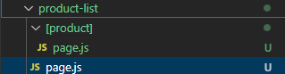

product-list > page.js:

"use client"
import Link from "next/link";
import React from "react";

export default function ProductList({params}){
console.log(params);
return(
<>
<h2>Product List</h2>
<ul>
<li><Link href={"/product-list/product01"}>Product 01</Link></li>
<li><Link href={"/product-list/product02"}>Product 02</Link></li>
<li><Link href={"/product-list/product03"}>Product 03</Link></li>
</ul>
</>);
}

[product] > page.js

"use client"
import Link from "next/link";
import React from "react";

export default function ProductList({params}){
console.log(params);
return(
<>
<h2>Product Details</h2>
<ul>
<li><Link href={"/product-list/product01"}>Product 01</Link></li>
<li><Link href={"/product-list/product02"}>Product 02</Link></li>
<li><Link href={"/product-list/product03"}>Product 03</Link></li>
</ul>
Product Details is: ------- {params.product}
</>);
}

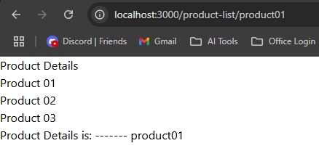
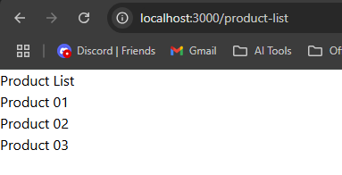

Routing Catch-all Segments

This is using for dynamic number of segment in url

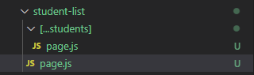

student-list > page.js

"use client"
import Link from "next/link";
import React from "react";

export default function StudentList(){
return(
<>
<h2>Student List</h2>
<ul>
<li><Link href={"/student-list/student01"}>student 01</Link></li>
<li><Link href={"/student-list/student02"}>student 02</Link></li>
<li><Link href={"/student-list/student03"}>student 03</Link></li>
</ul>
</>
)
}

student-list > […students] > page.js

"use client"
import Link from "next/link";
import React from "react";

export default function StudentList({params}){
console.log(params);
return(
<>
<h2>Student Details</h2>
<b>Student Name</b>: {params.students[0]}<br/>
<b>Topic Name</b>: {params.students[1]}<br/>
<b>Part Name</b>: {params.students[2]}<br/>
</>
)
}

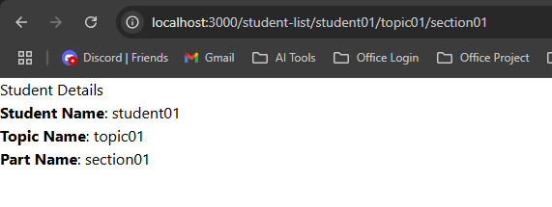

not-found.js

"use client"
import Link from "next/link";
import React from "react";

export default function PageNotFound(){
return(
<>
<h2>Page not found</h2>
</>
)
}

jjkhjkhjkhj

