npm i @mui/material @emotion/react @emotion/styled @mui/icons-material

Packages Explained :
@mui/material → The core Material UI component library → Buttons, TextFields, Cards, Dialogs, etc.
@emotion/react → Required styling engine for MUI (CSS-in-JS)
@emotion/styled → Enables styled components using Emotion
@mui/icons-material → Material Design icons as React components → Example: <HomeIcon />, <MenuIcon />

Install fonts for mui
https://fontsource.org/
select font > click on Install button > copy npm code > paste the code in our project terminal
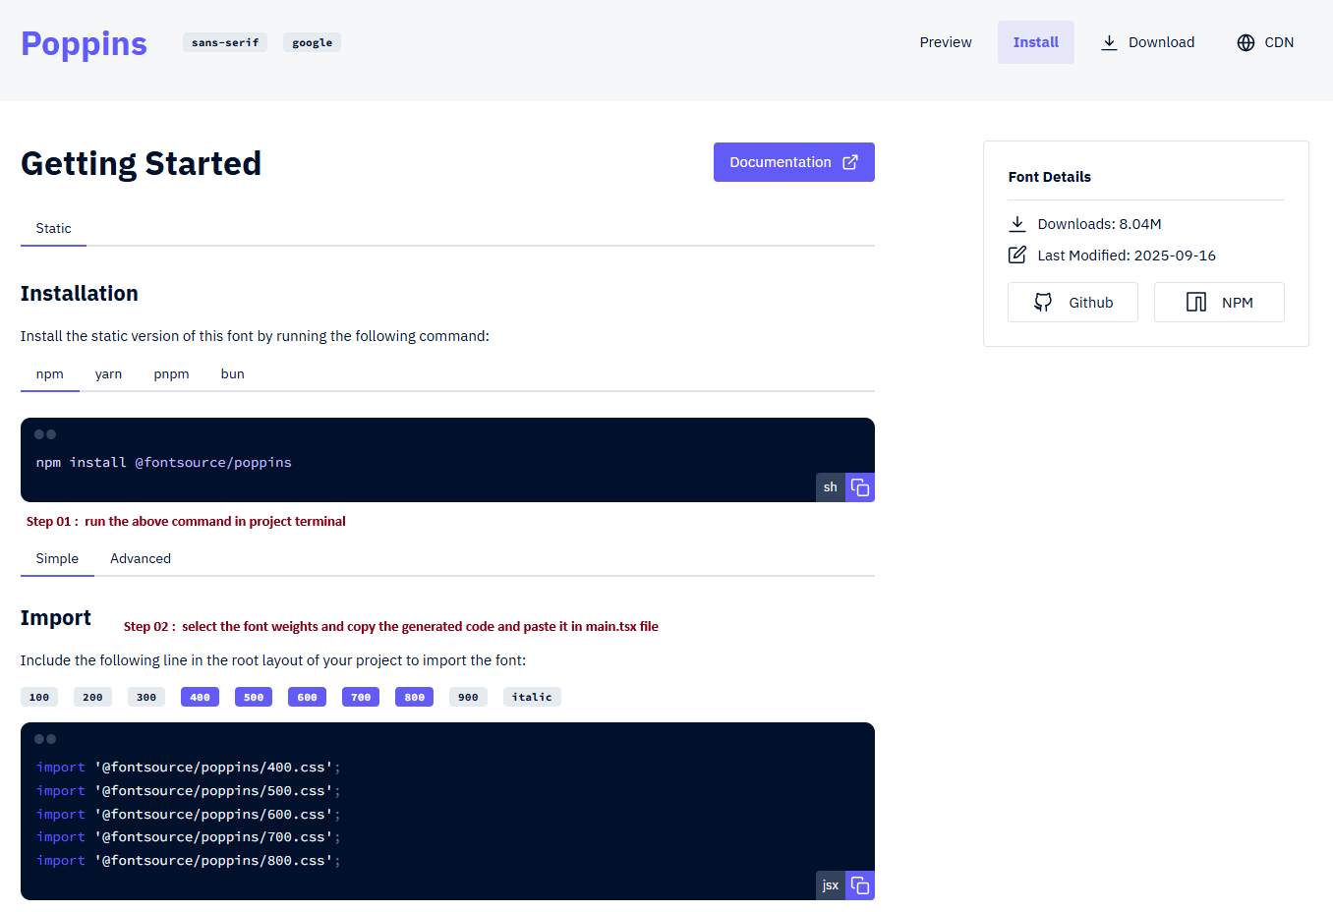

src\main.tsx  import { StrictMode } from 'react'  import { createRoot } from 'react-dom/client'  import './index.css'  import App from './App.tsx'  import '@fontsource/poppins/400.css';  import '@fontsource/poppins/500.css';  import '@fontsource/poppins/600.css';  import '@fontsource/poppins/700.css';  import '@fontsource/poppins/800.css';  createRoot(document.getElementById('root')!).render(  <StrictMode>  <App />  </StrictMode>,  ) | src\index.css: first clean the file the  body {  font-family: 'Poppins', sans-serif;  } | Also clean the App.tsx file:  function App() {  return (  <>  Home  </>  )  }  export default App

For check that mui installation test the code in App.tsx file
import { Button } from "@mui/material"  function App() {  return (  <>  <Button>Normal</Button>  <Button variant="outlined">Outlined</Button>  <Button variant="contained">contained</Button>  <Button disabled>Disabled</Button>  <Button href="#text-buttons">Link</Button>  <Button variant="contained" href="#text-buttons">Link</Button>  </>  )  }  export default App | 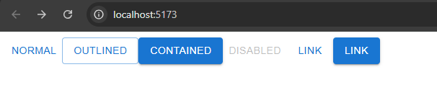

Normalize the css like: margin:0px, padding:0px in body
In App.tsx: Add below tag  import { Button, CssBaseline } from "@mui/material"  function App() {  return (  <>  <CssBaseline/> {/* this one is required for normalize css */}  <Button>Normal</Button>  . . .  </>  )  }  export default App | 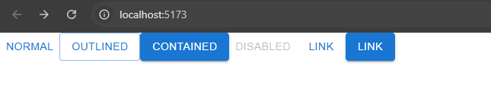

Textfield Properties
import { TextField } from '@mui/material';  import { useState } from 'react';  const TextFieldsTemplates = () => {  const [inputValue, setInputValue] = useState('')  return (  <>  <TextField />  <br/>  <br/>  <TextField  value={inputValue}  onChange={(e) => setInputValue(e.target.value)}  error={!inputValue}  disabled={isLoading}  />  </>  )  }  export default TextFieldsTemplates | 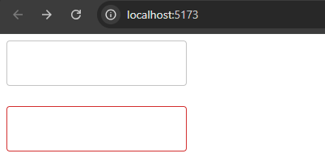  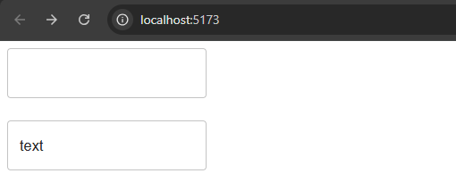

Container Setup (Stack):
Stack is a container component for arranging elements vertically or horizontally.

1 = 8px  2 = (8px * 2 ) 16px  usage: Stack default css: flex-direction: column  Example 01: gap={2} // 16px  Example 02: gap={"10px"} | import { Stack } from '@mui/material'  <Stack gap={"10px"}>  <div style={{background:"gray"}}>Stack 01</div>  <div style={{background:"gray"}}>Stack 02</div>  <div style={{background:"gray"}}>Stack 03</div>  </Stack> | 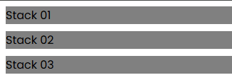
Change direction | <Stack direction="row" gap={"10px"}>  <div style={{background:"gray"}}>Stack 01</div>  <div style={{background:"gray"}}>Stack 02</div>  <div style={{background:"gray"}}>Stack 03</div>  </Stack> | 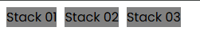
Responsive Break Points  xs -> extra small 0px and up  sm -> small 600px and up  md -> medium 900px and up  lg -> large 1200px and up  xl -> extra large 1536px and up | <Stack direction={{ xs: "column", sm: "row" }}>  <Stack  direction={{ xs: "column", sm: "row" }}  spacing={{ xs: 1, sm: 2, md: 4 }}  >
Use container | import { Container } from "@mui/material";  <Container>  <div style={{background:"gray"}}>element 01</div>  <div style={{background:"gray"}}>element 02</div>  <div style={{background:"gray"}}>element 03</div>  </Container> | 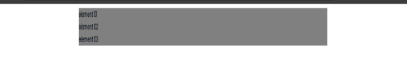
Container + Stack + responsive  xs -> extra small 0px and up  sm -> small 600px and up  md -> medium 900px and up  lg -> large 1200px and up  xl -> extra large 1536px and up | import { Container, Stack } from "@mui/material";  <Container>  <Stack direction="row" spacing={{ xs: 1, sm: 2, md: 4 }}>  <div style={{background:"gray"}}>element 01</div>  <div style={{background:"gray"}}>element 02</div>  <div style={{background:"gray"}}>element 03</div>  </Stack>  </Container>  <Container maxWidth="md"></Container>

Icon use:
npm install @mui/icons-material @mui/material @emotion/styled @emotion/react  https://mui.com/material-ui/material-icons/  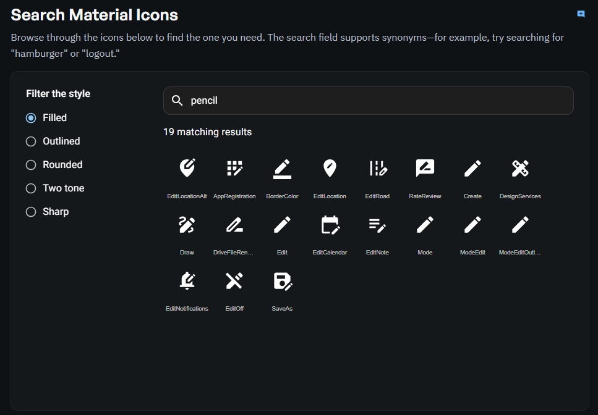  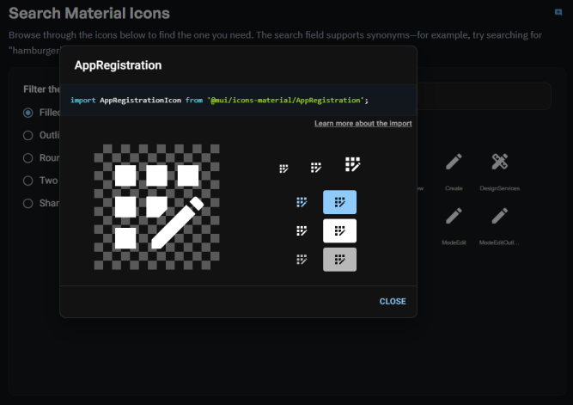  Copy the code above and paste in desire file | import AppRegistrationIcon from '@mui/icons-material/AppRegistration';  import { Button } from "@mui/material"  <>  ...  <AppRegistrationIcon/>  </>  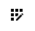  <AppRegistrationIcon fontSize="large" color="error"/>    <Button startIcon={<AppRegistrationIcon />} variant="contained">Outlined</Button>  <Button endIcon={<AppRegistrationIcon />} variant="outlined">Outlined</Button>  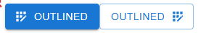

Range Slider Properties
import { Slider } from '@mui/material'  const RangeSliderTemplate = () => {  return (  <>  <Slider/>  <Slider defaultValue={30}/>  </>  )  }  export default RangeSliderTemplate | 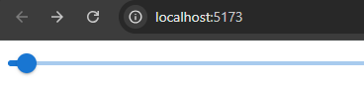
Customization:
We customize ui for style using sx props.  We will change the UI of the slider with sx props  <Slider sx={{height: "10px", width: "200px"}}/> | 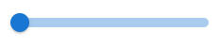
Color & Theme
https://mui.com/material-ui/customization/color/  https://mui.com/material-ui/customization/default-theme/  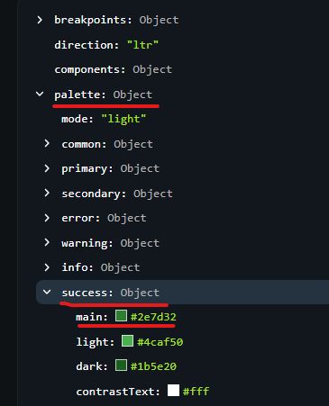 | <Slider sx={{height: "10px", width: "200px", color: "red"}}/>  With theme color  https://mui.com/material-ui/customization/default-theme/  <Slider sx={{height: "10px", width: "200px", color: "success.main"}}/>  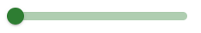
Customize elements of slider
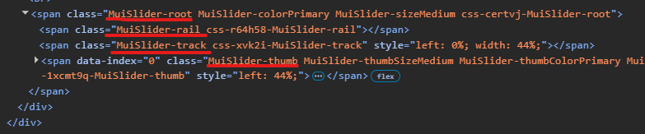  <Slider sx={{  height: "10px",  width: "200px",  color: "success.main",  "& .MuiSlider-thumb":{  backgroundColor: "red",  ":hover":{  backgroundColor: "success.dark"  }  },  "& .MuiSlider-rail":{  backgroundColor: "warning.main"  },  "& .MuiSlider-track":{  backgroundColor: "warning.dark",  borderColor: "warning.dark",  }  }}/> | Here MuiSlider-root is the root class. So if we want to change the color of thumb, then copy the thumb class MuiSlider-thumb.  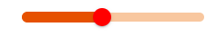  Hover:  
Customize elements of slider based on state (example: if slider is disabled) | In normal disabled view:  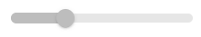
https://mui.com/material-ui/customization/how-to-customize/  <Slider  disabled  sx={{  color: "success.main",  "&.Mui-disabled":{  ".MuiSlider-thumb":{  backgroundColor: "secondary.main",  }  },  }}  />  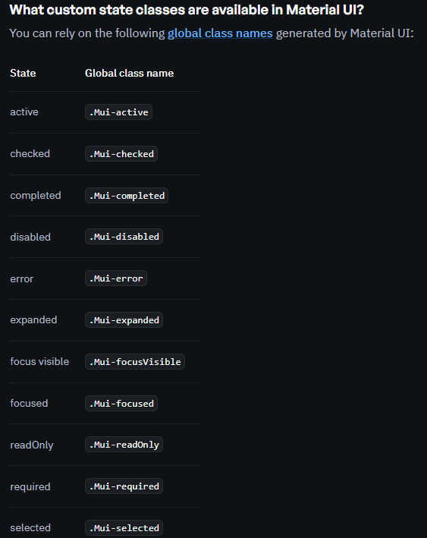 | With customize code:  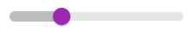  We can also write like below:  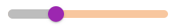  <Slider  defaultValue={30}  disabled  sx={{  height: "10px",  width: "200px",  color: "success.main",  "&.Mui-disabled":{  ".MuiSlider-thumb":{  backgroundColor: "secondary.main",  }  },  "&.Mui-disabled .MuiSlider-rail":{  backgroundColor: "warning.main"  },  }}  />

Reusable Component:
Create a custom component for custom styling
Option 01: customize sx object
<Slider sx={(theme) => ({
width: theme.spacing(10),
color: theme.palette.error.main
})} />

Option 02: making with a different component
// theme is a object which is initial config provided by MUI
const CustomSliderStyle = styled(Slider)<SliderProps>(({theme}) => ({
// width: "80px", // we can use like this or like below
width: theme.spacing(10), // 10 * 8px = 80px
color: theme.palette.warning.dark,
"& .MuiSlider-thumb": {
backgroundColor: theme.palette.success.main,
":hover": {
backgroundColor: theme.palette.success.dark
}
},
"& .MuiSlider-rail": {
backgroundColor: theme.palette.warning.main
},
"& .MuiSlider-track": {
backgroundColor: theme.palette.warning.dark,
borderColor: theme.palette.warning.dark,
}
}))

const CustomStyled = () => {
return (
...
<CustomSliderStyle/>
)}

Add custom properties with sliderProps
// passing custom props with custom style component  const CustomSliderStyleWithCustomPropsType = styled(Slider, {  shouldForwardProp: (prop) => prop !== "error"  // shouldForwardProp: When you create a styled component, all props are normally forwarded to the underlying DOM element. But error is NOT a valid HTML attribute. React will show warning: React does not recognize the error prop on a DOM element.  // This Line Do NOT pass the error prop to the DOM element. error will be used only for styling logic and It will NOT appear in the final HTML.  })<CustomSliderStyleProps>(({theme, error}) => ({  // width: "80px", // we can use like this or like below  width: theme.spacing(10), // 10 * 8px = 80px  color: theme.palette.warning.dark,  "& .MuiSlider-thumb": {  backgroundColor: theme.palette.success.main,  ":hover": {  backgroundColor: theme.palette.success.dark  }  },  "& .MuiSlider-rail": {  backgroundColor: theme.palette.warning.main  },  "& .MuiSlider-track": {  // dynamic color based on error prop  backgroundColor: error ? theme.palette.secondary.dark : theme.palette.error.dark,  borderColor: error ? theme.palette.secondary.dark : theme.palette.warning.dark,  }  })) | <CustomSliderStyleWithCustomPropsType />  <CustomSliderStyleWithCustomPropsType error />

Global Theme Overrides:
Set global font family:
In App.tsx:
import { createTheme, ThemeProvider } from "@mui/material";

const customTheme = createTheme({
typography: {
fontFamily: "Poppins, sans-serif",
}
})

function App() {
return (
<ThemeProvider theme={customTheme}>
. . . .
</ThemeProvider>
)
}

export default App

Set global button Varient
const customTheme = createTheme({  typography: {  fontFamily: "Poppins, sans-serif",  },  components: {  MuiButton:{  defaultProps: {  variant: "contained" // set default variant  }  }  }  }); | Without global variant:  <Button>Normal 01</Button>  <Button>Normal 02</Button>  <Button>Normal 03</Button>  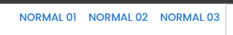  With Global variant “contained”:  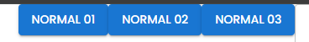
const customTheme = createTheme({  typography: {  fontFamily: "Poppins, sans-serif",  },  components: {  MuiButton:{  defaultProps: {  variant: "contained" // set default variant  },  // styleOverrides is used inside the theme to globally customize the default styles of any MUI component.  // Instead of styling each component manually, you override it once in the theme.  styleOverrides: {  root:{ // set global customization  fontSize: "1.5rem",  }  }  }  }  }); | Without style overrides  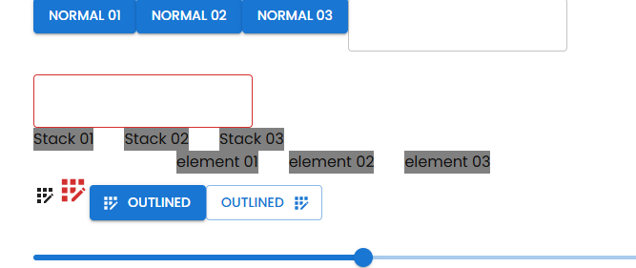  With style overrides  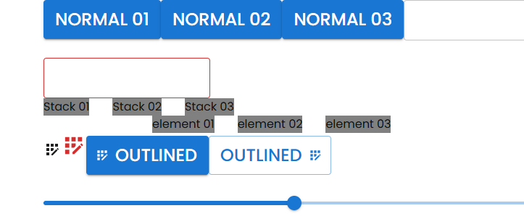
const customTheme = createTheme({  typography: {  fontFamily: "Poppins, sans-serif",  },  components: {  MuiButton:{  defaultProps: {  variant: "contained" // set default variant  },  styleOverrides: {  root:{  fontSize: "1.5rem",  variants:[ // set global customized variants  {  props:{  variant:"outlined", // this is a rule  color:"secondary", // this is a rule  }, // if this props is passed then this style will be applied. So if variant is "outlined" and color is "secondary" then the font size will be 0.5rem  style:{  fontSize:"0.8rem"  }  }  ]  }  }  }  }  }); | Without custom variant  <Button>Global customize variant</Button>  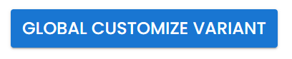  With custom variant  <Button variant="outlined" color="secondary">Global customize variant</Button>  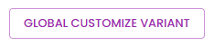
import { red } from "@mui/material/colors";  variants:[ // set global customized variants  {  props:{  variant:"dashed",// this is a custom varient  },  style:{  border:`4px dashed ${red[500]}`,  }  }  ]  <Button variant="dashed" color="secondary">Global customize variant</Button>  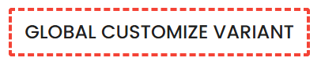  Error: Type '"dashed"' is not assignable to type 'OverridableStringUnion<"text" | "outlined" | "contained", ButtonPropsVariantOverrides> | undefined'. | Solution:  To use custom “dashed” varient. We need to use “Module Augmentation” provided by type script. For that  src/types/mui.d.ts [here d mean global declaration]  import '@mui/meterial'; // by importing this we tell the typescript that we are using Module Augmentation  // what type of mui library to enhance.  declare module '@mui/material/Button' {  /*  this are exported from @mui/meterial/button component. We can add our own types here  export interface ButtonPropsVariantOverrides {}  export interface ButtonPropsColorOverrides {}  export interface ButtonPropsSizeOverrides {}  */  interface ButtonPropsVariantOverrides {  dashed: true;  }  }  After this the type error will not show again
typography: {
fontFamily: "Poppins, sans-serif",
button: {
fontSize: "3.5rem" // we can also change the global button size here like this
}
},

Nested theme provider:
const customTheme = createTheme({  typography: {  fontFamily: "Poppins, sans-serif",  h1: {  fontSize: "4rem",  color: "blue",  }  },  });  const customInnerTheme = createTheme({  typography: {  fontFamily: "Arial, sans-serif",  h1: {  fontSize: "4rem",  color: "red",  },  }  }); | <ThemeProvider theme={customTheme}>  <Typography variant="h1">Hello</Typography>  <ThemeProvider theme={customInnerTheme}>  <Typography variant="h1">Nested ThemeProvider Hello</Typography>  </ThemeProvider>  </ThemeProvider>  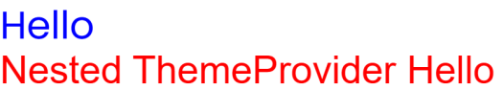
variants:[  {  Props: (props) => props.variant === "dashed" && props.color !== "secondary",  style:{  border:`1px dashed ${blue[500]}`,  color:blue[900],  fontSize: "20px"  }  }  ] | <Button variant="dashed">Global customize variant 02</Button>  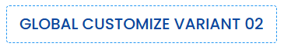

Global CSS Overrides:
const customTheme = createTheme({  components: {  // global css override. this will come under components -> MuiCssBaseline  MuiCssBaseline: {  styleOverrides: (theme) => `  h2 {  color: ${theme.palette.success.main};  }  `  }  }  }); | <Typography variant="h2">Hello h2</Typography>  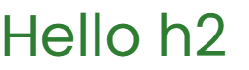

Dark Mode & System Mode:
Create a component in App.tsx:  import { ..., RadioGroup, useColorScheme } from "@mui/material";  const customTheme = createTheme({  colorSchemes: {  dark: true, // this will enable dark color theme  }  });  function ThemeToggler() {  const { mode, setMode } = useColorScheme(); // this will set the theme mode  // useColorScheme() is a hook from MUI v5+ (experimental) / v6 used to control light / dark / system mode easily.  if(!mode) return null; // this will check the default theme mode. If not selected anything then it will return null. So the system radio will default selected  return (  <RadioGroup value={mode} onChange={(e) => setMode(e.target.value as 'light' | 'dark' | 'system')}>  <FormControlLabel control={<Radio />} label="Light" value="light" />  <FormControlLabel control={<Radio />} label="Dark" value="dark" />  <FormControlLabel control={<Radio />} label="System" value="system" />  </RadioGroup>  )  }  Then add it inside App component:  <ThemeToggler/> | 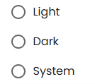  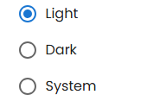
Customize dark and light theme:  colorSchemes: {  // dark: true, // default activation  // customize dark theme  dark: {  palette: {  primary: {  main: "#ff0000"  },  secondary: {  main: "#00ff00"  }  }  }  }  //We can also use opacity in color  main: alpha("#ff0000", 0.2) // with opacity  // import alpha at top  import { alpha, ... } from "@mui/material"; | Without customize theme:  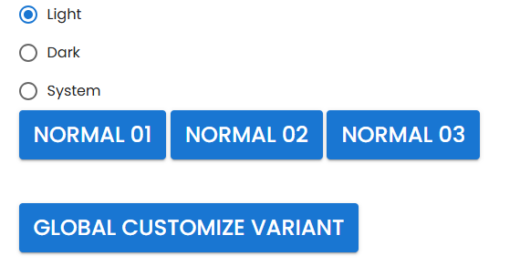  With customize theme:  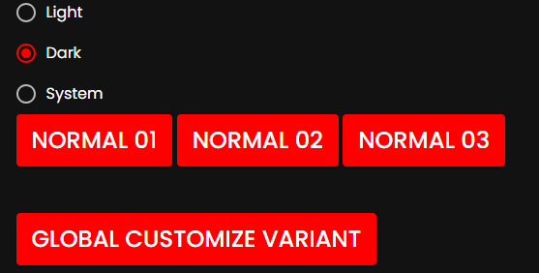  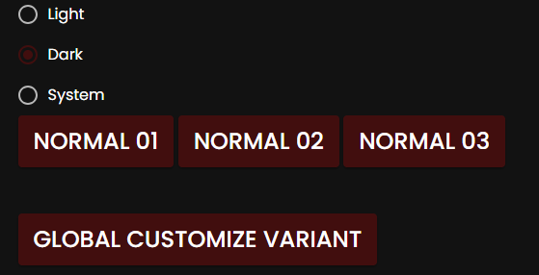
Create custom color palette:
colorSchemes: {  dark: {  palette: {  primary: {  ...  },  // by default “customColor” so error. Because it is added by me not present in Mui.  customColor: {  main: "#ff00ff"  }  }  }  }  <Button color="customColor">custom Color</Button> | 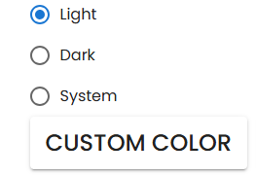  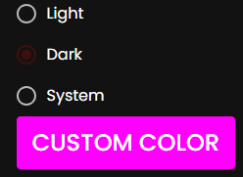

ghfgh

