Java Basics

What is Object?
objects means it's a real world entity like car bike ATM anything. So real world every real world entity has two things one is called behavior/ functionality means what the object performed . Another thing it is called properties and it’s mean how object look like, its color, height etc or we can tell about the object after observing that object.

what is Procedural Programming?
Procedural Program is divided into functions and it will pass the data whatever is required from one function to another function. It does not provide proper way to hide the data. It gives importance to functions and data moves freely and data can change in any function. So they are very Tight Coupled ( Means: we have one function which create a variable and we pass the variable to another so that the variable is moving around one function to another and another function changing it and than using it and those who created it that dose not have information about it ) because they are freely passing the data there is no way to hide the data. So what It’s say that it give importance to function but it doesn't focus on the data and data moves freely from one function to another from another function and anybody can change it no control over that. Also in Overloading, Inheritance not possible and Code re-usability does not present.

What is OOPS?
OOPS stand for object oriented programming as the name itself says that it's Orient toward so everything you have to think from an object. OOPS provide data hiding. It’s means OOPS Class will bind function and Data an that function will work on the Data. So it has full control over it.

What is Class?
Class is a Blueprint/ Skeleton of an object where we can write it’s Behavior and Properties and create a object out of it. To create a Object, a class is required.

Core principles / Pillar of OOPS: OOPS has four Pillars

- Data Abstraction
- Data Encapsulation
- Inheritance
- Polymorphism

Data Abstraction : It hides the internal implementation and shows only essential functionality to the user. Example, we have a Car - we shows only the break pedal, and if we press it, car speed will reduce. But how internally it will reduce we don't know. Because that is Abstracted to us.
Advantages of abstraction increase security and confidentiality. We can achieved it through Interface and abstract classes.

Data Encapsulation: is the process of bundling data variables and methods (functions) that work on the data into a single unit, like a class, which restricting direct access to the data. Instead of accessing or modifying data directly, you we methods to interact with it.
Advantages of Encapsulation
- Loosely coupled code: because of data encapsulation class takes the ownership of the available functions and use this function for access variable, it’s means every functions are not related with each other.
- Better access control and security

Example, It’s like putting your valuables in a box (class), locking it (restricting access), and giving others a key (methods) to interact with the items in a controlled way. This helps protect the data and ensures it’s used properly.

Abstraction vs Encapsulation

Abstraction | Encapsulation
Focuses on what functionality is provided. | Focuses on how data is accessed and protected.
Achieved by using abstract classes or interfaces to hide implementation details. | Achieved by making attributes private and providing methods for controlled access.
Concerned with reducing complexity by hiding unnecessary details. | Concerned with data security and integrity.

Inheritance: Capability of a class to inherit properties from their Parent Class. It can inherit both functions and variables, so we do not have to write them again in child class.

Advantages of Inheritance
- Code re-usability
- We can achieve polymorphism using Inheritance

Types of Inheritance

- Single Inheritance
- Multilevel Inheritance
- Hierarchical Inheritance
- Multiple Inheritance - through interface we can resolve the diamond problem

- Single Inheritance: is a type of inheritance in Object-Oriented Programming (OOP) where a class (called the child class or derived class) inherits the properties and methods of a single parent class or base class.

Key Feature:
- The child class can reuse the methods and attributes of the parent class, reducing code duplication.
- The child class can extend or override the parent class's functionality.
- Single inheritance is straightforward, involving only one parent and one child class.

- Multilevel Inheritance: is a type of inheritance in Object-Oriented Programming (OOP) where a class is derived from a child class, which itself is derived from another parent class. In other words, a class inherits from a class, and then another class inherits from that derived class, forming a chain.

Key Feature:
- A child class inherits from a parent class, and another child class inherits from that child class.
- Each class in the chain can reuse and extend the properties and methods of its parent class.
- Multilevel inheritance creates a hierarchy of classes.

- Hierarchical Inheritance: is a type of inheritance in Object-Oriented Programming (OOP) where multiple child classes inherit from a single parent class. In this structure, all child classes share the properties and methods of the parent class but can also define their own additional functionalities.

Key Feature:
- One parent class is shared by multiple child classes.
- Common functionality is written in the parent class and reused by all the child classes.
- Each child class can have its own methods or override the parent's methods without affecting other child classes.

4. Multiple Inheritance is a type of inheritance in Object-Oriented Programming (OOP) where a child class inherits from more than one parent class. This allows the child class to access the properties and methods of all its parent classes.

Key Feature:
- A single child class can inherit from multiple parent classes.
- The child class can reuse the functionality of all parent classes.
- Multiple inheritance allows the child class to combine features and behavior from multiple sources

Polymorphism: Poly mean Many and Morphism mean Form. A same method, behaves differently in different situation.
Example: A person can be father, Husband, Employee etc, Water can be liquid, solid and gas

Types of Polymorphism:

- Compile Time / Static Polymorphism / Method Overloading: is a feature in Object-Oriented Programming (OOP) that allows a class to have multiple methods with the same name but different numbers or types of parameters. It is a way to achieve compile-time polymorphism or static binding. On the basis of return type overloading can not be done. Can be done only on the basis of parameters. During the compile time does not check the return type.

Key Feature:
- Same Method Name: All methods share the same name but differ in their parameter lists.
- Different Parameter Lists: Methods can differ by the number, type, or order of parameters.
- Compile-time Resolution: The method to be called is determined at compile time based on the arguments provided.

- Run Time / Dynamic Polymorphism / Method Overriding: is a feature in Object-Oriented Programming (OOP) that allows a child class to provide a specific implementation of a method that is already defined in its parent class. The method in the child class overrides the method in the parent class, enabling runtime polymorphism. Here method name and argument should be same only internal implementation can be different and which one to call that depend on runtime. So on runtime it will check that from which class we have created the object on the base of this check that the method is present on that class or not. If have then it will call that method but if not then it will call the method from parent class and it will call on run time only

Key Feature:
- Same Method Name: The child class uses the same method name as defined in the parent class.
- Same Parameters: The method in the child class must have the same parameters (signature) as the method in the parent class.
- Runtime Polymorphism: The method to be executed is determined at runtime based on the object being referenced.
- Inheritance: Method overriding occurs in a parent-child class relationship.

Difference Between Method Overloading and Method Overriding:

Feature | Method Overloading | Method Overriding
Definition | Same method name with different parameters. | Redefining a method in the child class.
Binding | Compile-time (Static Binding). | Runtime (Dynamic Binding).
Purpose | Provides multiple ways to perform similar tasks. | Extends or modifies the behavior of the parent class.
Relationship | Happens within the same class. | Happens between parent and child classes.

Objects Relationship: In Object-Oriented Programming (OOP), object relationships refer to how objects are associated or interact with each other in a system. These relationships define how objects work together to achieve a specific functionality or represent real-world scenarios

Is-a Relationship: Achieved through inheritance. Inheritance form an is-a relation between its parent child classes.
Example: Dog is-a Animal.

Has-a Relationship: Whenever, an object is used in other class, it's called HAS-A relationship. Relationship could be one-one, one-many, many-many.
Example:
School has Students
Bike has Engine
School has Classes

Association: relationship between 2 different Objects

Aggregation (weak Relationship): Both Objects. Can survive individually, means ending of one object will not end other object.

Composition (Strong Relationship): Ending of One object will end another object

What is Java?
Java Programme is a platform independent Language,
Java is a Object Oriented Programming (OOPS).
Advantage of Java is Portability [WORA - Write once, Run Anywhere]
Java is a Static Typed Language [ every variable has a datatype which tells what kind of data it can store ]
Java is a Strong Typed Language [ for each datatype we have a range between which we can assign a value to this variable, So we have a restriction or we have a limit on the value which can be assign to this ]

Check java version: java -version

3 Main Components:

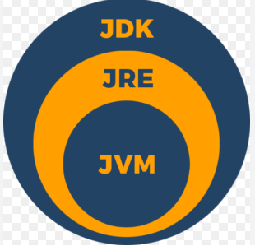

- JVM - Java Virtual Machine: is platform dependent ( As per OS[windows, MAC] we need different JVM ). JVM convert byte Code to Machine Code and for JVM we get Portability. JVM has J-I-T(Just In Time) Compiler

flow of JVM:

- JRE - Java Runtime Environment: is platform dependent. JRE has JVM + class Libraries. In JRE we can run any java byte code, but can not write any code inside it.

- JDK - Java Development Kit :is platform dependent. Java programming language information is present in JDK. Also have java compiler and debugger.
JDK = JRE + Programing Language + Compiler + Debugger etc…

JSE: Java Standard Edition
JEE: Java Enterprise Edition
JME: Java Mobile/Micro Edition

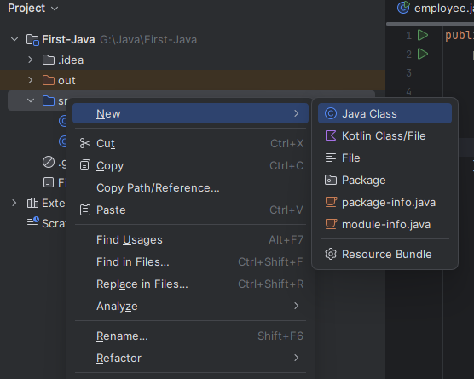

employee.java

public class employee {
public static void main(String args[]){
// main method -> is the starting point of the programme
// void -> is return type means the method can not return anything
// public -> it can be called from anywhere. public with any programme or method or variable can be invoked from anywhere and main methode has to be invoked by JVM So we make it public because JVM has to call it, it has to be invoked from outside of the package or outside of the directory
// Static -> When we create any method, variable static means it is not a part of object, now it is a part of class, and we can directly access it through the class name instead of creating an object we can call method inside it with class name itself.
int a = 10;
System.out.println("Value of a is: "+ a);
}
}

In Terminal: javac employee.java will create bytecode file with the name of employee.class
In Terminal: java employee will show the result

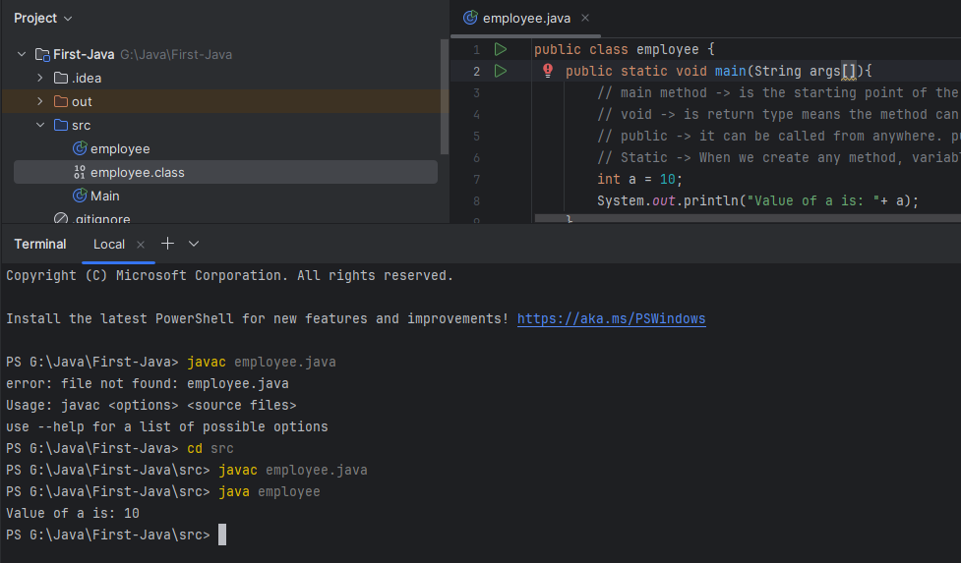

** Note: java file name and class name should be same because java out restriction that there will be one public class and the class name should be same as file name, and inside the public class main method will present. So when JVM compile the code it will call the main method for the starting point of compilation from the class name what it get from the file name.

What is Variable?
Variable is a container which holds a value.
Datatype VariableName = value;
int a = 10;

Variable name:
- Variable name is Case-Sensative
- Variable name can be start with $_ and letter but not with number
- Variable name can not be JAVA reserved keyword like new, class etc..
- Variable name should be all small if it contains only 1 word else camel case should be follows
[ Example: int city = “kolkata”; int cityName = “kolkata”; ]
- For constant, variable name should be defined in CAPITAL LETTER

What is a "bit"?
A bit is the smallest unit of information in computing, and it can only have two possible values: 0 or 1.
Each additional bit doubles the number of combinations.

How Many Combinations Per Bit?
For 1 bit, you have 2¹ = 2 (0, 1)
For 2 bits, you have:2² = 4 (00, 01, 10, 11)
For 16 Bits, Since 16 bits have 16 positions, and each position can either be 0 or 1,
the total number of combinations is: 2¹⁶ = 65,536

Example with 16 Bits:
If you have 16 bits, you can form combinations like:
0000 0000 0000 0000 → Decimal value: 0
0000 0000 0000 0001 → Decimal value: 1
1111 1111 1111 1111 → Decimal value: 65,535 (largest value for unsigned numbers).
Each of the 16 bit positions can independently be 0 or 1, leading to 2¹⁶ possible combinations.

Variable Type:
- Primitive Type

char, byte, short, int, long - integral type (is a data type used to store whole numbers (integers) without any fractional or decimal part)
float and double - fractional type

Char: is 2 bytes / 16 bits. Char is representation of ASCII values. Range 0 to 65535. The Unicode range is from U+0000 to U+10FFFF, covering over 1.1 million possible characters.

byte: is 8 bits. Signed 2 complement, Range: -128 to 127, default value is 0.

short: 2 bytes / 16 bits.Signed 2 complement, Range: -32768 to 32767, default value is 0.

long: 8 bytes / 84 bits.Signed 2 complement, Range: -2⁶³ to 2⁶³-1, default value is 0. assign value like -> long = 500L;

float: 32 bits. IEEE 754 values. IEEE 754 with this format float stores the data

double: 64 bits. IEEE 754 values

- Non-Primitive Type / Referance Data type

Type of conversion:

1. Automatic / Widening Conversion : when conversion from lower datatype to higher datatype it do Automatic conversion
2. Narrowing / Downcating / Explict Conversion : when conversion fromhigher datatype to lower datatype Automatic downcasting doesn’t happened. We need to manually type cast to it.
3. Promotion during expression: during an expression if we cross the range it do internal promotion.
4. Explicat casting during Expression: during an expression if any of datatype is higher than another then all variable converted to the higher one

Kinds of variables:

public class employee {
int memberVariable; // member variable / instant variable - default value = 0
static int staticVariable = 100; // Static Variable / class variable
employee(){ } // Constructor Parameters
public void dummyMethod(){
byte localVariable = 100; // Local Variables
}
// Method Parameter
public int dummyMethod2(int a, int b){
return a+b;
}
}

- Local: is a variable that is declared inside a method, constructor, or block in a program. It is exists only during the execution of the method or block in which it is declared.

public class employee {
public void dummyMethod(){
byte localVariable = 100; // Local Variables
}
}

- Instance / Member Variable: A member variable, also known as an instance variable, is a variable that is declared inside a class and is associated with the objects (instances) of that class. Each object of the class has its own copy of the member variables, and they represent the state or attributes of the object.
Example: We created two object from same class. So two objects has its own copy of member variable. It's means that each object will work on it's own member variable and it can have any value and other have other value.

// employee.java
public class employee {
int memberVariable; // member variable / instant variable - default value = 0
}

// Student.java
public class Student {
public static void main(String args[]){
employee obj1 = new employee();
System.out.println(obj1.memberVariable);
}
}

- Static/class variable: also known as a class variable, is a variable that is static value mean copy of one. Even we create two objects of that class there one copy exists and both objects can access the variable via class name. This variable related to the class not shared among the objects.

// employee.java
public class employee {
static int staticVariable = 100; // Static Variable / class variable
}

// Student.java
public class Student {
public static void main(String args[]){
employee obj1 = new employee();
employee obj2 = new employee();
System.out.println(employee.staticVariable);
}
}
// result: 100

- Method Parameters

// employee.java
public class employee {
// Method Parameter
public int dummyMethod2(int a, int b){
return a+b;
}
}

- Constructor Parameters: Constructor parameters are variables that are passed to a constructor when creating an object of a class. Constructor name should be same as class name.

public class employee {
employee(){ } // Constructor Parameters
}

