**SCHOOL OF COMPUTING (SoC)**

**ST0503 Back-end Web Development**

**2021/2022 SEMESTER 2**

**ASSIGNMENT 2**

**Instructions and Guidelines:**

1. The assignment **source code** must be submitted before 7th Feb 2022, 8am. You are required to submit your source codes to the BlackBoard. Remember to provide your Class, Group, Admission Number(s) and Name(s) on the softcopy.
2. A word document showing the additional APIs or modifications should be included in the submission.
3. You are required to **clearly** provide instructions on how to setup the project on the lecturer's laptop in a text file that is to be included in the softcopy submission.
4. Students are to work in a group of 1-2 members.
5. **Students of 2 member group must complete 1 extra advanced feature (without extra marks) stated in the document or be penalized 10 marks**.
6. Marks will be given separately for each student in the group, depending on his contribution to the assignment. The assignment will account for **30%** of your final grade*.*
7. The assignment should be implemented using Node JS, Express and MySQL.
8. The interview will be conducted during the lessons in the week of **7th Feb 2022**. You are expected to explain the program logic and modify the program during the interview. **If you are absent, you will be awarded zero mark for the assignment.**
9. **No marks will be awarded**, if the work is copied or you have allowed others to copy your work. Warning: Plagiarism means passing off as one's own the ideas, works, writings, etc., which belong to another person. In accordance with this definition, you are committing plagiarism if you copy the work of another person and turning it in as your own, even if you would have the permission of that person. Plagiarism is a serious offence and disciplinary action will be taken against you. If you are guilty of plagiarism, you may fail all modules in the semester, or even be liable for expulsion.
10. 50% of the marks will be deducted for assignments that are received within ONE (1) calendar day after the submission deadline. No marks will be given thereafter.

Exceptions to this policy will be given to students with valid LOA on medical or

compassionate grounds. Students will need to inform the lecturer as soon as reasonably possible. Students are not to assume on their own that their deadline has been extended.

# Assignment 2

Assignment 2 is built on-top of the API you built in assignment 1.

## Assignment Requirements

You are required to fulfil the following basic requirements:

* Front-end for the web application (You are allowed to use open source templates downloaded from the internet)
* Persistent login (and logout)
* Search products by name OR brand. (General Public)
* View product details (including product info, average rating and all reviews in one page)

(General Public)

* Add new reviews (Only for **Registered Members**)
* Add category preferences for system recommendation **(**Onlyfor **registered members)**
* Add new products (Only for **Admins**)
* Add new category (Only for **Admins**)
* Ensure necessary JWT checking for access rights for relevant web api

You can add in more APIs or modify your existing APIs or the database structure to satisfy the requirements of the app.

You can produce your own design for your web app.

Some example web pages are shown below just for reference. Your design/implementation can be different:

1. Login Page

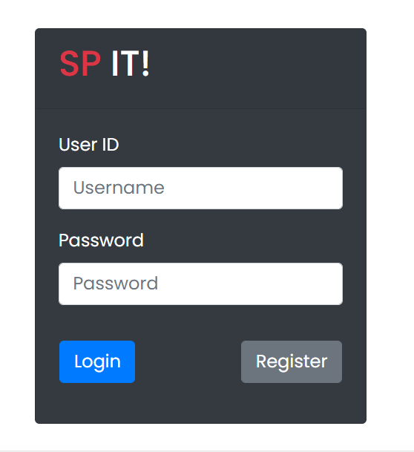

1. Home page



The home page contains a search form for users to search for product listings

Users can also click log out to log out of the page if they are logged in.

1. Search results page

The search results page should contain matching results for the search fields from the search page. Brief info on the matching products (eg name) should be shown. Users can click on the product to view detailed info about the product.

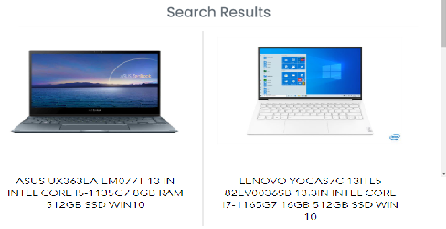

1. Product Details Page

This page should show the product’s details, including name, category, description, price, rating etc.

The Write review button and writing of reviews should only be shown/allowed for logged in members.



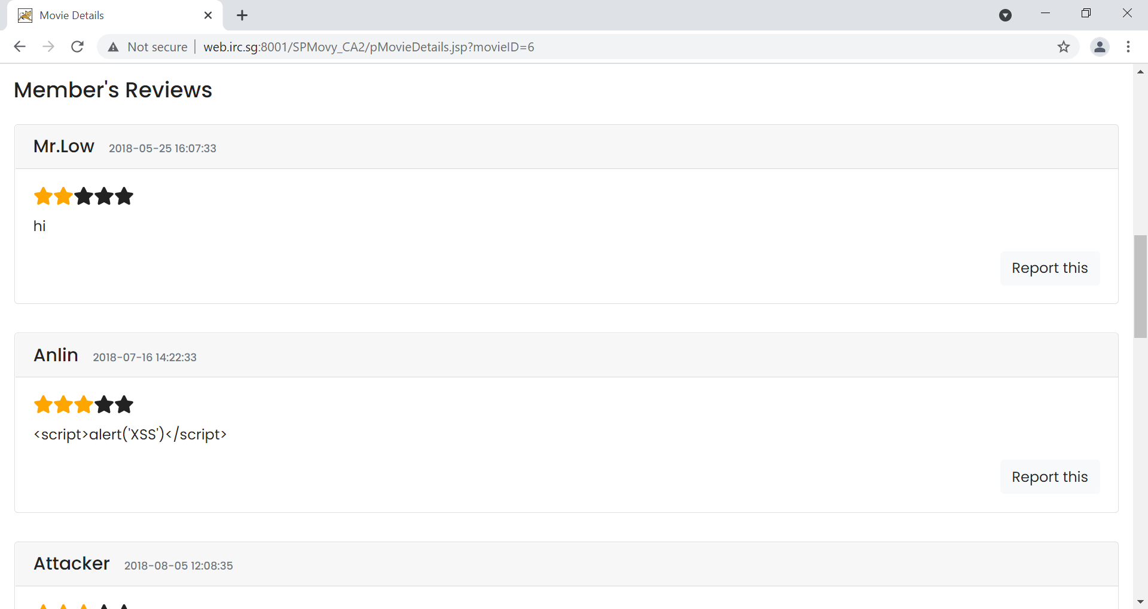

1. Add new category preferences

Page with checkboxes containing category names for user to select his category preferences. After user selects the appropriate checkboxes, the category preferences will be inserted into the database.

1. Add new products:

Page to enter all required fields and submit to add new product. Note for product insertion, frontend should allow admins to select category name (from existing category list in checkboxes) instead of categoryid. But during the insertion to product table, categoryid should be inserted instead.

7. Add new Category

Appropriate error message should be displayed in the event of a failed insertion due to duplicate name.

**Grading Guidelines**

The assignment will be assessed based on the following criteria:

* Demonstrate the requirements stated above correctly and effectively (80%)
* Graphical User Interface and user friendliness: (10%)
* Advanced Features (10%)
* Amount of individual contribution to the project
* Question & Answer during the interview

**Bonus Requirements for the web application(You can suggest useful functions for the web app too)**

* Provide upload of actual image when creating new products
* Add and search promotions for products
* Purchasing products and then confirm payment details and check out with data saved to database
* Edit/Delete of products for admin