**AR App Proposal**

**Student Name** : Jayden Yap Jean Hng

**Student ID** : 2112790

**Class** : DAAA/FT/2A/04

1. **App Title**

Summon a Disco

1. **App Features**

App uses plane tracker to display multiple “summon signs” that the user can tap to summon various characters to dance. The summoning feature is inspired by a game “Dark Souls” but with a fun twist with dancing. When summoned, there will be disco lights and music playing.

When tapping on the screen (not object) all objects will be repositioned to where the user tapped.There will be UI option picker too (see below)

1. **App Information Architecture + UI Design**

UI Design

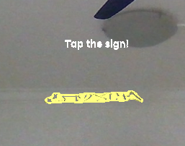user will see multiple of these signs next to each other on the plane

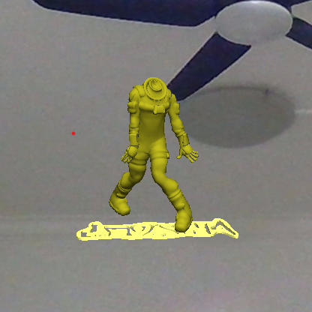after tap, 3d animation model will appear and dance, along with effects and music

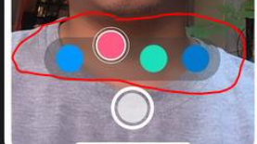- will have UI option picker to choose which 3d models/animations/light effects to use

-eg colour option:. Blue=Blue themed models/disco lights

eg. choosing which model: there will be icons that display a thumbnail of the 3d model (for example a stormtrooper) so if u select that the model will be stormtrooper

1. **List if using any 3D Models, Image Targets (if you choose fixed target tracker) and Audios etc**

**For 3D Models:**

I will use various mixtures of models+animations from mixamo. They have a wide assortment of dance animations and 3D models to choose from. I can also try finding other assets elsewhere but this website will already be enough for me.

[**https://www.mixamo.com/#/?page=1&type=Motion%2CMotionPack**](https://www.mixamo.com/#/?page=1&type=Motion%2CMotionPack)

**For audio**:

I will get music/various sound effects from youtube converters