**Project by**

**Jayesh Debnath [(1930125@kiit.ac.in)](mailto:(1930125@kiit.ac.in)) NamrataModak [(1906404@kiit.ac.in)](mailto:(1906449@kiit.ac.in))**

**Saikat Das [(1906355@kiit.ac.in)](mailto:(1906355@kiit.ac.in)) Riya Mandal [(1906493@kiit.ac.in)](mailto:(1906493@kiit.ac.in))**

**BIOSCOPE**

The Project “BIOSCOPE” is a App that lets us to know the information related to the movies. This app will be helpful to find the release date of movies, people can search for movies , Find out recommendations,also see cast and reviews and trailers of all movies and web series and review any movie and tv shows easily.

In this project, we have used the Recycler view to show the list of the movies. As we click on a movie, it directs the user to another activity that contains the poster along with release date and ratings. On the front page, we have a search interface to search for any movie of our liking. It also contains a spinner that contains options like top rated movies, upcoming movies, now playing and popular movies for the users to choose from.

**Introduction**

Welcome to bioscope app.We have built a OTT platform with react and Added Firebase Auth to authenticate users .You can search for movies , Find out recommendations,also see cast and reviews and trailers of all movies and web series. Below you will find a current list of the available methods on our movie, tv series .

User authentification (email only)

To login/sign in, click on the icon which display (sign up) from within your home page page. You can also view the screenshots below for Help

: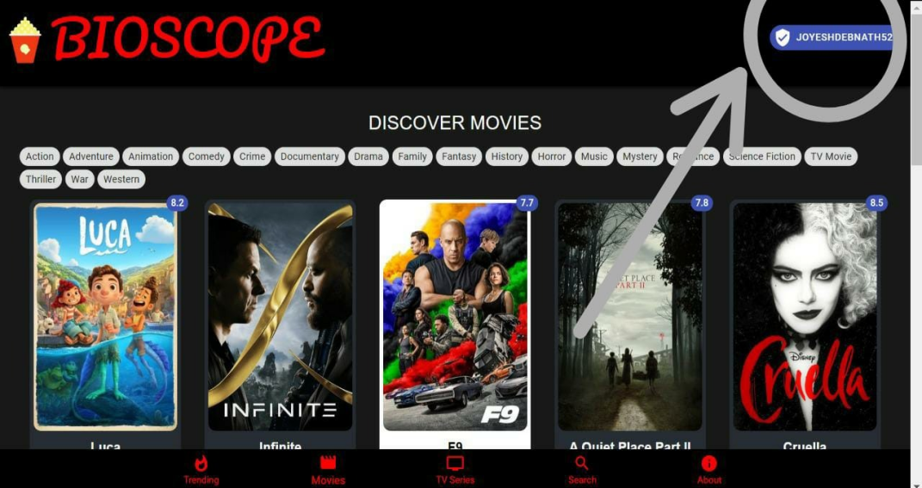

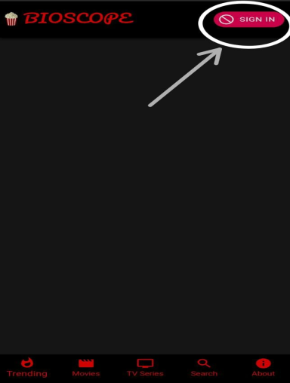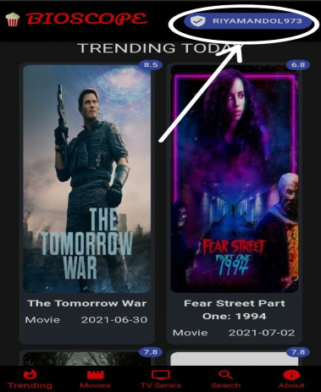

The bioscope sign in process is optimized for mobile devices also so you can access these pages on a desktop computer , mobile and mobile devices .

A few useful tips...

The configuration methods are useful to get the static lists of data we use throughout the database. You can find things like the languages, countries, timezones and translations that we use. The configuration method also holds useful image information.

Understanding the basics of our authentication is useful.

#### Purpose

The main purpose of this project to reach out to the people who watch movies very often. This application aims at providing all information related to the movies at one place to the user.

#### Scope

The scope of the application is that it provides the user the information about the movie. It also gives information about the rating, year of release along with proving them the similar movies to the searched movie. It gives user to view the currently playing trailer along with the top rated movies, popular movies and upcoming movies.

**A summary of the major functions that the app will perform**

1. The app contains a search interface in which we can search the movie of our choice along with similar movies.

2. It contains a icon which displays options like trending movies, popular movies, top rated movies etc.

3. The app contains movies displayed in grid layout.

4. On clicking on a movie, the user gets directed to another activity which contains the poster of the movie along with movie description and similar movies.

General Features

Top rated movies

Upcoming movies

Popular movies

Popular TV shows

Top rated TV shows

**Account Features**

Get details

Get lists (created and marked as favourite)

Get favourite movie list

Get the account state for a movie (rated, marked as favourite )

Account Session Features

Rate a movie

Add/remove a movie to your favourites

Add/remove a movie to your watch list

**Movie Features**

**Search**: Search for movies with a text query and you can also use voice command to search movies

**Discover**: Search for movies based on data. Movies are queryable by fields like average rating, certifications, release dates and genres.

**Get details**

Primary info

Alternative titles

Cast

Crew

Images (posters, backdrops)

Release information

Trailers

Similiar movies

Reviews

Belongs to lists

Changes

**TV Features**

**Search**: Search for TV series with a text query and you can also use voice command to search TV series

**Discover**: Search for TV series based on data. TV series are queryable by fields like average rating, TV network and genres.

**Get details**

Primary info

Cast

Changes

Crew

Images (posters, backdrops)

External IDs

**GENRE SEARCH:-**

A novel user interface for a web searching that allows genre-based navigation through three major

functionalities:-

* Limiting search to specified genres
* Visualizing the hierarchy of genres
* discovered in the search results
* Accepting user feedback on the
* relevancy of the specified genres.

**SYSTEM DESIGNS:-**

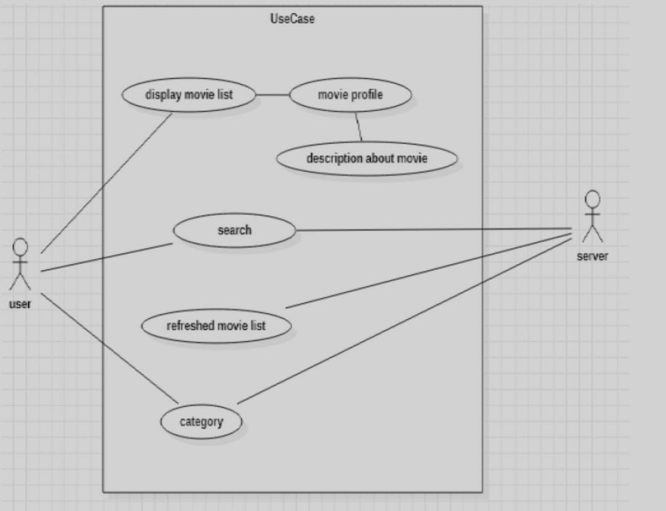

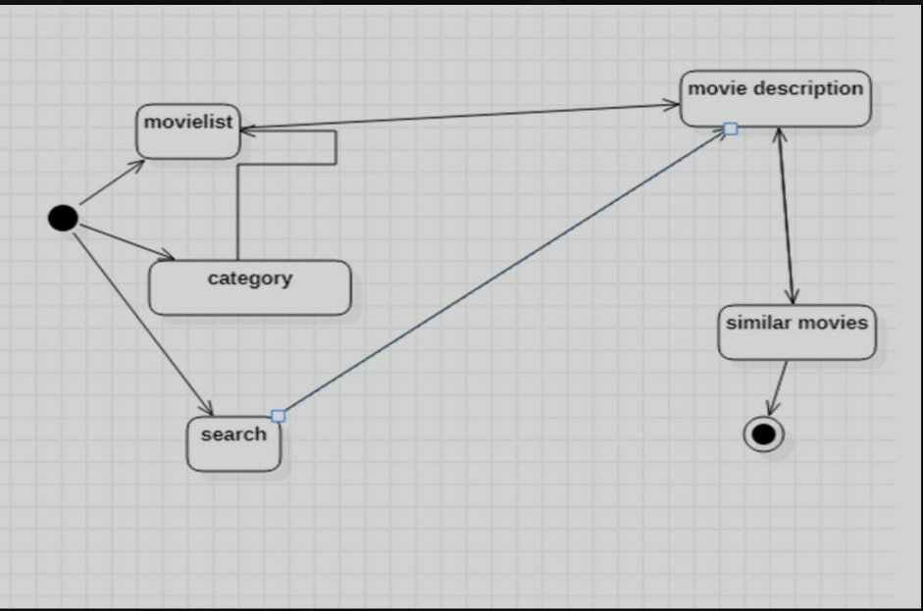

**USER AUTH:-**

By logging in, we mean that we need a session Id. This session ID will be further used to get the account details, add a movie to the favourite list , and bring the watchlist and delete a movie from favoritelist .You can also delete the session ID.

There are 2 steps to get the Session ID -

Get a request token by /authentication/token/new. This will give a request token.

Validate the username and password for your account by making authentication/token/validate_with_login with username, password, and request token received in step 1, in the request body to get another request token. If you receive the token, that means the username and password are correct and you can proceed with creating the session. But, if the username and password are invalid, you won’t get the request token and won’t be able to get the session id.

**PASSWORD RECOVERY:-**

If a user forgets the password,password recovery is available.An option called “Forgot Password?” is available there.On clicking, it will ask for our mail where the password recovery link will be sent. After providing the registered mail a password recovery link will be sent in the registered mail from where we can get access to the account. Here, firebase and context API is used.

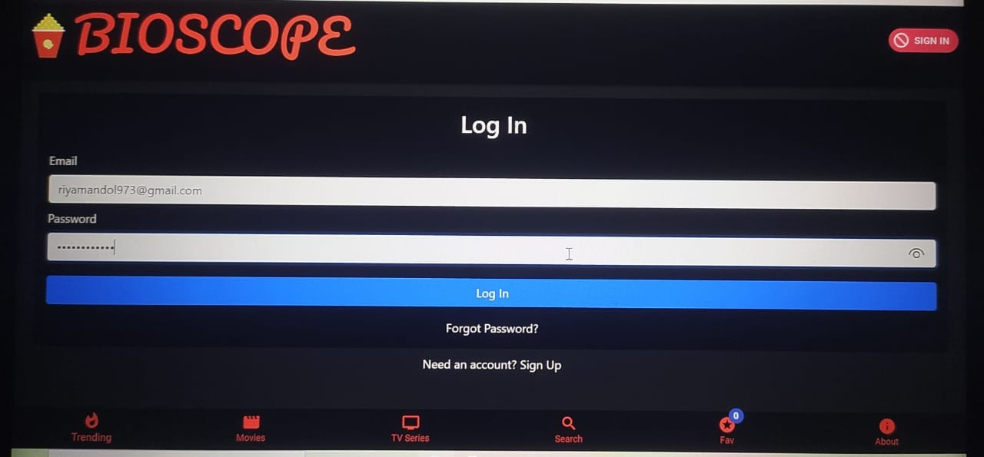

**FAV-LIST:-**

Real time notification in Navbar to see the number of favourite movies or TV shows we have added to

our list.CRUD Operation is undergoing in this feature. Material-UI has been used here.

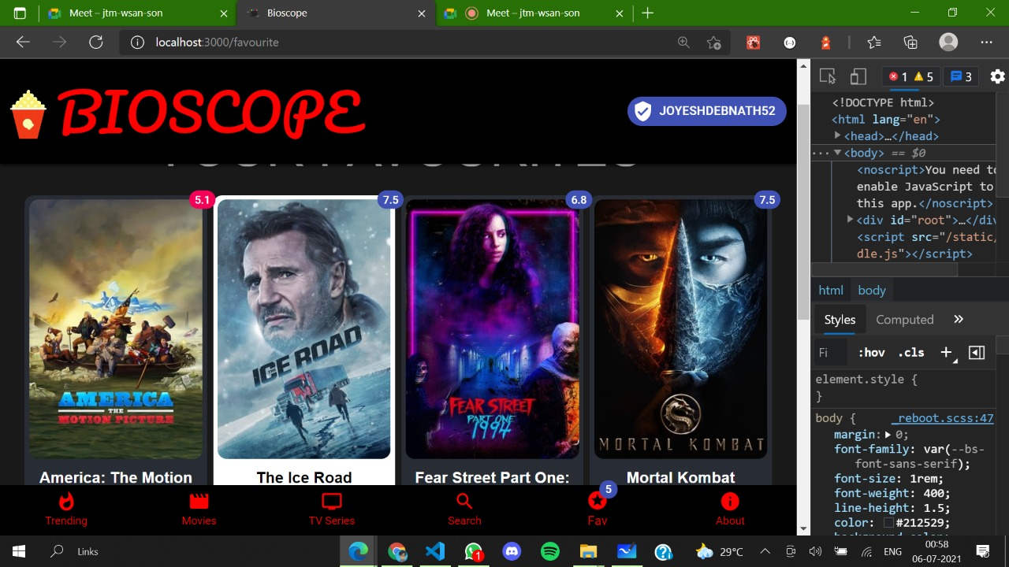

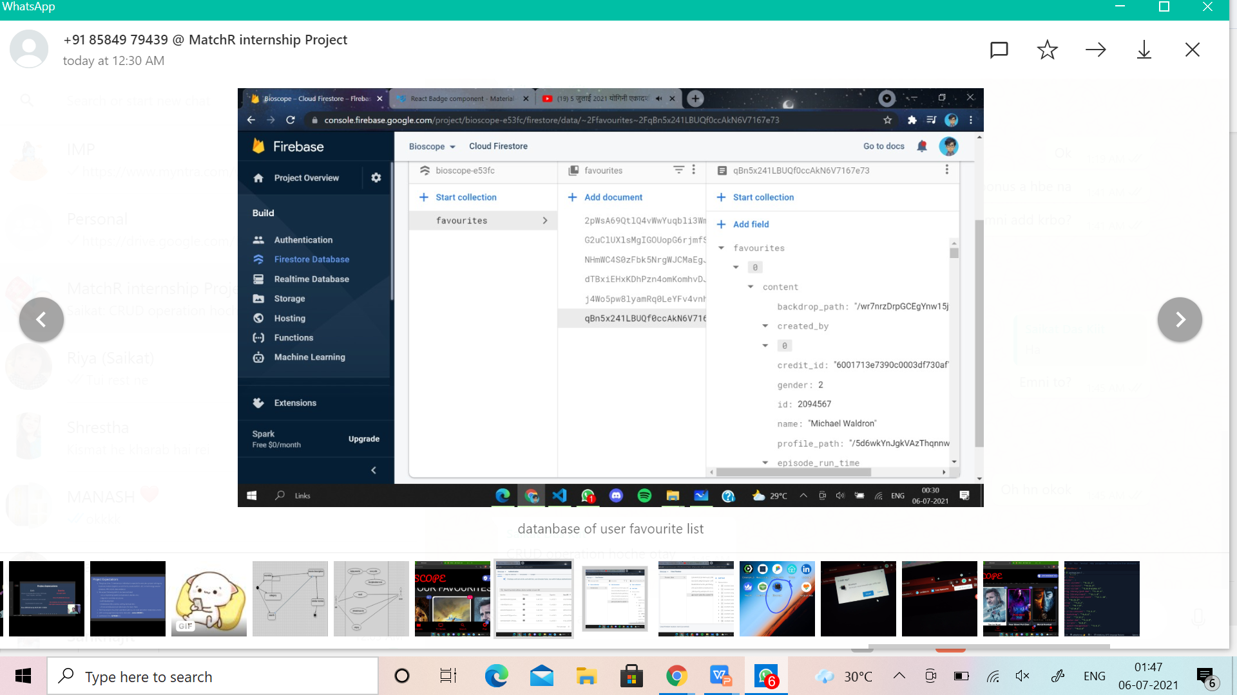

**Database of User’s Favourite List.**

**OFFICIAL TRAILERS:-**

Any movie or TV show searched will have an option of watching the trailer.If clicked,it will lead us a to

a new tab in YouTube which will play its official trailer. Here,YouTube API is used.

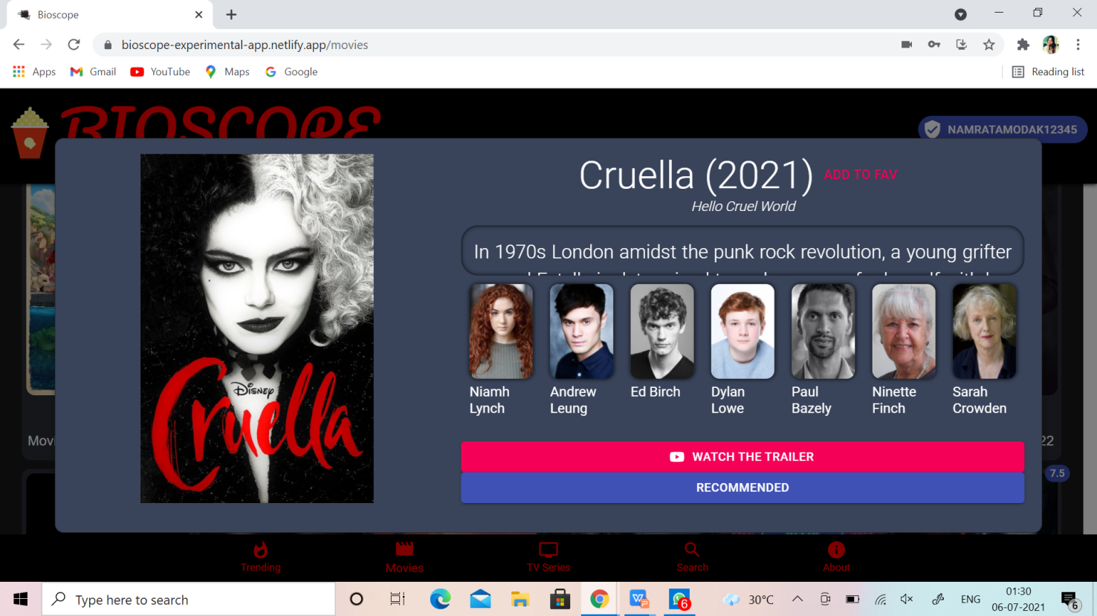

**PDF DOWNLOAD:-**

In the About section a option will be available of downloading the pdf. Here the presentation will get downloaded in the pdf form and henceforth one can easily look at the idea-map of our app.

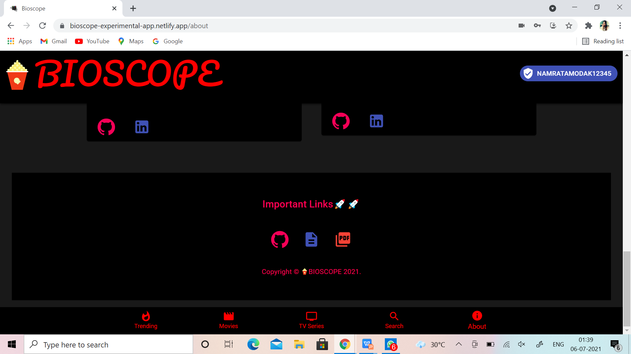

**TEAMWORK SPECIFICATION**

**Riya Rani Mandal** - Architecture, Overview Document, Styling with Bootstrap and CSS.

**Namrata Modak** - Presentation(PPT), Styling with CSS,Material Icon And Lab,material UI Core.

**Saikat Das** - Frontend with React (Components , Pages),Custom Hooks,Context API,Voice recognition search ,

Hosting,Conversion of App to PWA.

**Joyesh Debnath** - User Authentication,

Firebase & Firestore,making the styling responsive,Handling Bugs.