Library Digital Repository and Book Loan System
Database schema documentation — 25 tables | MySQL 8.0+ | SQLAlchemy 2.x | Alembic
Revision: e7f05f915f31 | 28 October 2026

Scope and verification
This document describes the implemented database models and migration. It does not implement services, controllers, routes, or recommendation algorithms. SQLite model and migration checks were executed locally; live MySQL migration must be verified on the student’s MySQL server.

Architecture and normalization
3NF-oriented design: repeating relationships use junction tables; resource attributes belong to resources; borrower information belongs to users; loan records reference physical copies; notification delivery attempts are separated from notification content. Audit JSON is an event snapshot, not authoritative master data. A work/edition distinction, publisher normalization, and consent history are deferred as documented design limits.
MySQL uses InnoDB, utf8mb4, unsigned BIGINT surrogate IDs and UTC DATETIME(6) convention. SQLite tests use INTEGER IDs and SQLite DATETIME. Check constraints require MySQL 8.0.16+ for enforcement.

Entity-relationship diagrams

Access and security
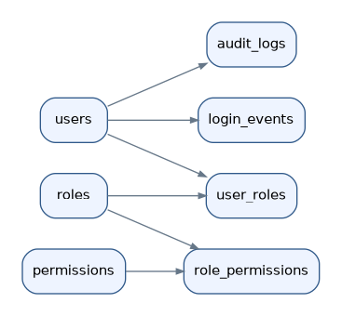

Catalogue and circulation
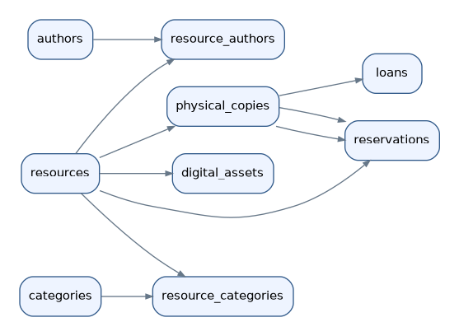

Personalization and messaging
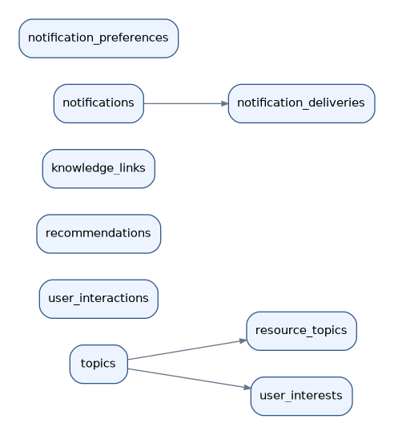

Detailed table dictionary

1. roles
Column | Type | Required / Key | References
id | INTEGER | PK NOT NULL
name | VARCHAR(50) | UQ NOT NULL
description | VARCHAR(255) | NULL
Foreign keys: None
Unique constraints: name | CHECK: None
Indexes: None

2. permissions
Column | Type | Required / Key | References
id | INTEGER | PK NOT NULL
code | VARCHAR(100) | UQ NOT NULL
description | VARCHAR(255) | NULL
Foreign keys: None
Unique constraints: code | CHECK: None
Indexes: None

3. user_roles
Column | Type | Required / Key | References
user_id | INTEGER | PK NOT NULL | users.id
role_id | INTEGER | PK NOT NULL | roles.id
assigned_at | DATETIME | NOT NULL
Foreign keys: user_id → users.id; role_id → roles.id
Unique constraints: None | CHECK: None
Indexes: None

4. role_permissions
Column | Type | Required / Key | References
role_id | INTEGER | PK NOT NULL | roles.id
permission_id | INTEGER | PK NOT NULL | permissions.id
Foreign keys: permission_id → permissions.id; role_id → roles.id
Unique constraints: None | CHECK: None
Indexes: None

5. users
Column | Type | Required / Key | References
id | INTEGER | PK NOT NULL
username | VARCHAR(50) | UQ NOT NULL
email | VARCHAR(255) | UQ NOT NULL
password_hash | VARCHAR(255) | NOT NULL
first_name | VARCHAR(100) | NOT NULL
last_name | VARCHAR(100) | NOT NULL
account_status | VARCHAR(20) | NOT NULL
created_at | DATETIME | NOT NULL
updated_at | DATETIME | NOT NULL
Foreign keys: None
Unique constraints: email, username | CHECK: ck_users_status
Indexes: None

6. resources
Column | Type | Required / Key | References
id | INTEGER | PK NOT NULL
title | VARCHAR(255) | NOT NULL
isbn | VARCHAR(20) | UQ NULL
resource_type | VARCHAR(30) | NOT NULL
description | TEXT | NULL
publisher | VARCHAR(200) | NULL
publication_year | SMALLINT | NULL
language_code | VARCHAR(10) | NOT NULL
created_at | DATETIME | NOT NULL
updated_at | DATETIME | NOT NULL
Foreign keys: None
Unique constraints: isbn | CHECK: None
Indexes: None

7. authors
Column | Type | Required / Key | References
id | INTEGER | PK NOT NULL
full_name | VARCHAR(200) | NOT NULL
orcid | VARCHAR(19) | UQ NULL
Foreign keys: None
Unique constraints: orcid | CHECK: None
Indexes: None

8. resource_authors
Column | Type | Required / Key | References
resource_id | INTEGER | PK NOT NULL | resources.id
author_id | INTEGER | PK NOT NULL | authors.id
author_order | SMALLINT | NOT NULL
Foreign keys: resource_id → resources.id; author_id → authors.id
Unique constraints: uq_resource_author_order | CHECK: ck_author_order_positive
Indexes: None

9. categories
Column | Type | Required / Key | References
id | INTEGER | PK NOT NULL
name | VARCHAR(100) | UQ NOT NULL
description | VARCHAR(255) | NULL
Foreign keys: None
Unique constraints: name | CHECK: None
Indexes: None

10. resource_categories
Column | Type | Required / Key | References
resource_id | INTEGER | PK NOT NULL | resources.id
category_id | INTEGER | PK NOT NULL | categories.id
Foreign keys: category_id → categories.id; resource_id → resources.id
Unique constraints: None | CHECK: None
Indexes: None

11. topics
Column | Type | Required / Key | References
id | INTEGER | PK NOT NULL
name | VARCHAR(150) | UQ NOT NULL
description | TEXT | NULL
Foreign keys: None
Unique constraints: name | CHECK: None
Indexes: None

12. resource_topics
Column | Type | Required / Key | References
resource_id | INTEGER | PK NOT NULL | resources.id
topic_id | INTEGER | PK NOT NULL | topics.id
relevance_weight | NUMERIC(8, 5) | NOT NULL
Foreign keys: topic_id → topics.id; resource_id → resources.id
Unique constraints: None | CHECK: ck_resource_topic_weight
Indexes: None

13. physical_copies
Column | Type | Required / Key | References
id | INTEGER | PK NOT NULL
resource_id | INTEGER | NOT NULL | resources.id
barcode | VARCHAR(100) | UQ NOT NULL
shelf_location | VARCHAR(100) | NULL
condition_status | VARCHAR(30) | NOT NULL
circulation_status | VARCHAR(30) | NOT NULL
acquired_at | DATE | NULL
Foreign keys: resource_id → resources.id
Unique constraints: uq_physical_copy_resource, barcode | CHECK: ck_copy_circulation, ck_copy_condition
Indexes: ix_physical_copies_resource_id (resource_id)

14. digital_assets
Column | Type | Required / Key | References
id | INTEGER | PK NOT NULL
resource_id | INTEGER | NOT NULL | resources.id
asset_name | VARCHAR(255) | NOT NULL
storage_uri | VARCHAR(1000) | NOT NULL
mime_type | VARCHAR(100) | NOT NULL
file_size_bytes | INTEGER | NULL
access_level | VARCHAR(30) | NOT NULL
uploaded_at | DATETIME | NOT NULL
Foreign keys: resource_id → resources.id
Unique constraints: None | CHECK: None
Indexes: ix_digital_assets_resource_id (resource_id)

15. loans
Column | Type | Required / Key | References
id | INTEGER | PK NOT NULL
user_id | INTEGER | NOT NULL | users.id
copy_id | INTEGER | NOT NULL | physical_copies.id
borrowed_at | DATETIME | NOT NULL
due_at | DATETIME | NOT NULL
returned_at | DATETIME | NULL
loan_status | VARCHAR(20) | NOT NULL
issued_by | INTEGER | NULL | users.id
received_by | INTEGER | NULL | users.id
active_copy_id | INTEGER | NULL GENERATED
Foreign keys: copy_id → physical_copies.id; issued_by → users.id; user_id → users.id; received_by → users.id
Unique constraints: uq_active_loan_copy | CHECK: ck_loan_status, ck_loan_due_after_borrowed, ck_loan_return_after_borrowed
Indexes: ix_loans_issued_by (issued_by), ix_loans_user_id (user_id), ix_loans_copy_id (copy_id), ix_loans_received_by (received_by)

16. reservations
Column | Type | Required / Key | References
id | INTEGER | PK NOT NULL
user_id | INTEGER | NOT NULL | users.id
resource_id | INTEGER | NOT NULL | physical_copies.resource_id, resources.id
reserved_at | DATETIME | NOT NULL
expires_at | DATETIME | NULL
reservation_status | VARCHAR(20) | NOT NULL
fulfilled_copy_id | INTEGER | NULL | physical_copies.id
Foreign keys: resource_id → physical_copies.resource_id; user_id → users.id; fulfilled_copy_id → physical_copies.id; resource_id → resources.id
Unique constraints: None | CHECK: ck_reservation_status
Indexes: ix_reservations_user_id (user_id), ix_reservations_resource_id (resource_id)

17. user_interactions
Column | Type | Required / Key | References
id | INTEGER | PK NOT NULL
user_id | INTEGER | NOT NULL | users.id
resource_id | INTEGER | NULL | resources.id
interaction_type | VARCHAR(30) | NOT NULL
search_query | VARCHAR(500) | NULL
occurred_at | DATETIME | NOT NULL
Foreign keys: resource_id → resources.id; user_id → users.id
Unique constraints: None | CHECK: ck_interaction_payload, ck_interaction_type
Indexes: ix_user_interactions_resource_id (resource_id), ix_user_interactions_user_id (user_id)

18. user_interests
Column | Type | Required / Key | References
user_id | INTEGER | PK NOT NULL | users.id
topic_id | INTEGER | PK NOT NULL | topics.id
interest_weight | NUMERIC(8, 5) | NOT NULL
last_updated_at | DATETIME | NOT NULL
Foreign keys: topic_id → topics.id; user_id → users.id
Unique constraints: None | CHECK: ck_user_interest_weight
Indexes: None

19. recommendations
Column | Type | Required / Key | References
id | INTEGER | PK NOT NULL
user_id | INTEGER | NOT NULL | users.id
resource_id | INTEGER | NOT NULL | resources.id
relevance_score | NUMERIC(8, 5) | NOT NULL
recommendation_reason | VARCHAR(500) | NULL
generated_at | DATETIME | NOT NULL
model_version | VARCHAR(50) | NULL
Foreign keys: user_id → users.id; resource_id → resources.id
Unique constraints: None | CHECK: ck_recommendation_score
Indexes: ix_recommendations_resource_id (resource_id), ix_recommendations_user_id (user_id)

20. knowledge_links
Column | Type | Required / Key | References
id | INTEGER | PK NOT NULL
source_resource_id | INTEGER | NOT NULL | resources.id
target_resource_id | INTEGER | NOT NULL | resources.id
relationship_type | VARCHAR(50) | NOT NULL
strength | NUMERIC(8, 5) | NOT NULL
Foreign keys: target_resource_id → resources.id; source_resource_id → resources.id
Unique constraints: uq_knowledge_link | CHECK: ck_knowledge_distinct, ck_knowledge_strength
Indexes: ix_knowledge_links_source_resource_id (source_resource_id), ix_knowledge_links_target_resource_id (target_resource_id)

21. notifications
Column | Type | Required / Key | References
id | INTEGER | PK NOT NULL
user_id | INTEGER | NOT NULL | users.id
notification_type | VARCHAR(50) | NOT NULL
title | VARCHAR(200) | NOT NULL
message | TEXT | NOT NULL
created_at | DATETIME | NOT NULL
read_at | DATETIME | NULL
Foreign keys: user_id → users.id
Unique constraints: None | CHECK: None
Indexes: ix_notifications_user_id (user_id)

22. notification_preferences
Column | Type | Required / Key | References
user_id | INTEGER | PK NOT NULL | users.id
email_enabled | BOOLEAN | NOT NULL
in_app_enabled | BOOLEAN | NOT NULL
personalization_consent | BOOLEAN | NOT NULL
updated_at | DATETIME | NOT NULL
Foreign keys: user_id → users.id
Unique constraints: None | CHECK: None
Indexes: None

23. notification_deliveries
Column | Type | Required / Key | References
id | INTEGER | PK NOT NULL
notification_id | INTEGER | NOT NULL | notifications.id
channel | VARCHAR(20) | NOT NULL
delivery_status | VARCHAR(20) | NOT NULL
attempted_at | DATETIME | NOT NULL
delivered_at | DATETIME | NULL
error_message | TEXT | NULL
Foreign keys: notification_id → notifications.id
Unique constraints: None | CHECK: ck_delivery_status, ck_delivery_channel
Indexes: ix_notification_deliveries_notification_id (notification_id)

24. audit_logs
Column | Type | Required / Key | References
id | INTEGER | PK NOT NULL
actor_user_id | INTEGER | NULL | users.id
action | VARCHAR(100) | NOT NULL
entity_type | VARCHAR(100) | NOT NULL
entity_id | VARCHAR(100) | NULL
old_values | JSON | NULL
new_values | JSON | NULL
ip_address | VARCHAR(45) | NULL
occurred_at | DATETIME | NOT NULL
Foreign keys: actor_user_id → users.id
Unique constraints: None | CHECK: None
Indexes: ix_audit_logs_actor_user_id (actor_user_id)

25. login_events
Column | Type | Required / Key | References
id | INTEGER | PK NOT NULL
user_id | INTEGER | NULL | users.id
attempted_identifier | VARCHAR(255) | NULL
event_type | VARCHAR(30) | NOT NULL
ip_address | VARCHAR(45) | NULL
occurred_at | DATETIME | NOT NULL
Foreign keys: user_id → users.id
Unique constraints: None | CHECK: None
Indexes: ix_login_events_user_id (user_id)

Special integrity controls
loans.active_copy_id is a stored generated column set to copy_id for active or overdue loans and NULL otherwise. A unique constraint prevents two simultaneous active loans for one physical copy. This relies on the SQL NULL uniqueness semantics supported by MySQL and SQLite.
reservations(fulfilled_copy_id,resource_id) references physical_copies(id,resource_id), and physical_copies has the matching composite unique constraint. A reservation without a fulfilled copy may keep fulfilled_copy_id NULL.
notification_preferences.personalization_consent defaults to FALSE in Python. Applications must enforce consent before collecting interaction events; schema alone cannot enforce that workflow.

Verification checklist
☐ All 25 SQLAlchemy tables registered
☐ SQLite schema creation and initial Alembic migration
☐ MySQL credentials configured locally (not included)
☐ MySQL connection test succeeds
☐ Alembic current returns e7f05f915f31
☐ SHOW TABLES lists 25 application tables plus alembic_version
☐ SHOW CREATE TABLE loans confirms generated column and unique key
☐ SHOW CREATE TABLE reservations confirms composite foreign key

